
EAL support at St Philip’s Who is the EAL learner?
(DfE definition)
A pupil learning English as an additional language who has a first language other than English (DfE)
First language is defined as “any language other than English that a child was initially exposed to during early development and continues to be exposed to in the home or community.” (DfE)
A pupil who uses EAL can range from a beginner in learning English to a very fluent speaker of English.
At St Philip’s we aim to improve the policy, practice and systems to enable children in the UK that speak English as an Additional Language to overcome any disadvantage through language education.

We use the PAWS approach:
P – Prepare for a smooth arrival or transition into school (see below)
A – Alert children and school team about new pupils and families and celebrate the different cultures
W – make our learning environment as Welcoming as possible
S – Support pupils using visuals, offering additional resources and adapting teaching strategies

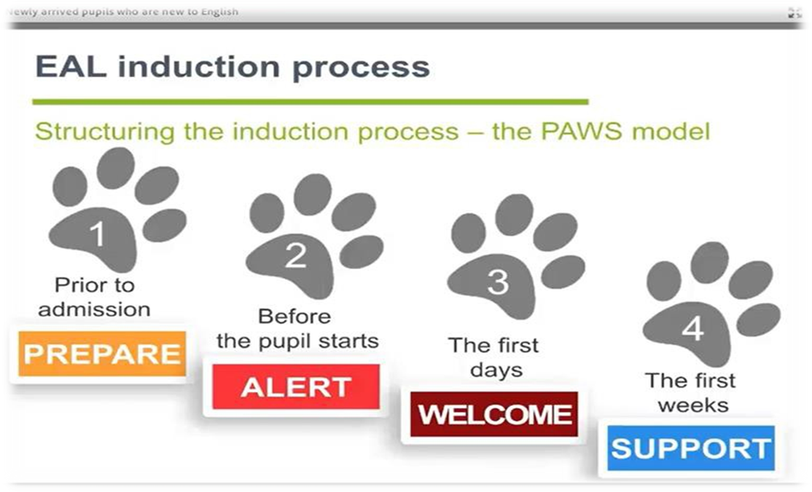

Pupils are added to the EAL list and teachers will check:
- How far the pupil is able to express his/her knowledge in the English Language
- How far the pupil can use formats and systems used in school to express their knowledge
- How far the pupil has been able to respond to receiving an education in English
The English proficiency of pupils with English as an additional language is recorded using the following categories:

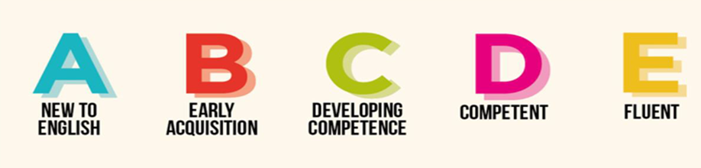
Some of the resources listed below may be used to assess and track pupils:
EAL assessment framework by NASSEA
Bell Foundation assessment framework
Sefton Complementary Education service - EAL support worker
SENDCO and Educational Psychologist (when applicable)
Some adaptive teaching strategies:
Word mats and visuals
Pre-teaching of vocabulary and over learning
Word wheels
WAGOLLS and demonstration modelling
Short tasks
Multi-sensory teaching techniques
Reading buddies
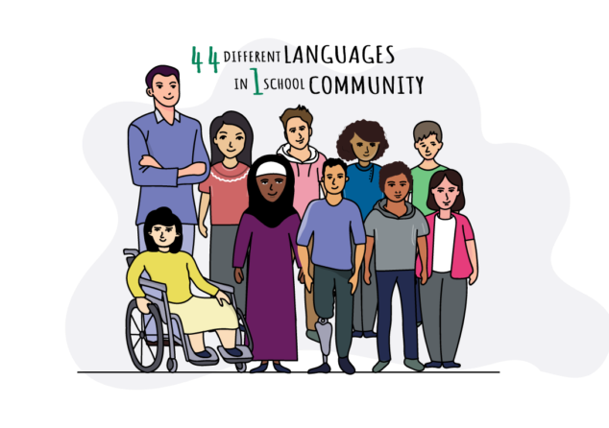
Positive peer support
Role play opportunities
Audio books and files
Translating programmes

