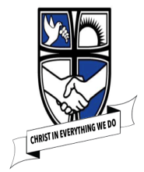
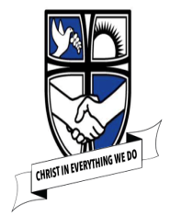
EYFS Understanding the World – Threads of Geography
Knowledge Organiser
  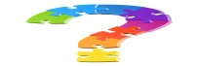  Links to Development Matters | Early Reading Linked to Key Texts
Reception:  • Draw information from a simple map.  • Recognise some similarities and differences between life in this country and life in other countries.  • Explore the natural world around them.  • Recognise some environments that are different to the one in which they live. | Autumn 1  Jake’s First Day  Marvellous Me  Monkey Puzzle  Leafman  Handa’s Surprise  Non – Fiction based around families, human bodies, growing. | Autumn 2  The Scarecrow’s Wedding  The Runaway Iceberg  The Polar Express  The Christmas Story
Early Learning Goals
People and Places  • Describe their immediate environment using knowledge from observations, discussions, stories, non-fiction texts and maps.  • Explain some similarities and differences between the natural world around them and contrasting environments, drawing on their experiences and what has been read to them in class.  The Natural World  • Explore the natural world around them, making observations and drawing pictures of animals and plants.  • Know some similarities and differences between the natural world around them and contrasting environments. Drawing on their experiences and what has been read to them in class.  • Understand some important processes and changes in the natural world around them, including the seasons and changing states of matter. | Spring 1  The Jolly Postman  Cops and Robbers  Fireman Sam  Topsy and Tim | Spring 2  Mad about Minibeasts  The Very Hungry Caterpillar  Snail Trail  The Tiny Seed
 | Summer 1  Jack and the Beanstalk  The Gingerbread Man  The Three Little Pigs | Summer 2  Sharing a Shell  Tiddler  The Whale’s Song  The Seal Surfer  The Dolphin Boy  Lighthouse Keepers lunch
  Concepts | 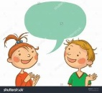  Key vocabulary
• I know where I live (Southport, England) | Southport, United Kingdom, Great Britain, World, country, town, city, London, capital, seaside, coast
• I know the name of my school and can say some of the things I pass on my way to school.  • I know some of the features of my immediate environment. | St Philip’s C.E. Primary School, Hampton Road, St Philip’s Church, shops, park, houses, beach
• I know some of the people who work in my community and what they do. | Community, jobs, doctor, teacher, shop, park, binmen, carers, road, map, police officer, fire officer, help, support, criminals
• I know the names of the four seasons.  • I know the main features of the weather in each of the seasons. | seasons, Autumn, Winter, Spring, Summer, weather, climate
• I know that not all places in the world are the same. | hot, cold, desert, ice, rainforest, seaside, mountains
• I know some of the animals and plants that live and grow around me. | Daffodil, daisy, tree, nettles, ladybird, spider, insects, mice
• I know what harvest is. | Crop, wheat, food, festival, thanking, farm, farmers, combine harvester, harvesting
• I know some of the festivals that are celebrated around the world. | Harvest, Christmas, Diwali, Chinese New Year
• I know that different foods are grown around the world. | Papaya, sugar beet, cocoa, coffee, guava, tangerines, plum, avocado, orange, fruit, vegetable
• I know that London is the capital of England. | London, capital city, England, Queen, Royal Family
• I know some animals from different parts of the world. | near, far, Africa, Antarctic, Arctic, England
How this is achieved in EYFS at St Philip’s
Autumn Term:  All about me:  • Look at where we live, describe features we see on the way to school.  • Draw my route to school.  • Explore the school, where are the different rooms in relation to one another. What happens in each room?  • Explore the school grounds, look at features of our school environment.  • Look at maps of Southport (paper, Digimap and Google Earth) explore and discuss the features found on local maps.  • Discussing where we were born and where our extended family live using world maps/globes for support.  Polar Explorers:  • Explore hibernation and migration, looking at contrasting environments/animals around the world in the autumn.  • Explore harvest time in the UK and farming at harvest time.  • Observe seasonal weather changes and longer nights in the autumn compared to the summer.  • Observe and explain decomposition of pumpkins  • Observe, explore and compare contrasting natural environments around the world: polar regions, Kenya  • Explore compare/contrast our environment with polar regions.  • Explore, compare, contrast, observe, draw and discuss animals native to polar regions and Africa.  • Discuss global warming and the impact on polar regions  Festivals  • Explore festival origins/celebrations across the world, using a world map/globe.  • Observe changes – light  Spring Term:  People who help us:  - Explore looking after our community environment and recycling.  - Discuss how we can help look after our local and world environments  - Exploring schools’ grounds and observing seasonal changes in the winter/spring.  - Observe seasonal weather changes in the winter/spring (ice exploration)  Mad About Minibeasts:  - Explore, observe and identify UK minibeasts.  - Look after  - Explore natural spring resources in provision, asking questions and making/drawing observations.  - Spring walk around School grounds describing and discussing what is found.  Festivals  - Exploring the festival and family traditions of Chinese New Year | Summer Term:  Traditional Tales:  - Map of Jack’s journey to the market.  Under the Sea/ Pirates Ahoy!:  - Exploring creatures that live in the sea and in rockpools.  - Pirate treasure maps.  Curriculum links and further research  Christian values – thankfulness, caring, loving  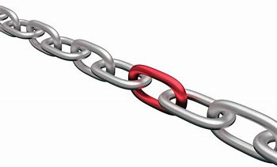  - Art/DT – draw maps and observational drawings of local area/surroundings  - Science – To explore the natural world around them, describing what they see, hear and feel whilst outside;  - To observe the effect of changing seasons on the natural world around them;  Enrichment Opportunities  - Role play areas – Fruit and veg shop, home corner.  - Reading area – all about me books, non-fiction body parts, explorers, people who help us, atlas, maps  - Children will explore their classroom, school and school grounds and know who key people are in school.

