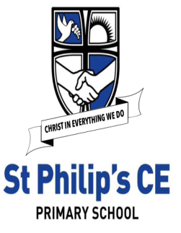
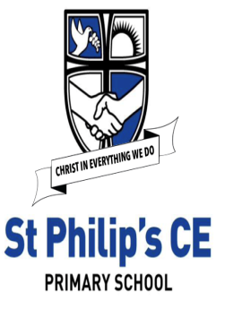
EYFS Expressive Arts and Design – Threads of DT
Knowledge Organiser
    Links to Development Matters | Early Reading Linked to Key Texts
Reception:  • Explore, use and refine a variety of artistic effects to express their ideas and feelings.  • Return to and build on their previous learning, refining ideas and developing their ability to represent them.  • Create collaboratively, sharing ideas, resources. | Autumn 1  Jake’s First Day  Marvellous Me  Monkey Puzzle  Leafman  Handa’s Surprise  Non – Fiction based around families, human bodies, growing. | Autumn 2  The Scarecrow’s Wedding  The Runaway Iceberg  The Polar Express  The Christmas Story
Early Learning Goals
Creating with materials  • Safely use and explore a variety of materials, tools and techniques, experimenting with colour, design, texture, form and function.  • Share their creations, explaining the process they have used. | Spring 1  The Jolly Postman  Cops and Robbers  Fireman Sam  Topsy and Tim | Spring 2  Mad about Minibeasts  The Very Hungry Caterpillar  Snail Trail  The Tiny Seed
 | Summer 1  Jack and the Beanstalk  The Gingerbread Man  The Three Little Pigs | Summer 2  Sharing a Shell  Tiddler  The Whale’s Song  The Seal Surfer  The Dolphin Boy  Lighthouse Keepers lunch
  Concepts | 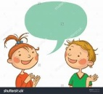  Key vocabulary
• I know how to use scissors safely.  • I can cut along a straight line.  • I can cut along a wavy line. | scissors, cut, straight, curve, shape, safely, blade, sharp, blunt
• I can join two items using tape.  • I can use glue to fix items together | join, hold, fix, glue, attach, tape
• I know how to draw a plan.  • I know that I can adapt and change something I have made.  • I can work with a friend, sharing ideas. | design, plan, create, pencil, make, change, adapt, together, colour, improve
• I know that some materials are better for building with than others.  • I can talk about what I have made and say why. | explain, why, features, pieces, texture, materials, hard, soft, shiny, waterproof, transparent, building, structure, strength, long, short, rough, smooth
How this is achieved in EYFS at St Philip’s
Autumn Term:  All about me:  • Create our homes from construction blocks.  Polar Explorers:  • The Scarecrow’s Wedding masks  • Making / decorating cards for various occasions.  • Diyas lamps  Spring Term:  People who help us:  • Design and create police/fire rescue equipment from junk  • Making fire engines.  Mad About Minibeasts:  • Design and build minibeast houses, adapting work where necessary.  • Make kites | Summer Term:  Traditional Tales:  • Making castles.  • Observe the effects of cooking when making Gingerbread men and bread.  • Design and create products for a purpose such as houses for the pigs.  Curriculum links and further research  Christian values – thankfulness, caring, loving  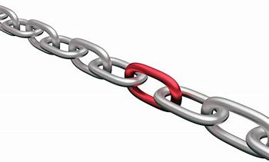  - Geography – draw maps and observational drawings of local area/surroundings  - Science/Geography – To explore the natural world around them, describing what they see, hear and feel whilst outside;  - Science/Geography - To observe the effect of changing seasons on the natural world around them;  General learning throughout the year  • Children can self-select from a range of tools and materials in the continuous provision.  • Children learn by experimenting with tools such as scissors, staplers and hole punches. They make use of fixing and joining materials such as Sellotape, masking tape, string, pipe cleaners and glue.  • Through questioning children are encouraged to talk about what they like about their work and other children’s designs and how they would improve it.  • Help to design and make small worlds in line with topic.

