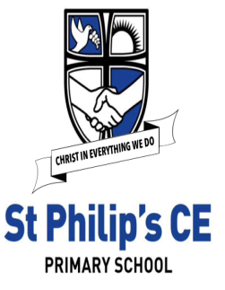
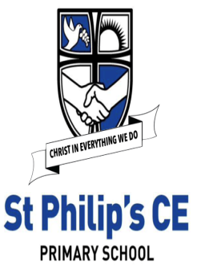
EYFS Expressive Arts and Design – Threads of Art
Knowledge Organiser
  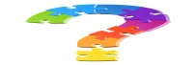  Links to Development Matters | Early Reading Linked to Key Texts
Reception:  • Explore, use and refine a variety of artistic effects to express their ideas and feelings.  • Return to and build on their previous learning, refining ideas and developing their ability to represent them.  • Create collaboratively, sharing ideas, resources | Autumn 1  Jake’s First Day  Marvellous Me  Monkey Puzzle  Leafman  Handa’s Surprise  Non – Fiction based around families, human bodies, growing. | Autumn 2  The Scarecrow’s Wedding  The Runaway Iceberg  The Polar Express  The Christmas Story
Early Learning Goals
Creating with materials  • Safely use and explore a variety of materials, tools and techniques, experimenting with colour, design, texture, form and function.  • Share their creations, explaining the process they have used.  UTW:  The Natural World  • Explore the natural world around them, making observations and drawing pictures of animals and plants. | Spring 1  The Jolly Postman  Cops and Robbers  Fireman Sam  Topsy and Tim | Spring 2  Mad about Minibeasts  The Very Hungry Caterpillar  Snail Trail  The Tiny Seed
 | Summer 1  Jack and the Beanstalk  The Gingerbread Man  The Three Little Pigs | Summer 2  Sharing a Shell  Tiddler  The Whale’s Song  The Seal Surfer  The Dolphin Boy  Lighthouse Keepers lunch
  Concepts | 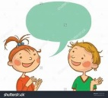  Key vocabulary
• I know that when I mix two colours it makes a different colour.  • I know red and blue makes purple.  • I know yellow and blue makes green.  • I know red and yellow makes orange.  • I know how to use a paint brush and pallet. | colour, paint, mix, water, blend, change, light, dark, pallet, brush, shade
• I know that artists create works of art.  • I can talk about what I see in a picture or piece of art. | artist, Wassily Kandinsky, abstract, portrait, landscape, features, line, shade, texture, detail, shape, pens, pencils, crayons, pastels, paint, chalk, clay, wool, material
• I can draw the things I see around me, making simple representations.  • I know how to match the colours I see to what I want to represent.  • I know how to draw a simple face.  • I know how to use paint tools with care and precision.  • I can talk about my artwork. | observe, features, line, shade, texture, portrait, match, detail, shape, pens, pencils, crayons, pastels, paint, chalk, clay, wool, material, talk
• I know that materials can be joined / mixed to create interesting effects. | design, create, make, join, hold, fix, glue, attach, tape, effect, detail
How this is achieved in EYFS at St Philip’s
Autumn Term:  All about me:  • Teach the children how to use the brushes correctly and how to wash them.  • Self-portraits / loose art faces.  • Draw and paint family members.  • Draw a friend.  • Use mirrors to look at features. – explore expressions.  • Transient art – Art without Glue using a variety of resources both natural and man -made. Inspired by Autumn & Andy Goldsworthy  • Harvest – create fruit baskets using colour mixing skills.  • Still life observational drawings of Autumnal objects  • Look at and explore art from around the world.  Polar Explorers:  • The Scarecrow’s Wedding masks  • Winter Christmas themed art – snow globes  Festivals  • Fireworks – watch videos, represent using different media/ large and small body movements.  • Clay diyas lamps  Spring Term:  People who help us:  • Learn to draw fire engines – look at a variety of vehicles that help us.  Mad About Minibeasts:  • Minibeasts – clay snails / symmetry / observational drawings of caterpillars, butterflies, tadpoles.  • Still life observational drawings of Spring objects  • Exploring the artwork of Kadinsky | Summer Term:  Traditional Tales:  • Making Gingerbread men  • Creating our own props and performing puppet plays based on traditional tales.  • Castles – explore shape and pattern. Make a castle model.  Under the Sea/ Pirates Ahoy!:  • Create group weaving to represent the sea.  • Under the sea/ rockpool collage  • Make pirate ships.  Curriculum links and further research  Christian values – thankfulness, caring, loving  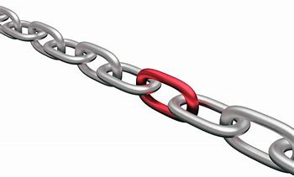  - Geography – draw maps and observational drawings of local area/surroundings  - Science/Geography – To explore the natural world around them, describing what they see, hear and feel whilst outside;  - Science/Geography - To observe the effect of changing seasons on the natural world around them;  General learning throughout the year  • Child-led activities  • Exploring a range of media throughout the year – pens, pencils, crayons, pastels, poster paint, watercolours, marbling, clay, wool, material and food materials etc  • Outdoor art using a range of mark making materials such as paint rollers and different sized brushes on a large scale.  • Craft Area enables children to self -select resources that they need / want to test out including masking tape and glue to join

