St Philip’s C of E Primary School

4th September 2026
Dates for your Diary.
Mon 7th – Reception children full time

Weds 9th Sep- Meet the teacher

Weds 9th Sep- RSE parent information sessions

Sunday 13th – The Mayors civic service in church 3pm

Every Thursday before School
Choco Church in church!

Harvest- Monday 12th October in church (pm, time to be confirmed)

Parent meetings- class teachers
Weds 21st October (afternoon)

P.S High School Open Evening Dates are out for Y5 and Y6. Check high schools individually.

Welcome and thank you!
Welcome back everyone, and a special welcome to our new Reception Children. It is wonderful to see all of the children back to school safely, looking so well and making such a great impression on their new classroom staff.

Thank you to all of our parents and carers, you have as always gone the extra mile to support your child during the first week at school and ensure that they have everything they need. Children look super smart in their uniforms…
Quick uniform reminder
Uniform lists are on the website – label it all!
We have additional uniform items available at church, please speak to the office if there is anything you need.

We look forward to welcoming all parents to our annual Meet the Teacher Event

Meet the teacher event. Weds 9th September
This year we have Relationship and Sex Education Presentations before each session, please attend if you would like to know more about this important area of your child’s learning.
Times are as follows…
Infant RSE Meeting- 4.45 pm
Infant Meet the Teacher R, 1 and 2- 5 pm
Junior RSE Meeting- 5.15 pm
Junior Meet the teacher- 5.30 pm
These sessions are not for children.
Our first Christian Value of the year is Friendship.
At our school we are kind to everybody, adults and children alike. We speak to and treat people the way we would like to be treated. We can disagree but we need to disagree in a polite and constructive way!
This half term we will be talking about what makes a good friend, who Jesus chose as his friends and how we can behave in a way that enables us to be a great friend.
We will be learning how to manage when friendships falter and how to make up and move on.
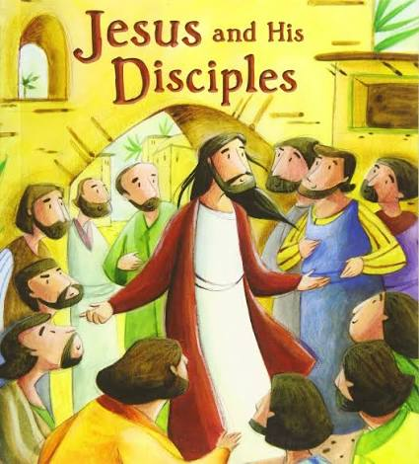

After School Clubs
The After School Club Timetable was sent out yesterday.
Please reserve places via our booking system. Once the places are gone you will be unable to book.
Teachers and Teaching Assistants give up their time for free to run these clubs, we expect the children to attend each week and behave in line with our school rules, be ready, be respectful and be responsible. If your child is booked to attend but does not attend or decides they do want to attend please let the office know.

School places
We have 2 spaces in our Reception class if you know of anyone

Before the holidays we sent this link out to you. We received an email back from the Children’s Commissioner to say we had only submitted 10 responses! Would anyone have time to do this with their child please?

New website
www.stphilipssouthport.com
We are in the process of changing our school website.
Please be aware that if you go to the website this weekend you may not be able to access the site due to the changeover.
We are very hopeful that the website will be up and running early next week. Please be patient with us as we update everything and upload content.

 | You’ve been  Spotted  Name Christian Value |  | Behaviour award | Star of the week | Math’  Magician | Handwriting and presentation award | Behaviour Buddy |  | Math’  Magician
R | Theo | Friendship | Sebastian | Isabella | Olive | Tate | Jacob |  | Belle
1 | Reuben | Friendship | Olivia | Edie | Lily | George S | Leo |  | Logan
2 | Scarlett | Friendship | Inaya | Louis | Alisa | Aysha | Steven |  | Aaliyah
3 | Kiera | Friendship | Elaine | Louie J | Gustaw | Thanul
4 | Thuwaraka | Helpfulness | Kourtney | Ellie H | Rory | Hannah | Samuel |  | Gladys
5 | Gabriel | Friendship | Ava | Esme | Alice | Brody | Melodeigh |  | Nelly
6 | Noah | Community | Sam | Lauren Yazmin Chloe
This week’s attendance winners are: Year 4 with 100% attendance
Year One – 96.8%
Year Two -96.7%
Year Three – 98.3%
Year Four – 100%
Year Five – 98.3%
Year Six – 96.4%
Attendance at our school is exceptional thanks to our wonderful parents,carers, children and staff. We expect all children in school everyday unless they are unwell. Pleae telephone the school office to let us know the reason your child is absent.
A really friendly heads up to all parents and carers. I am required by the Local Authority to fine parents for term time holidays . I don’t want anyone to be surprised as it can be awkward! All requests for term time holidays are unauthorised and I am unable to give permission for them.
Kind regards
Mrs Edward

Year 4 worked really hard on their double page RE spreads about characters from History who have stood up for their beliefs.

