Calculation Policy



Lead | Luke Highton
Head | Sandie Edward
Chair of Governors | Jeremy Hooper
Policy amended | September 2026
To be reviewed | Jan 2027

At St Philip’s CE Primary, as children begin to understand the underlying ideas of calculation, they will develop ways of recording to support their thinking and methods. Over time children will learn how to use models and images, such as empty number lines, bar models and part-whole models to support their mental and informal written methods of calculation. This policy demonstrates the concrete, pictorial and abstract calculation approaches for each strand of the Mathematics National Curriculum.

Our aim is that children leave St Philip’s CE Primary equipped with mental and written methods which they understand and can use correctly when faced with a calculation. We aim for children to be able to decide which method is most appropriate and have strategies to give an approximate answer and to check their solutions.

At whatever stage in their learning and whatever method is being used, it must still be underpinned by a secure and appropriate knowledge of number facts, along with those mental skills that are needed to carry out the process and judge if it was successful.

This policy indicates the progression of written methods within each of the four operations All methods will be used across a range of contexts E.g., money, measures, time etc. and will be applied to decimals as appropriate.

The 2014 National Curriculum places great emphasis on the importance of pupils using the correct mathematical language as a central part of their learning. As children sometimes find this difficult, each class uses ‘stem sentences’ to help the children to explain their mathematical thinking and help cognition. This approach ensures opportunities for children to develop quality mathematical dialogue.

At St Philip's we follow the White Rose Maths scheme of learning and use the White Rose calculation policies to support progression. These have been adapted to reflect the needs and expectations of St Philip's pupils and our wider mathematics curriculum. Throughout the policies, each operation is broken down into skills with detailed models and images to effectively teach each concept. The overview of skills across the year groups provides consistency throughout the school.

Teaching and Learning Principles
At St Philip's, calculation teaching is underpinned by our mastery approach to mathematics. Children are taught to develop a deep conceptual understanding of calculation strategies through the consistent use of concrete, pictorial and abstract representations.
Retrieval practice is a key feature of mathematics teaching. Through Tough Ten activities and recap tasks, children regularly revisit previously taught calculation skills and number facts, enabling them to strengthen long-term memory and retain key mathematical knowledge over time.
Children are encouraged to explain and justify their thinking using accurate mathematical vocabulary. Stem sentences, mathematical discussion and reasoning opportunities are embedded throughout lessons to ensure children can articulate their understanding and develop confidence when solving problems.
Calculation teaching supports our whole-school five-part lesson structure, with opportunities for retrieval, explicit modelling, guided practice and independent application of learning.

The policies apply to the teaching of Years 1 – 6. Please see link below to access the full policies.

Maths in EYFS

The EYFS framework stresses the importance in early years of ‘developing a strong grounding of number’ in order to ‘develop the necessary building blocks to excel mathematically’.
In Reception at St Philips, the White Rose scheme of learning and NCETM materials are used to inform and guide planning to create a curriculum where children are introduced to concepts in a variety of ways, encouraging mathematical thinking and talking. The updated White Rose Reception scheme underpins the new Educational Programme for Mathematics (DFE 2020).
We strive to ensure that the teaching of maths is both age-appropriate and engaging. A mathematics rich environment is important for the children to explore and experience. At St Philips, not only do the children experience direct mathematical teaching every day but there are mathematical elements running throughout the continuous provision, from the reading corner, to the outdoor area, to the art activities. The children experience and explore maths through carefully planned activities where manipulatives are used continuously to construct a solid understanding of number. The use of concrete apparatus when introducing a concept means teaching is engaging, this is followed by a hands-on approach where the children can practice and consolidate their learning.

EFFS schemes of learning - https://whiteroseeducation.com/resources?year=reception&subject=maths#supportingmaterials

Calculation Non-Negotiables
- All children have access to concrete and pictorial representations where needed.
- Accurate mathematical vocabulary is explicitly taught and expected.
- Children are encouraged to explain, justify and prove their thinking.
- Retrieval practice is used to strengthen recall of number facts and calculation strategies.
- Misconceptions are identified and addressed promptly.
- Fluency, reasoning and problem-solving opportunities are embedded throughout teaching.
- Independence is promoted through effective questioning and appropriate scaffolding.

PROGRESSION THROUGH CALCULATION GUIDANCE

This guidance has been developed from the White Rose Calculation Policy: which was written as a guide to indicate the progression through Addition, Subtraction, multiplication and Division in Years 1 – 6.

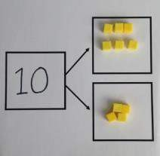

 | Objective | Concrete | Pictorial | Abstract
Year 1 | Add1-digit numbers within 10 Number bonds of 5, 6, 7, 8, 9 and 10 | 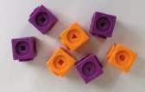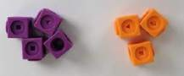  Use cubes to add two numbers together as a group or in a bar.  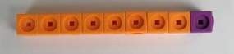 | 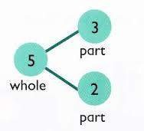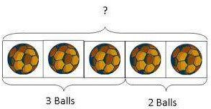  Use pictures to add two numbers  together as a group or in a bar.  3 2 | 2 + 3 = 5  3 + 2 = 5 2  5 = 3 + 2  5 = 2 + 3  3  Use the part-part-whole diagram as shown above to move into the abstract.
Year 1 | Counting | 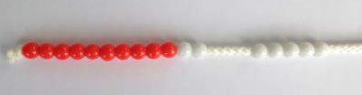  Start with the larger number on the bead string and then count on to the smaller number 1 by 1 to find the answer.  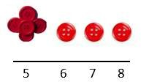 | Use a number line to count on in ones.  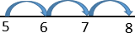 | 5 + 3 = 8
 | Regrouping to make 10 | 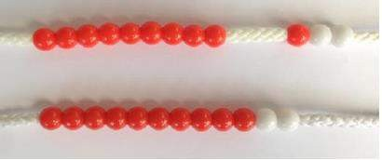  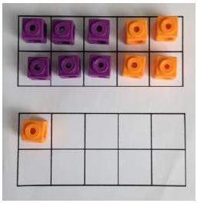  6 + 5 = 11  Start with the bigger number and use the smaller number to make 10 | 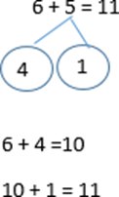  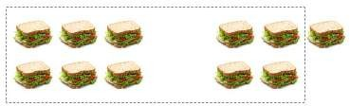 | 6 + 5 = 11
Year Yea Year 1 and 2 | Add1-digit numbers within 20 | When adding 1-digit numbers that cross 10, it is important to highlight the importance of ten ones equaling 10.  Different manipulatives can be used to represent this exchange. Use concrete resources alongside number lines to support children in understanding how to partition their jumps.  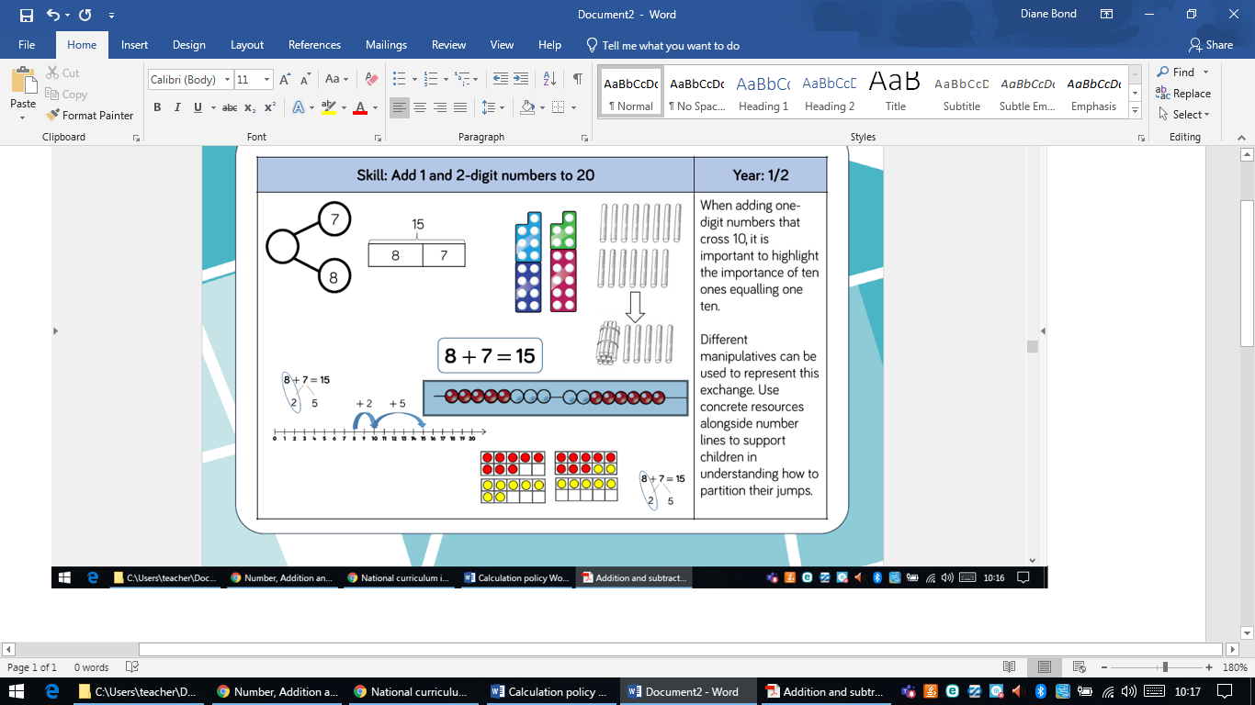 |  | 8 + 7 = 15








 | Objective | Concrete | Pictorial | Abstract
Year 2 | Adding 3 single digit numbers | 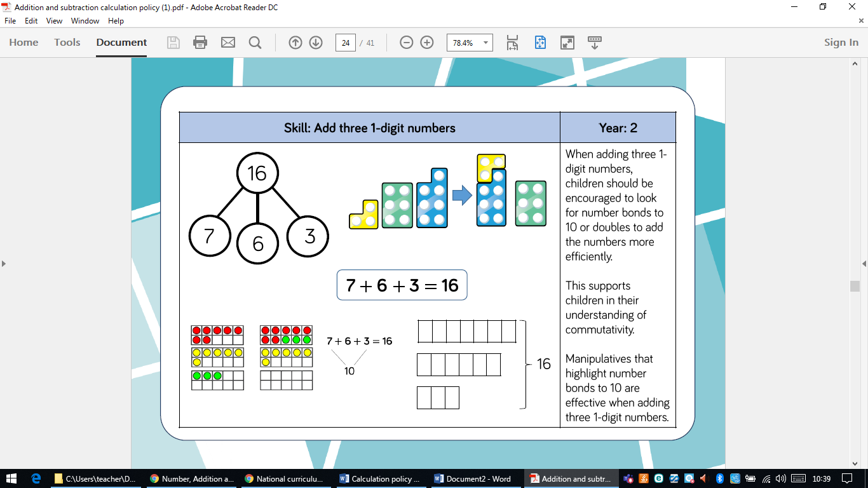  Children should be encouraged to look for number bonds to 10 or doubles to add the numbers more efficiently. | 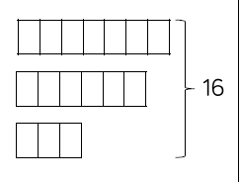
Year 2 | Adding 3 single digit numbers | 4 + 7 + 6= 17  Put 4 and 6 together to make 10. Add on 7.  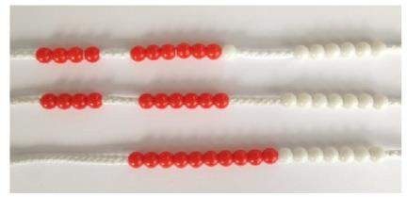  Following on from making 10, make 10 with 2 of the digits (if possible) then add on the third digit. |     Add together three groups of objects. Draw a picture to recombine the groups to make 10.  + +      + | 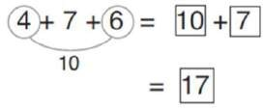  Combine the two numbers that make 10 and then add on the remainder.
Years 2 and 3 | Aaaa Add 1 and 2 -digit numbers to 100 | Children should count on from larger number and apply knowledge of number bonds 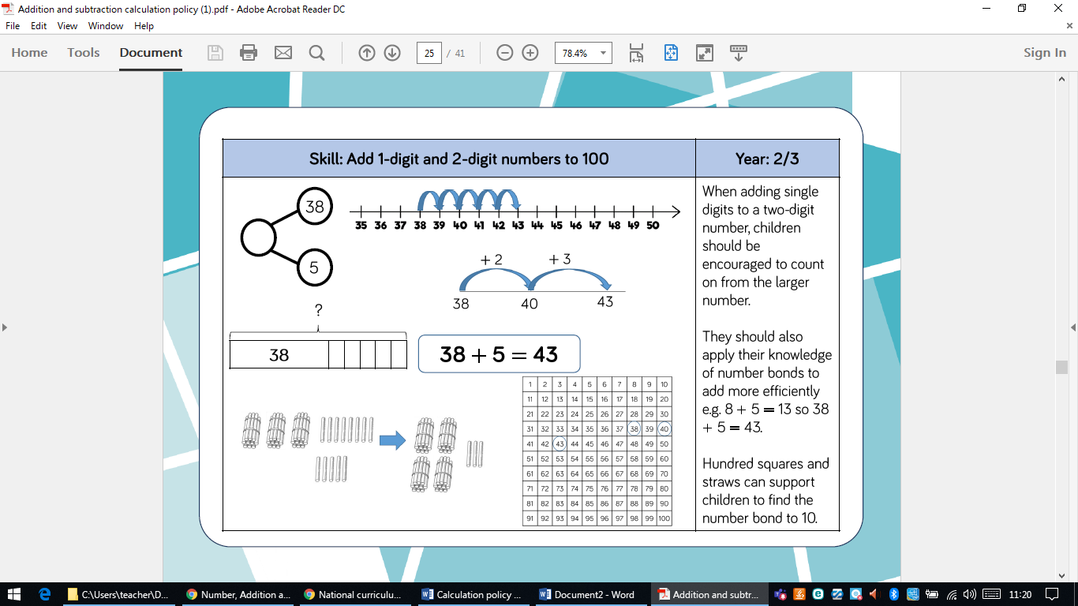 |  | 38+5 = 43

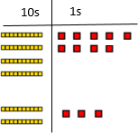
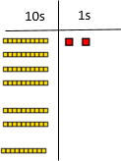

 | Objective | Concrete | Pictorial | Abstract
Years 2 and 3 | Addition without regrouping  Adding 2-dit numbers to 100 | Add together the ones first, then add the tens. Use the Base 10 blocks first before moving onto place value counters.  24 + 15 =  44 + 15 =  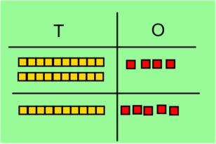  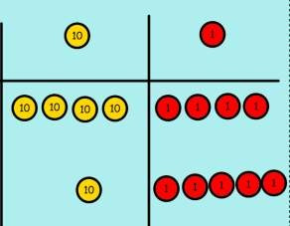 |             After physically using the base 10 blocks and place value counters, children can draw the counters to help them to solve additions.  10s 1s | 24 + 15 = 39
Years 2 and 3 | Addition with regrouping  Adding 2-dit numbers to 100 | Make both numbers on a place value | Using place value counters, children can | 49 + 23 = 72  40 + 9  20 + 3  60 + 12 = 72
Years 2 and 3 | Addition with regrouping  Adding 2-dit numbers to 100 | grid. | draw the counters to help them to solve | 49 + 23 = 72  40 + 9  20 + 3  60 + 12 = 72
Years 2 and 3 | Addition with regrouping  Adding 2-dit numbers to 100 |  | additions. | 49 + 23 = 72  40 + 9  20 + 3  60 + 12 = 72
Years 2 and 3 | Addition with regrouping  Adding 2-dit numbers to 100 |  | 10s 1s | 49 + 23 = 72  40 + 9  20 + 3  60 + 12 = 72
Years 2 and 3 | Addition with regrouping  Adding 2-dit numbers to 100 |  |  | 49 + 23 = 72  40 + 9  20 + 3  60 + 12 = 72
Years 2 and 3 | Addition with regrouping  Adding 2-dit numbers to 100 |  |  | 49 + 23 = 72  40 + 9  20 + 3  60 + 12 = 72
Years 2 and 3 | Addition with regrouping  Adding 2-dit numbers to 100 | Add up the units and exchange 10 ones |  | 49 + 23 = 72  40 + 9  20 + 3  60 + 12 = 72
Years 2 and 3 | Addition with regrouping  Adding 2-dit numbers to 100 | for 1 ten. |  | 49 + 23 = 72  40 + 9  20 + 3  60 + 12 = 72
Years 2 and 3 | Addition with regrouping  Adding 2-dit numbers to 100 |  | 10s 1s | 49 + 23 = 72  40 + 9  20 + 3  60 + 12 = 72
Years 2 and 3 | Addition with regrouping  Adding 2-dit numbers to 100 |  |  | 49 + 23 = 72  40 + 9  20 + 3  60 + 12 = 72
Years 2 and 3 | Addition with regrouping  Adding 2-dit numbers to 100 |  |  | 49 + 23 = 72  40 + 9  20 + 3  60 + 12 = 72
Years 2 and 3 | Addition with regrouping  Adding 2-dit numbers to 100 |  |  | 49 + 23 = 72  40 + 9  20 + 3  60 + 12 = 72
Years 2 and 3 | Addition with regrouping  Adding 2-dit numbers to 100 |  |  | 49 + 23 = 72  40 + 9  20 + 3  60 + 12 = 72

 | Objective | Concrete |  | Pictorial | Abstract
Year2/3 | Add 2-digit numbers to 100 | 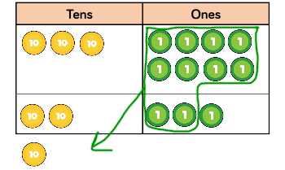  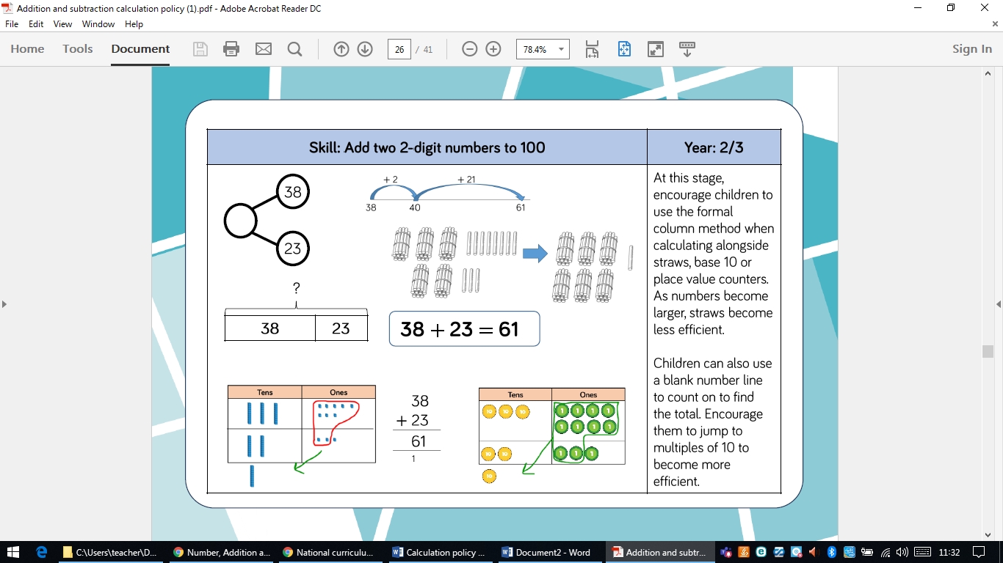 |  | 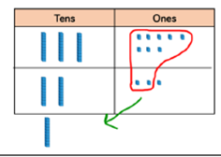 | At this stage, only introduce formal column addition once children are secure with using concrete apparatus and using straws, for example, becomes less efficient. Children should still be using other strategies such as regrouping to make 10 so they can calculate mentally rather than becoming reliant on column addition.  38 38 + 23 = 61  23 +  61
Year 3 | Adding numbers with up to 3 digits | Make both Numbers on a place value grid. Add the ones and exchange 10 ones for a ten. Add the tens and exchange 10 tens for 100. |  | Children will be able to draw a pictorial representation of the columns and place value counters to support their learning and understanding.  100s 10s 1s  100s 10s 1s | Children should write out their calculations alongside concrete resources so they can see the links to the written column method.  200 + 60 + 5  100 + 60 + 4  400 +20 + 9  As children progress, they will move from the expanded to compacted method.  265 +  164  429
Year 4 | Column method with regrouping  Addition up to 4 digits | Base 10 and place value counters are the most effective manipulatives when adding numbers with up to 4 digits. |  | As above, the children can draw a pictorial representation of the place value grid to support learning and understanding. | Children should write out their calculations alongside concrete resources so they can see the links to the written column method.  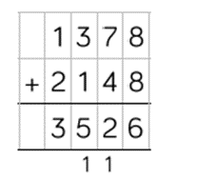
Year 5 | Adding with up to 3 decimal places | Place value counters and plain counters on a place value grid are the most effective manipulatives when adding decimals 1, 2 and 3 decimal places |  | Again, the children can draw a pictorial representation of the place value grid to support learning and understanding  Other pictorial representations of the calculation.  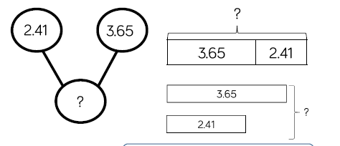 | 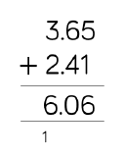  Children need experience adding decimals with a variety of decimal places.  This includes putting this into context when adding money and other measure.
Year 5/6 | Column method with regrouping  Adding numbers with more than 4 digits | Consolidate understanding using numbers with more than 4 digits and extend by adding numbers with up to 3 decimal places.
Year 5/6 |  | Concrete | Pictorial |  |  | Abstract
Year 5/6 |  | 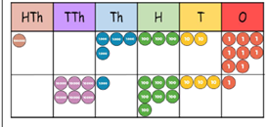  Place value counters and plain counters on a place value grid are the most effective manipulatives when adding numbers with more than 4 digits. | 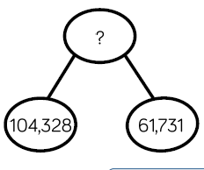  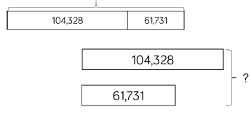 |  |  | 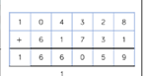  Children should be encouraged to work in the abstract, using the column method to add large numbers efficiently.

 | Objective | Concrete | Pictorial | Abstract
Year 1 | Taking away ones | Use physical objects, counters, cubes etc. to show how objects can be taken away. | Cross out drawn objects to show what has been taken away. | 4 – 2 = 2
Year 1 | Taking away ones |   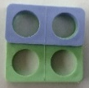  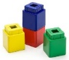  first then now  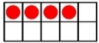 | 4– 2 = 2 4  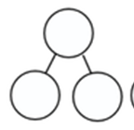  4  4  2  2 | 4 – 2 = 2
Year 1 | Counting back | Make the larger number in your subtraction. Move the beads along your bead string as you count backwards in ones.  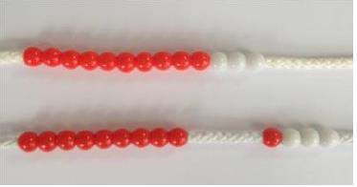  13 – 4 = 9 | Count back on a number line or ruler.  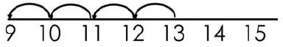  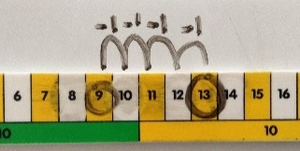  Start at the bigger number and count back the smaller number, showing the jumps on the number line or ruler. | Put 13 in your head, count back 4. What number are you at?
Year 1 | Find the difference | Compare amounts and objects to find the difference.  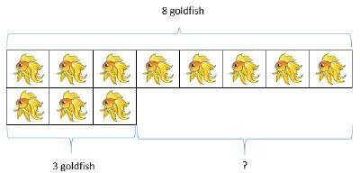  Use cubes to build towers or make bars to find the difference. Use basic bar models with items to find the difference.  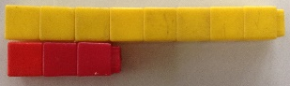 | 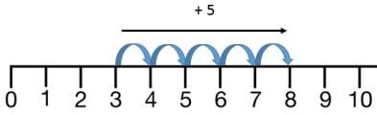  Count on to find the difference.  Draw bars to find the difference between 2 numbers. | Hannah has 8 goldfish. Helen has 3 goldfish.  Find the difference between the number of goldfish the girls have.

 | Objective | Concrete | Pictorial | Abstract
Year 1/2 | Subtracting 1- and 2-digit numbers to 20 | When subtracting 1-digit numbers that cross 10, it is important to highlight the importance of 1 ten being equal to 10 ones.  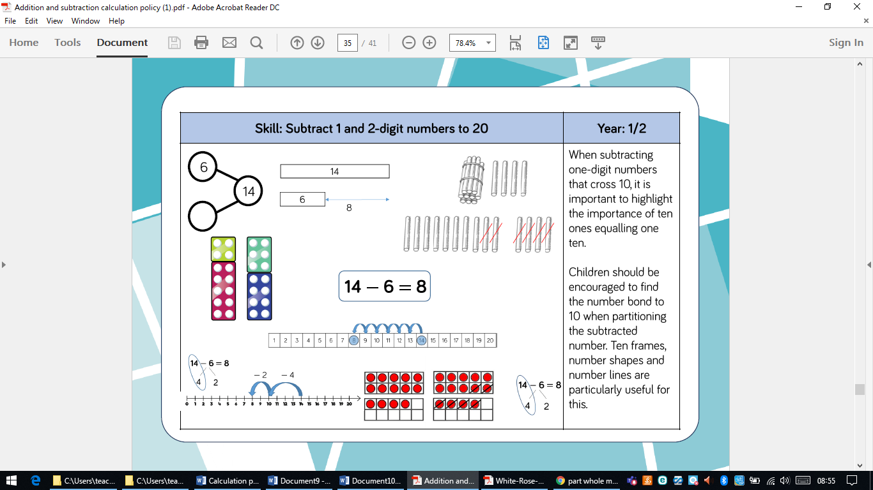  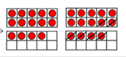  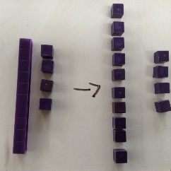 | Children are encouraged to use a number line to count back.  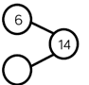  Children should be able to explain which number is the whole and which are the 2 parts.  Children should be encouraged to find the number bond to 10 when partitioning the subtracted number. Number lines and tens frames are useful for this. | 14 - 6 = 12

 | Objective | Concrete | Pictorial | Abstract
Year 2 | Column method without regrouping | 75 – 42 = 33  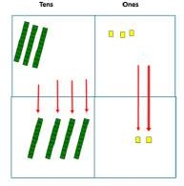  Use Base 10 to make the bigger number then take the smaller number away.  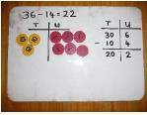  Show how you partition numbers to subtract.  36 – 14 =22 | ones  tensss  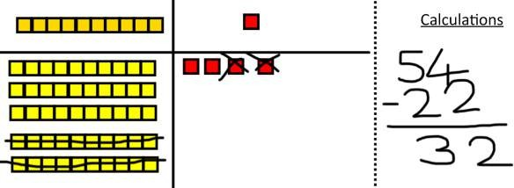  Draw the Base 10 or place value counters alongside the written calculation to help to show working.  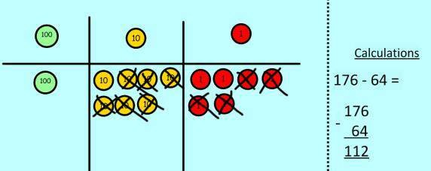 | 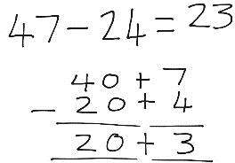  This will lead to a clear written column subtraction.  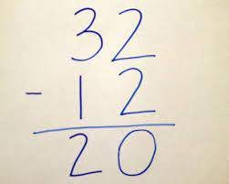
Year 2 | Subtracting 1 and 2 digit numbers to 100, with re-grouping | 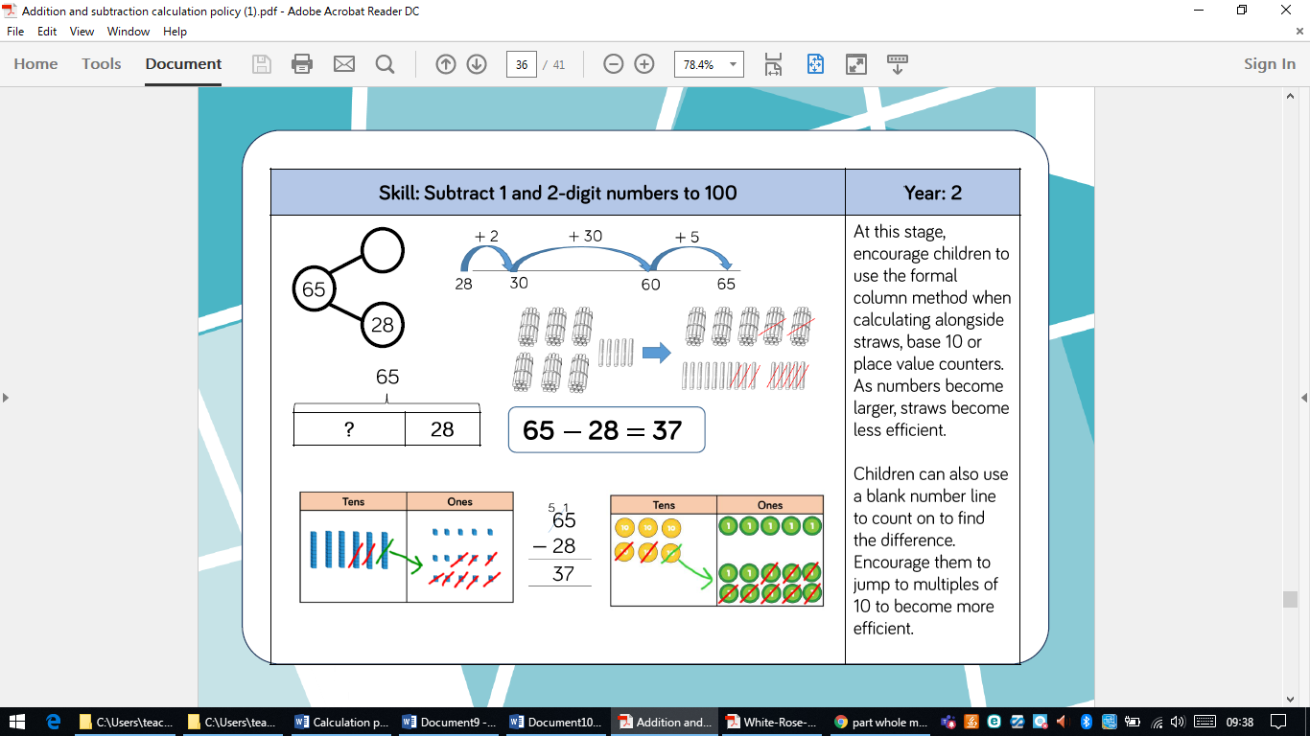  Children need to develop an understanding of how to exchange 1 ten for 10 ones when regrouping is required. | Children can use a blank number line to count on to find the difference. Encourage children to jump to multiples of 10 to become more efficient. | 65 – 28 = 37  Only when children are completely secure with exchange and regrouping, should the formal column method be introduced alongside the concrete apperatus.

 | Objective | Concrete | Pictorial | Abstract
Year 3 onwards | Column method with regrouping | Use Base 10 to start with before moving on to place value counters. Start with one exchange before moving onto subtractions with 2 exchanges.  Make the larger number with the place value counters  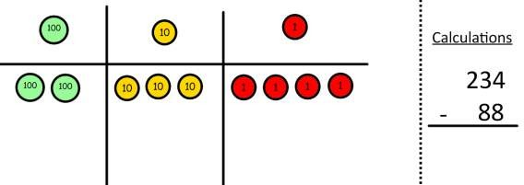  Start with the ones, can I take away 8 from 4 easily? I need to exchange 1 of my tens for 10 ones.  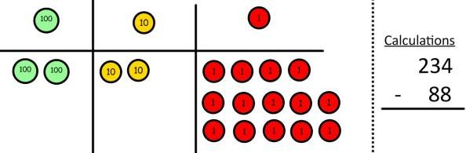  Now I can subtract my ones.  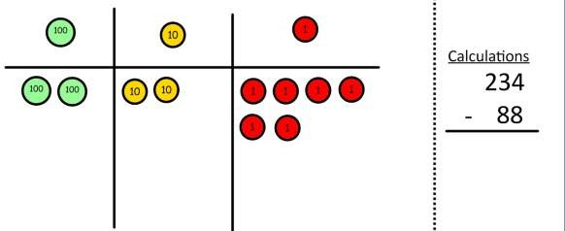 | 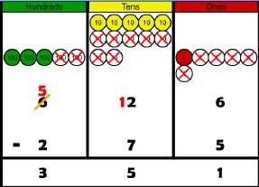  Draw the counters onto a place value grid and show what you have taken away by crossing the counters out as well as clearly showing the exchanges you make.  When confident, children can find their own way to record the exchange/regrouping.  Just writing the numbers as shown here shows that the child understands the method and knows when to exchange/regroup.  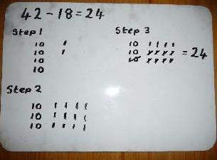 | 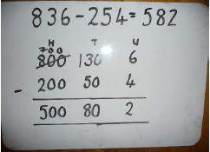  Children can start their formal written method by partitioning the number into clear place value columns.  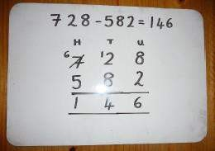  Moving forward the children use a more compact method.  This will lead to an understanding of subtracting any number including decimals.  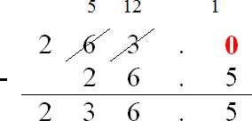

 | Objective | Concrete | Pictorial | Abstract
Year 3 up | Column method with regrouping | Now look at the tens, can I take away 8 tens easily? I need to exchange 1 hundred for 10 tens.  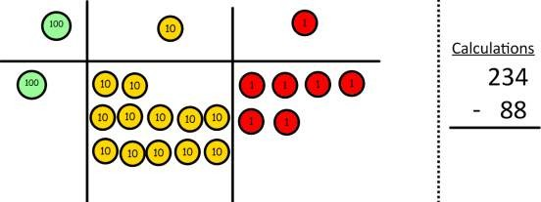  Now I can take away 8 tens and complete my subtraction.  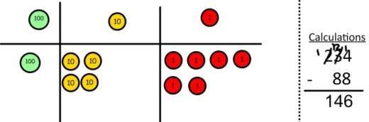  Show children how the concrete method links to the written method alongside your working. Cross out the numbers when exchanging and show where we write our new amount. | Draw the counters onto a place value grid and show what you have taken away by crossing the counters out as well as clearly showing the exchanges you make. | 234 -  88
Year 3 | Subtract numbers up to 3 digits | 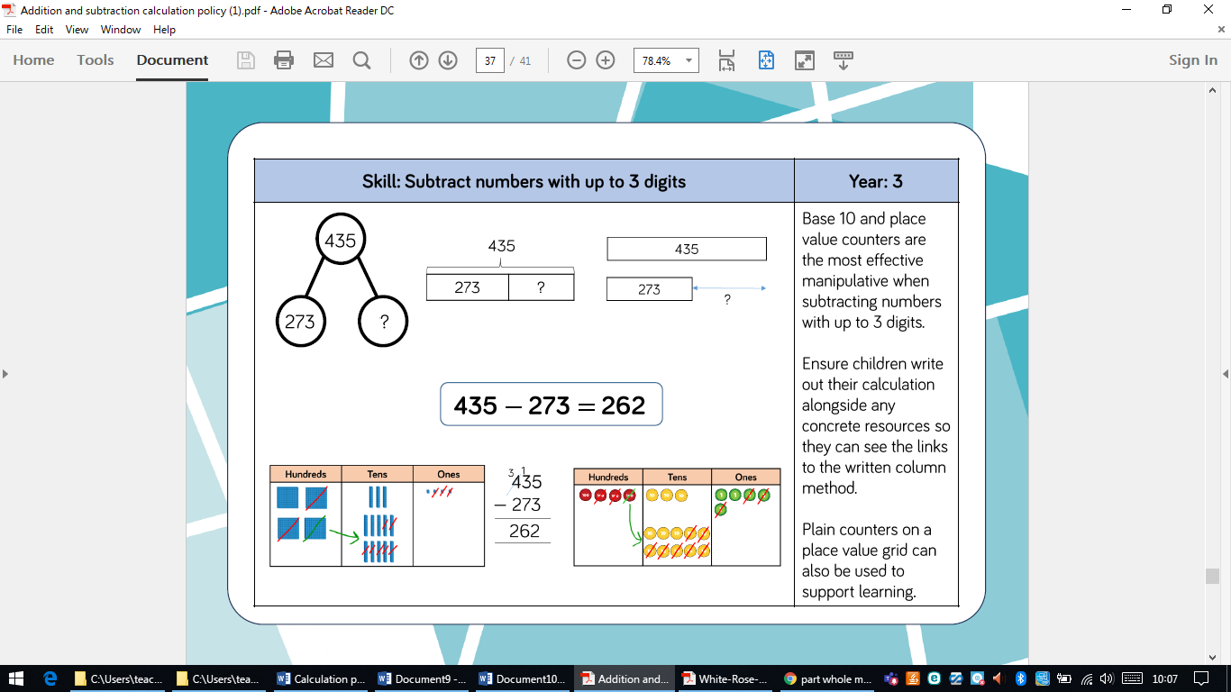  Base 10 and place value counters are the most effective manipulative when subtracting 3-digit numbers. | Children should be encouraged to also draw place value grids to support their learning. | Children should write out their calculations alongside concrete resources so they can see the links to the written column method.

 | Objective | Concrete | Pictorial | Abstract
Year 4  Year 4 up | Subtract numbers with up to 4 digits | Base 10 and place value counters are the most effective manipulatives when subtracting 4-digit numbers  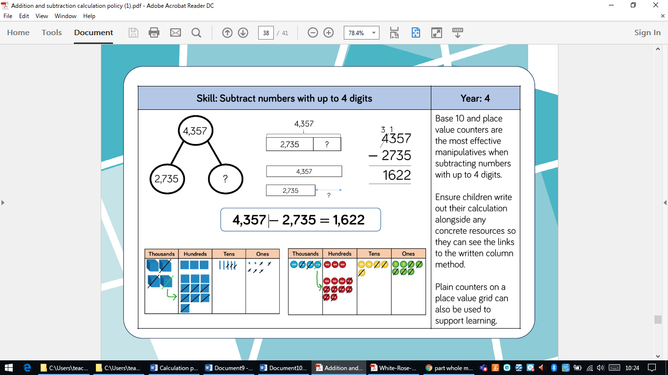 | Children should be encouraged to also draw place value grids to support their calculation.  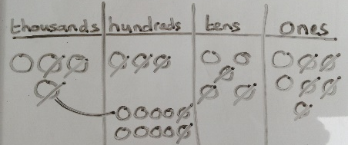 | Children should write out their calculations alongside concrete resources so they can see the links to the written column method.
Year 5 | Subtract with up to 3 decimal places | 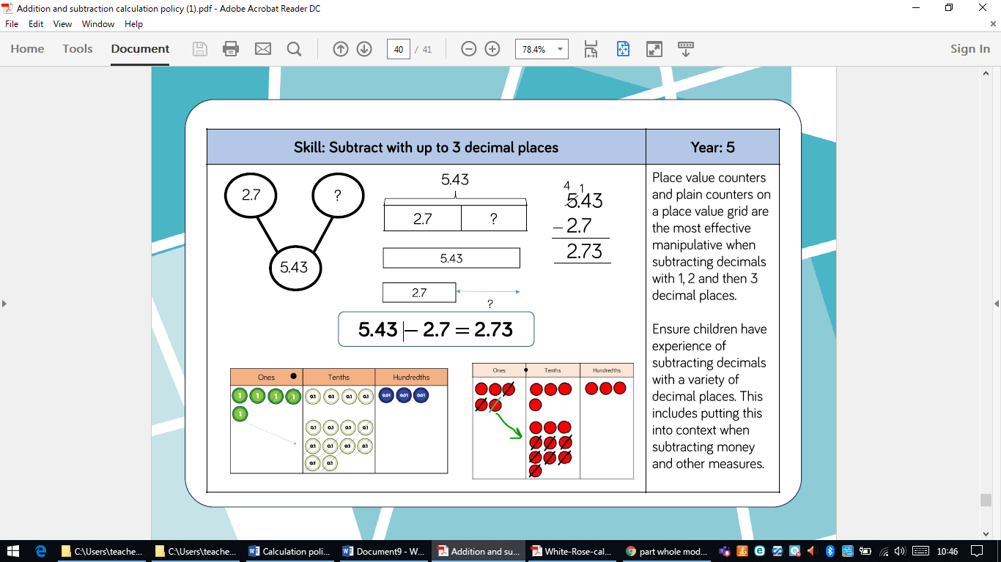  Place value counters or plain counters on a place value grid are the most effective manipulatives when subtracting numbers with more than 4 digits. |  | Children need experience subtracting decimals with a variety of decimal places.  This includes putting this into context when subtracting money and other measures.
Year 5 /6 | Subtract numbers with more than 4 digits. | 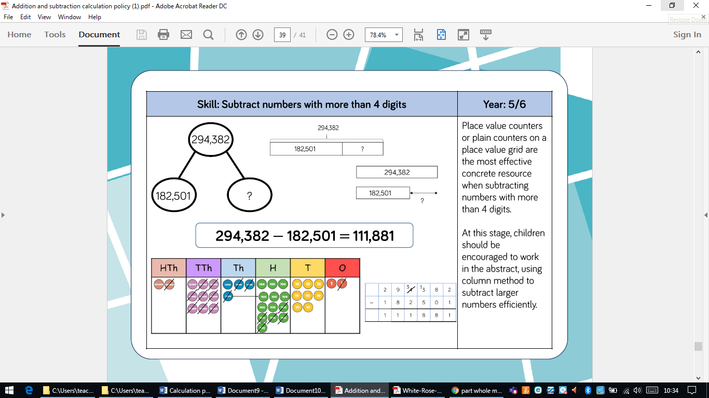  Place value counters or plain counters on a place value grid are the most effective manipulatives when subtracting numbers with more than 4 digits. | As above, children could be draw place value grids to support their calculation, if necessary. | At this stage, children should be encouraged to work in the abstract, using the column method to subtract large numbers efficiently.





 | Objective | Concrete | Pictorial | Abstract
Year 1/2 | Solve 1-step problems using  multiplication  Repeated addition | 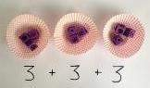  In Year 1 children use concrete and pictorial representations to solve problems.  Use different objects to add equal groups.  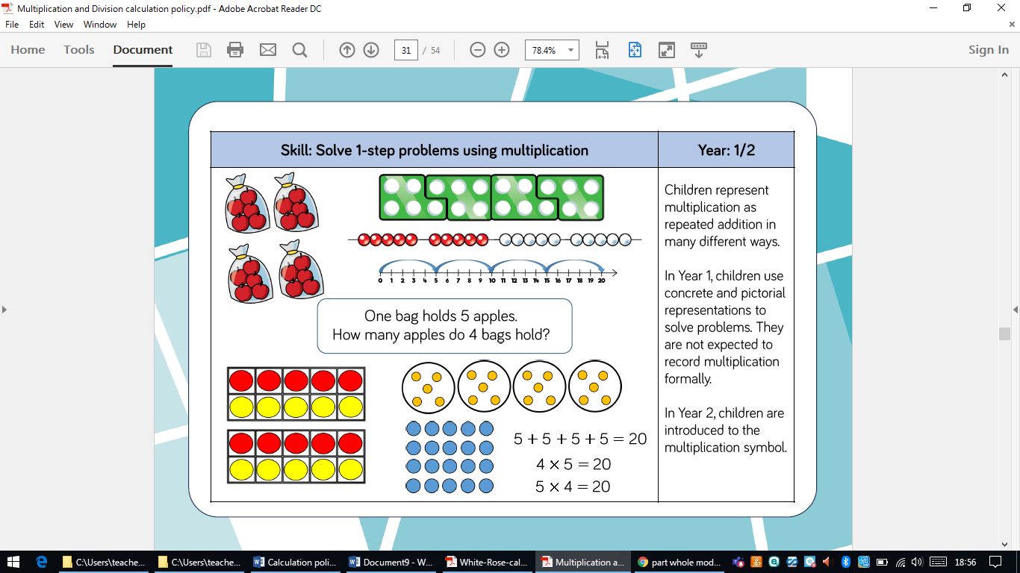 | There are 3 plates. Each plate has 2 star biscuits on. How many biscuits are there?    2 + 2 + 2 = 6  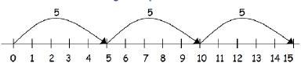  5 + 5 + 5 = 15 | Write repeated addition sentences to describe objects and pictures.    2 + 2 + 2 = 6  In Year 1 children are not expected to record multiplication formally. In Year 2 children are introduced to the multiplication symbol.
Year 1/2 | Arrays- showing commutative multiplication | Create arrays using counters/cubes to show multiplication sentences.  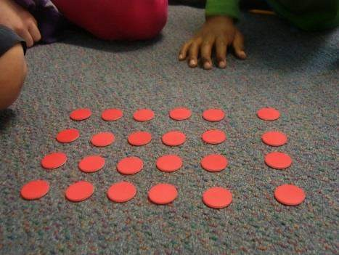  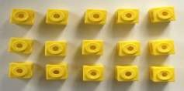 | 4 × 2 = 8  2 × 4 = 8  2 × 4 = 8  4 × 2 = 8  Draw arrays in different rotations to find  commutative multiplication sentences | Use an array to write multiplication sentences and reinforce repeated addition.  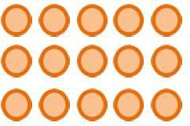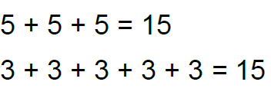

 | Objective | Concrete | Pictorial | Abstract
Year 3/4 | Multiplying 2-digit numbers by 1-digit numbers | 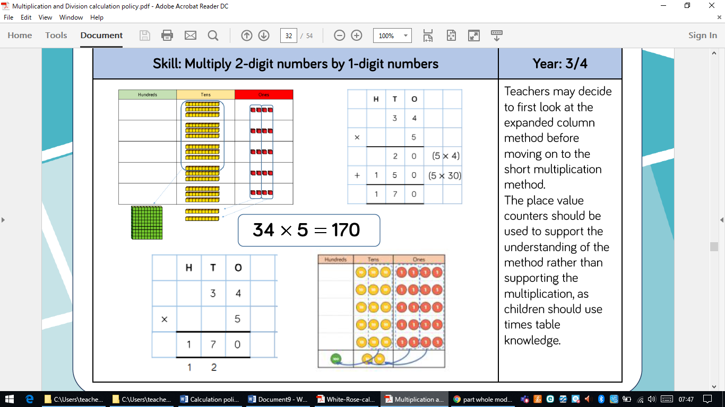  Place value counters should be used to support understanding of the method rather than supporting multiplication, as children should use times tables knowledge. | 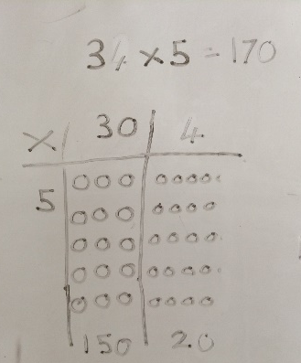 | Teachers may look at the expanded method first before moving on to short multiplication method

 | Objective | Concrete | Pictorial | Abstract
Year 3/4 | Multiplying 3-digit numbers by 1 digit | 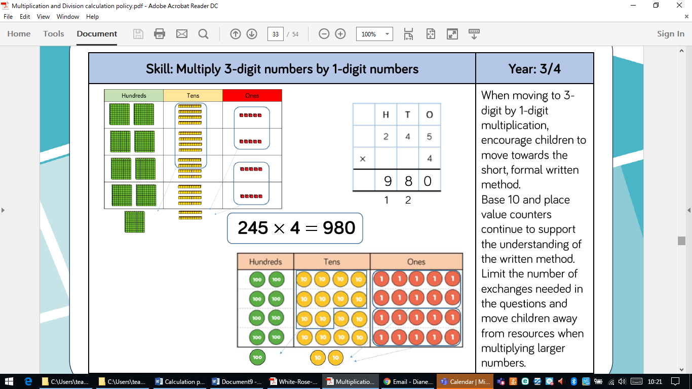  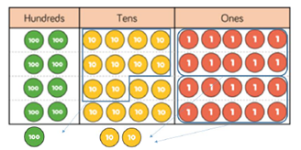  Use base 10 and place value counters to support the understanding of the written method. | Children can draw place value grids to support learning but should be using tales tables knowledge rather than relying on counters for calculation purposes. | When moving to 3-digit by 1-digit multiplication, encourage children to move towards the short, formal written method.

 | Objective | Concrete | Pictorial | Abstract
Year 5 | Multiply 4-digit numbers  by 1-digit numbers | 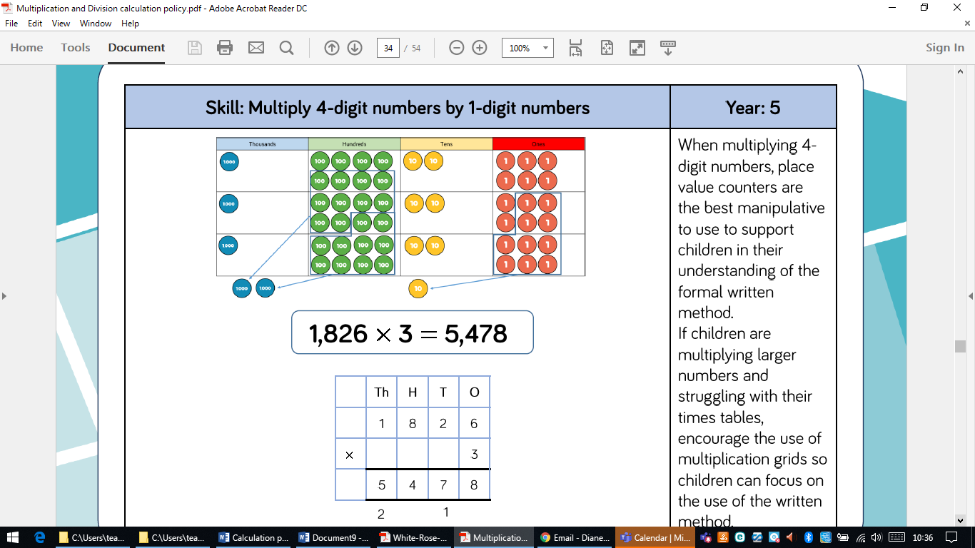  When multiplying 4-digit numbers, place value counters are the best manipulative to support children in their understanding of the formal written method. | 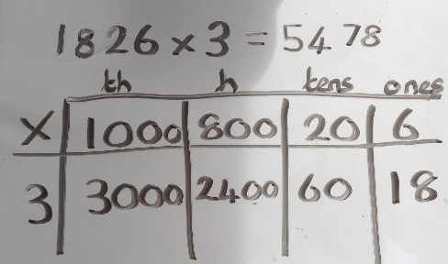  If children are struggling with their times tables when multiplying larger numbers, encourage the use of a multiplication grid so children can focus on the use of the written method.
Year 5 | Multiply 2-digit numbers by 2-digit numbers | 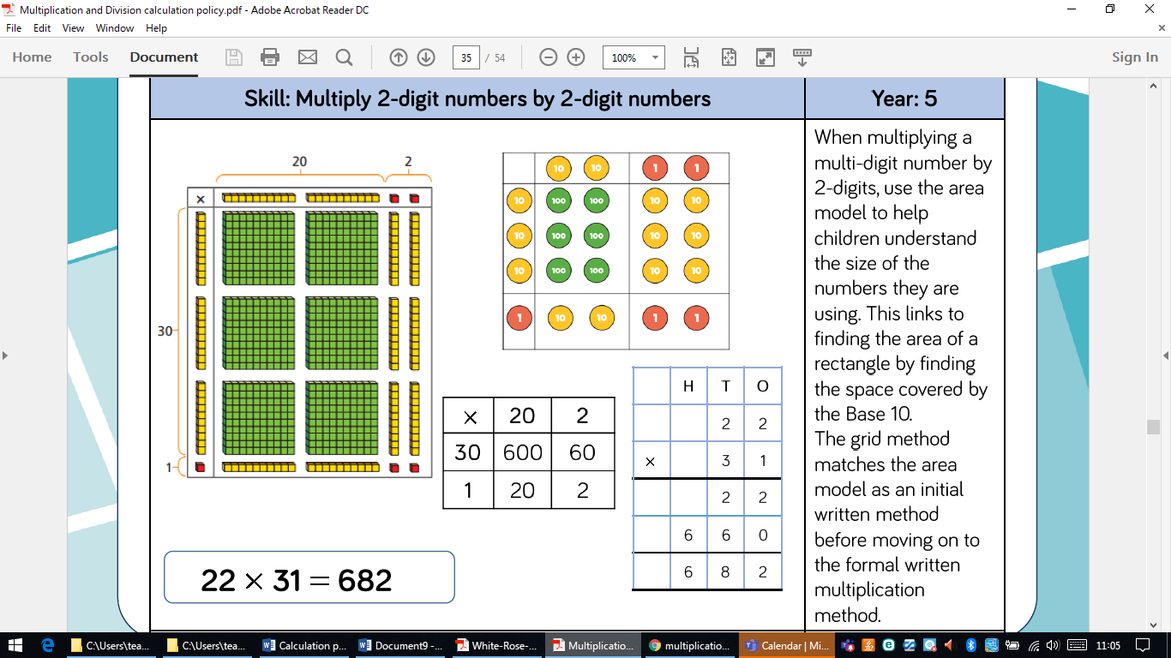  When multiplying a multi-digit number by 2-digits, use the area model to help children to understand the size of the numbers they are using. This links to finding the area of a rectangle by finding the space covered by the Base 10. | The grid method matches the area model as an initial written method before moving on the formal written multiplication. | Make sure children are lining up columns carefully.
 | Objective | Concrete | Pictorial | Abstract
Year 5 | Multiply 3-digit numbers by 2-digit numbers | 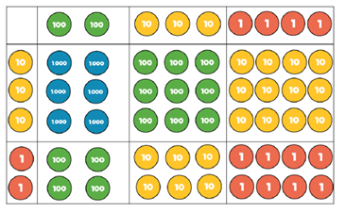  Children can continue to use the area model when multiplying 3-digits by 2-digits. Place value counters become more efficient to use. | 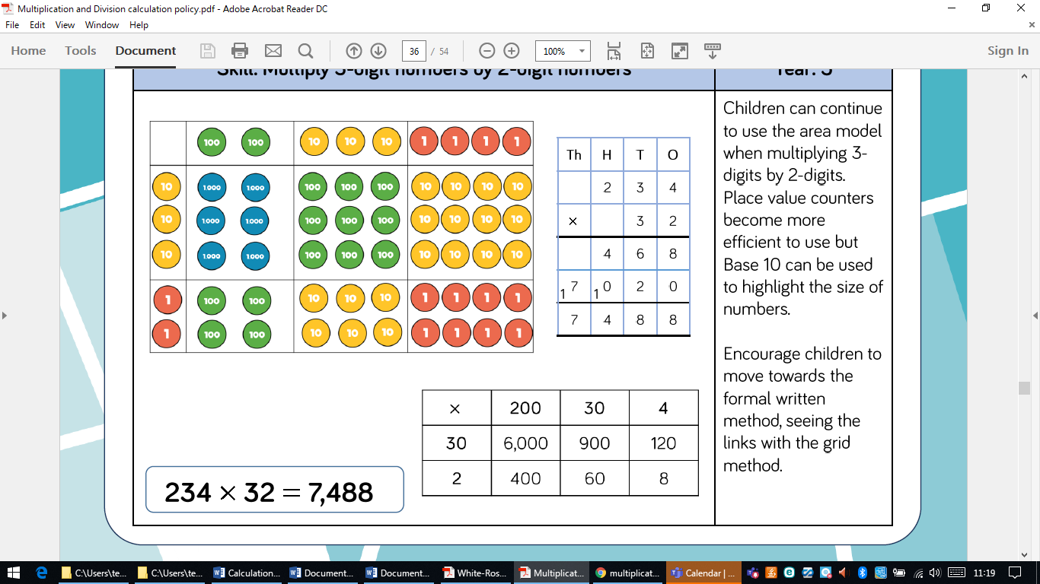  Grid method | Encourage children to move towards the formal written method, seeing the links with the grid method.
Year 5/6 | Multiply 4-digit numbers by 2-digit numbers | 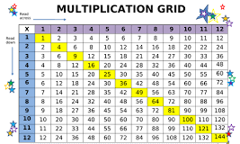  If children are struggling with times tables, multiplication grids should be provided to support so they can focus on the use of the method. |  | 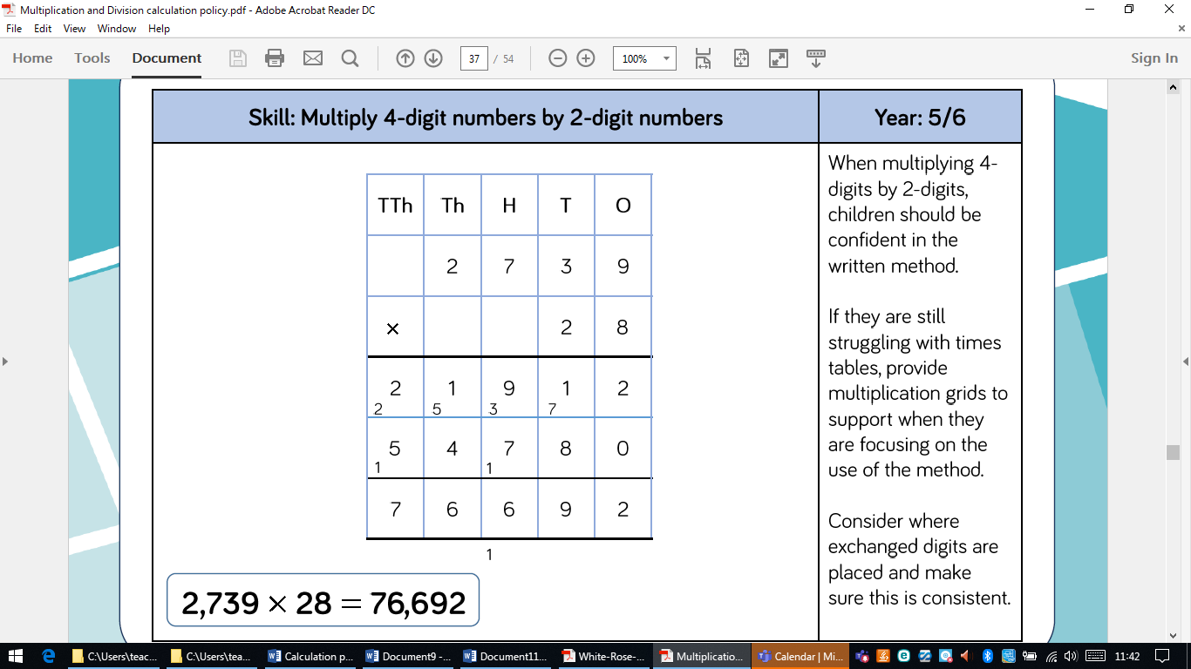  When multiplying 4 digits by 2-digits, children should be confident in the written method.

 | Objective | Concrete | Pictorial | Abstract
Year 1/2 | Sharing | I have 8 cubes, can you share them equally between two people?  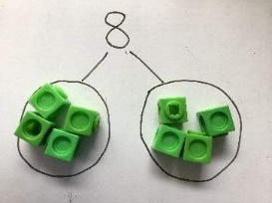  Children solve problems by sharing amounts into equal groups. | Children use pictures or shapes to share quantities.  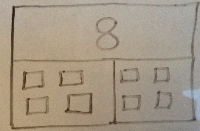 | In Year 1, children use concrete and pictorial representations to solve problems, they are not expected to record division formally. The division symbol is introduced in Year 2  Share 8 cubes between two people.  8 ÷ 2 = 4
Year 1/2 | Grouping | 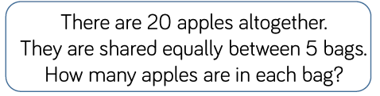  Children solve problems by grouping and counting the number of groups.  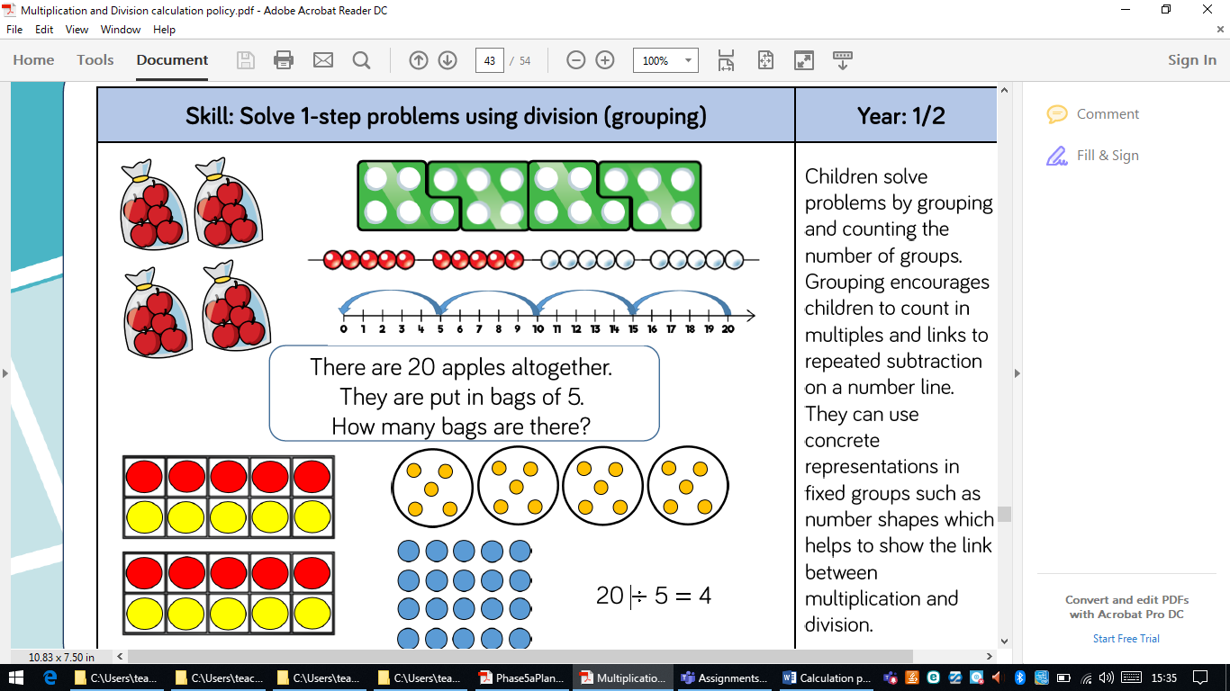  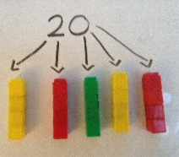  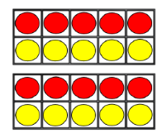  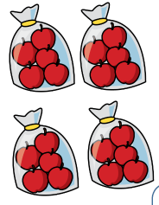  Grouping encourages children to count in multiples. | Use a number line to show jumps in groups. The number of jumps equals the number of groups. Children can see links between grouping on a number line and repeated subtraction.  Think of the bar as a whole. Split it into the number of groups you are dividing by and work out how many would be within each group.  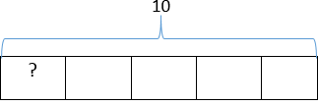  20 | 20 ÷ 5 = 4
 | Objective | Concrete | Pictorial | Abstract
Year 1 and 2 | Divide 2 digit by 1 digit (sharing with no exchange) | 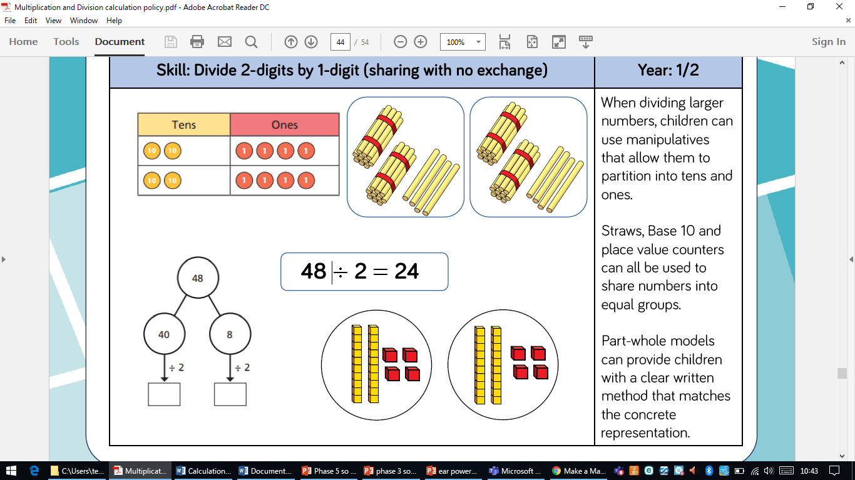  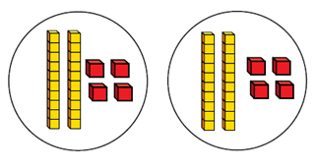  When dividing larger numbers, children use manipulatives (eg straws, base 10, place value counters) that allow them to partition into tens and ones. | Part whole models can provide children with a clear written method that matches the concrete representation.

 | Objective | Concrete | Pictorial | Abstract
Year 3/4 | Division with arrays | 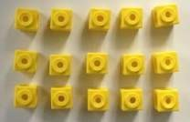  Link division to multiplication by creating an array and thinking about the  number sentences that can be created. Eg 15 ÷ 3 = 5 5 x 3 = 15  15 ÷ 5 = 3 3 x 5 = 15 | 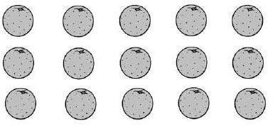  Draw an array and use lines to split the array into groups to make multiplication and division sentences. | Find the inverse of multiplication and division sentences by creating four linking number sentences.  5 x 3 = 15  3 x 5 = 15  15 ÷ 5 = 3  15 ÷ 3 = 5
Year 3/4 | Dividing 2 digits by 1 digit (sharing with exchange) | When dividing numbers involving exchange, children can use Base 10 and place value counters to exchange one ten for ten ones. Children should start with the equipment outside the place value grid before sharing the tens and ones equally between the rows.  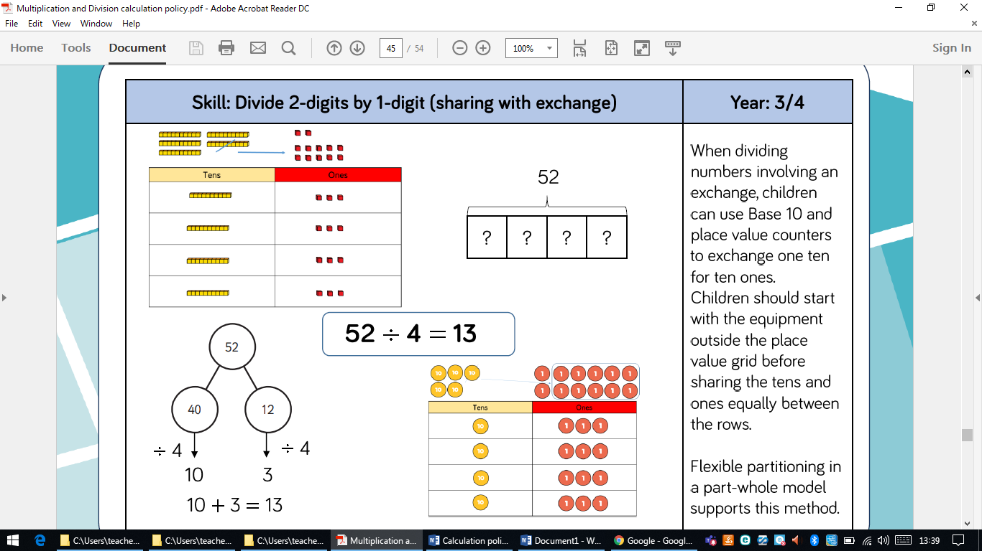  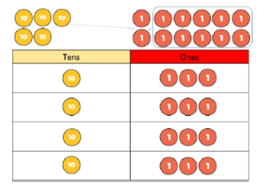 | Flexible partitioning in a part whole model supports this method.  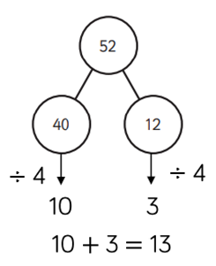
Year 3/4 | Objective | Concrete | Pictorial | Abstract
Year 3/4 | Divide 2-digits with 1-digit (sharing with remainders) | 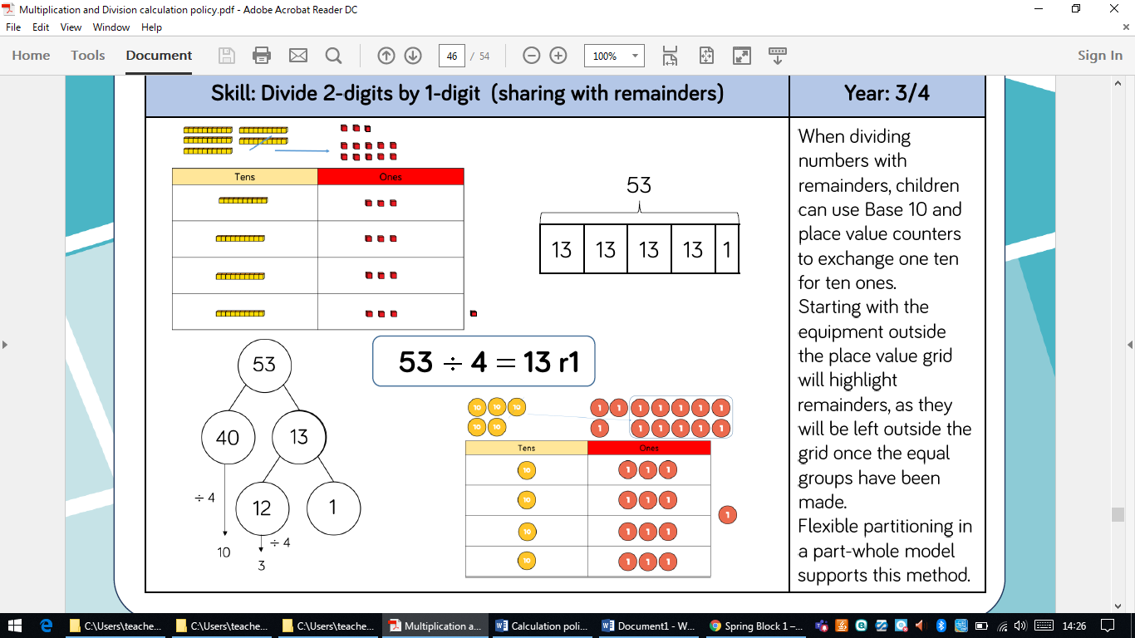  When dividing numbers with remainders, children can use Base 10 and place value counters to exchange one ten for ten ones. Starting with the equipment outside the place value grid will highlight remainders, as they will be left outside the grid once the equal groups have been made. | Flexible partitioning in a part whole model supports this method.
 | Objective | Concrete | Pictorial | Abstract
Year 4/5 | Divide 2-digits by 1-digit (grouping) | When using the short division method, children use grouping. Starting with the largest place value, they group by the divisor.  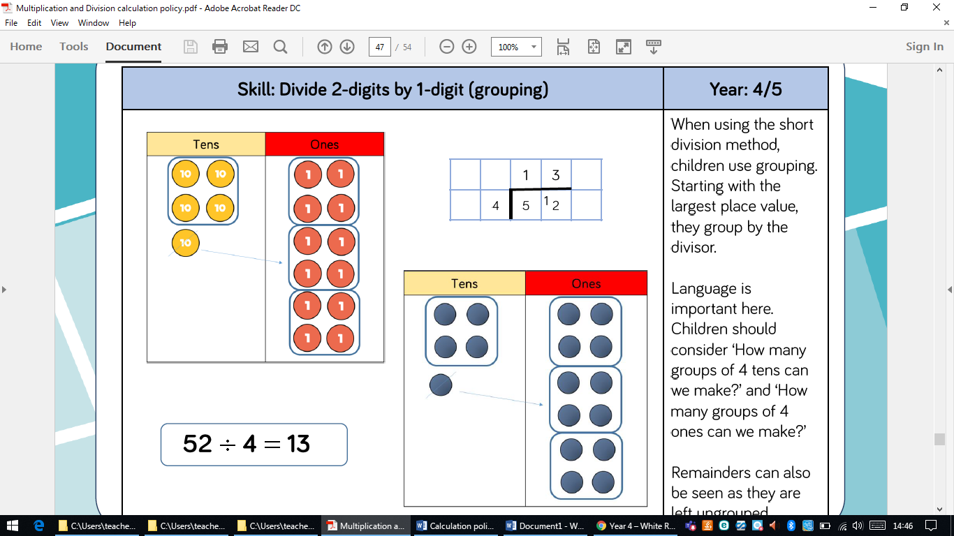  Language is very important here. Children should consider ‘How many groups of four 10s can we make?’ and ‘How many groups of 4 ones can we make?’  Remainders can also be seen as they are left ungrouped. | Children can draw place value grids to support learning.
 | Objective | Concrete | Pictorial | Abstract
Year 4 | Divide 3-digits by 1-digit (sharing) | Children can continue to use place value counters to share 3-digit numbers into equal groups. Children should start with the equipment outside the place value grid before sharing the hundreds, tens and ones equally between the rows.  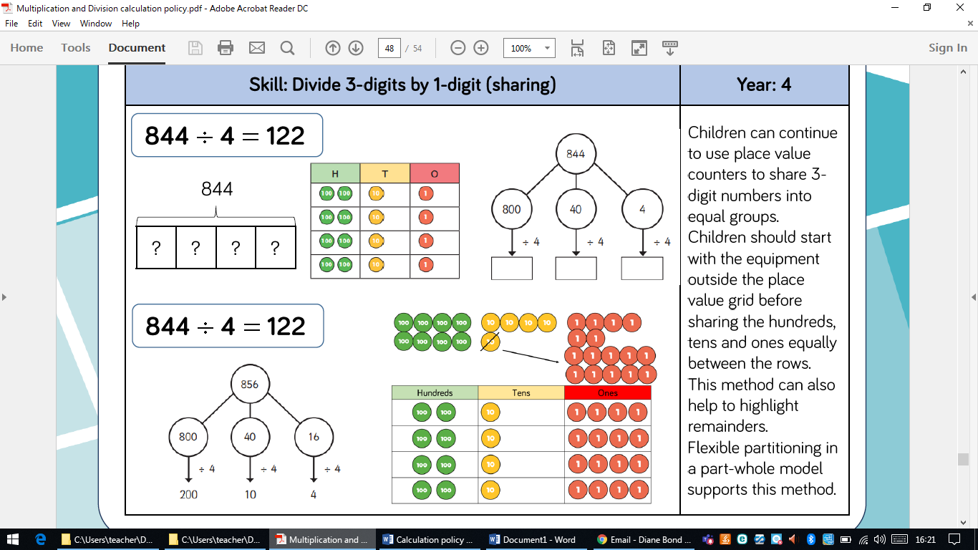  This method can also help to highlight remainders. | Flexible partitioning in a part whole model supports this method. | 856 ÷ 4 = 214
 | Objective | Concrete | Pictorial | Abstract
Year 5 | Divide 3-digits by 1-digit (grouping) | 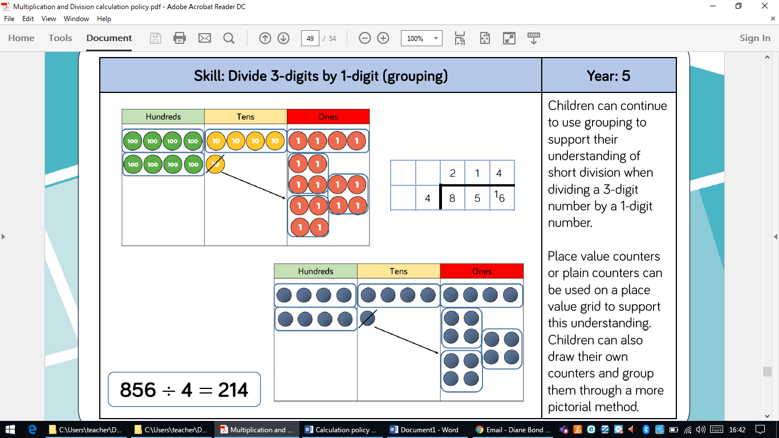  Children can continue to use grouping to support their understanding of short division when dividing a 3-digit number by a 1-digit number.  Place value counters or plain counters can be used on a place value grid to support this understanding.  Children should be encouraged to record the formal method alongside the concrete apparatus to see links. | Children can also draw their own counters and group them through a more pictorial method.
Year 5 | Divide 4=digits by 1-digit (grouping) | 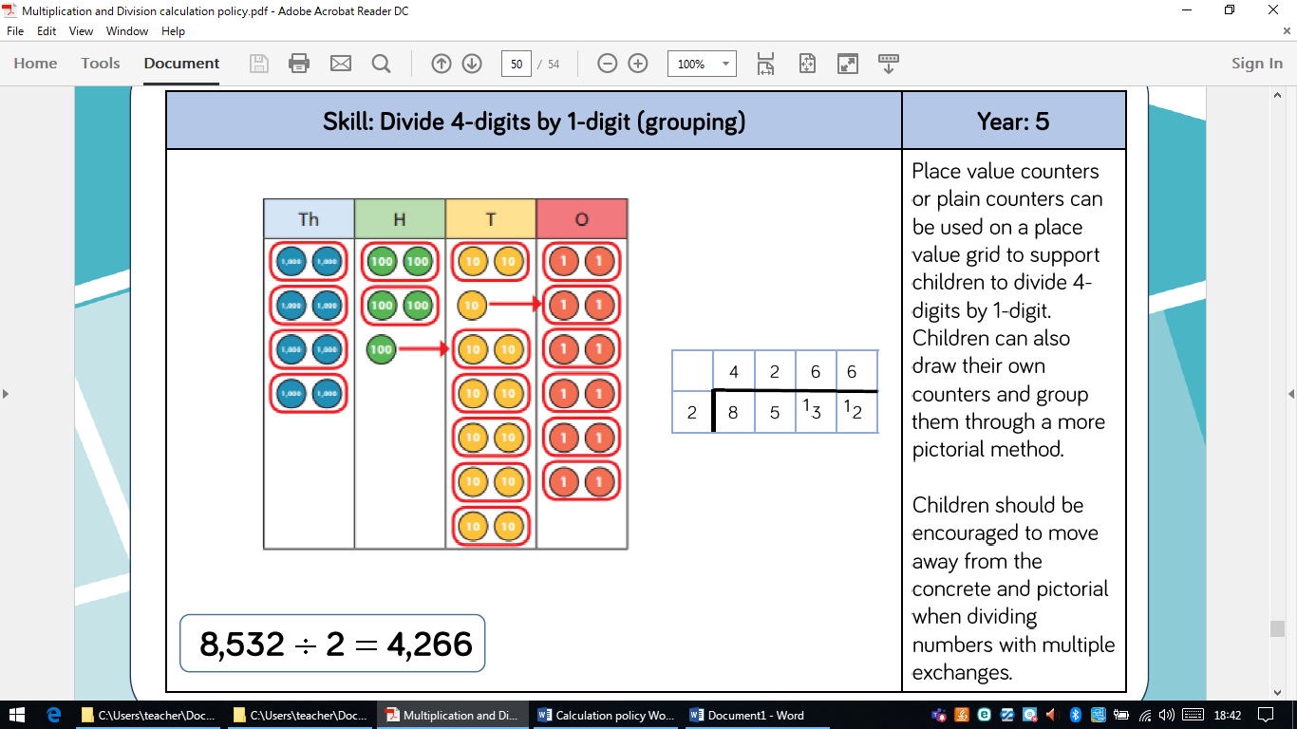  Place value counters or plain counters can be used on a place value grid to support children to divide 4-digits by 1-digit. | Children can also draw their own counters and group them through a more pictorial meethod. | Children should be encouraged to move away from the concrete and pictorial when dividing numbers with multiple exchanges.

 | Objective | Concrete | Pictorial | Abstract
Year 6 | Divide multi-digits by 2-digits (short division) | When children begin to divide up to 4-digits by 2-digits, written methods become the most accurate as concrete and pictorial representations become less effective. | 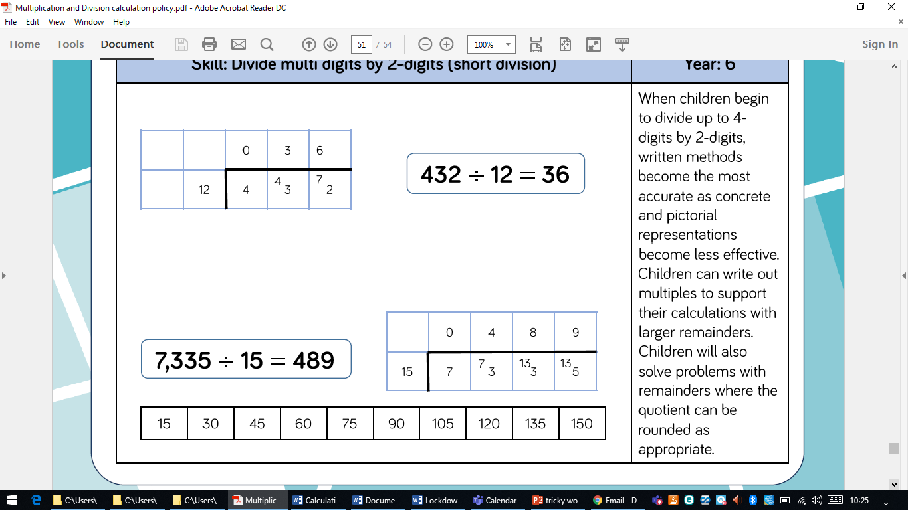  Children can write out multiples to support their calculations with larger remainders.  12, 24, 36, 48, 60, 72, 84, 96, 108, 120

 | Objective | Concrete | Pictorial | Abstract
Year 6 | Divide multi-digits by 2-digits  Long division |  | 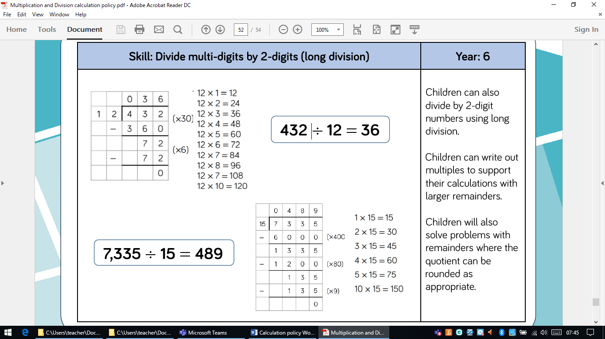  Children can write multiples to support their calculations. | Children can also use long division to divide by 2 digit numbers.
Year 6 | Divide multi-digits by 2-digits  Long division |  |  | 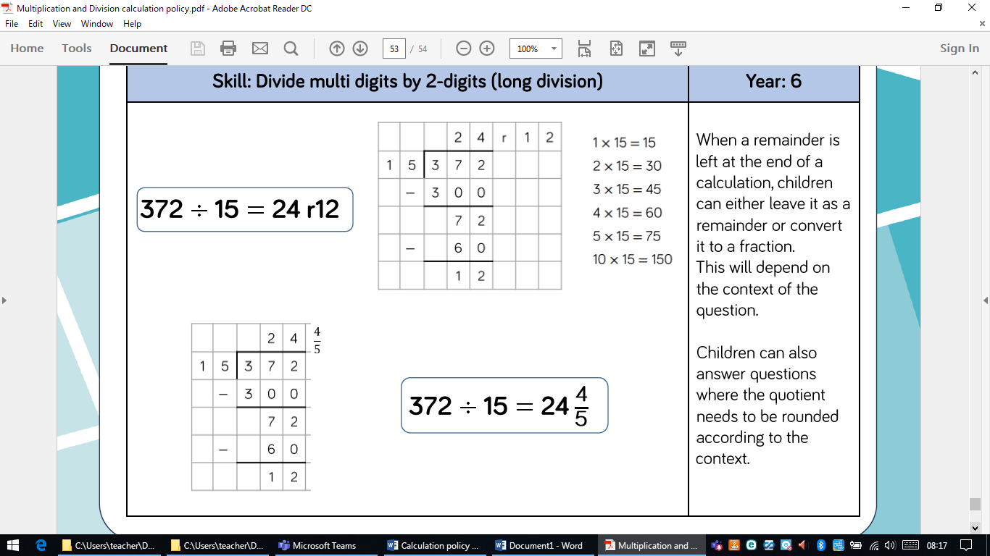  When a remainder is left at the end of a calculation, children can either leave it as a remainder or convert it to a fraction. This will depend on the context of the question.  Children can also round the quotient.

