

Maths Intentions, Implementation
and Impact Statement
At St Philip’s our Maths Curriculum is driven by our whole school vision and values.

Happiness, Love and Security Abound Everyone is Special
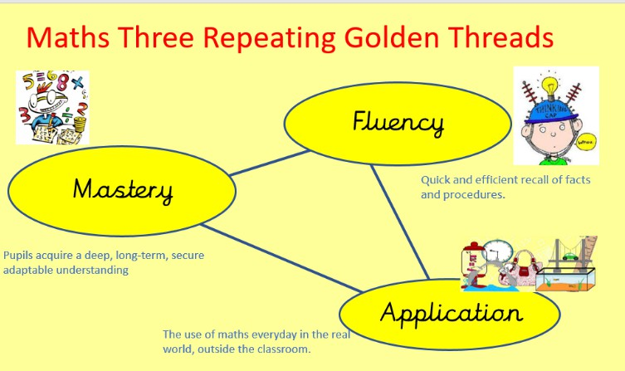
Every achievement is celebrated Relationships and teamwork matter A beacon of light in the community Christ is in everything we do

Subject Leader: Luke Highton

Maths: intentions
Our golden threads run through our maths provision - Educating for Wisdom, Knowledge and skills - Educating for hope and aspiration - Educating for community and living well - Educating for dignity and respect

It is our intention for every child to develop a sound understanding of Maths, equipping them with the skills of calculation, reasoning and problem solving that they need in life beyond school.
Maths is a journey and a long-term goal, achieved through exploration, practise and application over time. At each stage of learning, children should be able to demonstrate a deep, conceptual understanding of the topic and be able to continue to build on this.
There are 3 levels of learning:
- Shallow learning: surface, temporary, often lost
- Deep learning: it sticks and can be recalled and used
- Deepest learning: can be transferred and applied in different contexts
The deep and deepest levels are what we are aiming for by teaching maths using the Mastery approach
As a school we base our learning on a broad and balanced curriculum and strive to deliver a wide and varied learning experience, alongside our Christian values. We are fully committed to developing each child’s unique potential within a secure and caring environment. We believe that our children should not only reach their best academically, but also develop a thirst for knowledge, foster a love of learning and leave our school with exceptional independent learning skills.
By the end of the Juniors we want our children to leave our school with a range of positive maths experiences and skills:
  - enjoying maths
  - approaching maths with confidence and resilience
  - knowing why it is an important subject to study
  - with a sound knowledge of the areas outlined in the National Curriculum
  - with the ability to draw upon their knowledge outside the school setting, so as to solve problems in everyday situations
At St Philip’s we aim to:

- Give all children equal opportunities in mathematics, regardless of gender, culture, race, ability, interests or maturity.
- Help all children become confident mathematicians.
- Enable all children to enjoy mathematics by nurturing positive attitudes.
- Develop the mathematical potential in every child.
- Give children a firm basis of knowledge, skills and understanding so that they are numerate and able to work flexibly.
- Provide opportunities for all children to use and apply their mathematical knowledge in other areas of the curriculum in meaningful contexts.
- Encourage positive inclusion of all children including children with special needs, for example dyslexia and dyscalculia
`

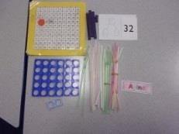
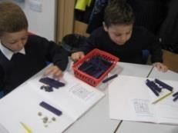
Maths: implementation

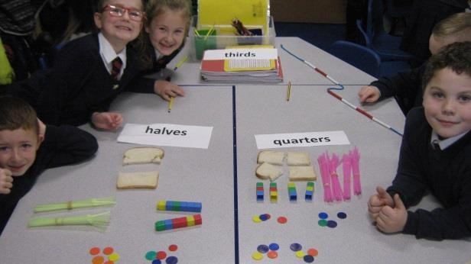
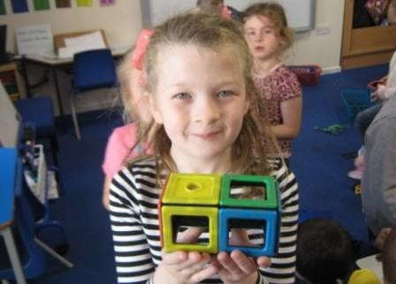
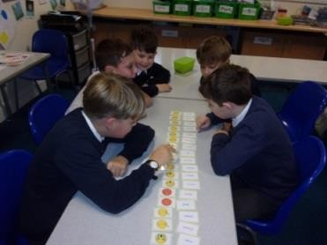
Class teachers are supported in a range of ways:
  - A subject leader to co-ordinate subject
  - An outline scheme of work – White rose Maths
  - A series of maths ladders which outline progression
  - Maths resources in every classroom to support children’s learning

A curriculum which …
    - Is aimed at developing maths mastery
    - is carefully planned to build and deliver new knowledge
    - has a real focus upon building on small steps
    - incorporates regular retrieval practice through Tough Ten activities to strengthen long-term retention and recall of key mathematical knowledge and skills.

The essential idea behind mastery is that all children need a deep understanding of the mathematics they are learning so that:
- Future mathematical learning is built on solid foundations which do not need to be re-taught;
- There is no need for separate catch-up programmes due to some children falling behind;
- Children who, under other teaching approaches, can often fall a long way behind are better able to keep up with their peers, so that gaps in attainment are narrowed whilst the attainment of all is raised.
The mastery approach incorporates objects, pictures, words, numbers and symbols to help children explore and demonstrate mathematical ideas, enrich their learning experience and deepen understanding. Together, these elements help cement knowledge so pupils truly understand what they’ve learnt.
All pupils, when introduced to a key new concept, should have the opportunity to build competency in this topic by taking this approach. Pupils are encouraged to physically represent mathematical concepts. Objects and pictures are used to demonstrate and visualise abstract ideas, alongside numbers and symbols.
Concrete – children have the opportunity to use concrete objects and manipulatives to help them understand and explain what they are doing.
Pictorial – children then build on this concrete approach by using pictorial representations, which can then be used to reason and solve problems.
Abstract – With the foundations firmly laid, children can move to an abstract approach using
numbers and key concepts with confidence.

At St Philips we use many different teaching strategies
We aim to provide children with a balance of mathematical opportunities delivered in variety of ways to address differing learning styles.
- learning through play with lots of ‘hands on’ and real-life experiences utilizing practical resources, especially the benefits of Numicon
- maths games and puzzles encouraging discussion and dialogue and group work
- open ended tasks, designed to challenge children’s thinking and understanding whilst applying their mathematical knowledge
- written maths to teach, practise and consolidate calculation skills
- ICT to support and enhance mathematics and cross curricular links wherever possible

Retrieval practice is a key feature of mathematics teaching at St Philip's. Through the use of Tough Ten activities and recap tasks, children regularly revisit previously taught learning, strengthening long-term memory, improving fluency and supporting the retention of key mathematical knowledge and skills over time.

Our Five-Part Lesson Structure
At St Philip's, all mathematics lessons follow a consistent five-part structure to support children in developing fluency, reasoning and problem-solving skills whilst securing long-term retention of mathematical knowledge.
1. LO & Key Vocabulary
- The learning objective is shared and discussed.
- Key mathematical vocabulary is introduced, displayed and explicitly taught.
- Children are encouraged to use precise mathematical language throughout the lesson.
2. Recap (Tough Ten & Recap Task)
- Tough Ten takes place three times weekly and focuses on retrieval of prior learning from beyond the previous lesson.
- A short recap task revisits learning from the previous lesson to identify misconceptions and consolidate understanding.
- Retrieval practice supports the transfer of learning into long-term memory.
3. Starter
- Children engage in a short mathematical activity, discussion or problem.
- This activates prior knowledge and prepares children for the new learning.
- Opportunities are provided for mathematical talk and reasoning.
4. New Learning (Teacher Modelling & Guided Practice)
- New concepts are explicitly taught through high-quality teacher modelling.
- Teachers use the CPA approach (Concrete, Pictorial, Abstract) where appropriate.
- Children work collaboratively and practice new learning with support before moving to independent application.
- Questioning is used throughout to check understanding and address misconceptions.
5. Independent Practice & Plenary
- Children apply their learning independently through carefully matched tasks.
- Opportunities for fluency, reasoning and problem-solving are provided.
- Lessons conclude with a plenary where learning is reviewed against the learning objective and misconceptions are addressed.

Non-Negotiables Across Every Maths Lesson
- Consistent use of mathematical vocabulary.
- Opportunities for reasoning and explanation.
- Retrieval practice to strengthen long-term memory.
- High-quality teacher modelling.
- Children encouraged to explain, justify and prove their thinking.
- Immediate identification and addressing of misconceptions.
- Appropriate challenge for all learners.
- Support staff promote independence through questioning rather than providing answers.

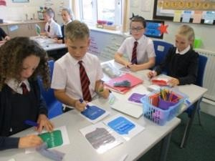
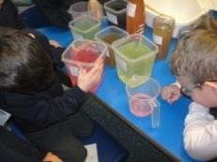
Maths: impact

When measuring the impact of our curriculum, our intentions are:
  - to develop our learner’s learning
We strive to ensure that our children’s attainment in maths is in line with or exceeding their age related expectations. We measure this carefully using a range of materials, so that children will be academically and physically prepared for the next phase of their education.
  - To develop behaviours and habits to become effective learners
We encourage children to persevere when something is challenging; to be highly motivated to succeed and achieve; and are equipped with all the personal skills to do this.
The impact of the mastery approach means that children:

  - Develop flexibility and fluidity to move between different contexts and representations of mathematics.
  - Have the ability to recognise relationships and make connections in mathematics
  - Develop quick recall of facts and procedures
  - Retain mathematical knowledge over time through regular retrieval practice.
  - Use and apply precise mathematical vocabulary confidently.
- Communicate mathematical thinking confidently using accurate mathematical vocabulary.
- Explain and justify their reasoning using mathematical language.
- Demonstrate increasing independence when tackling unfamiliar problems.
- Make connections between different areas of mathematics.
- Show resilience and confidence when challenged.
- Successfully move between concrete, pictorial and abstract representations.
- Are prepared for the next stage of their mathematical education through secure understanding of key concepts.
- Develop rapid recall of key number facts and previously taught mathematical concepts through regular retrieval practice.
In mathematics at St Philip's, impact is evident when children can confidently recall prior learning, reason mathematically, communicate their thinking clearly and apply their knowledge independently in a range of contexts.
A mathematical concept or skill has been mastered when a child can show it in multiple ways, using the mathematical language to explain their ideas, and can independently apply the concept to new problems in unfamiliar situations.

Early Years
At St. Philip’s C of E Primary School, maths is delivered through a well-planned play-based approach, with a balance of adult led and child-initiated activities. Throughout the foundation stage, long, medium and short-term plans ensure that each child has the opportunity to develop their knowledge, skills and understanding in every area at the appropriate developmental level. Our long-term planning ensures coverage so that all children have opportunities to work towards and achieve the Early Learning Goals (ELG's) that define the expectations for most children to reach by the end of the EYFS. We follow a half termly topic-based approach which allows flexibility to ensure that both children’s needs and interests are considered.
Children in Reception will be welcomed into a maths rich environment at St. Philip’s. We follow the EYFS Development Matters Framework. We ensure that the children get to experience maths in real life contexts and have plenty of opportunity to develop their own understanding of numbers and shape, space and measures through play. The children will receive a daily short input relating to a specific objective and complete a practical task relating to this objective. The learning environment also supports and extends children’s learning further with a vast choice of play opportunities in the continuous provision. A child’s ability to solve problems is actively encouraged and promoted at every given opportunity. We also undertake maths related trips, number hunts and shape detective outings.


