Early Years Foundation Stage Policy

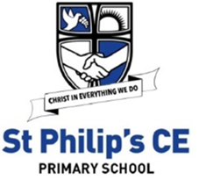

Lead | Pippa Houghton
Head | Sandie Edward
Chair of Governors | Jeremy Hooper
Policy amended | Sept 2026
To be reviewed | Sept 2029

Contents

Title Page No.

Early Years Foundation Stage Policy 3

Assessment in Reception 9

Reading in Reception 11

Writing in Reception 13

Maths in Reception 13

Appendix 1: EYFS Framework 15

Early years Foundation Stage Policy

The Early Years Foundation Stage (EYFS) applies to children from birth to the end of the reception year. Our Early Years Foundation Stage accommodates children from the age of 4 to 5 years of age, we do not have nursery provision. In our school we have one full-time reception class which can accommodate 30 children. Children who have turned four by the 1st September of that school year could be offered a place in our reception class. The reception class has a full-time teacher and a full-time teaching assistant. To ensure best practice and continuity our foundation stage class works closely with other local schools in order to moderate judgements.

Legislation
This policy is based on requirements set out in the Early Years Foundation Stage statutory framework for group and school-based providers, dated 13 July 2026 and effective from 1 September 2026.

Aims
At St. Philip’s C of E Primary School Early Years Foundation Stage, we aim to give each child a positive and meaningful start to their school life, in which they can establish solid foundations on which to develop into independent and fearless lifelong learners.
We will encourage children to develop independence within a secure and friendly atmosphere; to support children in building relationships through the development of social skills such as cooperation and sharing; to help each child to recognise their own strengths and achievements through experiencing success and by developing the confidence to work towards personal goals.
Our high expectations will enable each child to develop socially, physically, intellectually and emotionally and to achieve their full potential. We will offer a structure for learning that has a range of starting points and unlimited availability for development through a wide range of new and exciting first-hand experiences that will give children the opportunity to consolidate, explore and test their skills, knowledge and understanding alongside existing experiences. We will ensure that children are kept healthy and safe and that they achieve the knowledge and skills they need to start school.

The Curriculum
The Reception class follows the statutory 2026 Early Years Foundation Stage (EYFS) framework document, which is available on the school website or to download at https://assets.publishing.service.gov.uk/media/6a5f8e4fb00f3323bf1a23a1/EYFS_group_and_school_based_from_September_2026.pdf The following policy details the specifics of our school provision.
The EYFS is based upon four principles:
- A Unique Child
- Positive Relationships
- Enabling Environments with teaching and support from adults
- Learning and Development

- A Unique Child
We recognise that every child is a competent learner who can be resilient, capable, confident and self-assured. We recognise that children develop in individual ways, at varying rates. Children’s attitudes and dispositions to learning are influenced by feedback from others; we use praise and encouragement, as well as celebration/ sharing assemblies and rewards, to encourage children to develop a positive attitude to learning.
- Positive relationships
We recognise that children learn to be strong and independent from secure relationships and aim to develop caring, respectful and professional relationships with the children and their families.
- Enabling environments with teaching and support from adults
We recognise that children learn and develop well in enabling environments with teaching and support from adults, who respond to their individual interests and needs and help them to build their learning over time. By working alongside children in their play, we are able to establish positive relationships quickly and continually assess their development whilst providing immediate next steps and challenge, to deepen and extend their learning further.
- Learning and development
Our reception class has a bright classroom and a large outdoor classroom, which is solely for use by reception children. All our learning environments are organised to allow children to explore and learn securely and safely. There are areas where the children can be active, be quiet and rest. The areas of learning are defined within the class so that children are able to find and locate equipment and resources independently.
Areas of Learning
The EYFS is made up of three prime areas of learning:
- Communication and Language
- Physical Development
- Personal, Social and Emotional Development
There are four specific areas of learning:
- Literacy
- Mathematics
- Understanding the World
- Expressive Arts and Design
At St. Philip’s C of E Primary School, all areas are delivered through a well-planned play-based approach, with a balance of adult led and child-initiated activities. Throughout the foundation stage our long, medium and short-term plans ensure that each child has the opportunity to develop their knowledge, skills and understanding in every area at the appropriate developmental level. Our long-term planning ensures coverage so that all children have opportunities to work towards and achieve the Early Learning Goals (ELG's) that define the expectations for most children to reach by the end of the EYFS. We follow a half termly topic-based approach which allows flexibility to ensure that both children’s needs and interests are taken into account.

Play
Learning through play underpins our approach to teaching and learning in the foundation stage. We embrace the fact that young children learn best from activities and experiences that interest and inspire them to learn. In doing so we can provide children with stimulating, active play experiences in which they can explore and develop their learning and to help them make sense of the world. Children have opportunities through their play to think creatively and critically alongside other children as well as on their own. They are able to practise skills, build upon and revisit prior learning and experiences at their own level and pace. Play gives our children the opportunity to pursue their own interests, inspire those around them and consolidate their understanding and skills. The children learn to adapt, negotiate, communicate, discuss, investigate and ask questions. Our adults take an active role in child-initiated play through modelling, facilitating, teaching and extending play, skills and language.

Characteristics of Effective Learning
The EYFS also includes the characteristics of effective teaching and learning and we plan activities with these in mind. The characteristics highlight the importance of a child’s attitude to learning and their ability to play, explore and think critically about the world around them. The three characteristics are;
Playing and Exploring – children investigate and experience things, and ‘have a go’.
Active Learning – children concentrate and keep on trying if they encounter difficulties, and enjoy achievements.
Creating and Thinking Critically – children have and develop their own ideas, make links between ideas, and develop strategies for doing things.

Inclusion
Our whole school ethos, as well as that of the foundation stage, embraces inclusion. We recognise and respect the abilities and strengths of our children at all levels of development and the wealth of knowledge and experience that they bring from their differing backgrounds and cultures.
We give our children every opportunity to achieve their best. We do this by taking account of our children’s range of life experiences when planning for their learning and we set realistic and challenging expectations that meet the needs of individual children, so that children are able to reach their full potential. We achieve this by planning to meet the needs of boys and girls, children with special educational needs, children who are more able, children from all social and cultural backgrounds, children of different ethnic groups and those from diverse linguistic backgrounds. We aim to build upon and extend children’s knowledge, experience and interests, and develop their self-esteem and confidence using a wide range of teaching strategies based on children’s learning needs.
We will provide: a wide range of opportunities to motivate and support children and to help them to learn effectively; a safe and supportive learning environment in which the contribution of all children is valued; resources which reflect diversity and are free from discrimination and stereotyping; challenging activities for all children and for those whose ability and understanding are advanced. We will make daily formative assessments to ensure that children are ‘on track’ for the time of year, and to ensure that support is adjusted to target specific areas of support as necessary. Where a specific need is suspected we will liaise with the Special Educational Needs co-ordinator and seek advice from outside agencies, such as the speech and language service, the educational psychologist and the bi-lingual support services amongst others. We adhere to the Equal Opportunity and Inclusion policies of the school.
More information about inclusion at St Philip’s, including our ‘SEND policy’ can be found on the ‘SEND’ page of our website https://st-philips-church-of-england-primary-school.secure-primarysite.net/send/.

Early Years Pupil Premium
We will endeavour to identify our least advantaged pupils and inform parents or carers of their opportunity to apply for their child’s entitlement to extra funding in school. We identify barriers to learning, and ensure that all extra funding we receive will be used to support areas in which we identify that the child will best benefit. We will make daily formative assessments to ensure that children are ‘on track’ for the time of year, and to ensure that support is adjusted to target specific areas as the child develops.

Transitions
At St. Philip’s C of E Primary School, we recognise that starting school has the potential to be a stressful time for both children and parents. To this end we have established a strong procedure for transitions to ensure that our children and parents are as confident and secure as they can be when facing this new challenge.
Reception parents are invited to a new intake meeting in the summer term before the children start school to provide parents with key information, school expectations, knowledge on our curriculum and assessment and advice on how they can help their child. All children are visited in their nursery setting by their new teacher prior to starting school so that they can get to know their teacher, and children are also invited to a “stay and play” session in the latter part of the summer term. We always maintain open lines of communication with previous nurseries and school settings and may, at times, contact them to request additional information regarding a child’s educational, social and emotional well-being.
At the beginning of the school year new reception children are given a week’s settling in period to ensure that they have the time to become secure and familiar with the new routines before starting school full time. For the first week children attend school in the morning or afternoon only and for the second week children attend for full days.
At the end of reception children have the opportunity to meet with their new teacher in their classrooms prior to starting Year one. At the end of each school year the reception teacher has the opportunity to share their knowledge of each child’s knowledge, understanding and achievements, including end of year assessment data, with their next class teacher to ensure that all teachers have a well-rounded picture of the children prior to the new school year.
Throughout the reception year, when children are ready they are gradually introduced to whole school activities such as assemblies and to using the infant playground.
Community Links
At St. Philip’s C of E Primary School, the reception class enrich learning and encourage strong links with the local community. We arrange local trips to supermarkets and arts venues. We also enjoy having visitors by inviting in members of the local community during our topic on people who help us.
Partnership with Parents
We believe that parents and carers are a child’s first educator and therefore work very closely to ensure they are involved in what their child does at school. We want parents to feel they can speak to us about their child and to feel comfortable in our setting. As well as the Reception visit days we offer invitations to our parents to various craft sessions and special events to give them the opportunity to share their child’s learning environment, have time to talk informally with the practitioners and to meet other parents. We also offer parents a variety of learning workshops to provide advice and information on how they can support their child’s learning. Parents are welcomed and encouraged to share information about their child, to ask questions and to discuss their child’s learning with the teachers.
In reception parents are encouraged to support children’s learning through completing reading records and simple homework activities.
Safeguarding
Children learn best when they are healthy, safe and secure, when their individual needs are met, and when they have positive relationships with the adults caring for them. We follow the safeguarding and welfare requirements detailed in the Early Years Foundation Stage Statutory Guidance (2026) and we adhere to the school’s safeguarding policy. More information can be found in the government’s publications ‘Working together to safeguard children’ and ‘Keeping children safe in education’ using the links below.
https://www.gov.uk/government/publications/working-together-to-safeguard-children--2
https://www.gov.uk/government/publications/keeping-children-safe-in-education--2
From 1 September 2026, the school follows the Department for Education's guidance on children's screen use in early years settings. Screen use in Reception is limited, carefully planned, age-appropriate and linked to a clear learning, communication or accessibility purpose. Children do not access screen content without adult oversight, and screens do not replace high-quality interaction, practical play, stories, physical activity or outdoor learning. Appropriate assistive technology for pupils with SEND is considered according to individual need.
The school's safeguarding arrangements set out how mobile phones, cameras and other electronic devices with imaging or sharing capabilities may be used. Digital content is checked before use; advertising, autoplay, algorithm-driven content and unsuitable artificial intelligence tools are avoided in Reception.
The school follows the safer-recruitment and suitability requirements in the EYFS framework and Keeping Children Safe in Education. Staff and regular volunteers working directly with Reception children must have the appropriate identity, reference, enhanced DBS and, where eligible, children's barred-list checks before starting. Occasional supervised helpers are managed through the school's risk-assessment and volunteer procedures. Staff and prospective staff must disclose relevant information that may affect their suitability, subject to the legal rules on protected convictions and cautions.
Banned dog breeds within section 1 of the Dangerous Dogs Act 1991, including the XL Bully type, must not be kept or present on the school premises at any time, including where a dog has a certificate of exemption.
The detailed safer-sleep requirements for children under two are not applicable because the school provides Reception provision only. If a Reception pupil needs to rest or sleep because of a medical condition, disability or other identified need, an individual plan and risk assessment will specify safe supervision and care arrangements.
When Reception pupils attend school-run breakfast or after-school care, the safeguarding and welfare requirements in section 3 of the EYFS framework continue to apply. The learning, development and assessment requirements in sections 1 and 2 do not apply to wraparound-only care for children who normally attend Reception or an older class during the school day.
Further safeguarding and welfare procedures, including child protection, allegations against staff, whistleblowing, online safety, safer recruitment and staff conduct, are set out in the school's Child Protection and Safeguarding Policy, Online Safety Policy, Staff Code of Conduct and associated procedures.
The school follows its Attendance Policy and EYFS attendance procedures. Unexplained or prolonged absences are followed up promptly with parents/carers. Patterns of attendance are monitored and concerns regarding a child's welfare are referred through safeguarding procedures where appropriate.
Staff, volunteers and students are expected to follow the school's Whistleblowing Policy and are encouraged to raise concerns about unsafe practice or safeguarding matters through established procedures.
The school fulfils its duties under the Prevent Duty and works to protect children from the risk of radicalisation and extremism.

Keeping Healthy
We are a healthy school and our children under 5 receive free milk and all children have access to fresh water and free fruit from a Government scheme. Reception children are eligible for free school meals or can choose to bring in a healthy packed lunch. We promote good Oral Hygiene to the children and signpost parents and carers to advice provided by the NHS, such as https://www.nhs.uk/live-well/healthy-body/taking-care-of-childrens-teeth/. Throughout the year we plan cooking activities to give children experiences of a range of healthy food.
The administration of medicines is managed in accordance with the school's Supporting Pupils with Medical Conditions Policy and EYFS statutory requirements.
The school works closely with parents and carers to ensure that any food allergies, intolerances or dietary requirements are identified and managed safely. Information regarding allergies is recorded, shared with relevant staff and reviewed regularly. Where appropriate, individual allergy action plans are put in place and staff are made aware of the signs and symptoms of allergic reactions, including anaphylaxis, and the procedures to follow in an emergency. Children are supervised appropriately during snack and meal times to help ensure their safety and wellbeing.

Health and Safety
The foundation stage classroom has their own toileting facilities and we teach the children the importance of hygiene, hand washing techniques.
At least one suitably qualified paediatric first aider is available whenever Reception children are present and accompanies children on off-site visits.

Assessment in Reception
The Reception team formatively assess the children each day whilst working alongside the children in either an adult initiated activity or during child-initiated play, with the main purpose of:
- Ascertaining what each unique child can do.
- Considering what the child needs to learn next, and modelling it to them.
- Planning activities that enable the child to make progress. This might be ‘in the moment’ planning, or planned into future lessons.
The class teacher tracks whether a child is “on track”, or “not on track” in each area of learning, each half term. The purpose of which is to inform future planning and to close gaps by providing specific targeted interventions to the children who are “not on track”. The baseline assessment takes place within the first few weeks of the children starting school and takes the form of tasks for the children to complete and observational checklists completed whilst monitoring their play. By having a good understanding of the child’s abilities and characteristics of learning when they start school, the class teacher is able close gaps early on in the year and plan next steps in learning.
The EYFS profile assessment is carried out in the final term of Reception. The main purpose of the EYFS profile is to provide a reliable, valid and accurate assessment of individual children at the end of their Reception year. EYFS profile data is used to:
- Inform parents about their child’s development against the early learning goals (ELGs) and the characteristics of their learning.
- Help the Year 1 teacher to plan an effective, responsive and appropriate curriculum that will meet the needs of each child.
Children in Reception are assessed against the Prime and Specific areas of Learning in the EYFS profile, which summarises and describes children’s attainment at the end of the reception year. It is based on on-going observation and assessment in the three prime and four specific areas of learning and the three learning characteristics, set out below;

The prime areas of learning:
- Communication and language
- Physical development
- Personal, social and emotional development

The specific areas of learning:
- Literacy
- Mathematics
- Understanding the world
- Expressive arts and design
The learning characteristics:
- Playing and exploring
- Active learning
- Creating and thinking critically
The Teacher makes a judgement as to whether a child is meeting the level of development expected at the end of the Reception Year (expected), or not yet reaching this level (emerging). This judgement is then shared with the ‘EYFS Link Governor’ and with the parents of the child.Reading in Reception
At St. Philip’s C of E Primary School children will enter the Reception classroom and take part in high-quality, phonics sessions every day. A systematic programme using Essential Letters and Sounds (ELS) taught at a rapid pace: children are introduced to 1 phoneme per day throughout the first term. ELS Phonics is an OFSTED accredited scheme and has been built upon the latest research and understanding about how children learn to read, how we ensure that this stays in their long-term memory and how to get the best outcome for all learners. ELS lessons are effective, lively and a fun way to begin the reading and writing journey. The teaching of this is multi-sensory and active approach uses the wider school environment such as the Reception outdoor area to ensure purposeful learning is taking place. The sounds taught each week are sent home as they are introduced in class to consolidate learning and to keep parents/carers up to date on the progress being made in school.
During phonic sessions children learn how to do use robot arms and blending hands as a way to segment each word. The teacher shows children how to do this for example; c-a-t = cat. The sounds (phonemes) are spoken aloud, in order, all through the word. This is called blending which is a vital skill for reading.
They will also learn to do it the other way around; cat = c-a-t. The whole word is spoken aloud, and then broken up into its sounds (phonemes) in order, all through the word. This process is called segmenting and is a vital skill for spelling.
‘Harder to read words’ (irregular words such as “I”, “said”, “some”) are also taught as part of the ELS phonics scheme. Children are continually assessed during and at the end of each period and if secure move onto the next phase sounds as appropriate. Small group and 1:1 phonics intervention take place when gaps in phonics knowledge are identified. Interventions include discrete focus sessions on blending, segmenting, phoneme recognition and daily reading with an adult.
When the children begin to learn some initial letter sounds, home school reading records are sent home along with picture books initially, developing to phonetically suitable reading books when the child is ready. These books are organised into coloured levels based on a national book banding system and parents are encouraged to listen to their children read as often as possible.
The teacher or teaching assistant in Reception Class listen to the children read individually, at least once a week. In addition to this, the teacher conducts whole class reading sessions. Workshops are also held to inform parents of how they can help with supporting their child in learning to read.

Writing in Reception
Teachers will model how to form letters correctly, so that children can eventually acquire a fluent and legible handwriting style. All children will be encouraged to develop a tripod grip when holding a pen or pencil which needs considerable co-ordination and practice. Fine and gross motor skill activities will be encouraged on a daily basis to ensure that children’s fingers and shoulders are strengthened to provide the necessary form and stamina for writing.
When the children are ready, the teacher will deliver a daily guided writing session where after the children are encouraged to work independently – chopping out words, checking on the letter chart and writing – remembering to keep talking to their pencil as it is easy to forget what they had planned to say.
The children have the opportunity each day to produce independent writing during continuous provision. These opportunities are often linked to our themes, such as writing menus for a cafe, shopping lists and sentence writing using object and picture stimuli. We ensure that children are aware of the purpose for their writing, and who their audience is. Children are encouraged to, and given the opportunity to share their writing with the rest of the class.
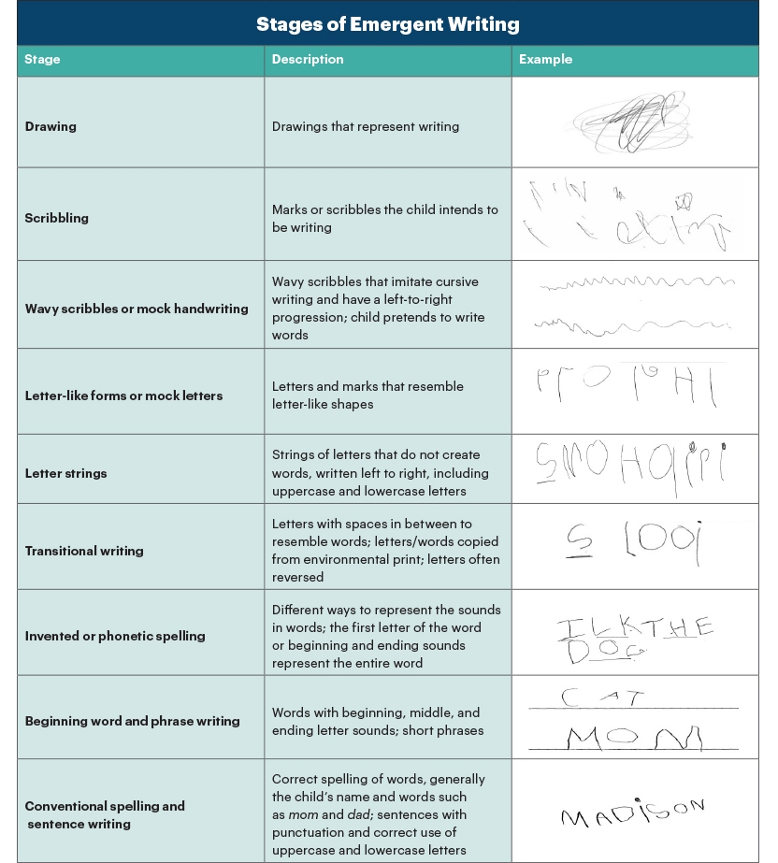
We assess, identify and encourage next steps using the stages of emergent writing, shown below.

Maths in Reception
Children in Reception will be welcomed into a maths rich environment at St. Philip’s C of E Primary School. We follow the EYFS Development Matters Framework. The expectations at the end of the Reception Class are as follows:

Maths  Number | Children count reliably with numbers from 1-20, place them in order and say which is 1 more/less than a given number. Using quantities and objects, they add and subtract two single-digit numbers and count on or back to find the answer. They solve problems, including doubling, halving and sharing. | Children estimate a number of objects and check quantities by counting up to 20. They solve practical problems that involve combining groups of 2, 5 or 10 or sharing into equal groups.
Maths  Numerical Patterns | Use everyday language to talk about size, weight, capacity, position, distance, time & money to compare quantities and objects and to solve problems. Recognise, create and describe patterns. Explore characteristics of everyday objects and shapes and use mathematical language to describe them. | Estimate, measure, weigh and compare and order objects and talk about properties, position and time.

We ensure that the children get to experience maths in real life contexts and have plenty of opportunity to develop their own understanding of number and numerical patterns. We also ensure that children are given the opportunity to explore spaces, shapes and measures. The children will receive a daily short input relating to a specific objective and complete a practical task relating to this objective. The learning environment also supports and extends children’s learning further with a vast choice of play opportunities in the continuous provision. A child’s ability to solve problems is actively encouraged and promoted at every given opportunity. We also undertake maths related trips, number hunts and shape detective outings.
Small group and 1:1 math intervention take place when gaps in learning are identified. Interventions include focus sessions on rote counting, counting 1:1 correspondence, number recognition and shape recognition.

Monitoring and Review
The implementation of this policy will be monitored by the Headteacher and EYFS Lead through:
- Learning walks and observations.
- Monitoring of planning and assessment information.
- Analysis of EYFS outcomes and attainment of key groups.
- Discussions with pupils, staff and parents.
- Evaluation of transition arrangements and parental engagement.
The Governing Board, through the designated EYFS Link Governor, will receive regular updates on EYFS outcomes and provision.
This policy will be reviewed every three years, or sooner if there are significant changes to legislation, statutory guidance or school practice.

Transition from EYFS to Key Stage 1
At St Philip's CE Primary School, we recognise the importance of ensuring a smooth and successful transition from Reception into Year 1.
Reception and Year 1 staff work closely together to:
- Share assessment information and knowledge of individual pupils.
- Identify pupils requiring additional support or challenge.
- Plan curriculum experiences that build upon children's prior learning.
- Support pupils' emotional wellbeing and confidence during the transition process.
- Ensure continuity in routines, expectations and learning environments.
This collaborative approach enables children to move confidently into the next stage of their education while maintaining a love of learning and positive attitudes towards school.

At St Philip's CE Primary School, we are committed to providing a nurturing, ambitious and inclusive Early Years environment where every child is valued as a unique individual. Through high-quality teaching, rich learning experiences, strong partnerships with families and a curriculum rooted in exploration and play, we strive to ensure that all children develop the knowledge, skills and characteristics they need to thrive both academically and personally.
Guided by our Christian vision, we aim to instil confidence, curiosity, resilience and kindness, ensuring that every child leaves Reception ready for the opportunities and challenges of Key Stage 1 and beyond.

Appendix: EYFS Framework Summary
1. Prime Areas
The Prime Areas of Learning are the foundations for children's development and learning. They support children in building relationships, developing communication skills, and becoming confident and healthy learners.
- Communication and Language
- Physical Development
- Personal, Social and Emotional Development
2. Specific Areas
The Specific Areas build on the Prime Areas and provide children with knowledge and skills across a broader curriculum.
- Literacy
- Mathematics
- Understanding the World
- Expressive Arts and Design
3. Characteristics of Effective Learning
These describe how children learn and engage with experiences.
- Playing and Exploring: Investigating and experiencing things, and having a go.
- Active Learning: Concentrating, persisting, and enjoying achievements.
- Creating and Thinking Critically: Developing ideas, making connections, and solving problems.
4. Early Learning Goals (ELGs)
The Early Learning Goals set out the expected level of development that most children should reach by the end of the Reception year. They are used to assess children's progress across all areas of learning and development within the EYFS framework.

