No child should suffer harm, either at home or at school. Everyone who works in our school has a responsibility to make sure that all our young people are safe.
This leaflet has been given to you to make sure you understand what is expected of you. Please ask a member of staff if you are unclear about anything in it, and keep the leaflet in a safe place, so that you can read it again if you need to.
If you are worried about the safety of any young person in our school, you must report this directly.

CONTACTS
Senior Designated Person for Safeguarding Children (SDP)

Mrs Sandie Edward
Headteacher
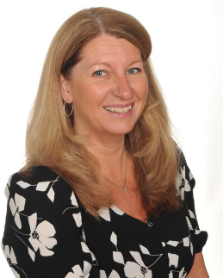

Mrs Alison Klaassen
Deputy Head Teacher
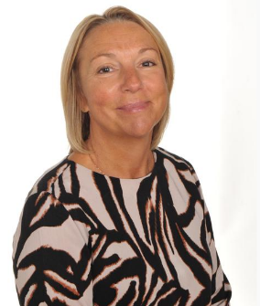

Governor with safeguarding responsibility:
Claire Kite
Chair of Governors
Mr Jeremy Hooper

SAFEGUARDING ADVICE FOR VOLUNTEERS & VISITORS

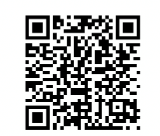
Our full Safeguarding Policy is available on our website via the QR code;

A copy is also available at the school office.
Child Protection Advice for Volunteers & Visitors
Thank you for your interest in becoming a volunteer or visitor. As a school we are committed to safeguarding and meeting the needs of children and we hope this leaflet will provide some useful advice and information when working with children at St. Philip’s C of E Primary School.
What are my responsibilities as a Volunteer?
All those who come into contact with children through their everyday work whether paid or voluntary have a duty to safeguard and promote the welfare of children.
DBS checks
St. Philip’s C of E Primary School’s Recruiting and Selection Procedures specify that all volunteers who have contact with children of a specified nature (i.e. teaching) or in a specified place (i.e. a school) and is frequently, intensively or overnight (i.e. once a week or more, four or more occasions in a 30-day period, or overnight – between 2 – 6 a.m.), will require a DBS. This is to help ensure that unsuitable people are prevented from working with children. The office manager will inform you as to whether or not you require a DBS. If you do not, you should not be left unsupervised with children. A link will be sent to you and you will be advised which documentation is necessary for you to present for the ID check to be completed. It is a requirement, also, that you inform the Headteacher immediately if you or someone you live with become subject to any criminal investigation, caution or conviction. This helps to protect you as well as the young people in your care.

What should I do if I am worried about a child?
If whilst working with a child you become concerned about:
- Comments made by a child
- Marks or bruising on a child
- Changes in the child’s behaviour or demeanour Please report these concerns to the class teacher, who if they feel it is appropriate will pass the information on to the school’s Senior Designated Person for Safeguarding.
What should I do if a child discloses that s/he is being harmed?
Although the likelihood of this is small it is important to know what to do in such an eventuality as children rarely lie about such matters
- Listen to what is being said without displaying shock or disbelief; accept what is being said
- Allow the child to talk freely
- Reassure the child, but do not make promises that might not be possible to keep
- Do not promise confidentiality but explain to the child that you may have to tell their teacher or Headteacher in order that they can provide appropriate help
- Do not interrogate the child or ask leading questions
- Reassure the pupil that it is not their fault
- Stress that it was the right thing to tell
- Do not ask the child to write a statement
- Do not criticise the alleged perpetrator
- Immediately record details of the disclosure, including wherever possible the exact words or phrases used by the child. Forms for the recording of information of this nature are available from the school office and should be completed and returned to the Senior Designated Person for Safeguarding to enable the matter to be dealt with in the most appropriate way. Please ensure you have signed and dated the record.
What should I do if the alleged abuser is a member of the school staff?
You should report such allegations to the Headteacher.
What should I do if the alleged abuser is the Headteacher?
You should report such allegations to the Chair of Governors.
How do I ensure that my behaviour is always appropriate?
Appropriate relationships with children should be based on mutual trust and respect. As a volunteer you may well be working closely with children sometimes on a one to one basis. Children, especially when they are young, are often spontaneously affectionate and tactile and it is important not to alienate them through lack of response or by appearing to reject this. You should, however, be careful about touching pupils. If you are working with a pupil on his/her own always ensure that the door is left open or that you can be visible to others. Do not photograph pupils, unless requested to by the class teacher, exchange e-mails or text messages, or give out your own personal details. Any unprofessional contact with pupils (e.g. through a social networking site) may leave you vulnerable to an allegation of abuse being made against you. Please help us to safeguard the children in our care by following these guidelines.

