Our goal is always to support families and keep children safe.

🚦 Personal Safety
We teach children important personal safety skills to help them stay safe in and out of school, including:
- Understanding stranger danger and who to trust
- Road safety and how to travel safely to and from school
- Body boundaries and the importance of saying “no”
- Who to talk to if they feel unsafe or uncomfortable
We use age-appropriate resources like the PANTS Rule (from the NSPCC) to help children understand:
- Their body belongs to them
- They have the right to say no
- They should speak out if something doesn’t feel right
You can support this by having regular, open conversations about personal safety.

🌐 Online Safety
We teach children how to stay safe online and encourage parents to:
- Monitor internet use at home
- Talk regularly about online activity
- Use parental controls and privacy settings
- Be aware of and comply with age limits and restrictions


SAFEGUARDING ADVICE FOR PARENTS
Our full Safeguarding Policy is available on our website via the QR code; a copy is also available at the school office. https://www.stphilipssouthport.com/child-protection-including-safeguarding/
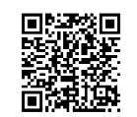

What is Safeguarding?
Safeguarding means keeping children safe from harm, ensuring they are healthy, happy, and able to learn and grow in a secure environment. It covers everything from physical safety and emotional well-being to protecting children from abuse or neglect.
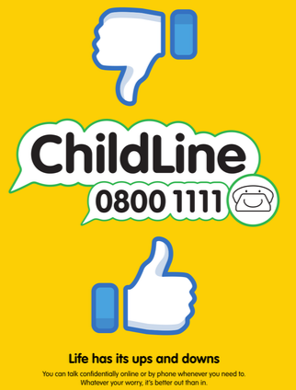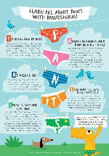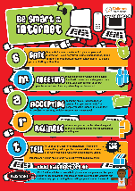
💡 Our Commitment
At St Philip’s Primary School, your child’s safety is our top priority. We are committed to:
- Creating a safe, supportive environment
- Promoting well-being and resilience
- Identifying concerns early and taking action quickly
- Working closely with parents and carers
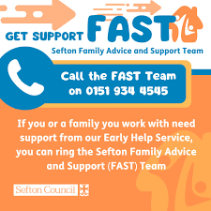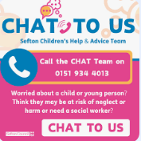

Meet Our Safeguarding Team
Designated Safeguarding Lead (DSL):
Sandie Edward, Head Teacher and Designated Safeguarding Lead
📞 Contact: Head@sps.sefton.school
Deputy DSL(s):
Alison Klaassen, Deputy Designated Lead
📞 Contact: Klaassena@sps.sefton.school
Emma Cooper, Designated Lead for Cared for Children
📞 Contact: Coopere@sps.sefton.school
Our staff are trained in safeguarding procedures and know how to respond if they or you are worried about a child.
🔍 What We Look Out For…. No concern is too small to be shared.
We are alert to signs that a child may need help, such as:
- Changes in behaviour or mood
- Injuries that raise concern
- Bullying (in person or online)
- Signs of neglect or emotional distress
🛡️ What Happens If We Have a Concern?
If we’re worried about a child’s safety:
- We talk to the child sensitively.
- We may contact parents or carers.
- We may seek the views of the people in school who know them
If needed, we would make a referral to SEFTON FAST or CHAT and we would work with external safeguarding professionals to support your child and your family. We would seek your consent to refer unless we believed this would put your child at risk of harm.

🧠 Mental Health & Wellbeing
We support children’s mental health through:
- Regular check-ins
- Access to school counsellors, EMHP, TAS team or support staff
- Referrals to external services where needed
If you have concerns, please talk to us. We’re here to help.
🤝 Working Together
Parents and carers play a vital role in safeguarding. Here’s how you can help:
- Keep contact details up to date
- Let us know about changes at home
- Talk to your child about staying safe
- Speak up if something doesn’t feel right
📩 Need to Talk?
We’re always here to listen. Contact us at school or speak to a member of the safeguarding team. Together, we can make sure every child feels safe, supported
Governance of Safeguarding
- We complete an annual audit and submit this to the Local Authority
- We report half termly to our Governing Board in relation to safeguarding
- Our named Governor for Safeguarding is
Jeremy Hooper, safeguarding and online safety governor
📞 Contact: via the school office

Safeguarding is a community responsibility; we all have a part to play.

.

