Attendance Analysis 2024 - 2025
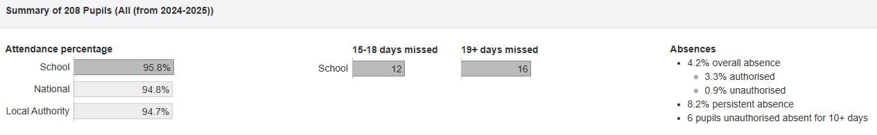

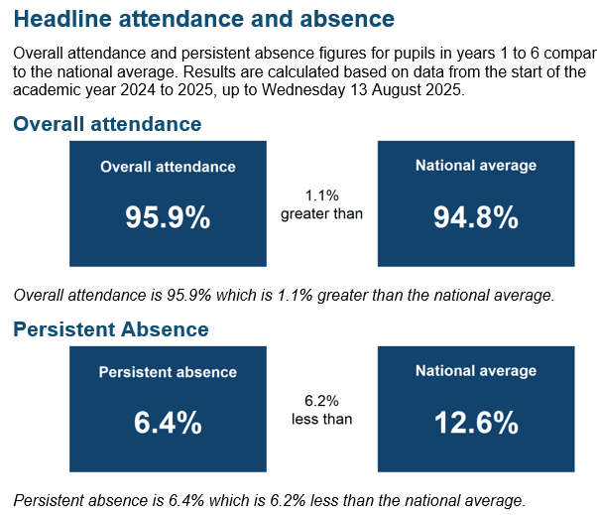
School Attendance has been a top priority this year and has formed a significant part of our safeguarding work. Ensuring all of our children have attendance above 95% has been our goal and we have worked hard to meet with families who have not managed to ensure this right for their child.
This year we have applied the new attendance guidance from the DFE and have updated our attendance and safeguarding policies in line with these new statutory guidelines. Our updated policies for this academic year are ready to be ratified at Oct 25 Full Board.
We are working with our Learning Partnership on an attendance project. Whilst our attendance looks good at first glance there is always room for improvement. This year we will focus on
- Term time holidays
- Days off before or after a holiday. 74 children were absent before or after a school holiday. This has increased by 9 children this year.
- Reviewing our plan for Inset days to try to minimise broken weeks.
- Children whose absence is 90 -94%. We had 47 children in this bracket
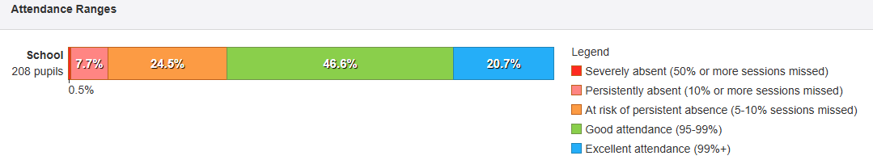
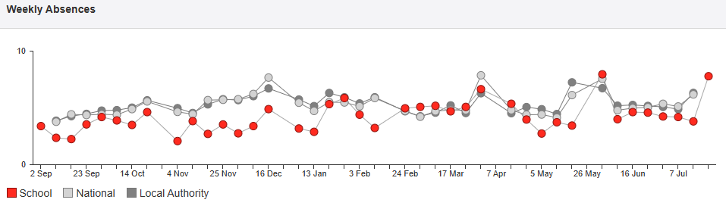
We had 3 episodes of attendance peaks that can be seen on the weekly absence graph, the first in the spring term as a result of chicken pox and the second as a result of extended holidays the week after half term in May/early June. Thirdly our last day of term fell on a Tuesday and the Monday and Tuesday represent families leaving for their summer break early to try to take advantage of lower costs.
Our first response systems remain in place and we continue to respond immediately to any unexplained absences as detailed in our attendance and safeguarding policies. Sefton have produced a new template for this.
Children receive awards and certificates for good attendance, however due to equality reasons we do not present these in front of the whole school. We are sensitive to the fact that children with medical conditions have attendance impacted through no fault of their own. 43 children received 99% or above awards. An increase of 7 children whose attendance is exceptional on last year.
We report all absences of children open to Early Help, Child in Need, Child Protection and those who are previously or presently Looked After or are in Care. We have internal monitoring of children who we have identified as having a particular area of vulnerability.
We have made home visits and assigned key staff to families we believe need more support. We always offer Early Help but this is more often than not refused. This year we have had some success with the introduction of Team Around the School and have been liaising with our family worker to support 1 family in particular who was waiting for specialist provision.
This year we have continued to track and monitor any child whose attendance is below 95%. Our Local Authority assigned an Attendance Worker from the welfare team who meets with our attendance team termly. We complete a detailed pre-meeting sheet and spend time discussing cases that we feel as a school we need external support with.
As a school we have found the DFE Attendance Data on the VYE platform exceptionally useful especially to ensure timely and accurate information to Governors.

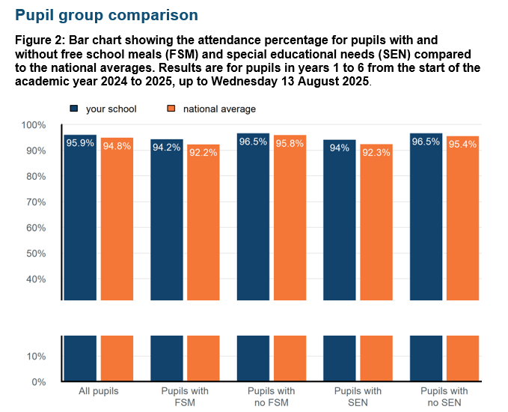

Previous academic year comparison
Figure 3: Bar chart showing the attendance percentage for pupils with and without free school meals (FSM) and special educational needs (SEN) compared to last year. Results are for pupils in years 1 to 6 from the start of the academic year 2024 to 2025, up to Wednesday 13 August 2025.
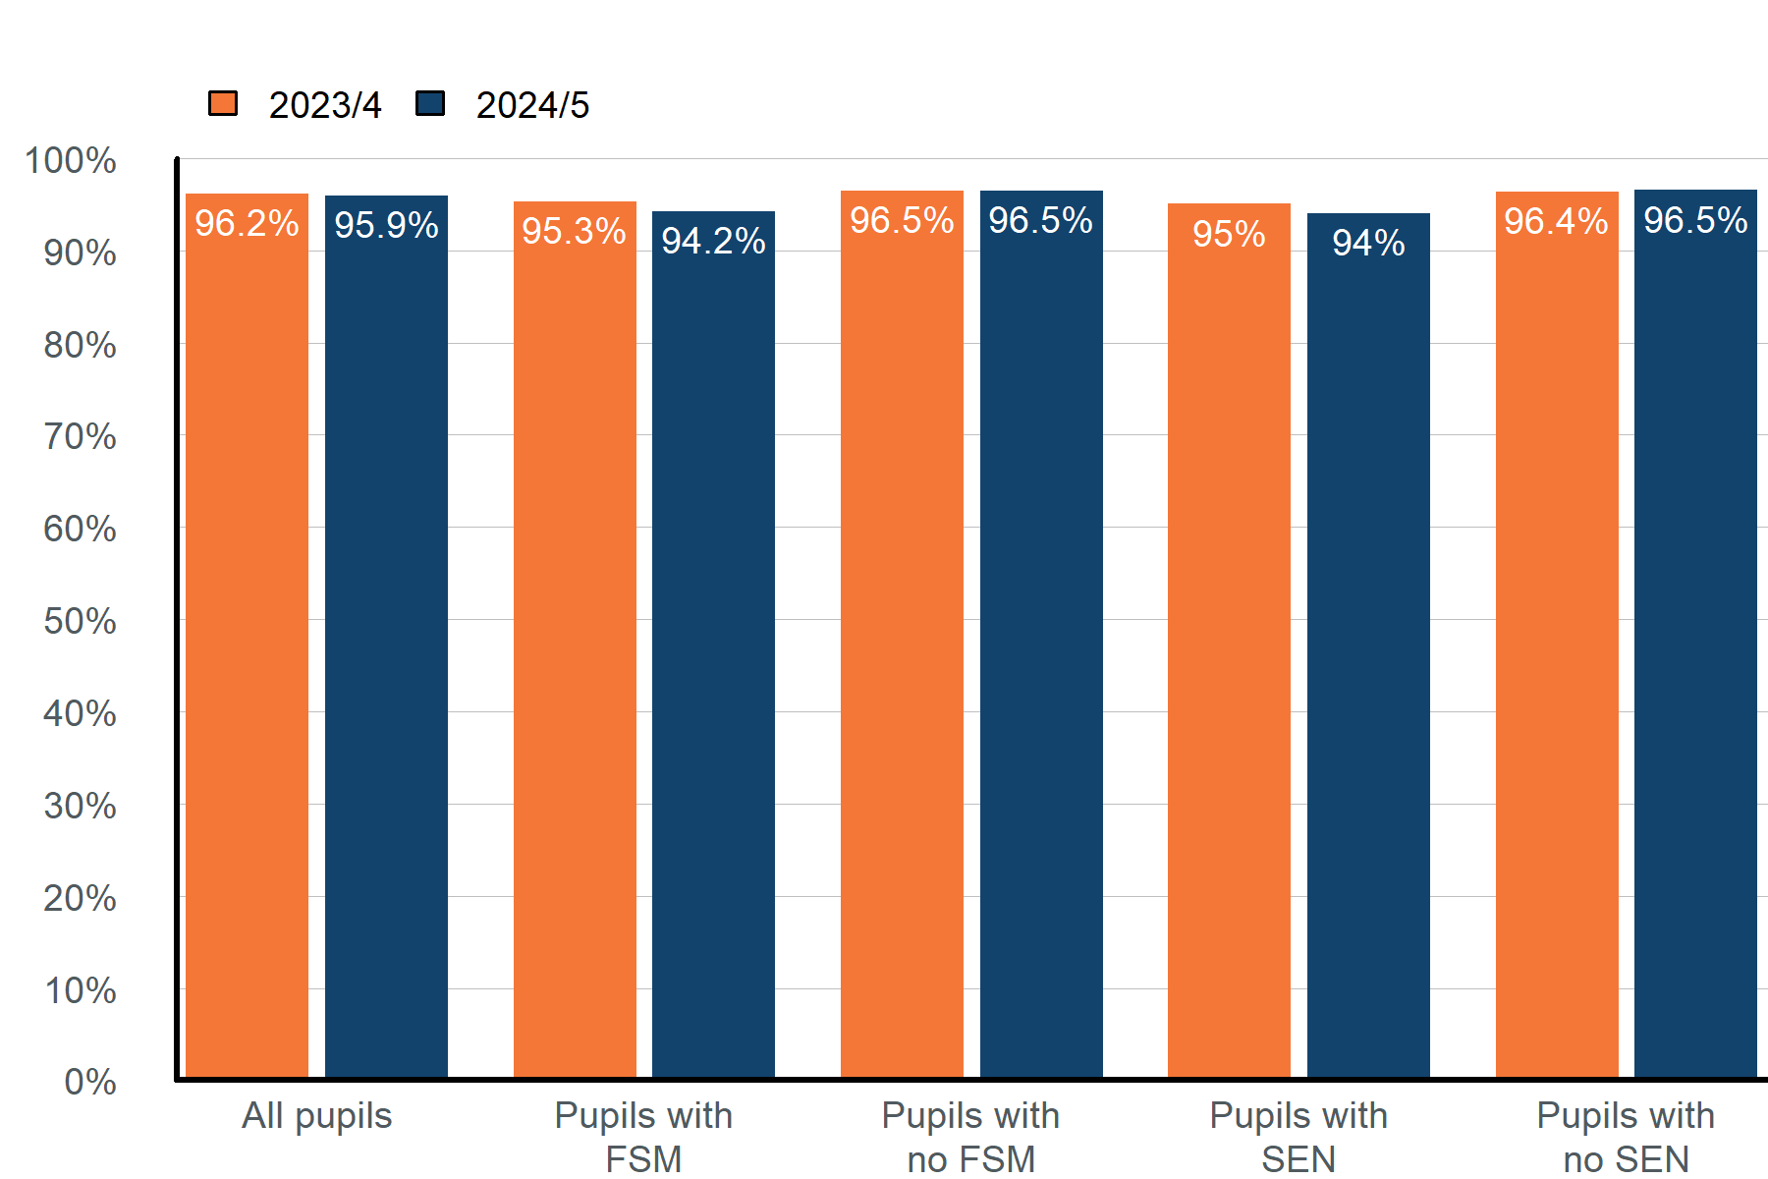

Graph alternative: table of attendance for different pupil groups from the start of the academic year 2024 to 2025, up to Wednesday 13 August 2025.
Pupil group | Attendance | National average
All pupils | 95.9% | 94.8%
Pupils with free school meals (FSM) | 94.2% | 92.2%
Pupils with no FSM | 96.5% | 95.8%
Pupils with special educational needs (SEN) support | 94% | 92.3%
Pupils with no SEN | 96.5% | 95.4%

Graph alternative: table of attendance for different pupil groups from the start of the academic year 2024 to 2025, up to Wednesday 13 August 2025, compared to the same period last year.
Pupil group | Attendance 2023/4 | Attendance 2024/5
All pupils | 96.2% | 95.9%
Pupils with free school meals (FSM) | 95.3% | 94.2%
Pupils with no FSM | 96.5% | 96.5%
Pupils with special educational needs (SEN) support | 95% | 94%
Pupils with no SEN | 96.4% | 96.5%

Attendance information is monitored daily by the school office and any concerns are brought direct to the head teacher who is the attendance lead. Immediate issues were addressed by the Head Teacher either by phone call, meeting or home visit. We continued to work with wider services to support all of our families and ensure that they get the help that they require.
We have a number of skilled professionals in school including those trained in HeartMath and mentoring and we employ the services of the voluntary sector such as bereavement and debt counsellors. We work closely with our local high schools to ensure a consistent and joined up approach for siblings. We utilised access to wider mental health services and now have a mental health practitioner on site to refer children with complex attendance needs. This has been useful for children with anxiety.
Family counselling has been offered to several families who have wider difficulties which impact on attendance and attendance levels have improved for these individuals. Early Help has been offered and we have demonstrated success with this strategy. Sadly, the majority of our families decline this type of support despite our efforts to raise awareness of the benefits. Our councillor continues to meet with some of our most vulnerable and emotionally challenged children.
This year we have been embedding a medical appointment slip which requires medical evidence before allowing children authorised time off to attend appointments. We also sent information home in relation to time off for appointments, to inform parents that children should be kept off for the appointment time only and picked up or brought back to school in an appropriate time scale. We found that parents had been keeping children off for a day or a half day when they only had a half hour appointment.
We have maintained our policy of not authorising Term Time absence except in exceptional circumstances. Further information about term time leave is available on our website. I have met with any families who are unhappy that their term time leave has not been authorised and I have liaised with our secondary colleagues to ensure consistency of approach.
At St Philips we believe that good attendance is key to good progress and attainment and we strive to ensure that all of our children are supported in the best way possible. We ensure that an open-door policy is in place to offer help and support to those who need it.
At Meet the Teacher, Parents Evening and termly outcomes reporting we now include attendance. Parent feedback supports the usefulness of the new attendance information included in our end of year reports.
Stars on the door is our strategy which raises the profile of attendance daily after the register is completed. The class attendance monitor places a big yellow star on the door to enable other staff to congratulate the class. We will be working to raise the profile of Attendance Champions as part of our Pupil Leadership Offer. Attendance Ambassadors now have a weekly slot during celebration worship to share good news and attendance winners with the whole school.
As a school we have found the DFE Attendance Data on the VYE platform exceptionally useful especially to ensure timely and accurate information to Governors.
Summary
This has been a successful year with the hard work of previous years showing dividends. The very vast majority of our families work with us to ensure good attendance and it is testament to the hard work of the staff that attendance remained so high this year. When children are absent our class teachers were proactive and ensured that gaps in curriculum delivery were filled either with additional tasks, catch up sessions or curriculum work sent home.
We had 1 child who presented significant attendance challenge this year as a result of SEND needs, we utilised a range of approaches including soft starts, TAS support and finally a reduced timetable and home learning. Decisions in relation to this child were taken at a multi-agency level and took into account DFE guidance and statutory responsibilities.
We had 14 children with attendance below 90%, we worked as hard as possible over the final term to raise awareness with parents in terms of missed learning and missed social opportunities. 5 of the 14 were at 89%. We will write to those families in the Autumn term to set our expectation
Overall, with illness taken removed, our children lost 463.5 days of learning this has reduced from 561 in the academic year 23 – 24.
Some of the reasons behind this include
- Term time holidays
- Transport difficulties
- Children new to our school and not yet understanding the “St Philip’s expectations” around attendance.
- Parental anxiety and or additional mental ill-health
- Barriers, perceived by parents to be SEND needs.
- Cross-generational non-school attendance and attitudes to education.
We continue to work to address all of these barriers.
Goal for 2025 – 2026 is to
- Aim for overall attendance to be above 96%
- Embed the role of class Attendance Champions
- Reduce the number of term time holidays
- Try even harder to reduce the number of PA children
- Ensure all children have attendance above 95%, improving outcomes for each individual
- Review all low attainers to identify any improvements that can be made in relation to days missed.
- Tackle absence before and after school holidays. Use the toolkit to support this
- Highlight benefits of wrap around care in relation to attendance concerns.
- Early letter to PA families from last year – open offer “what can we do together”.
- Link attainment to outcomes wherever possible. Needs to become part of class teacher narrative. “Good attendance, good outcomes, great attendance, great outcomes.

Approaches to continue
- Continue to ensure all staff see non-school attendance as a safeguarding concern
- Term time leave is unauthorised unless EXCEPTIONAL
- Use of sanctions – penalty notices fine
- Extend use of CPOMS to record and detail attendance concerns, including class teachers in more detail.
- Attendance to be included on agenda for parents’ meetings and meet the teacher
- Continue to monitor PPG attendance by individual children and Free School Meals children, include attendance on Pupil Progress. Attendance has been slightly lower than for these children.
- October half term letter to any children with odd days absence, PA or Mon, Fri absence
- October Early Help Mail shot- parental engagement and signposting
- Continue to support families and ensure that shame around poverty and struggling to meet children’s needs is reduced – this is a community responsibility – offers of practical support for uniform, basic toiletries, emergency packs, food bank vouchers, use of breakfast club etc to continue.
- Continue to discourage term time absence by adding a half termly box to the newsletter.
- Re-direction of some PP money to meet particular needs of individual children to ensure homework clubs and catch up where required.
- Home visits to continue
- Continue to seek medical evidence for families who are absent due to illness and request refreshed evidence where cases have shown no improvement
- Continue to use wider service and refer to providers including EMHP, Counsellors, play therapist. TAS

Key Actions for 2025 - 26
- Update Safeguarding policy in line with attendance – annual update
- Ensure Admin and SLT have access and are able to use the DFE attendance dashboard and new attendance toolkit. Train new School Business Manager in our processes
- Learn all that we can from our Attendance Review meetings.
- Request more help from wider agencies to support the work of school staff.
- Ensure all staff are aware of the Sefton Attendance Tool Kit – access training for Key staff when available
- Stars on the door and Attendance Champions to be refreshed.
- Staff training for new staff – Autism and Sensory Profiles to further understand how we can support our SEND children to improve attendance of individual children
- Uniform hub with Church and work with Choco Church

