Palm Sunday  What happened?  How did you feel?  What did the people shout?    Jerusalem  donkey  crowd  Palm leaves  amazing  excited | Easter Sunday- resurrection  What happened?  tomb  stone  garden  Mary Magdalene  Disciples  How did you feel?  amazed delighted  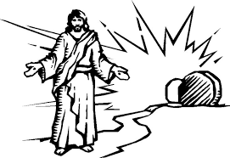
Last supper  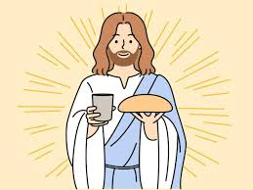  bread wine friends Passover  How did you feel?  Judas disciples  betray Jesus  Washing disciples feet | Garden of Gethsemane  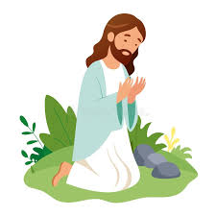  What happened?  How did you feel?  praying arrest  sleeping soldiers  disciples Judas  sad upset angry


