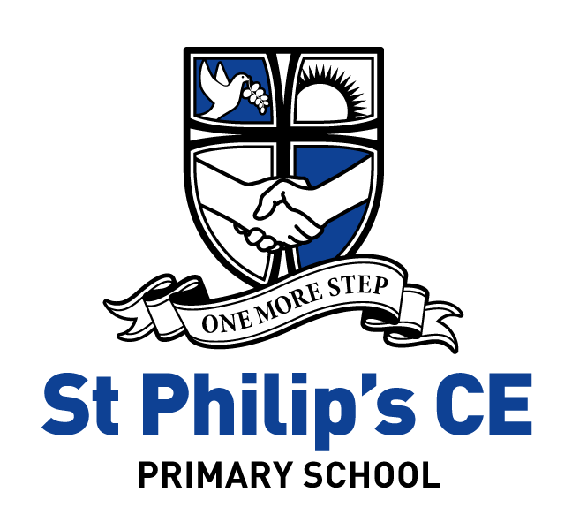 End of Key Stage Expectations
By the end of Key Stage 1 children are expected to:
- talk about God as creator of the world who loves us.
- know that God is three in one, Father, Son and Holy Spirit.
- be able to retell both the nativity and Easter stories.
- use religious words to talk about the celebrations of Christmas, Easter and Pentecost.
- know that Christians believe Jesus is the Son of God who died on the cross and rose again.
- know that Jesus had 12 special friends called disciples.
- know that the Bible is our holy book and it contains God’s big story, the salvation plan.
- be able to retell stories of Jesus’ miracles.
- have visited a church and confidently talk about their experience and what they have learnt.
- have had opportunity to ask reflective questions that wonder about Christian practice, values and beliefs.
- be able to give examples of how Christians, put their beliefs into action.
- know the names and significance of holy books from other faiths.
- know the places where people of other faiths worship.
- be developing a sense of their own values and the values of others.
- have experienced taking part in the celebration of Harvest Festival.

By the end of Key Stage 2 children are expected to:
- know that God is three in one, Father, Son and Holy Spirit – the Trinity.
- know that in the beginning God created everything and it was good. People spoilt the environment and their relationship with God. This is known as the Fall.
- know that Christians believe that Jesus is the Messiah, the Saviour who came to rescue all people and restore their relationship with God.
- know that Christians believe Jesus is the Son of God who died on the cross, rose again and is alive with us today.
- know that Christians believe that Jesus will come again and Earth and Heaven will be transformed to be as God intended (the Kingdom of God).
- Christians try to put the teaching of Jesus, the good news, into practice in their everyday lives and build God’s Kingdom on earth as best they can.
- know that Pentecost was the start of the church.
- know that Christians believe that the Holy Spirit is at work in their lives today.
- know that Christianity is a worldwide multi-cultural faith.
- know that prayer is an important part of the life of a believer and explain why.
- know the names and stories of at least 3 people in the past and present times who have been called by God to do his work and speak his word.
- describe the impact responding to God’s call has on a believer’s life.
- use developing religious vocabulary to talk about the impact religion has on believers’ lives.
- be able to make comparisons and identify the similarities and differences between the rules for living in Christianity and two other world faiths.
- ask important questions about religion and belief that improves their learning.
- experience a visit to a place of worship other than a church.
- talk knowledgeably about places of worship, the names and features of buildings and the worship that takes place there.
- retell in detail the stories of Christmas and Easter describing core Christian beliefs and concepts.
- connect Christian practices, values and beliefs to events and teaching in the Bible.
- be able to describe and show understanding of the links between the teachings in other Holy Books and the behaviour of the believers.
- be able to express and explain their own opinions on issues they have discussed.
- use an increasingly wide religious vocabulary to talk about the meaning of rites of passage and pilgrimage experienced by believers as they journey through life.
- describe what they think motivates people of faith and explain what inspires and influences them personally.
- ask and suggest answers to questions that show their understanding of distinctive beliefs about God across three world religions.
- know and be able to talk about the links between Christianity and Judaism.
- describe the similarities and differences within and between Christian denominations with particular reference to the Eucharist.

