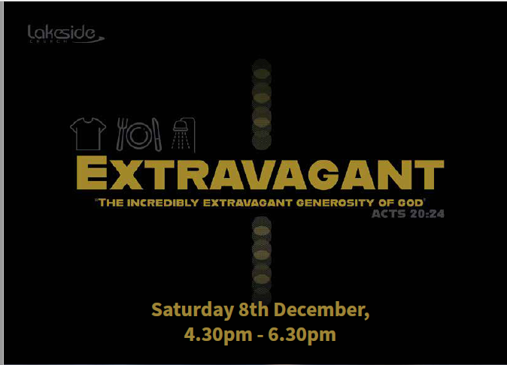

Putting our values into action!




Extravagant Event
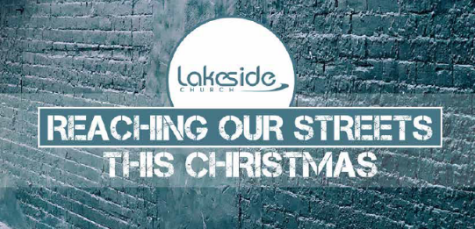
As a church school we have close links with local churches within our town. One of those churches is Lakeside Elim church, Southport.
The Lead pastor, Richard Vernon, and some members of the congregation had a vision last Autumn to put on a Christmas event for the homeless and needy within the town of Southport.
The event was named ‘Extravagant’ based on Acts 20 v 24…(Message version)
‘What matters most to me is to finish what God started: the job the Master Jesus gave me of letting everyone I meet know all about this incredibly extravagant generosity of God’
The plan was to have a three course Christmas dinner, entertainment and provide every guest with a new set of clothes, shoes, sleeping bags etc…. One of the ideas was to also give them a love gift at the end of the event- something that would be useful to them but also remind them after the event of God’s love for them. As I am a member of that church, I was already on the volunteer team to help with the event and thought that my school would also love to get involved in some way.
Our school vision is ‘Christ in everything we do’ – this seemed a God sent opportunity to show our faith in action by helping those in our local community. I approached my Headteacher with the idea that St Philips could organise the love gift. All staff agreed and Lakeside were delighted that we were going to help them fulfil this vision.

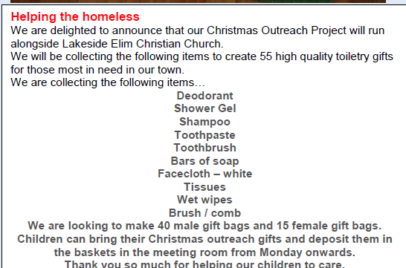
Within school, we have a group of children called Worship warriors – they explained the idea to the whole school in worship time and why it was important.

“We did it because other people are not as lucky as us and need help.” Henry, Worship Warrior
Each year group was assigned a different item to collect and details were shared with parents through the weekly school newsletter.

The generosity of the school family was amazing and over the next three weeks donations poured in ! We were able to fill all the bags needed and also to add extra gifts. Year 5 were responsible for packing the wash bags and also wrote gift cards to attach to each bag with a special message on.
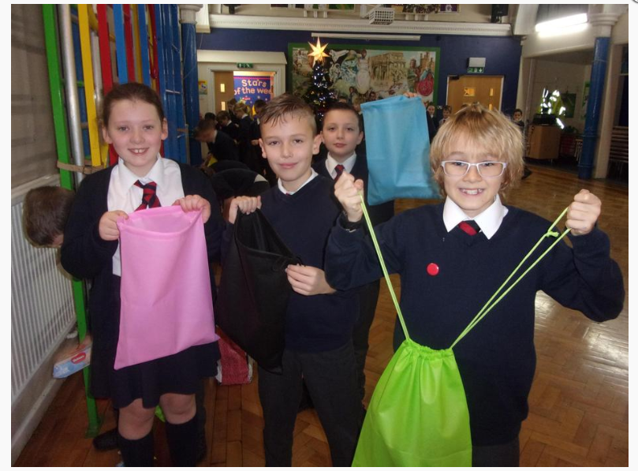
“I felt really good helping these people because they don’t have a lot and we do.”
“I felt proud we were helping people. “
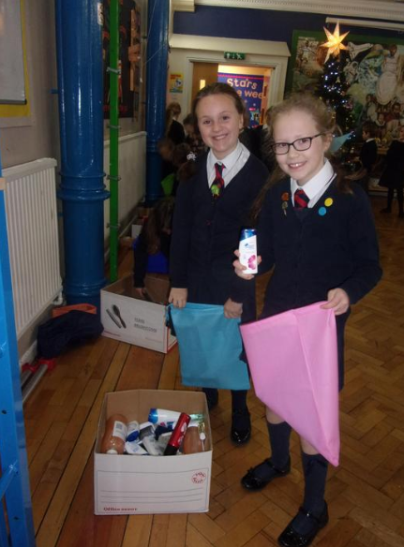

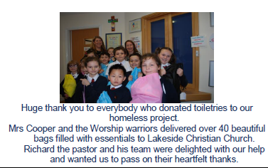

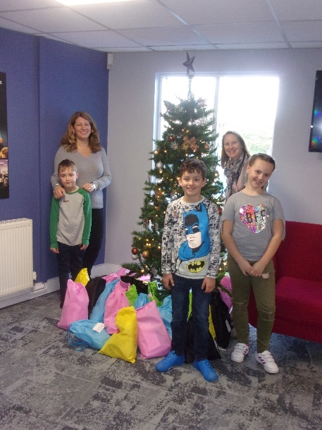
A group of Worship Warriors came with me and the Head teacher to deliver the bags to church. We were met by Richard, the lead pastor, who was delighted with our gifts. He showed the children all the bags of clothes which had been donated by church ready to be sorted and given out at the event.
“I felt really happy, helpful and excited for the people who were going to get the bags” Dianna, Worship Warrior


‘Our Extravagant Christmas event could not have happened without the support of a number of people and other agencies, with St Philip’s Primary School playing an absolutely major part in this. The way they took this project to heart and involved all the pupils and families was amazing- resulting in over 50 love gift bags full of much needed toiletries that blessed all those who came. The look on their faces as they received these was priceless. To be able to partner with St Philips in this way and see their heart to help those in our community speaks volumes about all they stand for and their desire to make a genuine difference. Thank you so much St Philip’s!’

Rev Richard Vernon, Lead Pastor, Lakeside Church Southport

This partnership between our school and Lakeside church had a huge impact on the lives of these people. It was a whole school project- with children involved at every level-inspiring their parents to contribute. However, it didn’t just impact the lives of guests at Extravagant, but impacted the lives of the children in our school. They learnt about compassion, generosity and how we should value everyone and see people through God’s eyes. It was a truly inspirational event- every member of our school family genuinely loved being part of this fantastic event!

