Faith in Action Day-
July 2019
Faith in action day is where we pray for others who are in need of help. We thought about how we could put our own faith into action.
What we are doing to help others:
For our homework we are trying to raise money or post letters to BE FREE in Cambodia. Here are some ideas we have had:
- We could bake cookies or cakes and sell them for extra money.
- We could make crafts like bracelets, slime or scrunchies and then sell them.
- We could send prayers, pictures or letters to them so they can hang them up on their walls.
We hope they are happy to receive these gifts as they would like to buy something for their playground.
Prayer
sacrifice
Year 5 face timed Craig from Lakeside Elim church who is in Cambodia.
Craig said that he will be bringing back some crafts that the BE FREE girls had made and possibly sell them to students in school.
They asked for money to go towards their playground, to make it more exciting for the children who are part of BE FREE in Cambodia.
We spoke with David and Esther, who run BE FREE, and they said they will be moving over to the UK in August and will come and visit us in school. Mark Savage came to tell us about Cambodia as he visited there and went to the Be Free project.

Parachute Prayers
Outside we used the multi-coloured parachute and played games. We lifted it up into the air and sat on the edge so it made a tent and we prayed for the people who were struggling in life .
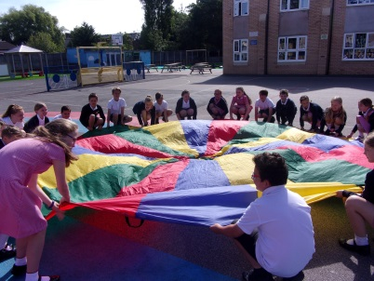
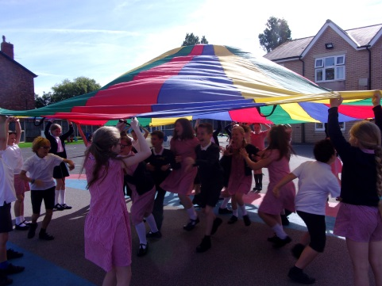
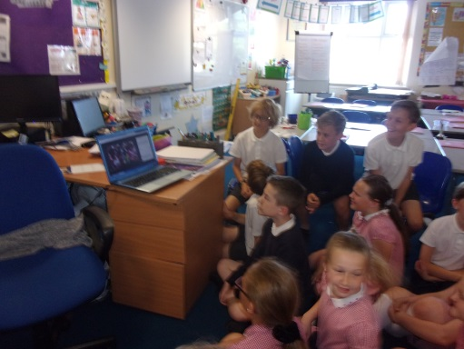
Face timing Elim church Cambodia!

