Faith in action day- July 2019

Reception joined forces with Years 1 and 2 where they enjoyed an assembly lead by Rev Marie-Anne. The theme of the assembly was "Loving our neighbour."
On returning to our classroom, we had a carousel of learning where Reception class discussed how those who believe in Hinduism care and love for their neighbour. We talked about the immortal soul and symbolised this by blowing bubbles and sending kind thoughts to those we know who have passed away.
Year 1 discussed Sikhism and how we can pass positive thoughts and smiles to our neighbours. We learnt about The 5Ks which are symbols of this faith. We then shared the simple symbol of a smile around our group.
Year 2 discussed Islam and how one of the 7 pillars of Islam is to do good deeds. In the afternoon we learned a song with sign language together (lead by Year 2 and Mrs Bond) and then went on to adventure play area with our paper dolls to join them together to symbolise 'loving our neighbours'.
All three classes later created various crafts relating to loving our neighbour. One of those was a heart. We combined our three hearts and we put our ‘faith into action’ by delivering the cards and letters to our family, friends and neighbours. We enjoyed working with our neighbours in school and mixed the year groups so we could work with different children.
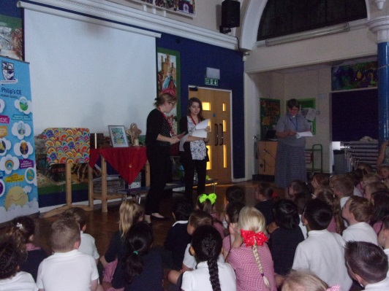
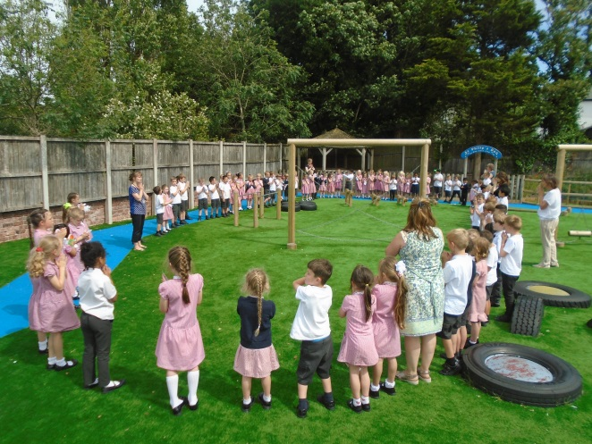
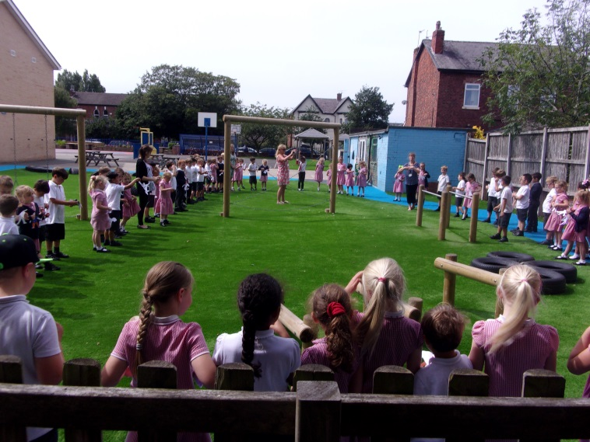
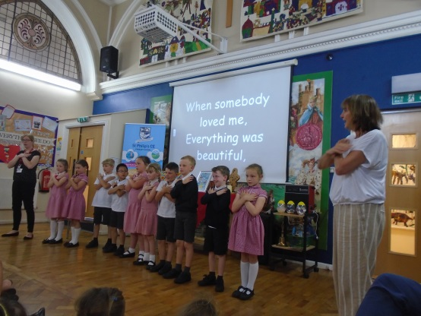
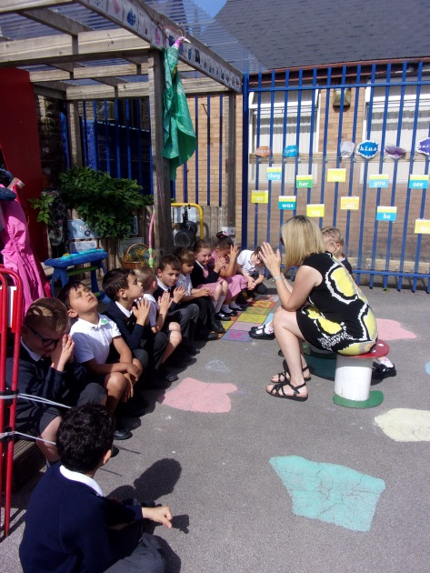

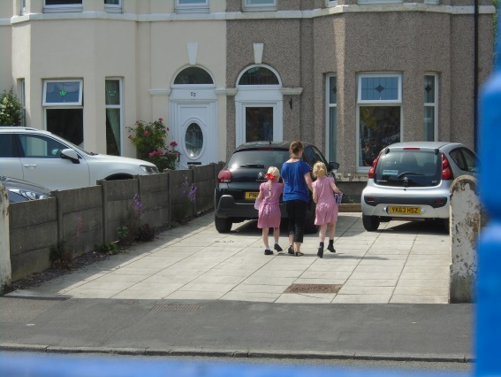
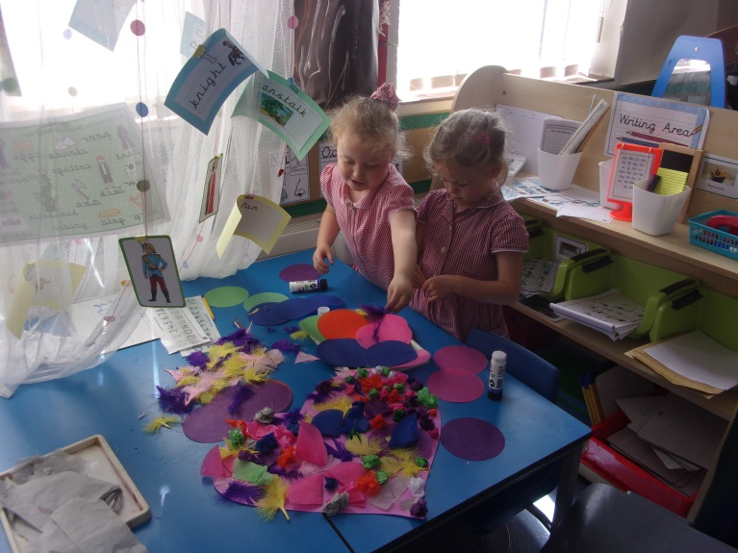
Delivering cards to our neighbours on Hampton road

Year 6 did a range of activities.We had three sets of visitors:
Two teenage Muslims came for a Q and A session
Hettie and Tabz shared what some Southport Christians do to put their faith into action e.g. Street Pastors and The Soup Kitchen

Rachel and Marie-Anne came and we put together ideas to help the church with its environment policy.

We also explored some Bible texts about faith and learned about inspirational Christians like Martin Luther King and Rosa Parks.

