On Monday 4th March the Worship Warriors visited St Philips Church for their Monday morning prayer meeting. We found out about different ways to pray. We learnt how to pray using our hands.

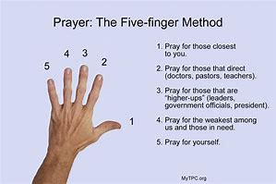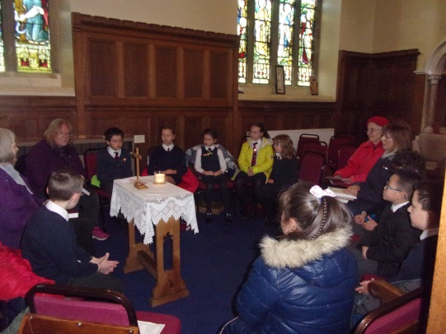
We really enjoyed the prayer meeting, it was really peaceful and a lovely start to the day and week. We really enjoyed saying the prayers for lots of different people who are important to us. As well as praying we also read Psalm 148 :1-12 it was all about praising God.
By Dianna and Henry

