

BREAKFAST
CLUB
£4 per child each morning


Breakfast Club Activities
There are a wide range of activities which take place each morning

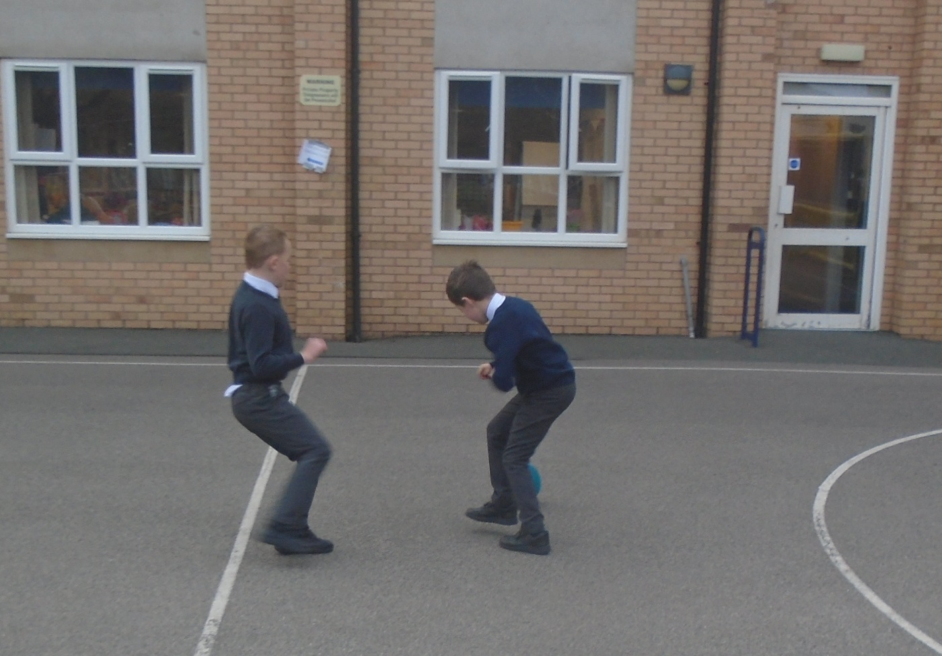

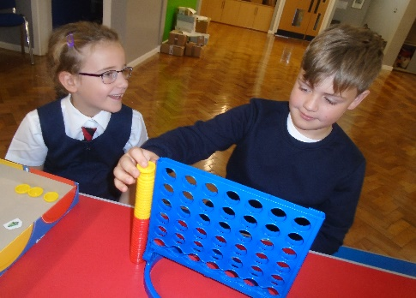



Breakfast Club Leaders
Both our Breakfast Club workers
are also employed by the school in
other roles. They are both on-site every day of the week.
Mrs Rimmer

Mrs Edwards

