
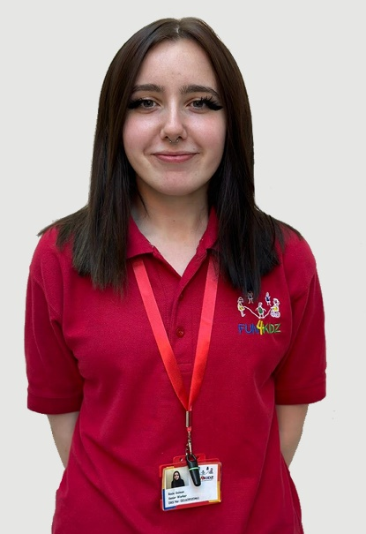



Emily B
Playworker
Rosie S
Senior Worker
OUR VALUES
- SAFE - A place that you trust to take care of your emotional and physical wellbeing. A place that enables you to share and grow.
- RELATIONSHIPS - A place where relationships are built on mutual respect and trust. People are caring, compassionate and honest towards each other.
- OPPORTUNITIES - A place that provides child, family and community led social opportunities that build connections and enables people to give, receive, share, support, have fun and learn with others.
- WELCOMING - A place that is welcoming and seeks to invite those who may not always feel included. A place that listens and responds to children, families and community members.
- LISTENING - Learning and growing a place that listens and learns. To create a place that has purpose and tries to be the best it can be.

If you have any questions, staff are here to help.
If you have any further queries, contact our office via Email : fun4kidzclubs@hotmail.com
or Telephone : 0151 942 9218
You May Also See:
Rebecca Scott
Debbie Stephens
Meet Our Afterschool Club Staff

