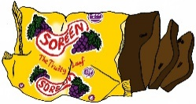

Fun4Kidz Afterschool Club Snack Menu
Week One
Monday


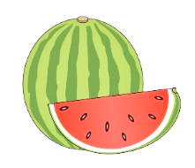
Potato Waffles with Beans
Malt Loaf
Tuesday


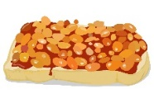
Crumpets with Butter/Jam
Melon
Wednesday

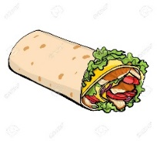

Spaghetti Hoops on Wholemeal Toast
Yoghurt
Thursday



Wraps with Ham/Cheese/ Tuna
Digestive Biscuit

Friday

Crackers with Cheese/Ham/Butter
Madeira Cake
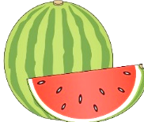
Fun4Kidz Afterschool Club Snack Menu
Week Two
Monday


Spaghetti Hoops on Wholemeal Toast
Melon
Tuesday

Crackers with Cheese/Ham/Butter
Madeira Cake
Wednesday

Crumpets with Butter/Jam
Malt Loaf

Thursday

Potato Waffles with Beans
Yoghurt
Friday

Wraps with Ham/Cheese/Tuna
Digestive Biscuit
Fun4Kidz Afterschool Club Snack Menu
Week Three
Monday

Crumpets with Butter/jam
Yoghurt
Tuesday

Potato Waffles with Beans
Digestive Biscuits
Wednesday

Wraps with Ham/Cheese/Tuna
Melon
Thursday

Crackers with Cheese/Ham/Butter
Malt Loaf

Friday

Spaghetti Hoops with Wholemeal Toast
Madeira Cake

