
The Graduated Approach to Supporting Children’s Learning at St Philip’s
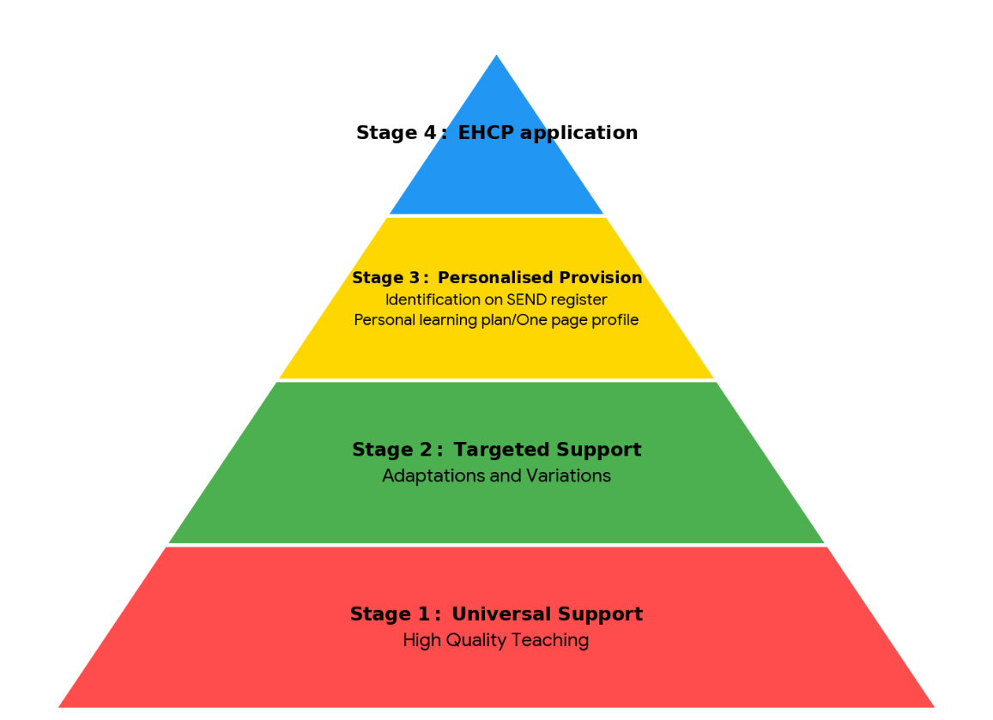

All children benefit from high quality teaching by their class teacher and work is carefully planned by them to support every child to be actively involved and learning. It is our aim that all children learn within their class for the majority of the day, including when on educational visits and with due regard of their needs.
We have a four-stage, graduated approach to supporting children’s learning needs. The graduated approach at every stage involves the following four-part cycle:
Assess - Plan – Do – Review
Stage One of the Graduated Approach – Universal Support
It is our firm belief that the needs of children are best met in the classroom and that every teacher is responsible and accountable for the progress and development of all children they teach, including those with special educational needs and disabilities.
At this universal level, we train our teachers to deliver high quality teaching, differentiated and adapted for individual children, through specific approaches and resourcing. We review the progress of all children and make rapid adjustments to support strategies and, where necessary, teachers’ understanding of the needs of the individuals they teach.
High quality first teaching will include:
A broad and balanced curriculum within an inclusive classroom.
Carefully planned and adapted practical, visual, concrete resources.
Modelling and scaffolding by adults within the classroom.
Curriculum assessment of progress to support target setting for children.
Assessment for learning and constructive feedback.
Stage Two of the Graduated Approach – Targeted support
If a child is not making progress in any one area, then appropriate in class provision will be applied to support their development in addition to the provision at Stage One.
We provide targeted support when we consider it appropriate to make additional short term special educational provision, to remove or reduce any obstacle to a child’s learning or to help them catch up if they are beginning to fall behind their peers.
Such specific, targeted one to one or small group interventions may be run outside the classroom, and limited to a number of weeks to minimise disruption to the regular curriculum. They may take the form of, but are not limited to:
- support within class through small groups and individual support
- adaptations and differentiation in the access to the learning
- variation in the tools and resources.
Stage Three of the Graduated Approach - Personalised provision and identification on the SEND register
If a child continues to make significantly slower progress than other children or works at a stage well below the expected standard for their age, then further provision may be agreed. In consultation with the parents and/or carers, the child will be added to the SEND register. A Learning Plan will be provided in which targets for progress, parents’ views and the child’s views are recorded.
Parents will receive a copy of the completed Learning Plan with a termly review date. Whilst the class teacher carefully matches the curriculum to the child’s needs, we can also provide a wide range of high quality SEND interventions to develop an individualised programme of specifically targeted support, which may comprise of one or more of the following:
In addition to Stages 1 - 2:
Investigation of strengths and needs.
Inclusion of parents and child as part of a Plan – Do – Review cycle of targeted assessment.
Targeted support within class through small groups and/or working individually with an adult.
Additional group or individual programmes.
Evidence based interventions delivered individually or in small groups between 6-18 weeks (e.g. phonics and reading interventions etc.). Reviewed 6 -12 weekly.
Adaptations to the curriculum to meet individual learning needs e.g. alternative methods of recording or additional time or work stations
Further variation in the tools and resources to support access.
Multi-professional planning and coordinated support may be in place e.g. Health colleagues, Speech and Language, Occupational Therapy, Deaf and Hearing Impaired Service, Visual Impairment Service, Team Around the School, SENIS and Children and Adolescents Mental Health Service (CAMHS).
Stage Four of the Graduated Approach – Education, Health and Care Assessment
If progress is limited and the child continues to work at a stage significantly below their cohort or continues to need a significantly higher level of support to make progress than they would normally be provided in a mainstream school, then an application for an Education, Health and Care assessment can be made to the local authority by school or parents. Before any application is made by a school, parents will always be consulted and the views of parents respected. This may result in an assessment, leading to a possible Education, Health and Care Plan (EHCP) and the child will then be supported at this stage.

