


HEAD – Mrs Edward
SENDCO – Mrs Klaassen, email – klaassena@sps.sefton.school or phone 01704 535737

This SEND Information Report is produced with due regard to:
The SEND Code of Practice (2014)
The Equality Act
The Children and Families Act

Reviewed – September 2025

At St Philip’s CE Primary School, we strive to support all children to enable them to reach their full potential. In order to do this, many steps are taken to support the children throughout their primary school learning journey.
Quality teaching is vital for all children. However, for some children there are occasions when further, additional support may be needed to help them to achieve their targets.

Roles and Responsibilities of the special needs and disability co-ordinator (SENDCO)

Our SENDCO is responsible for co-ordinating the specific provision delivered to support individual children with SEND. The SENDCO liaises with staff to monitor the pupil’s progress and plan further interventions where progress is slower than expected. There is regular contact with a wide range of external agencies that are able to give more specialised advice when required. Please follow the link below to read our SEND policy.

https://primarysite-prod-sorted.s3.amazonaws.com/st-philips-church-of-england-primary-school/UploadedDocument/22325fa3433d44a484dd67678d3b77bd/send-policy-2018.doc

The Local Offer
This will help you to understand what is normally available in schools to help children with SEN and/or a disability, as well as the options available to support families who need additional help to care for their child. Please follow the link to read St Philip’s local offer:

https://primarysite-prod-sorted.s3.amazonaws.com/st-philips-church-of-england-primary-school/UploadedDocument/ff360a6ab61442198475de7e40ddd80b/school-offer-2018-19.doc

You can also read Sefton’s Local offer here:-

https://mysefton.co.uk/2021/09/06/seftons-send-local-offer-website-refreshed/

1. How does St Philip’s Primary School know if children need extra help?
We know when pupils need help if:
· Concerns are raised by parents/carers, teachers or the child
· Progress continues to be less than expected
· There is a change in the pupil’s behaviour or progress

2. What should I do if I think my child may have special educational needs and/or disabilities?
The class teacher is the initial point for responding to parental concerns.
If you have further concerns then contact Mrs Klaassen who is the SENDCO.

3. How do I know how St Philip’s Primary School will support my child?
Please follow the link to read our Provision map for support at St Philip’s:

https://primarysite-prod-sorted.s3.amazonaws.com/st-philips-church-of-england-primary-school/UploadedDocument/e073eea2b9d643868465f634826b05cc/st-philips-provision-map-sen.doc

If a child is added to the SEND register then a learning plan is written in consultation with the child, parent/carer and class teacher. The SEND support will follow the graduated approach cycle; assess-plan-do-review. Plans will be reviewed regularly. The school is supported by a Sefton Inclusion Consultant who visits the school regularly to review school support and offer advice on SEND issues.
Pupil progress meetings are held for all pupils termly. This is a meeting where the class teacher meets with the Senior Leadership Team to discuss the progress of all of the pupils in their class.
If a pupil needs more support from an outside agency such as Occupational Health or Speech and Language then a referral will be made, with your consent. Recommendations are then added to the learning plan.
The Governing body ensure that the school is as inclusive as possible and treats all children and staff in an equitable way as defined by the DFE. Please follow the link to read St Philip’s accessibility plan to enable access to the environment, curriculum and information.

https://primarysite-prod-sorted.s3.amazonaws.com/st-philips-church-of-england-primary-school/UploadedDocument/080fb8ca-68f4-4cfa-8b4f-eaf5c53c6885/acccessibility-plan-2021-2022.doc

4. How will the curriculum be matched to my child’s needs?

At St Philip’s we follow a graduated approach for all children’s learning, progress and development. Quality first teaching takes the diverse needs of all learners into account.
Please see The Support Triangle below:

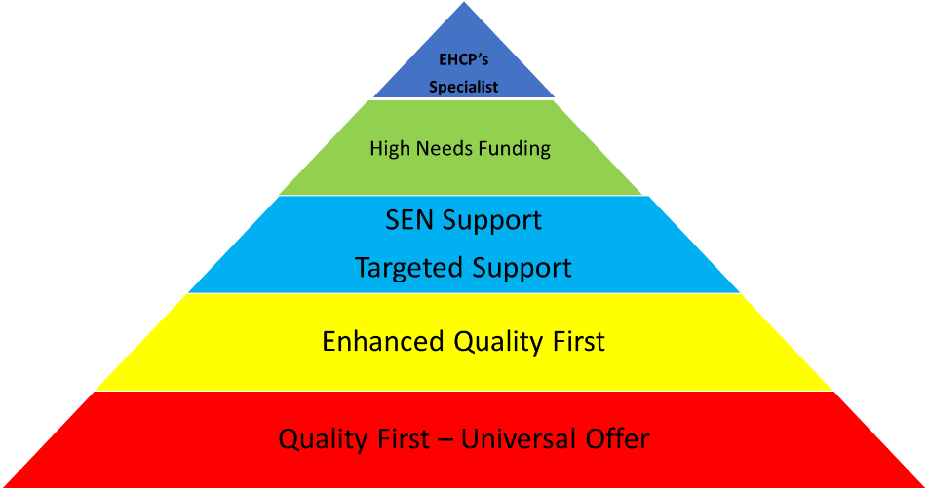

When a pupil has been identified with SEND, they are added to the SEND register and a specialised SEND learning plan is written for them. Work and learning will be differentiated and adapted when necessary by the class teacher to enable them to access the curriculum more easily. Teaching assistants may be allocated to work with the pupil in a small focus group and/or sometimes on a 1-1 basis. Appropriate specialist equipment may be given to the pupil, such as a writing slope, pencil grip, ear defenders, and the learning environment may be adapted too.

5. How will I know how my child is doing and how I can support them?

You will be able to discuss your child’s progress at Parents Evening and at SEND reviews. Ideas and suggestions of how you can help and support at home will be shared at these meetings.
Your child’s class teacher will be available at the end of each day if you wish to raise any concern. Appointments can be made to speak in more detail to the teacher or make an appointment to see Mrs Klaassen the SENDCO.

6. What support will there be for my child’s overall well-being?

The school offers a variety of additional support to promote positive well-being. These include:

Buddy systems within school
Team Around the School
Beech Tree counselling service
Educational Mental Health Practitioner from Mental Health in School Team
CAMHS service
Worry monster and worry box
Weekly PHCSE and circle time linked to Christian values
Heartmath – a software programme to improve emotional, mental and physical health
Well-being and emotional interventions
Sefton young carers
Visits from external agencies – NSPCC, Bully Busters, RELAX kids, Play therapist
Mental health lead teacher
Link Educational Psychologist
School Health
Emotional well-being nurse
Church minister and support from School Worker’s Trust

7. Pupil’s with medical needs

If a pupil has a medical need then a detailed individual health care plan can be compiled with support from the school nurse in consultation with parents/carers.
Children with complex medical needs will be assigned an Inclusion Consultant for children with complex needs from Sefton. An individual health Care Plan will be drawn up in consultation with the inclusion consultant, teachers, child and parents/carers.
Staff receive training delivered by the health care professionals eg. epipen and asthma training
Where necessary, and in agreement with parents/carers, medicines are administered in school but only where a signed medicine consent form is in place.
There are paediatric first aiders on the staff.

8. What specialist services and expertise are available at or accessed by the school?

The agencies used by school include:

Team Around the School
Inclusion Consultants
ASD and Complex Needs Team
Educational Psychologist
School Nurse and Health service
Social Services
Early Help family workers
Speech and language Therapy
Physiotherapy
Occupational Therapy
Mental Health in Schools Team
School counsellor

9. What training are the staff supporting children with SEND had or are having?

Many of our staff have achieved qualifications and attended training courses to support SEND. Training is then timetabled into the Continuing Professional Development timetable so that staff can then share and train others.
The SENDCO also regularly meets with the teaching staff and teaching assistants to discuss changes to SEND provision and new training opportunities that are available.
The SENDCO has the NASENCO award.

10. How will a child be included in activities outside the classroom including school trips?

Risk assessments are carried out and procedures are put in place to enable all children to participate. However if it is deemed that an intensive level of support is required a parent/carer may be asked to accompany their child.

11. How accessible is the school environment to all children?

As a school we are happy to discuss individual access requirements so that all children can participate in the curriculum. The school environment has been improved so that all children can take advantage of the education, benefits, facilities and services on offer at St Philip’s.
Some facilities we have include:
- Ramps around the school
- Disabled toilet facilities with a changing unit
- A lift to access Year 5 and Year 6
- Sensory pods
- Quiet ‘break out’ spaces
As a school, we make sure information is accessible to all pupils.
Please refer to the accessibility plan which is published online. This covers how the school has increased the extent to which pupils with disabilities can participate in the curriculum and take advantage of the education, benefits, facilities or services. It also covers how information is delivered and accessible to all pupils.

12. How will the school prepare and support my child when joining St Philip’s CE Primary School or transferring to a new school?

· Discussions between previous or receiving schools prior to pupil joining/leaving and parent /carer meetings arranged
· All pupils attend a transition session where they spend some time with their new class.
· Additional visits are also arranged for pupils who need extra time in a new school
. Reception teachers visit new children in their nursery settings and at home if requested
· Secondary staff visit pupils prior to them joining a new school and Year 6 teachers liaise with Head of Year at secondary schools
Please also refer to the admissions policy published online.

13. How are the school’s resources allocated and matched to children’s
special educational needs?

The SEND budget is allocated each financial year. The money is used to provide additional support/resources where needed and when applicable. Resources may include the deployment of staff, specialist programmes and interventions or resources. This will all depend on individual circumstances and the levels of need.

14. How is the decision made about how much support my child will receive?

These decisions are based upon termly tracking of pupil progress and after discussions with the child, parents, teachers and other specialists. The SENDCO will then monitor and track the pupil following the graduated approach.

15. How will I be involved in discussions about and/or planning for my child’s education?

All parents and carers are included in the process of setting targets, goals and having high expectations for their child. They will be included in:
Discussions with class teacher and/or SENDCO
Parents are encouraged to comment at their child’s review meetings if their child is on the SEND register. Review meetings will take place each term or more frequently when required.

16. Will my child be consulted and involved in their educational choices?

Most definitely!
Pupil voice is very important and there is a section on the support plan asking the child to complete their views. Children will be offered the relevant support to complete this section.

17. Who can I contact for further information?

If you wish to discuss your child’s educational needs, please contact the school office on 01704 535737 to arrange a meeting with Mrs Klaassen, the SENDCO.
Please see the link for the complaints policy if needed.
https://primarysite-prod-sorted.s3.amazonaws.com/st-philips-church-of-england-primary-school/UploadedDocument/959b0c5b2d614858a7d77339e2d3954c/complaints-policy-procedure-february-2015.docx

