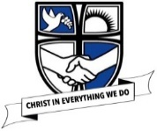
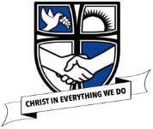
Year group  EYFS | EYFS
 | Developmental Matters: Areas of development (Linked to science aspects of learning)
ELG | The World  Children know about similarities and differences in relation to places, objects, materials and living things. | The World  Children talk about the features of their own immediate environment and how environments might vary from one another. They make observations of animals and plants and explain why some things occur, and talk about changes. | Technology  Early Learning Goal Children recognise that a range of technology is used in places such as homes and schools. They select and use technology for particular purposes. | People and Communities  Children talk about past and present events in their own lives and in the lives of family members. They know that other children don’t always enjoy the same things, and are sensitive to this. They know about similarities and differences between themselves and others, and among families, communities and traditions. | Health and self-care  Children know the importance for good health of physical exercise, and a healthy diet, and talk about ways to keep healthy and safe. They manage their own basic hygiene and personal needs successfully, including dressing and going to the toilet independently. | Communication and Language: Understanding  Children follow instructions involving several ideas or actions. They answer ‘how’ and ‘why’ questions about their experiences and in response to stories or events.
Possible activities | 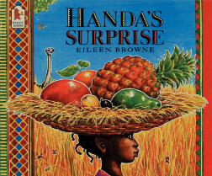  Handas surprise- needs of living things linked to diet and needs of humas.  PSTT- Jurassic Coast. ‘Make your own salt dough fossils’  ’Lets dig for fossils’  Ogden- Phizzi enquiry- balloon beards.  Ogden- Phizzi enquiry: Bubble snakes.  Ogden- Phizzi enquiry: Lolly stick skyscraper.  Ogden- Phizzi enquiry- Soggy cereal.- linked to Goldilocks and 3 bears book.  Ogden- Phizzi enquiry: stretchy chocolate.  Ogden Phizzi foundation cards: Lava lamps | The Crunch- observing seeds.  Ogden-Phizzi enquiry: Tea for a tiger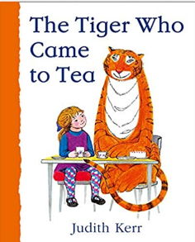  WOW science- Interesting facts about animals  WOW science- farm in the classroom  WOW science- animal tracks  WOW science- video clips of animals around the world.  WOW science- deadly dinosaur jigsaw  Curiosity corner- seasonal items from walks.  WOW science- woodland trust  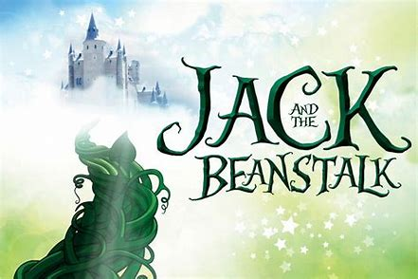  Good starter for plants  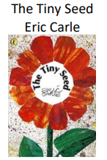  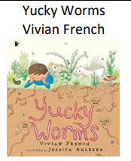  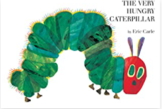 | 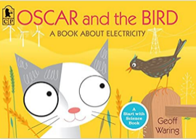 |  | Handas surprise- needs of living things linked to diet and needs of humas. | Ogden- Phizzi enquiry: Paperclip painting  Ogden- Phizzi enquiry: Pipe cleaner push and pull.  Ogden- Phizzi enquiry: sinking eggs.  Ogden- Phizzi enquiry: Wonderful wind  Make wand bubbles (101 brilliant things to do with kids)  Fly a carp kite windsock (101 brilliant things to do with kids)

 | Year 1
Year group 1 |  | Unit Objectives
Plants | Useful lesson starters/WOW moments/ visits | Name common plants and describe the basic structure of flowering plants, including deciduous and evergreen. | Identify and describe the basic structure of a variety of common flowering plants, including tress. |  |  |  |  |  |  |  | Knowledge retrieval/ Assessment
Plants | CAS- Visit to allotment | LTT- Blossoms- parts of a plant.  CAS- Labelling leaves, identifying trees  CAS- Which parts can we eat. | Starting point for teaching the topic of plants.  CAS- I spy adventure.  Flower Power- make potions and perfumes.  Observational drawings- link to Mothers Day cards, collages, printing.  CAS- Articulate through art- models of plants/trees.  WOW science- Leaf identification  PSTT- Garden Watch project.
Animals including humans | Useful lesson starters/WOW moments/ visits | Identify and name a variety of common animals including fish, amphibians, reptiles, birds and mammals. |  | Identify and name a variety of common animals that are carnivores, herbivores and omnivores. |  | Describe and compare the structure of a variety of common animals (fish, amphibians, reptiles, birds and mammals, including pets) |  |  | Identify, name, draw and label the basic parts of the human body and say which part of the body is associated with each sense |  |  | Knowledge retrieval/ Assessment
Animals including humans | CAS- Visit a zoo or farm. Bring toy animal to school- classify them.  CAS- Animal themed story books.  WOW science- Interesting facts about animals | CAS- How big, how small. Measure children on wall and put corresponding animal next to them.  CAS- open wide- animal masks with matching teeth inside.  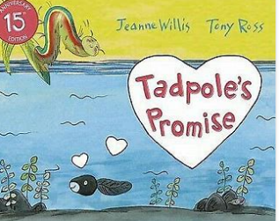  Exploring life cycles, helping children describe the difference in the lifecycle of a mammal, amphibian, insect and bird.  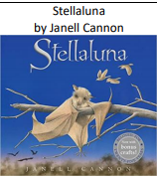 |  | CAS- What’s for dinner- classifying food animals eat.  CAS- Tiger who came to tea book. Create scientifically correct book about what they eat- extend to other animals.  WOW science- farm in the classroom  WOW science- animal tracks  WOW science- video clips of animals around the world. |  | CAS- Whos body part- show different animal parts and children to identify part and the animal  CAS- Animal xrays- visit vet.  WOW science- switch zoo- make hybrid animals  WOW science- what animals eat  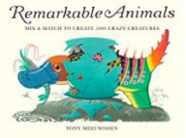 |  |  | CAS- Large scale labelling- draw around person and label.  CAS- Sing it, rhyme it play it- body songs.  CAS- Investigating five senses  RSC- something smells  RSC- sweet and sour  Handas surprise- needs of living things linked to diet and needs of humas.  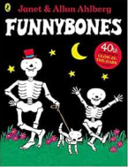
Materials | Useful lesson starters/WOW moments/ visits | Distinguish between an object and the material from which it is made. |  | Identify and name a variety of everyday materials, including wood, plastic, glass, metal, water, and rock |  |  | Describe the simple physical properties of a variety of everyday materials. |  |  | Compare and group together a variety of everyday materials on the basis of their simple physical properties. |  | Knowledge retrieval/ Assessment
Materials |  | CAS- Sorting rubbish.  CAS- Santa’s sorting: toys.  CAS- guessing game: whats in the box? |  | SSG- Charles Macintosh ‘The journey of the raincoat’  CAS: materials hunt  PSTT- Materials QR hunt.  CAS- Collecting materials display. |  |  | SSG- Charles Macintosh ‘The journey of the raincoat’  CAS- Collecting materials display.  CAS- waterproof/not waterproof, see through/not see through, stretchy/not stretchy. |  |  | SSG- Charles Macintosh ‘The journey of the raincoat’  RSC- Grouping and classifying materials  ‘That’s not my…’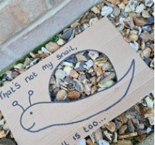
Seasonal Changes | Useful lesson starters/WOW moments/ visits | Observe changes across the four seasons. Observe and describe weather associated with the seasons and how day length varies. |  |  |  |  |  |  |  |  |  | Knowledge retrieval/ Assessment.
Seasonal Changes | Useful lesson starters/WOW moments/ visits | Autumn | Winter |  | Spring |  |  | Summer |  |  |  | Knowledge retrieval/ Assessment.
Seasonal Changes | Teach throughout the year.  ‘Our school throughout the year’ take all opportunities to take pictures and stick in.  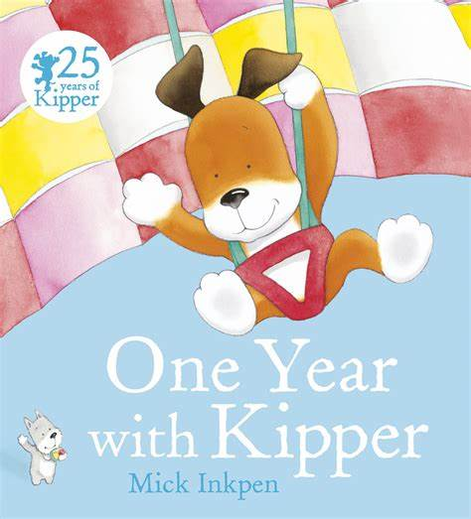  Link to seasonal changes as children work to observe changes across the seasons. | Autumn- welly walks/scavenger hunts. Why do leaves change colour?  CAS- Weather forecasting with pine cones.  Create an autumn leaf window tree (101 brilliant things to do with kids) | CAS- measure rainfall, temp- look for patterns  CAS- Winter: Winter walk. Evergreen and deciduous investigation.  CAS- how windy is it?  CAS- investigating snow incl instant snow, ice cubes  Spring: Journey sticks, measuring rainfall.  Play with artificial snow and ice balls with objects inside. |  | Children to wear cotton socks and run along the grass- turn inside out and fill with soil, water and see what seeds grow.  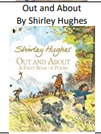 |  |  | summer hunt, temperature.  WOW science- woodland trust  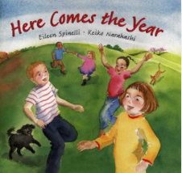  Season poems |  |  |  | CAS- create pictures/art work with moods of different seasons.  Create a weather tree (101 brilliant things to do with kids)

 | Year 2
Year group 2 |  | Unit Objectives
Plants | Useful lesson starters/WOW moments/ visits | - Observe and describe how seeds and bulbs grow into mature plants. |  |  | Find out and describe how plants need water, light and a suitable temperature to grow and stay healthy. |  |  | Knowledge retrieval/ Assessment
Plants | WOW science- woodland trust | CAS- observing plants from bulbs/seeds. Grow cress hair. |  |  | PSTT- Big Ideas ‘Big Questions- living or not’
Animals including humans | Useful lesson starters/WOW moments/ visits | Notice that animals, including humans, have offspring which grow into adults. | Find out about and describe the basic needs of animals, including humans, for survival (water, food and air) |  |  | Describe the importance for humans of exercise, eating the right amounts of different types of food, and hygiene. |  |  | Knowledge retrieval/ Assessment
Animals including humans |  | LTT- Stick and think (learning parts of the body)  WOW science- video clips of animals around the world.  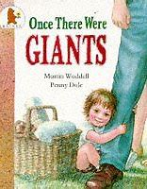  Supports children to understand that all animals, including humans have offspring which grow into adults. | WOW science- Interesting facts about animals  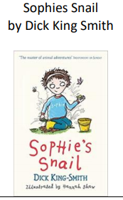 |  |  | PSTT- I bet you didn’t know ‘The science of handwashing’ with video links to Florence Nightingale  CAS- Superhero training school.  CAS- You are what you eat.  WOW science- interactive map of the body
Living Things | Useful lesson starters/WOW moments/ visits | Explore and compare the differences between things that are living, dead, and things that have never been alive. | Identify that most living things live in habitats to which they are suited and describe how different habitats provide for the basic needs of different kinds of animals and plants, and how they depend on each other | Identify and name a variety of plants and animals in their habitats, including microhabitats |  |  | Describe how animals obtain their food from plants and other animals, using the idea of a simple food chain, and identify and name different sources of food. |  | Knowledge retrieval/ Assessment
Living Things | CAS- Visit a local farm.  CAS- Quizzical questions. | PSTT- Big ideas ‘Odd one out’ Alive or not  PSTT- Big Ideas ‘Odd one out: dead or alive’  CAS- sorting and grouping pictures | LTT- Colourful caterpillars (Classification/  recording)  LTT and CAS- Habitat boxes  LTT- Heads- observing and how animals have adapted.  WOW science- which animals hibernate quiz?  WOW science: how do animals adapt to their environment?  SME- Habitats- Estate agent marketing  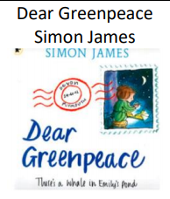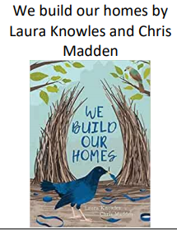  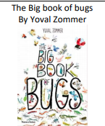 | CAS- Visit a local farm.  CAS- hunting and searching welly walk  CAS- post box problem  WOW science- farm in the classroom  WOW science- nocturnal animals  Hang up a bee house (101 brilliant things to do with kids)  STEM trails: Let’s Go Insects  STEM Trail: Let’s Go seaweed  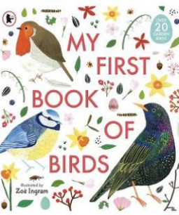  Help children meet the objective to identify and name a variety of common birds |  |  | CAS- find it, eat it drama.  CAS- Research- find out what animals eat.  The Crunch- Fast food chains
Materials | Useful lesson starters/WOW moments/ visits | Identify and compare the suitability of a variety of everyday materials, including wood, metal, plastic, glass, brick, rock, paper and cardboard for particular uses. |  |  | Find out how the shapes of solid objects made from some materials can be changed by squashing, bending, twisting and stretching. |  |  |  | Knowledge retrieval/ Assessment.
Materials |  | SSG- Charles Macintosh ‘The journey of the raincoat’  SSG- John Dunlop ‘Bouncy tyres and bouncy balls’  PSTT- Big Ideas ‘Odd one out- characteristics’  PSTT- Big Ideas ‘PMI- materials x 3’  CAS- Material munchers and material hunt.  CAS- Ridiculous materials.  CAS- Riddles and rhymes.  CAS- material testing: who’s afraid of the wolf- build houses for 3 pigs.  CAS- absorbent/not absorbent.  CAS- Move it/make it/test it  STEM trail: Let’s Go: Exploring the world (in school)  RSC- Properties of materials and their uses  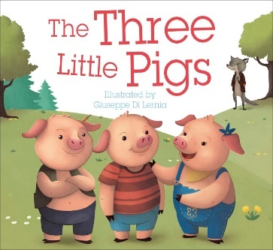  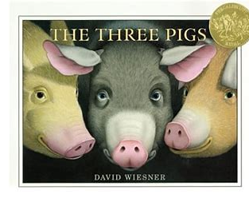  Starting point for identifying different materials and considering what properties they have and how this suits them for different purposes. |  |  | PSTT- Make a duck.  WOW science- material properties

 | Year 3
Year group 3 |  | Unit Objectives
Plants | Useful lesson starters/WOW moments/ visits | Identify and describe the functions of different parts of flowering plants: roots, stem/trunk, leaves and flowers. | Explore the requirements of plants for life and growth (air, light, water, nutrients from soil, and room to grow) and how they vary from plant to plant. |  |  | Investigate the way in which water is transported within plants. |  |  | Explore the part that flowers play in the life cycle of flowering plants, including pollination, seed formation and seed dispersal. |  | Knowledge retrieval/ Assessment
Plants | EEE- Plant unit of work exploration  WOW science- woodland trust  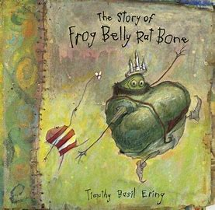  Provides a good setting for investigating plants and their benefits to our environment. | PSTT- Big Ideas ‘Odd one out- plant structures’  CAS- 3D plant with labels.  WOW science- Leaf identification  Active Assess- Plant parts card sort. | PSTT- I bet you didn’t know ‘how plants know good microbes from bad ones’  CAS- cress seed investigation- what a plant needs to grow  CAS- Ouch- take off parts of the plant and observe effects.  WOW science- healthy plant growth  Build a mini greenhouse (101 brilliant things to do with kids) |  |  | PSTT- Big ideas ‘PMI- plant food’  CAS- How do plants get water?  WOW science- add colour to flowers. |  |  | PSTT- I bet you didn’t know ‘What is happening to the bees’  LTT- Veg Tops- plant growth and propagation  CAS- Learning through role play- pollination.  WOW science- grow your own plants.  WOW science- how plants produce seeds  SME- Plant life cycle- links with writing outcomes and drama.  STEM trails: Let’s Go- Seed dispersal  Grow pea shoots (101 brilliant things to do with kids)  Plant pollinating pots (101 brilliant things to do with kids)  Floral sun catchers (101 brilliant things to do with kids)
Animals including humans | Useful lesson starters/WOW moments/ visits | Identify that animals, including humans, need the right types and amount of nutrition, and that they cannot make their own food; they get nutrition from what they eat. |  |  |  |  |  | Identify that humans and some other animals have skeletons and muscles for support, protection and movement. |  |  |  | Knowledge retrieval/ Assessment
Animals including humans | WOW science- interactive map of the body  WOW science- interactive tshirt | LTT- Eat your own words- edible menus.  EEE- Nutrition unit of work  CAS- Brush your teeth- fizzy sweets and drinks.  CAS- Reading and comparing nutrition labels. How much fat?  STEM Trails: Lets go- Sugar.  RSC- Edible experiments: bitter orange |  |  |  |  |  | CAS- Bones for protection- using everyday objects to represent organs.  CAS- muscles for movement- make a moving hand  WOW science- interactive bones program  WOW science- build a human body  WOW science- build a skeleton app
Materials- Rocks and soils | Useful lesson starters/WOW moments/ visits | Compare and group together different kinds of rocks on the basis of their appearance and simple physical properties. |  |  | Describe in simple terms how fossils are formed when things that have lived are trapped within a rock. |  |  |  | Recognise that soils are made from rocks and organic matter |  |  | Knowledge retrieval/ Assessment
Materials- Rocks and soils | WOW science- Mary Anning  PSTT- PSTT- Jurassic Coast materials.  EEE- Rocks unit of work  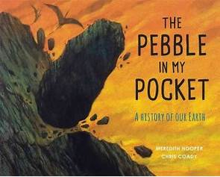  Starter for rock formation; showing the reader the process that the pebble goes through from its beginnings in a fiery volcano 480 million years ago. | CAS- comparing rocks by appearance/ properties.  CAS- I spy rocks.  SME- Rocks- Drama with chocolate bars- classification  Active Assess- Rock bingo. (recall)  RSC- Rocks and soils |  |  | SSG- Mary Anning ‘unfolding fossil fables’  CAS- Make a mould/ amber/CAST fossil.  WOW science- making a fossil. |  |  |  | CAS- Separating soil
Light and sound | Useful lesson starters/WOW moments/ visits | Recognise that they need light in order to see things and that dark is the absence of light.  Notice that light is reflected from surfaces. |  | Recognise that light from the sun can be dangerous and that there are ways to protect our eyes. |  |  | Recognise that shadows are formed when the light source is blocked by a solid object. |  | Find patterns in the way the size of the shadows change |  |  | Knowledge retrieval/ Assessment.
Light and sound | PSTT- Big Ideas ‘Odd one out- Light sources’  PSTT- Big Ideas- ‘Big questions- light’  EEE- Light and materials unit of work  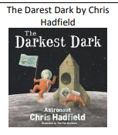 | CAS- In the cupboard!  CAS- sorting light sources  CAS- create a shield with shiniest material for Perseus to defeat Gorgon (Greeks link)  Ogden- Bear Cave  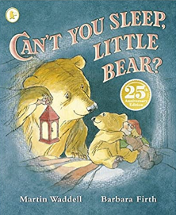  Ogden- Ideas over time: Light time line cards  See rainbows- refracting light (101 brilliant things to do with kids) |  | CAS- UV beads investigation  CAS- Datalogging day light.  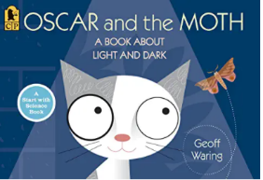 |  |  | CAS- Shadow sculpture- shadow size investigation.  Link to Attraction (BGT show)  WOW science: blocking light APP |  | CAS- Shadow sculpture- shadow size investigation.  Make a shadow puppet theatre (101 brilliant things to do with kids)  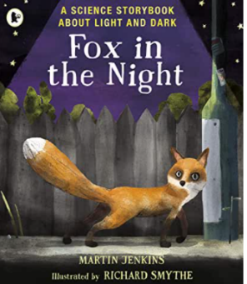
Forces  Magnets | Useful lesson starters/WOW moments/ visits | Compare how things move on different surfaces |  | Notice that some forces need contact between two objects, but magnetic forces can act at a distance. |  |  | Observe how magnets attract or repel each other and attract some materials and not others. |  | Compare and group together a variety of everyday materials on the basis of whether they are attracted to a magnet, and identify some magnetic materials. | Describe magnets as having two poles.  Predict whether two magnets will attract or repel each other, depending on which poles are facing |  | Knowledge retrieval/ Assessment.
Forces  Magnets | PSTT- I bet you didn’t know ‘What small magnetic robots can do’  PSTT- Science and History: crash test dummies’  EEE- forces and magnets unit of work  Play the sticky rice trick (101 brilliant things to do with kids)  Super bounce (101 brilliant things to do with kids)  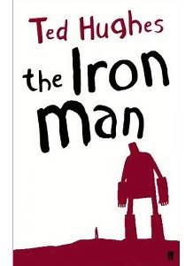  Explains how magnets attract or repel each other and attract some material and not others. | SSG- John Dunlop ‘Bouncy tyres and bouncy balls’  SSG- John McAdam ‘Bumpy Roads’  Ogden- Phizzi enquiry- slippy shoes |  | Ogden- Magnetometer  Ogden- Phizzi problem solving: manometer  Ogden- Phizzi Problem Solving: magnetic fishing game.  WOW science- Magnets  Create a compass (101 brilliant things to do with kids) |  |  | PSTT- Big Ideas- ‘Odd one out- magnetic or non-magnetic’  PSTT- Big ideas- ‘Odd one out-magnets’  Ogden- Phizzi Problem Solving: Fridge magnets. |  | CAS- Toyologist challenge x 5  CAS- The floating paperclip. | Ogden- Phizzi Problem Solving- magnetic racing game. |  | Ogden- Phizzi problem solving: manometer

 | Year 4
Year group 4 |  | Unit Objectives
Animals including humans | Useful lesson starters/WOW moments/ visits | Describe the simple functions of the basic parts of the digestive system in humans. |  |  |  | Identify the different types of teeth in humans and their simple functions. |  |  | Construct and interpret a variety of food chains, identifying producers, predators and prey. |  | Knowledge retrieval/ Assessment
Animals including humans |  | LTT- Sharing memory- explaining digestive system  CAS- Human digestive system model.  PSTT- Big Ideas ‘PMI- humans needing food’  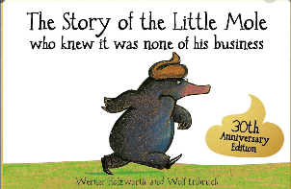  Use this book and make different animal poo- can children tell which animal it came from?  WOW science- interactive map of the body  WOW science- interactive tshirt  WOW science- build a human body  SME- Digestive system-travel brochure- linked with teeth.  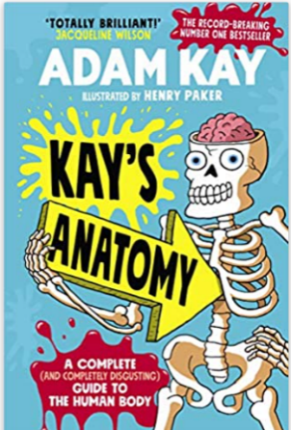 |  |  |  | LTT- Can Can- looking at sugar content in drinks (builds on knowledge of teeth)  EEE- Teeth and eating unit of work  CAS- open wide- model of the teeth  CAS- take a bite- function of teeth.  WOW science- teeth and eating interactive game. |  |  | CAS- Presenting food chains using cups.  CAS- Exploring owl pellets.  WOW science- video clips of animals around the world.  WOW science- Interesting facts about animals  Exploring life cycles, helping children describe the difference in the lifecycle of a mammal, amphibian, insect and bird.  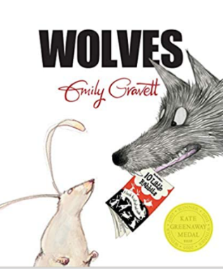  Brilliant for constructing and interpreting a variety of food chains as well as identifying producers, predators and prey.
Living Things | Useful lesson starters/WOW moments/ visits | Recognise that living things can be grouped in a variety of ways. |  |  |  | Explore and use classification keys to help group, identify and name a variety of living things in their local environment. |  |  | Recognise that environments can change and that this can sometimes pose dangers to living things. |  | Knowledge retrieval/ Assessment
Living Things | EEE- Living things and habitats unit of work. | CAS- human classification: same or different.  CAS- whole class key  Active Assess- graphic organiser.  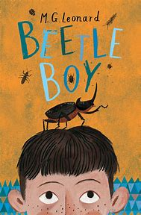  Classification and invertebrates |  |  |  | CAS- Animal classification using Lego blocks.  CAS- Out and about: outside classification keys.  WOW science: how do animals adapt to their environment?  SME- Habitats- Estate agent marketing  The Crunch- Save our Home, (Links to rainforest)  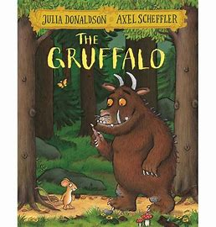  Starting point for habitats and to identify and name a variety of plants and animals in different habitats, including micro habitats.  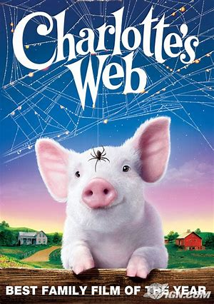  Lifecycles of different animals and plants |  |  | PSTT- Big Ideas ‘Odd one out- it is alive?’  PSTT- I bet you dint know- ‘Stripes and concealment’  CAS- Research it- endangered animals  WOW science- spot the camouflaged animals.  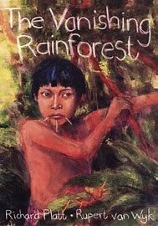  Looks at the human impact on the environment, in particular deforestation.
Materials- States of matter | Useful lesson starters/WOW moments/ visits | Compare and group materials together, according to whether they are solids, liquids or gases |  |  |  | Observe that some materials change state when they are heated or cooled, and measure or research the temperature at which this happens in degrees Celsius |  |  | Identify the part played by evaporation and condensation in the water cycle and associate the rate of evaporation with temperature. |  | Knowledge retrieval/ Assessment
Materials- States of matter | EEE- States of matter unit of work.  WOW science- solids, liquids and gases introduction  WOW science- changes in the state of materials video  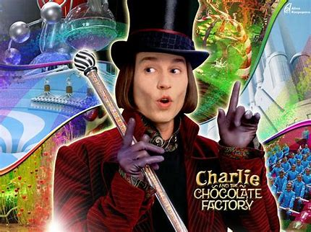  Provides a good context to learn about states of matter. | PSTT- I bet you didn’t know ‘How to clean water using a molecular sieve’  LTT- Mix it up- solids, liquid and gases.  LTT- Ballooning (SLG and mixing them)  LTT- Celebration Candles  CAS- ballooning around  CAS- Shopping bag sorting  WOW science- lava lamps  RSC- Science demonstration on solids, liquids and gases.  RSC- Solids, liquids and gases  RSC- Hubble bubble  RSC-sensational states |  |  |  | PSTT- Big Ideas- ‘Odd one out- reversible changes’ ‘Natural or manufactured’  PSTT- Big Ideas ‘PMI- changing materials x 2 including climate’  PSTT- Big ideas ‘Big questions- states of matter’  LTT- Shaky changes- reversible/  Irreversible.  CAS- investigate it: heating and cooling chocolate.  CAS- investigating melting and freezing points  CAS- who melts in the sun?  WOW science- solids, liquids, gas changing state interactive.  WOW science-baking soda experiments  Making Ice Cream  (101 brilliant things to do with kids)  Make fizzy Sherbet (101 brilliant things to do with kids)  Create yoghurt bites (101 brilliant things to do with kids)  RSC- Heating or cooling activity  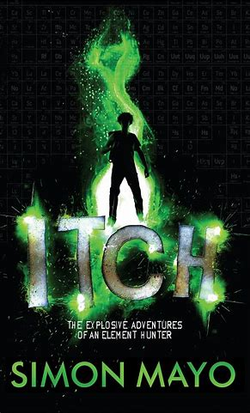  An element hunter who collects elements in the periodic table. Great for finding out about changes of state. |  |  | LTT- Watercycle seedlings. (applying knowledge of seed germination and growth)  Active Assess- Sequencing.  CAS- research it.  CAS- Modelling the water cycle  WOW science- build a barometer  RSC- The water Cycle
Sound | Useful lesson starters/WOW moments/ visits | To identify how sounds are made, associating some of them with something vibrating. |  | Recognise that vibrations from sounds travel through a medium to the ear |  |  | Find patterns between pitch of a sound and features of the object that produced it.  Find patterns between the volume of a sound and the strength of the vibrations that produced it. |  | Recognise that sound gets fainter as the distance from the sound source increases |  | Knowledge retrieval/ Assessment.
Sound | PSTT-Growing music project- science/DT/IT/music links.  EEE- Sound unit of work  Ogden Trust Sound box and unit of work.  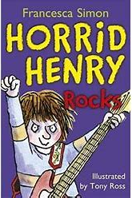  Explores sound and how sounds are made. | Poem the sound collector.  PSTT- I bet you didn’t know- ‘Odd one out- producing sound’  LTT- Sound Circus- vibrations  CAS- storm in a circle- using body for sounds. Link to Honda Civic- Choir TV advert.  Ogden- Research card: Helping us hear.  Ogden- Research cards: largest sound timeline.  Make your own sound effects (101 brilliant things to do with kids) |  | CAS- vibration stations  Ogden- Make a hydrophone: sound travel through water.  Ogden- Seeing sound vibrations  WOW science-science of the string phone |  |  | PSTT- I bet you didn’t know ‘Whale song is changing’  CAS- Data logger in the classroom  WOW science- sound study Jam |  | CAS- Make a clap-o metre |  | WOW science- Chrome music lab
Electricity | Useful lesson starters/WOW moments/ visits | Identify common appliances that run on electricity. |  | Construct a simple series electrical circuit, identifying and naming its basic parts, including cells, wires, bulbs, switches and buzzers.  Identify whether or not a lamp will light in a simple series circuit, based on whether or not the lamp is part of a complete loop with a battery |  |  | Recognise that a switch opens and closes a circuit and associate this with whether or not a lamp lights in a simple series circuit. |  | Recognise some common conductors and insulators, and associate metals with being good conductor |  | Knowledge retrieval/ Assessment.
Electricity | SSG- Michael Faraday ‘Wind power’  EEE- Electricity unit of work.  Ogden trust electricity box and unit of work.  Ogden- Phizzi Focus: Electricity  WOW science- renewable energy  WOW science- bend water with static electricity.  Bring ghosts to life- static electricity (101 brilliant things to do with kids)  Do the magic straw trick- static electricity (101 brilliant things to do with kids)  WOW science- the dangers of electricity | CAS- Mime it, cut it out- appliances which use electricity collage.  When Charlie McButton lost power audio book (Click for You Tube link)  Ogden- Ideas over time: Electricity.  WOW science- how is electricity supplied to your home?  STEM Trails- Let’s go: Electricity in school |  | PSTT- Big ideas ‘odd one out- components’  CAS- sweet circuits  WOW science- bend water with static electricity.  SME- Electricity- recipe book- basic circuit planning |  |  | CAS- working towards an electrical qualification. |  | PSTT- Big Ideas- ‘Odd one out- conductivity’ |  | CAS- Electricity challenges x 5
 | Year 5
Year group 5 |  | Unit Objectives
Animals including humans | Useful lesson starters/WOW moments/ visits | Describe the changes as humans develop to old age. |  |  |  |  |  |  |  |  | Knowledge retrieval/ Assessment
Animals including humans |  | EEE- Growth and development of humans unit of work  WOW science- interactive map of the body  WOW science- interactive tshirt  WOW science- build a human body  WOW Science- why do we have belly buttons?
Living Things | Useful lesson starters/WOW moments/ visits | Describe the differences in the life cycles of a mammal, an amphibian, an insect and a bird |  |  |  |  |  | Describe the life process of reproduction in some plants and animals |  |  | Knowledge retrieval/ Assessment
Living Things |  | SSG- Jane Goodall ‘Playground Observers’  PSTT- I bet you didn’t know ‘How to calculate the age of a shark’  CAS- physical sorting- identify their animal.  CAS- observation over time using real animals e.g chicks, butterflies, frogs |  |  |  |  |  | CAS-Time lapse videos of lifecycles.  EEE- Lifecycles unit of work  CAS- research lifecycles  CAS- Plant reproduction – grow new plants from parent plant.  WOW science- how plants produce seeds  WOW science- grow your own plants.  WOW science- woodland trust  WOW science- plant reproduction.  WOW science- how to plants adapt to arctic temperatures?  WOW science- meat eating plants  Grow magic roots (101 brilliant things to do with kids)  The Crunch: Salty seeds unit overview- linked to Mexico.
Materials- States of matter | Useful lesson starters/WOW moments/ visits | Compare and group together everyday materials on the basis of their properties, including their hardness, solubility, transparency, conductivity (electrical and thermal), and response to magnets | Know that some materials will dissolve in liquid to form a solution, and describe how to recover a substance from a solution |  |  | Use knowledge of solids, liquids and gases to decide how mixtures might be separated, including through filtering, sieving and evaporating |  | Give reasons, based on evidence from comparative and fair tests, for the particular uses of everyday materials, including metals, wood and plastic | Demonstrate that dissolving, mixing and changes of state are reversible changes | Explain that some changes result in the formation of new materials, and that this kind of change is not usually reversible, including changes associated with burning and the action of acid on bicarbonate of soda. | Knowledge retrieval/ Assessment
Materials- States of matter | PSTT- I bet you didn’t know ‘toilets in the future may charge your mobile phone’  PSTT- I bet you didn’t know ‘The disastrous effects of historical link’  CAS- material vocabulary generator.  Ogden- Ideas over time: Tallest buildings cards | PSTT- I bet you didn’t know ‘Slug slime might be the answer to medical adhesives’  CAS- response to magnets/thermal conductivity/  Absorbency/ stretch-ability  CAS- solubility investigation.  RSC- thermal and electrical insulation activity.  RSC- Teflon | LTT- Marble drop- properties of liquids test  LTT- Milk explosion- how materials react together.  CAS- which materials in the kitchen dissolve?  RSC- Mixing and dissolving materials  RSC- dense liquids  RSC- Mixed up solution Vs Mixture  RSC- Water |  |  | LTT- Colourful Columns- density  WOW science- blank ink separating colours  RSC- Science demonstration on separating materials  RSC- Separating mixtures  RSC- Colourful food: separating mixtures |  | SSG- Spencer Silver/Arthur Fry  ‘Sticky things’ | LTT- Slow melt-reversible/  Irreversible.  EEE- Properties and changes of materials unit of work.  SME- Mixing and separating materials-sports commentaries  RSC-Science demonstration on changing materials  RSC- Burning activity.  RSC- Jelly  RSC- Salt | CAS- making lemonade  CAS- creating new materials.  RSC- Irreversible changes.  RCS- Beat it- reversible and irreversible  RSC- Turn up the heat  RSC- Vinegar (bicarb) | CAS- challenge activities.
Earth and Space | Useful lesson starters/WOW moments/ visits | Describe the movement of the Earth, and other planets, relative to the Sun in the solar system |  | Describe the movement of the Moon relative to the Earth |  |  | Describe the Sun, Earth and Moon as approximately spherical bodies |  | Use the idea of the Earth’s rotation to explain day and night and the apparent movement of the sun across the sky. |  | Knowledge retrieval/ Assessment.
Earth and Space | PSTT- I bet you didn’t know ‘How to play planetary hide and seek’  PSTT- Big Ideas ‘PMI- space x 2’  PSTT- Big ideas ‘Big questions- light/space/stars x 4’  PSTT- Science and history ‘Life on mars, new technology’  EEE- Earth and Space unit of work.  CAS- Party on the planets.  CAS- Fiction vs Fact.  Ogden- Planetary picnic.  Ogden Trust Space box and unit of work.  Ogden- Ideas over time: Universe  WOW science- your weight in other worlds  WOW science- what is a meteor shower?  WOW science- Mars base camps  WOW science- solar system scope- star gazing  WOW science- international space station  WOW science- space station live  WOW science- NASA be a martian  WOW science- rocket science: build a rocket  WOW science- Nasa space place  WOW science- Design your own space buggy  WOW science- NASA APP  SME- Space: Communication with an alien.  Launch a rocket (101 brilliant things to do with kids)  Build a constellation nightlight (101 brilliant things to do with kids) | PSTT- I bet you didn’t know ‘One of Saturn’s moons may be a home for extra-terrestrial life’  Ogden- Playdough planets.  Ogden- Solar system in my pocket.  Ogden- Phizzi focus: Earth and Space.  Ogden- Research card: Earth and Space  WOW science- space  WOW science- guided tour of mars  WOW science- the scale of the universe  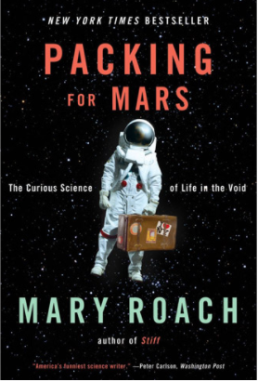 |  | CAS- Observing the phases of the moon, modelling phases of the moon  Make a lunar flip book (101 brilliant things to do with kids) |  |  | PSTT- Science and history- Did man really walk on the moon?’  CAS- surface of the moon- fair test investigation.  Ogden- Phizzi Focus: Moon landings.  Ogden- research cards: Moon landings.  Ogden- Research cards: Gravity  Ogden- Ideas over time: Moon landings card sort.  WOW science- where did the moon come from?  WOW science- moon quiz. |  |   Factual sections for help with teaching about the solar system.  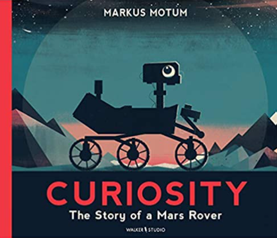  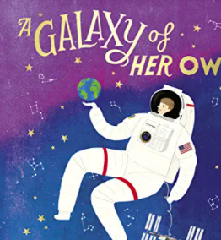 |  | PSTT- Big ideas- ‘Odd one out- space misconceptions’
Forces | Useful lesson starters/WOW moments/ visits | Explain that unsupported objects fall towards the Earth because of the force of gravity acting between the Earth and the falling object |  |  | Identify the effects of air resistance, water resistance and friction, that act between moving surfaces |  |  |  | Recognise that some mechanisms, including levers, pulleys and gears, allow a smaller force to have a greater effect. |  | Knowledge retrieval/ Assessment.
Forces | EEE- Forces unit of work  Ogden- Research cards: Friction  Ogden- Ideas over time: Bridges sort  Ogden- Ideas over time: Fastest way to travel card sort.  WOW science- monster physics  WOW science- build a bridge.  WOW science- make a balloon rocket  SME- Forces: Political debate- exploring all 5 forces.  Lots of great videos on forces in real life https://www.stemcrew.org/ resources/forces-lesson-4-forces-and-motion/  https://www.bbc.co.uk/ teach/terrific-scientific/KS2/zjwrjhv videos, resources and lesson plans. | SSG- Galileo Galilei ‘Pop music pendulums’  WOW science- pendulums.  CAS- Gravity carousel  WOW science make anti gravity hour glass  WOW science- falling for science  Levitate a ping-pong ball (101 brilliant things to do with kids)  https://www.stem.org.uk/resources/ elibrary/resource/31854/forces-mass-weight-and-gravity (Teachers TV explaining mass, weight and gravity)  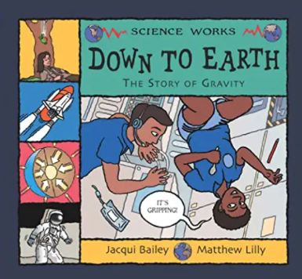 |  |  | PSTT- Big Ideas ‘PMI- Friction in real life’  CAS- Friction: Goalie Gloves investigation, zip wire investigation  CAS- Investigation air resistance.  Ogden- Forces in Flight.  Ogden- Phizzi enquiry- slippy shoes  Ogden- Forces and flight activity.  WOW science- investigation on friction.  WOW science- parachutes- air resistance.  STEM Trail- Let’s go: boats  Shoot an air cannon (101 brilliant things to do with kids)  Tip water over someones head (101 brilliant things to do with kids) Air pressure/force  Spin a centrifuge sprinkler (101 brilliant things to do with kids)  Compete in a paper helicopter race (101 brilliant things to do with kids) air resistance  Launch water bombs (levers) (101 brilliant things to do with kids)  Build a hovercraft- friction (101 brilliant things to do with kids)  https://spark.iop.org/collections/ contact-forces-teaching-approaches?gclid=CjwKCAiAtK7 9BRAIEiwA4OskBspZ1V6l1faCjXutl_ XMTVdUR4VZ4_M35k7uH-UV1F3nXSEU1Gp-1RoCxiMQAvD_BwE forces activities linked to buoyancy |  |  |  | CAS- Investigating pulleys  EOLAS+ Friction activity pulley car. (Paid unit of work)  CAS- Investigating levers  Ogden- Investigating gears.  WOW science- marvellous roller coaster.  WOW science- design your own helter skelter  Links to simple machines videos https://www.neok12.com/Simple-Machines.htm  How do bike gears work video https://www.youtube.com/ watch?v=oauDyIu_swM  How do levers work? Video https://www.bbc.co.uk/bitesize/ clips/zrp6n39  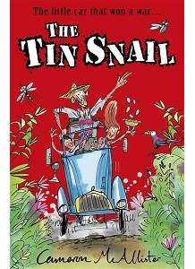  Context for learning about forces and mechanisms, including gears, leavers and pulleys.

 | Year 6
Year group 6 |  | Unit Objectives
Animals including humans | Useful lesson starters/WOW moments/ visits | Identify and name the main parts of the human circulatory system, and describe the functions of the heart, blood vessels and blood. |  |  | Recognise the impact of diet, exercise, drugs and lifestyle on the way their bodies function |  |  | Describe the ways in which nutrients and water are transported within animals, including humans | Knowledge retrieval/ Assessment
Animals including humans | EEE- Circulatory system unit of work.  LTT- Babysafe Brainsafe- protective mechanisms in the body  WOW science- build a human body  Active Assess- graphic organiser.  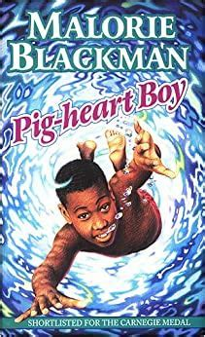  Good setting for learning about the heart and circulation.  Mark-Forensics - Intro to Forensic Investigation (mark-forensics.com) | SSG- Santorio Santorio ‘The journey of the pulse meter’  PSTT- STEM activities: exploding cells’  CAS- Learning about the heart- make heart model  CAS- Learning about circulatory system drama.  CAS- Learning more about blood. Make your own blood and label.  WOW science- interactive map of the body  WOW science- interactive tshirt  WOW science- why do cuts heal?  WOW science- how gravity affects blood flow around the body  See your own DNA (101 brilliant things to do with kids)  SME- Circulatory system- audio tour and annotated diagram. |  |  | PSTT- Science and history: Drug testing in science’  PSTT- Science and history ‘Time raiders: death of a dummy’  PSTT- STEM activities ‘Take your medicine’  WOW science- what cases colds and flu and how to get rid of it?  PSTT- Lets talk science and health resources (videos on liver and alcohol, diet diabetes and obesity, vaccines)  CAS- Healthy me journal  CAS- Investigating the effects of exercise on pulse rate.  CAS- running a healthy school tuck shop.  CAS- Impact on smoking model.  WOW science- why do we need to sleep?  WOW science: what germs can be found on your hands  RSC- Low fat  RSC- Rot |  |  | PSTT- I bet you didn’t know ‘How to grow a new skin’  PSTT- Science and history ‘Transporting living things’  The Crunch: Dazzling Digestion Unit  RSC- Elemental (Nutrients)  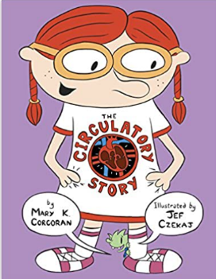 | CAS- Classifying microorganisms
Living Things | Useful lesson starters/WOW moments/ visits | Describe how living things are classified into broad groups according to common observable characteristics and based on similarities and differences, including microorganisms, plants and animals |  |  |  |  | Give reasons for classifying plants and animals based on specific characteristics. |  | Knowledge retrieval/ Assessment
Living Things |  | RSC- Kitchen K-mystery- microorganisms  RSC- Big Freeze: Microorganisms  RSC- Preserves |  |  |  |  | 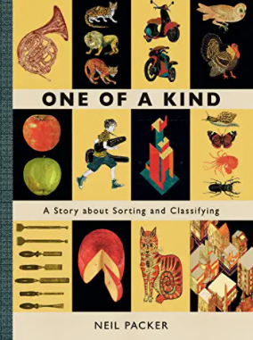
Evolution and Inheritance | Useful lesson starters/WOW moments/ visits | Recognise that living things have changed over time and that fossils provide information about living things that inhabited the Earth millions of years ago. |  |  | Recognise that living things produce offspring of the same kind, but normally offspring vary and are not identical to their parents |  |  | Identify how animals and plants are adapted to suit their environment in different ways and that adaptation may lead to evolution. | Knowledge retrieval/ Assessment.
Evolution and Inheritance | Evolution  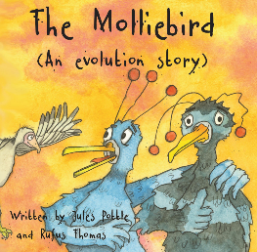  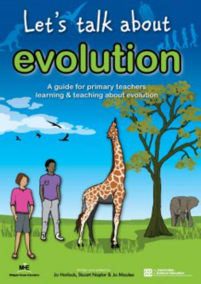  EEE- Evolution and inheritance unit of work | SSG- Charles Darwin ‘The Evolution of Evolution’  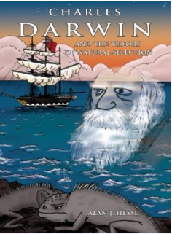  SSG- Mary Anning ‘unfolding fossil fables’  WOW science- Mary Anning  PSTT- Science and history ‘Testing the theory of evolution’  CAS- Fossil analogy  WOW science- the last mammoths.  SME- evolution- diaries, biographies and autobiographies  Animals incl humans |  |  | SSG- Jane Goodall ‘Playground Observers’  WOW science- switch zoo- make hybrid animals  WOW science- David Attenborough tree of life.  EEE- Classifying plants and animals  WOW science- cold blooded animals.  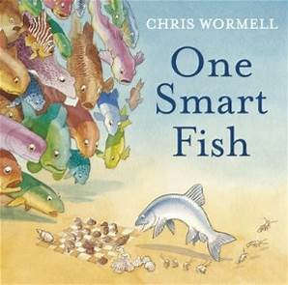  Provides a meaningful context for learning about adaptations and evolution. |  |  | PSTT- I bet you didn’t know ‘Evolution of life in cities’  CAS- investigating plant adaptations  PSTT—I bet you didn’t know..’Catching flu might depend on the type of place in which you live’  PSTT- I bet you didn’t know ‘Miracle healing could come from the Axolotl’  WOW science- bacteria  The Crunch- Save our Home, (Links to rainforest)
Light | Useful lesson starters/WOW moments/ visits | Recognise that light appears to travel in straight lines. | Use the idea that light travels in straight lines to explain that objects are seen because they give out or reflect light into the eye |  |  | Explain that we see things because light travels from light sources to our eyes or from light sources to objects and then to our eyes |  | Use the idea that light travels in straight lines to explain why shadows have the same shape as the objects that cast them. | Knowledge retrieval/ Assessment.
Light | EEE- Properties of light unit of work.  Ogden Trust light box and unit of work  Ogden- Research card: Light  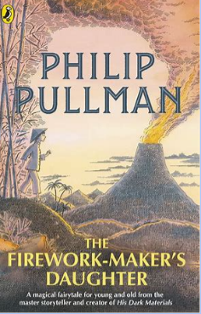  Good starting point for teaching about light. | CAS- Light in straight lines investigation.  CAS- Light maze  WOW science- Rainbow mechanic game. | WOW science- light reflection and refraction  Making a pinhole camera (101 brilliant things to do with kids) |  |  | Put someone in a cage (101 brilliant things to do with kids) how we see things.  Build a periscope (101 brilliant things to do with kids)+Ogden box |  | Link to Attraction (BGT show)
Electricity | Useful lesson starters/WOW moments/ visits | Associate the brightness of a lamp or the volume of a buzzer with the number and voltage of cells used in the circuit. |  | Compare and give reasons for variations in how components function, including the brightness of bulbs, the loudness of buzzers and the on/off position of switches |  |  |  | Use recognised symbols when representing a simple circuit in a diagram. | Knowledge retrieval/ Assessment.
 | PSTT- Big Ideas- ‘PMI- life before electricity’  PSTT- Big Ideas ‘Big questions- electricity/conductors’  EEE- Electricity unit of work  Ogden Trust- Electricity box and unit of work.  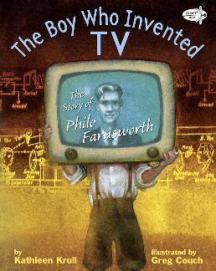  Ogden- Phizzi Focus: Electricity  WOW science-electrical engineering experiments | CAS- Learning about Alessandro Volta  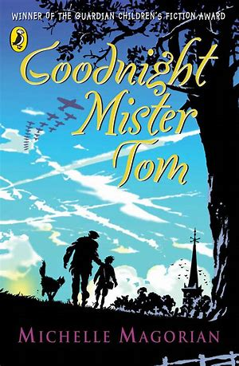  Explores the uses of electricity and how circuits work. |  | PSTT- Big Ideas- ‘PMI- life before electricity’  PSTT- Big Ideas ‘Big questions- electricity/conductors’  Ogden- Scribblebot  Ogden- Electroscope.  Ogden- Coin battery  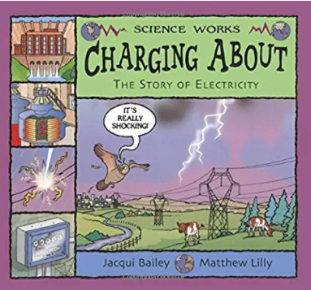 |  |  |  | CAS- who do you think you are? Symbols  CAS- Match it up- symbols with diagrams.  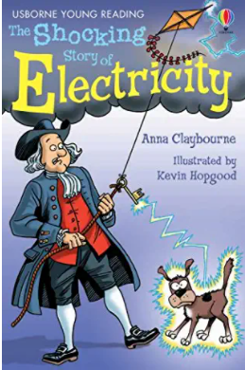 | CAS- Open ended challenge  Ogden- Fruity Batteries

KEY
PSTT- Climate Science
LTT- Comparative circus (round robin of investigations)
SSG- Standing on the shoulder of giants- PSTT resource
LTT- Look Think Talk activity by Gaynor Weavers
EEE- Explore, extend Engage.
CAT- Creative approach to teaching
SME- Science meets English

https://wowscience.co.uk/resource/inventioneers/

