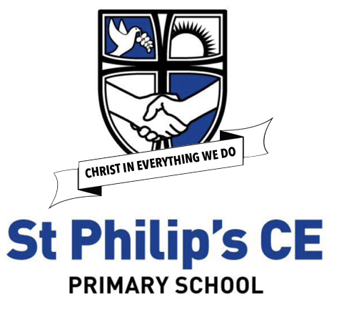

Music
Intentions, Implementation and Impact Statement

At St Philip’s our History Curriculum is driven by our whole school vision and values.

Happiness, Love and Security Abound
Everyone is Special
Every achievement is celebrated
Relationships and teamwork matter
A beacon of light in the community
Christ is in everything we do

Subject Leader: Stephanie Samuel
Music: intentions
Our golden threads run through our music provision - Educating for Wisdom, Knowledge and skills - Educating for hope and aspiration - Educating for community and living well - Educating for dignity and respect
Music is a universal language that embodies one of the highest forms of creativity. A high-quality music education should therefore engage and inspire pupils to develop a love of music, inspire their talent as musicians, and so increase their self-confidence, creativity and sense of achievement.
As pupils progress, they should develop a critical engagement with music, allowing them to compose and perform. It is important for children to be able to express themselves through their music, not only expressing their feelings and how they respond to music verbally but also to interpret these through subjects such as dance and drama.
Children should be able to identify a wide range of different genres of music both past and present; and be able to develop their judgements and express their preferences in a knowledgeable way. They should also be provided with the best in the classical musical canon; and demonstrate increasing discrimination and awareness of music from other cultures.
Music’s ability to affect the listener both spiritually and emotionally is increasingly harnessed to improve children’s mental health and form part of positive mindfulness practice. At St Philip’s, developing children’s wellbeing has always been an integral part of the ethos of the school and as such, music is used to create a calm atmosphere in lessons and contributes greatly to the children’s feeling of security and learning in a safe environment.
Music also forms an essential aspect of worship in a church school. As such our songs of praise and thankfulness in class, whole school and church worship help enrich the spirituality of our Christian community and develop empathic relationships.
In the EYFS and KS1, we first and foremost want the children to enjoy music. We want the children be confident and to encourage an exploration of how different sounds can be made using body percussion, percussive instruments and voices; and to begin to understand that there are different kinds of musical styles.
By the end of KS2, we want our children to leave school with a range of positive musical experiences and skills:
- Enjoying music
- Knowing why it is an important subject to study
- Having developed a sense of musicality
- Having a sound knowledge of the areas outlined in the National Curriculum
- Understanding musical concepts such as tempo, dynamics, pitch and beat
- Using a range of musical skills such as composing, performing, musical appreciation and independent discernment,
- Communicating these ideas through performance; and simple notation
- Interpreting music through expression, poetry and dance
- An understanding of the important contribution that composers, producers and performers have made, through the ages, to the wealth of music available to us
- Recognising that Music has its own universal language and notation
Music: implementation
Class teachers are supported in a range of ways:
- A subject specialist who is the subject leader
- A structured ‘Model Music’ scheme of work (Charanga)
- Whole school skills and knowledge documents
- Subject specific vocabulary for each year group
- Direct WOPs teaching for Year 4 and 5 provided by Sefton’s Music Service
- Visiting performers or “special events” organised
- The subject leader leads whole school singing practice.
- Who school access to a range of tuned and percussive musical instruments
INSET which has:
- Equipped teachers with a bank of Learning Objectives and differentiated Success Criteria
- Demonstrated activities to develop pupils understanding and participation in whole-class singing
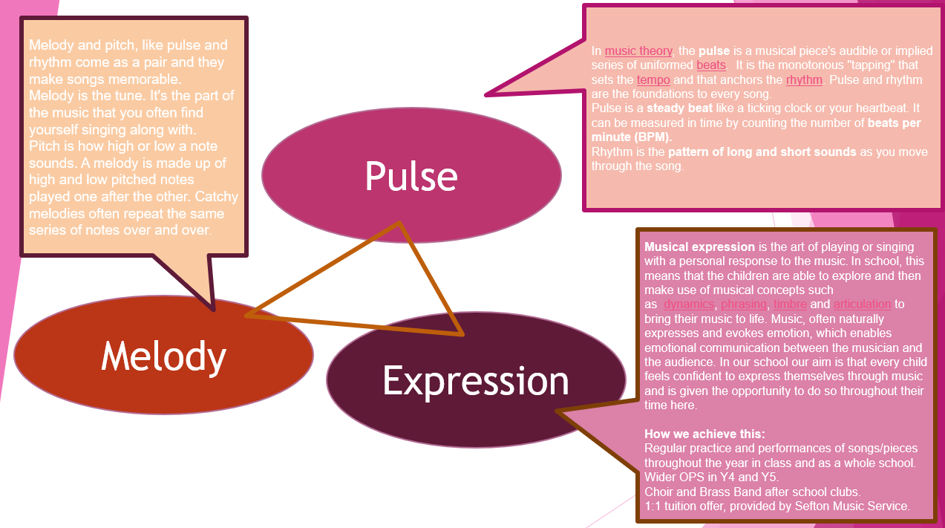
- Inroduced the Three Keys
Music – Three Key Words

Music: impact
- High levels of pupil enjoyment of Music
- Classroom and whole-school singing which encourages a feeling of “belonging” and inclusivity.
- Impressive examples of children’s performances across the age range, for example in Christmas Nativities, class worship and choir presentations in the community
- Developing music as a discreet subject with its own set of skills and vocabulary
- Integrating music into other subjects such as PE, RE and Literacy to develop skills of empathy, interpretation and appreciation; and create atmosphere
- Children appreciate a range of styles of music; and are able to recognise renowned composers and performers/ artists and give reasons for their preferences
How do I know I am better at music now than I was?
Pupils are encouraged to look back and see their emerging skills and successes. They reflect on their own and others’ performances within lessons; and receive immediate feedback given by an audience through the applause they receive after having performed.
The areas outlined in the National Curriculum and the Sefton Music guidelines are also within the statements in the school’s assessment tracking system. However below is an indication of the progress expected. This moves from the ability to make simple sounds and distinguish between them, to then combine these sounds and compose and perform. Children should become increasingly independent in choosing particular sounds for effect; and develop expression and interpretation.
By Year 5 and 6
- Pupils enjoy sharing their own compositions and performances and feel a sense of achievement; and are confident performers
- Pupils can perform in a variety of different styles using facial expression, a range of dynamics and show understanding of structure
- Pupils demonstrate good technique when handling instruments; and in singing
- Pupils have a broad factual knowledge and historical awareness of renowned musicians and composers, both classical and popular, and can identify some of their works and instrumentation.
- Pupils appreciate the work of others using correct musical terminology and can express reasoned choices of music for listening
- Pupils listen with attention to detail and can recall sounds/ tunes using aural memory
- Pupils use and understand simple staff and other musical notations

