St. Philips CE Primary School

Maths Vocabulary for the New National Curriculum

This document sets out Key Stage 1 (KS1) and Key Stage 2 (KS2) maths vocabulary under the new National Curriculum. The tables can be used to check pupils’ understanding of new vocabulary introduced in years 1-6.

The lists are intended as a guide as to what pupils should know, and are not exhaustive. Of course, key terms may be introduced earlier as a challenge for our learners, although it is also important to ensure that learning is ‘new’ and carries an ‘element of surprise’.

It is expected that key vocabulary is displayed on ‘Maths Learning Walls’ at appropriate times during the academic year, and is promoted through mathematical talk in lessons.

Maths Vocabulary – Years 1-6

St. Philips CE Primary School


New maths vocabulary for year 1

 |  |  |  |  |  |  |  |  |  |  |  |  |  |  |  |  | Geometry
 |  | Number and |  |  | Addition and |  |  | Multiplication |  |  |  |  |  | Geometry (position |  |  | Geometry |  |  |  |  |  | General/problem
 |  | Number and |  |  | Addition and |  |  | Multiplication |  |  | Measure |  |  | Geometry (position |  |  | (properties of |  |  | Fractions |  |  | General/problem
 |  | place value |  |  | subtraction |  |  | and division |  |  | Measure |  |  | and direction) |  |  | (properties of |  |  | Fractions |  |  | solving
 |  | place value |  |  | subtraction |  |  | and division |  |  |  |  |  | and direction) |  |  | shape) |  |  |  |  |  | solving
 |  | Number |  |  | Number |  |  | Odd, even |  |  | Full, half full, empty |  |  | Position |  |  | Group, sort |  |  | Whole |  |  | Listen, join in
 |  |  |  |  | bonds,
 |  | Zero, one, |  |  | number line |  |  | Count in twos, |  |  | Holds |  |  | Over, under, |  |  | Cube, cuboid, |  |  | Equal |  |  | Say, think, imagine,
 |  | two, three to |  |  |  |  |  | threes, fives |  |  |  |  |  | underneath, above, |  |  | pyramid, |  |  | parts, four |  |  | remember
 |  | twenty, and |  |  | Add, more, |  |  |  |  |  | Container |  |  | below, top, bottom, |  |  | sphere, cone, |  |  | equal
 |  | beyond |  |  | plus, make, |  |  | Count in tens |  |  | Weigh, weighs, balances |  |  | side |  |  | cylinder, circle, |  |  | parts |  |  | Start from, start
 |  |  |  |  | sum, total, |  |  | (forwards |  |  |  |  |  |  |  |  | triangle, square |  |  |  |  |  | with, start at
 |  | None |  |  | altogether |  |  | from/backwards |  |  | Heavy, heavier, heaviest, |  |  | on, in, outside, |  |  |  |  |  | One half, |  |  | Look at, point to
 |  |  |  |  |  |  |  | from) |  |  |  |  |  | inside |  |  | Shape |  |  | two
 |  | Count |  |  | Inverse |  |  |  |  |  | light, lighter, lightest |  |  |  |  |  |  |  |  | halves |  |  | Put, place, fit
 |  | (on/up/to/from/ |  |  |  |  |  | How many |  |  | Scales |  |  | around, in front, |  |  | Flat, curved,
 |  | down) |  |  | Double, near |  |  | times? |  |  |  |  |  | behind |  |  | straight, round |  |  | A quarter,
 |  |  |  |  |  |  |  |  |  |  |  |  |  |  |  |  | straight, round |  |  |  |  |  | Arrange, rearrange
 |  |  |  |  | double |  |  |  |  |  |  |  |  |  |  |  |  |  |  | two
 |  |  |  |  |  |  |  |  |  |  | Time
 |  | Before, after |  |  |  |  |  | Lots of, groups |  |  |  |  |  | Front, back |  |  | Hollow, solid |  |  | quarters
 |  |  |  |  |  |  |  |  |  |  |  |  |  |  |  |  | Hollow, solid |  |  |  |  |  | Change, change
 |  |  |  |  | Half, halve |  |  | of
 |  |  |  |  |  |  |  |  |  |  | Days of the week: Monday, |  |  |  |  |  |  |  |  |  |  |  | over
 |  | More, less, |  |  |  |  |  |  |  |  |  |  |  | Before, after |  |  | Corner (point,
 |  | many, few, |  |  | Equals, is the |  |  | Once, twice, |  |  | Tuesday, etc. |  |  |  |  |  | pointed)
 |  |  |  |  |  |  |  |  |  |  |  |  |  |  |  |  | pointed) |  |  |  |  |  | Split, separate
 |  | fewer, least, |  |  | same as |  |  | three times, five |  |  | Seasons: spring, summer, |  |  | Beside, next to,
 |  | fewest, |  |  | (including |  |  | times |  |  |  |  |  | Opposite |  |  | Face, side, edge
 |  |  |  |  |  |  |  |  |  |  | autumn, winter |  |  |  |  |  | Face, side, edge |  |  |  |  |  | Carry on, continue,
 |  | smallest, |  |  | equals sign)
 |  |  |  |  |  |  |  |  |  |  |  |  |  | Apart |  |  | Make, build, |  |  |  |  |  | repeat, what comes
 |  | greater, lesser |  |  |  |  |  | Multiple of, |  |  | Day, week, month, year, |  |  |  |  |  | Make, build,
 |  |  |  |  | Difference |  |  | times, multiply, |  |  |  |  |  |  |  |  | draw |  |  |  |  |  | next?
 |  | Equal to, the |  |  | between |  |  | multiply by |  |  | weekend |  |  | Between, middle,
 |  |  |  |  |  |  |  |  |  |  |  |  |  | edge, centre |  |  |  |  |  |  |  |  | Find, choose,
 |  | same as |  |  |  |  |  |  |  |  | Birthday, holiday
 |  |  |  |  |  |  |  |  |  |  |  |  |  |  |  |  |  |  |  |  |  |  | collect, use, make,
 |  |  |  |  | How many |  |  | Repeated
 |  |  |  |  |  |  |  |  |  |  |  |  |  | Corner |  |  |  |  |  |  |  |  | build
 |  | Odd, even |  |  | more to |  |  | addition |  |  | Morning, afternoon, evening,
 |  |  |  |  | make..?, how

Maths Vocabulary – Years 1-6

St. Philips CE Primary School

Pair

Units, ones, tens

Ten more/less

Digit

Numeral

Figure(s)

Compare

(In) order/a different order

Size

Value

Between, halfway between

Above, below

many more is…than..?, how much more is..?

Subtract, take away, minus

How many fewer is…than..?, how much less is..?

Array, row, column

Double, halve

Share, share equally

Group in pairs, threes, etc.

Equal groups of

Divide, divided by, left, left over

night, midnight

Bedtime, dinnertime, playtime

Today, yesterday, tomorrow

Before, after

Next, last

Now, soon, early, late

Quick, quicker, quickest, quickly , fast, faster, fastest, slow, slower, slowest, slowly

Old, older, oldest, new, newer, newest

Takes longer, takes less time

Hour, o'clock, half past

Clock, watch, hands

How long ago?, how long will it be to…?, how long will it take to…?, how often?

Always, never, often, sometimes, usually

Once, twice

First, second, third, etc.

Estimate, close to, about the

Direction

Journey

Left, right, up, down, forwards, backwards, sideways

Across

Close, far, near

Along, through

To, from, towards, away from

Movement

Slide, roll, turn, whole turn, half turn

Stretch, bend

Tell me, describe, pick out, talk about, explain, show me

Read, write, record, trace, copy, complete, finish, end

Fill in, shade, colour, tick, cross, draw, draw a line between, join (up), ring, arrow

Cost

Count, work out, answer, check same number(s)/different number(s)/missing number(s)

Number facts, number line, number track, number square, number cards

Abacus, counters, cubes, blocks, rods, die, dice, dominoes, pegs, peg board

Same way, different

Maths Vocabulary – Years 1-6

St. Philips CE Primary School

same as, just over, just under

Too many, too few, not enough, enough

Length, width, height, depth

Long, longer, longest, short, shorter shortest, tall, taller, tallest, high, higher, highest

Low, wide, narrow, deep, shallow, thick, thin

Far, near, close

Metre, ruler, metre stick

Money, coin, penny, pence, pound, price, cost, buy, sell, spend, spent, pay, change, dear(er), costs more, costs less, cheaper, costs the same as

How much?, how many?

Total

way, best way, another way

In order, in a different order

Not all, every, each

Maths Vocabulary – Years 1-6

St. Philips CE Primary School


New maths vocabulary for year 2

 |  | Number and place |  |  | Measure |  |  | Geometry (position |  |  | Geometry (properties |  |  | Fractions |  |  | Data/statistics |  |  | General/problem
 |  | value |  |  | Measure |  |  | and direction) |  |  | of shape) |  |  | Fractions |  |  | Data/statistics |  |  | solving
 |  | Numbers to one |  |  | Quarter past/to |  |  | Rotation |  |  | Size |  |  | Three quarters, one |  |  | Count, tally, sort |  |  | Predict
 |  | hundred |  |  |  |  |  |  |  |  |  |  |  | third, a third
 |  |  |  |  | m/km, g/kg, ml/l |  |  | Clockwise, |  |  | Bigger, larger, smaller |  |  |  |  |  | Vote |  |  | Describe the
 |  | Hundreds |  |  |  |  |  | anticlockwise |  |  |  |  |  | Equivalence, |  |  |  |  |  | pattern, describe
 |  |  |  |  | Temperature |  |  |  |  |  | Symmetrical, line of |  |  | equivalent |  |  | Graph, block graph, |  |  | the rule
 |  | Partition, |  |  | (degrees) |  |  | Straight line |  |  | symmetry |  |  |  |  |  | pictogram,
 |  | recombine |  |  |  |  |  |  |  |  |  |  |  |  |  |  |  |  |  | Find, find all, find
 |  |  |  |  |  |  |  | Ninety degree |  |  | Fold |  |  |  |  |  | Represent |  |  | different
 |  | Hundred more/less |  |  |  |  |  | turn, right angle
 |  |  |  |  |  |  |  |  |  |  | Match |  |  |  |  |  | Group, set, list, table |  |  | Investigate
 |  |  |  |  |  |  |  |  |  |  | Mirror line, reflection |  |  |  |  |  | Label, title
 |  |  |  |  |  |  |  |  |  |  | Pattern, repeating |  |  |  |  |  | Most popular, most
 |  |  |  |  |  |  |  |  |  |  | pattern |  |  |  |  |  | common, least
 |  |  |  |  |  |  |  |  |  |  |  |  |  |  |  |  | popular, least common

Maths Vocabulary – Years 1-6

St. Philips CE Primary School
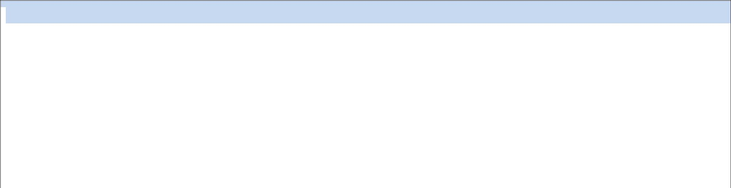
New maths vocabulary for year 3

 |  | Number and |  |  | Addition and |  |  | Multiplication |  |  |  |  |  | Geometry |  |  | Geometry
 |  | Number and |  |  | Addition and |  |  | Multiplication |  |  | Measure |  |  | (position and |  |  | (properties of |  |  | Fractions |  |  | Data/statistics
 |  | place value |  |  | subtraction |  |  | and division |  |  | Measure |  |  | (position and |  |  | (properties of |  |  | Fractions |  |  | Data/statistics
 |  | place value |  |  | subtraction |  |  | and division |  |  |  |  |  | direction) |  |  | shape)
 |  | Numbers to one |  |  | Column addition |  |  | Product |  |  | Leap year |  |  | Greater/less |  |  | Horizontal, |  |  | Numerator, |  |  | Chart, bar chart,
 |  | thousand |  |  | and subtraction |  |  |  |  |  |  |  |  | than ninety |  |  | vertical, |  |  | denominator |  |  | frequency table,
 |  |  |  |  |  |  |  | Multiples of four, |  |  | Twelve- |  |  | degrees |  |  | perpendicular |  |  |  |  |  | Carroll diagram,
 |  |  |  |  |  |  |  | eight, fifty and |  |  | hour/twenty-four- |  |  |  |  |  | and parallel lines |  |  | Unit fraction, non- |  |  | Venn diagram
 |  |  |  |  |  |  |  | one hundred |  |  | hour clock |  |  | Orientation |  |  |  |  |  | unit fraction
 |  |  |  |  |  |  |  |  |  |  |  |  |  | (same |  |  |  |  |  |  |  |  | Axis, axes
 |  |  |  |  |  |  |  | Scale up |  |  | Roman numerals |  |  | orientation, |  |  |  |  |  | Compare and
 |  |  |  |  |  |  |  |  |  |  | I to XIII |  |  | different |  |  |  |  |  | order |  |  | Diagram
 |  |  |  |  |  |  |  |  |  |  |  |  |  | orientation)
 |  |  |  |  |  |  |  |  |  |  |  |  |  |  |  |  |  |  |  | Tenths
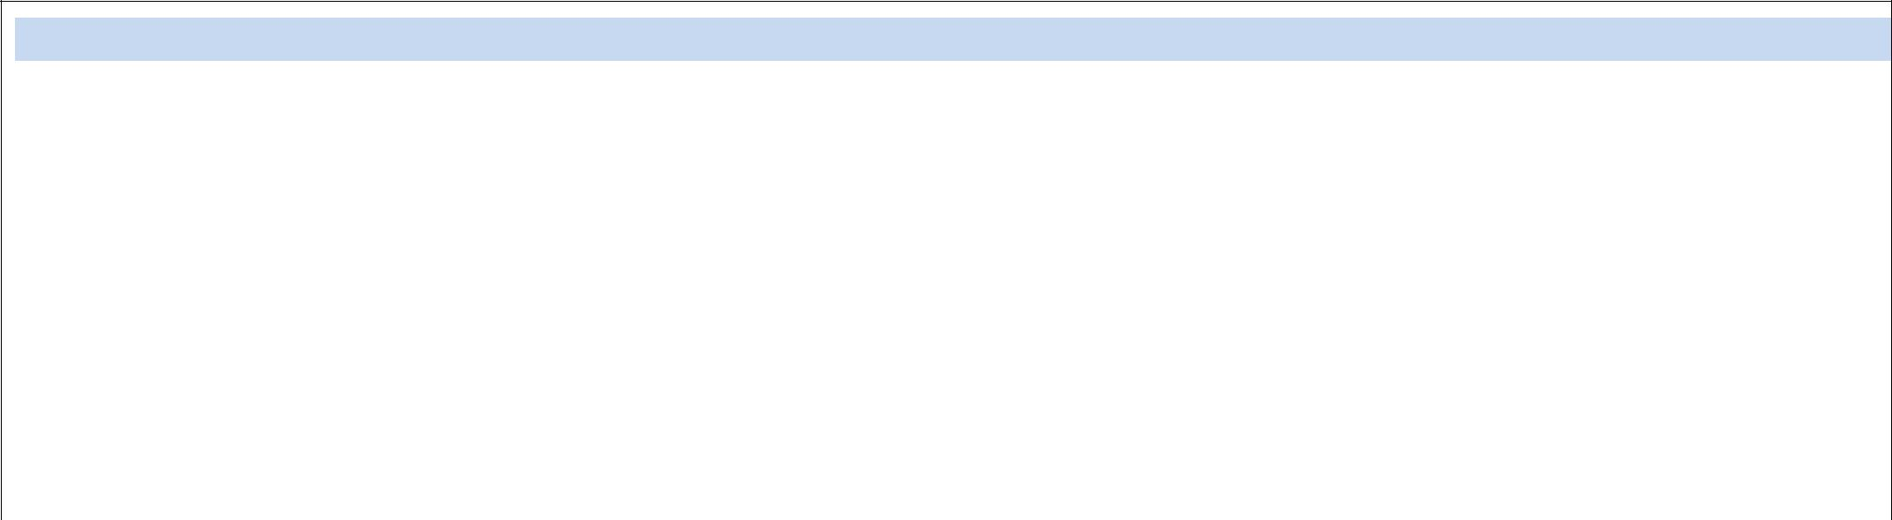
New maths vocabulary for year 4

 |  | Number and place value |  |  | Multiplication |  |  | Measure |  |  | Geometry (position |  |  | Geometry (properties |  |  | Fractions and |  |  | Data/statistics
 |  | Number and place value |  |  | and division |  |  | Measure |  |  | and direction) |  |  | of shape) |  |  | decimals |  |  | Data/statistics
 |  | Tenths, hundredths |  |  | Multiplication |  |  | Convert |  |  | Coordinates |  |  | Quadrilaterals |  |  | Equivalent decimals |  |  | Continuous data
 |  | Decimal (places) |  |  | facts (up to |  |  |  |  |  |  |  |  |  |  |  | and fractions
 |  |  |  |  | 12x12) |  |  |  |  |  | Translation |  |  | Triangles |  |  |  |  |  | Line graph
 |  | Round (to nearest)
 |  |  |  |  | Division facts |  |  |  |  |  | Quadrant |  |  | Right angle, acute
 |  | Thousand more/less than |  |  |  |  |  |  |  |  |  |  |  | and obtuse angles
 |  |  |  |  |  |  |  |  |  |  | x-axis, y-axis
 |  | Negative integers |  |  | Inverse
 |  |  |  |  |  |  |  |  |  |  | Perimeter and area
 |  | Count through zero |  |  | Derive
 |  | Roman numerals (I to C)

Maths Vocabulary – Years 1-6

St. Philips CE Primary School
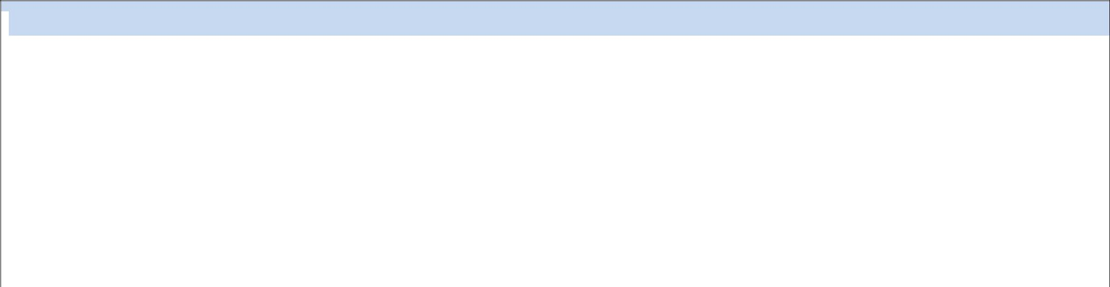
New maths vocabulary for year 5

 |  | Number and place |  |  | Addition and |  |  | Multiplication and |  |  | Measure |  |  | Geometry (position |  |  | Geometry (properties |  |  | Fractions, decimals and
 |  | value |  |  | subtraction |  |  | division |  |  | Measure |  |  | and direction) |  |  | of shape) |  |  | percentages
 |  | Powers of 10 |  |  | Efficient written |  |  | Factor pairs |  |  | Volume |  |  | Reflex angle |  |  | Regular and irregular |  |  | Proper fractions, improper
 |  |  |  |  | method |  |  |  |  |  |  |  |  |  |  |  | Polygons |  |  | fractions, mixed numbers
 |  |  |  |  |  |  |  | Composite |  |  | Imperial units, metric |  |  | Dimensions
 |  |  |  |  |  |  |  | numbers, prime |  |  | units |  |  |  |  |  |  |  |  | Percentage
 |  |  |  |  |  |  |  | number, prime
 |  |  |  |  |  |  |  | factors, square |  |  |  |  |  |  |  |  |  |  |  | Half, quarter, fifth, two
 |  |  |  |  |  |  |  | number, cubed |  |  |  |  |  |  |  |  |  |  |  | fifths, four fifths
 |  |  |  |  |  |  |  | number
 |  |  |  |  |  |  |  |  |  |  |  |  |  |  |  |  |  |  |  | Ratio, proportion
 |  |  |  |  |  |  |  | Formal written
 |  |  |  |  |  |  |  | method
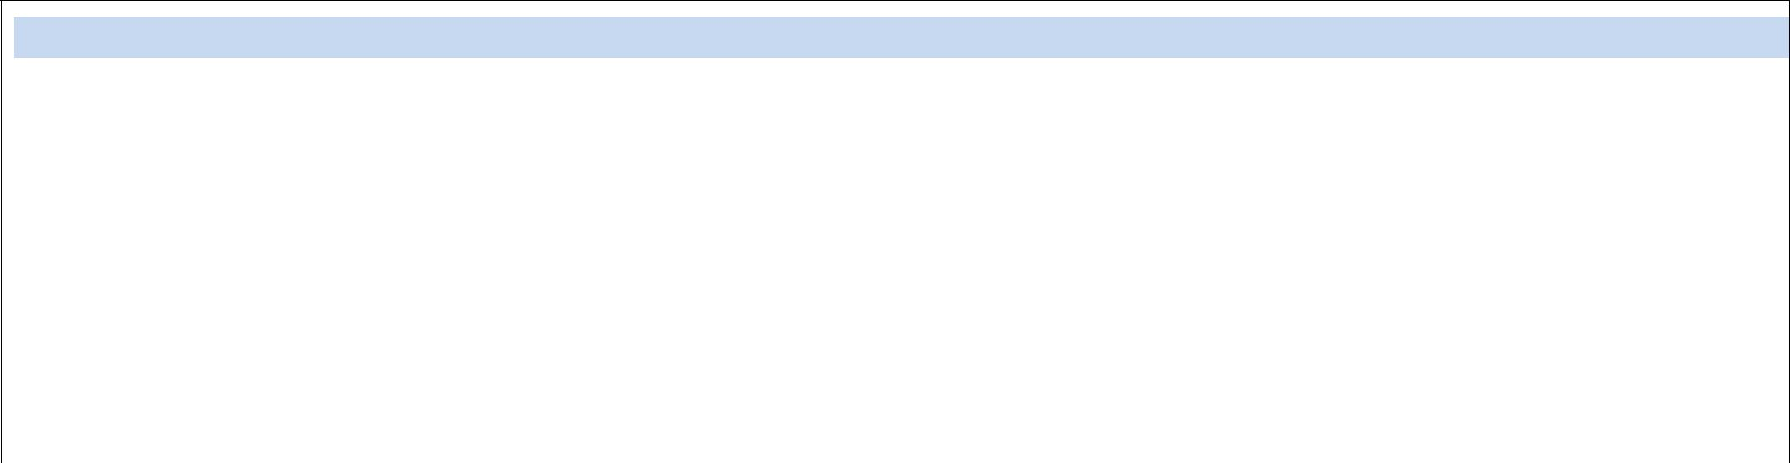
New maths vocabulary for year 6

 |  | Number and |  |  | Addition and |  |  | Multiplication |  |  | Geometry |  |  | Geometry |  |  | Fractions, decimals
 |  | Number and |  |  | Addition and |  |  | Multiplication |  |  | (position and |  |  | (properties of |  |  | Fractions, decimals |  |  | Algebra |  |  | Data/statistics
 |  | place value |  |  | subtraction |  |  | and division |  |  | (position and |  |  | (properties of |  |  | and percentages |  |  | Algebra |  |  | Data/statistics
 |  | place value |  |  | subtraction |  |  | and division |  |  | direction) |  |  | shape) |  |  | and percentages
 |  | Numbers to ten |  |  | Order of |  |  | Order of |  |  | Four quadrants |  |  | Vertically |  |  | Degree of accuracy |  |  | Linear number |  |  | Mean
 |  | million |  |  | operations |  |  | operations |  |  | (for coordinates) |  |  | opposite |  |  |  |  |  | sequence
 |  |  |  |  |  |  |  |  |  |  |  |  |  | (angles) |  |  | Simplify |  |  |  |  |  | Pie chart
 |  |  |  |  |  |  |  | Common |  |  |  |  |  |  |  |  |  |  |  | Substitute
 |  |  |  |  |  |  |  | factors, common |  |  |  |  |  | Circumference, |  |  |  |  |  |  |  |  | Construct
 |  |  |  |  |  |  |  | multiples |  |  |  |  |  | radius, |  |  |  |  |  | Variables
 |  |  |  |  |  |  |  |  |  |  |  |  |  | diameter
 |  |  |  |  |  |  |  |  |  |  |  |  |  |  |  |  |  |  |  | Symbol
 |  |  |  |  |  |  |  |  |  |  |  |  |  |  |  |  |  |  |  | Known values

Maths Vocabulary – Years 1-6

