 | Hist 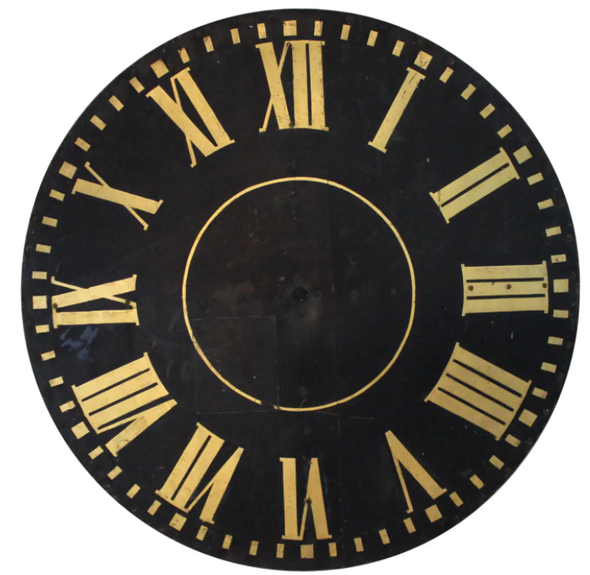ry  Newsletter  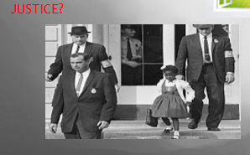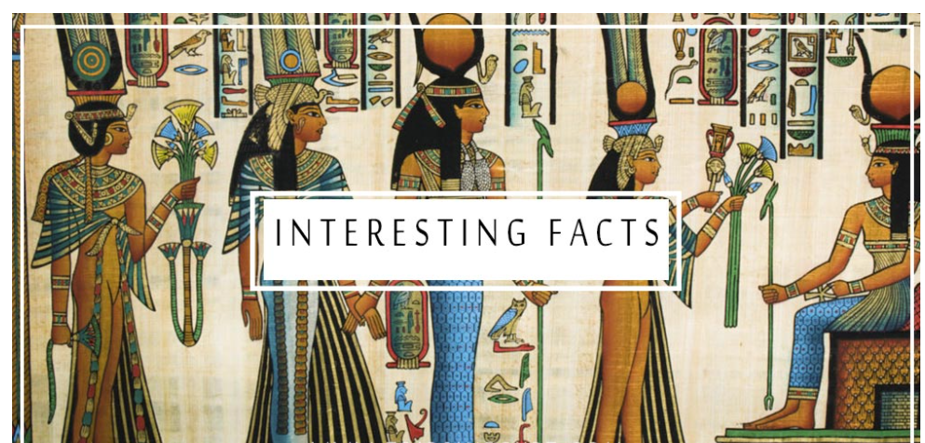  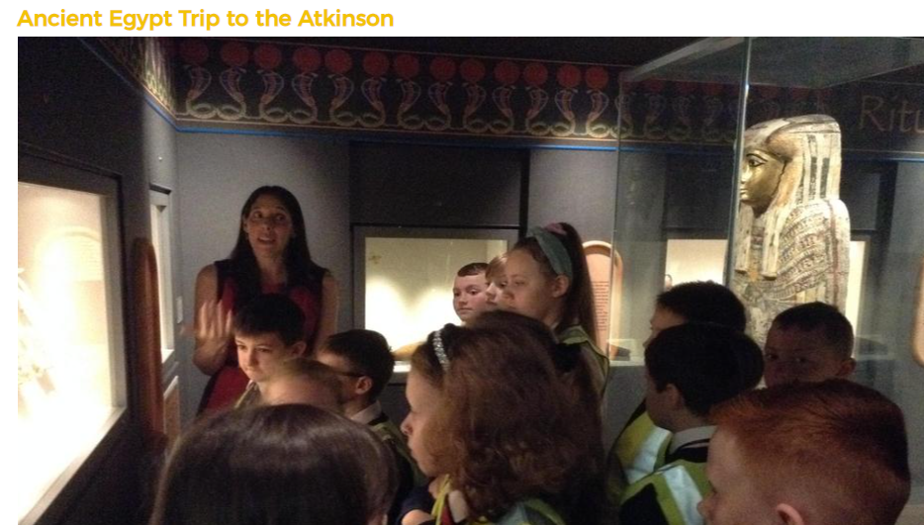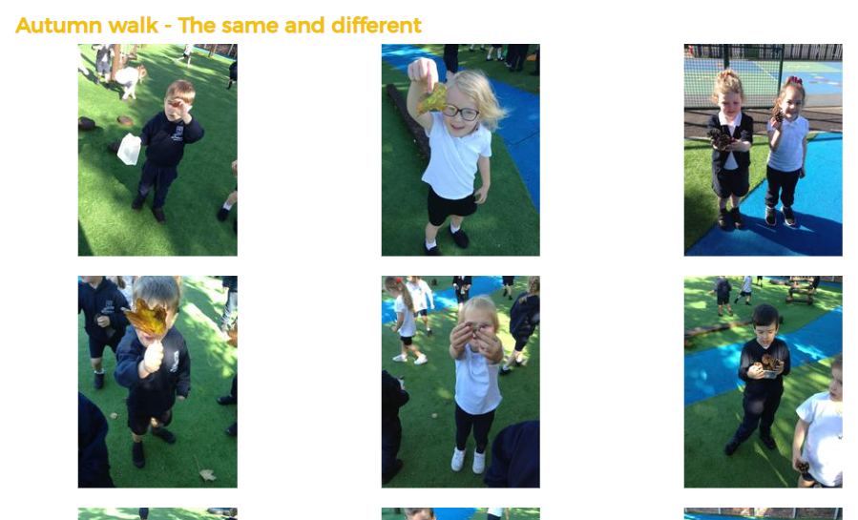  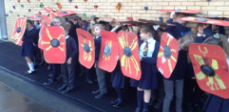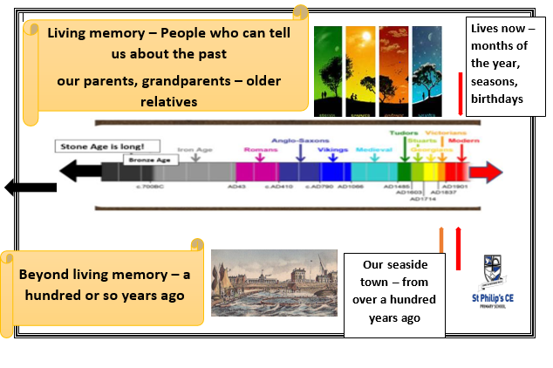  Pupil comments – using the Roman shields in a testudo formation made it all more real  The Atkinson has agreat Egyptian museum  Projects give us the chance to be more independent  History helps us appreciate our lives now – be inspired by the people of the past – respect other cultures – celebrate diversity – learn detective skills – and more! |   We’ve been busy!  We link history to the here and now – looking at how we can learn and improve on the past – here we link to our Christian value of Justice during our Black History Month activities  During the year junior classes undertake history projects – where they time travel to investigate the past as history detectives  Classes get out of the classroom – here is a visit to our local Egyptian museum and younger pupils investigating the local area  From Reception to Year 6 there are timelines for each classroom  We are proud to have the prestigious Gold History Quality Mark.  

