 | Hist 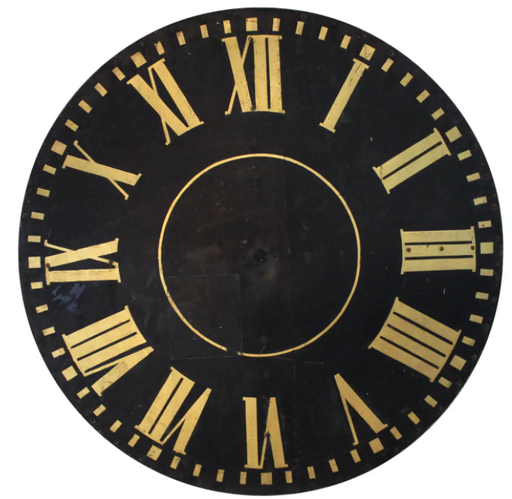ry  Newsletter  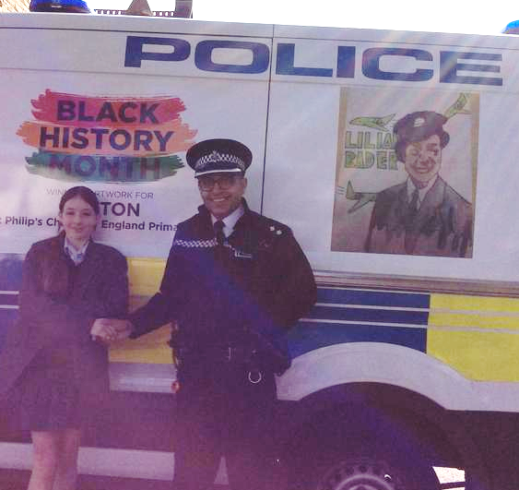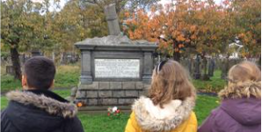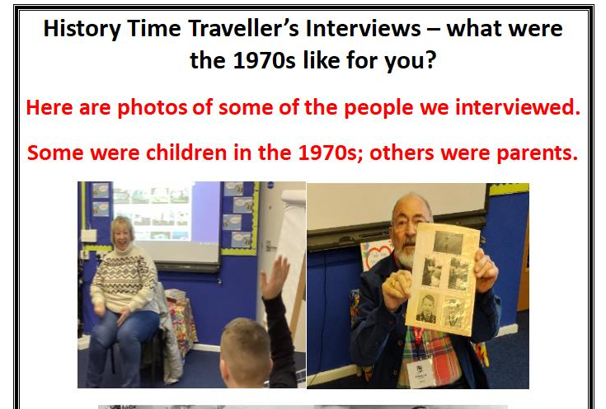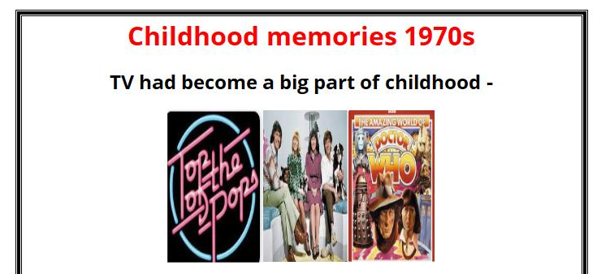  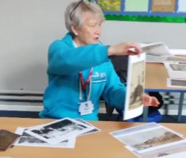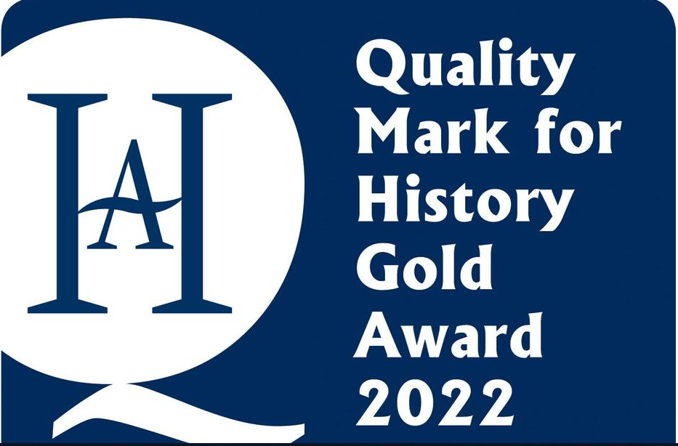  Pupil suggestions – The Atkinson and Liverpool World Museum are great for learning about Ancient Egypt  We loved the Beatles Story in Liverpool  If you are a fan of the Tudors – Rufford Old Hall  History helps us appreciate our lives now – be inspired by the people of the past – respect other cultures – celebrate diversity – learn detective skills – and more! |   We’ve been busy!  We won the Merseyside Police Competition for Black History Month for the second year running – see the photo of the police van.  Sefton Time Travellers Club – marking 50 years of Sefton – has been researching the 70s.  History Ambassadors have been visiting our local cemetery and other classes – to lead activities  We are proud to have the prestigious Gold History Quality Mark which recognises all the great history we’ve been doing over the last few years.  2024

