 | Hist 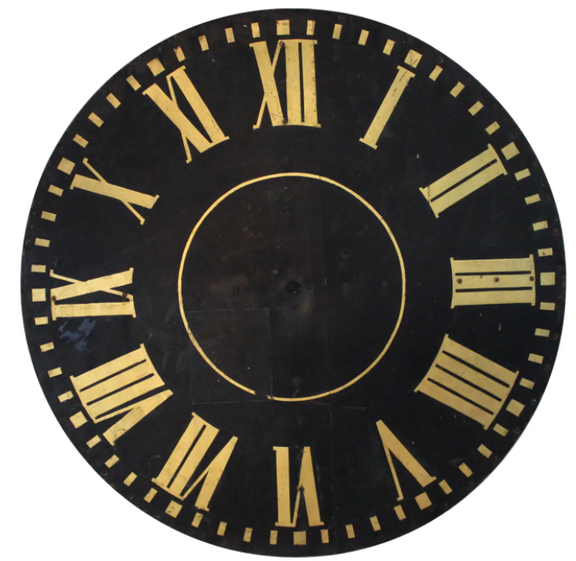ry  Newsletter    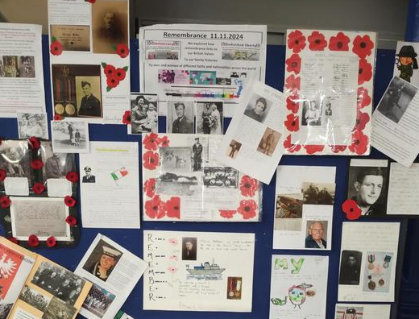  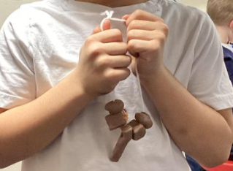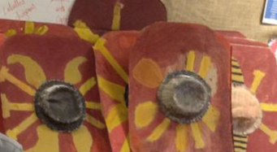  Pupil suggestions -  The Atkinson has a great exhibition of paintings showing how Southport grew into a seaside resort  The Western Approaches in Liverpool is all about WW2  History helps us appreciate our lives now – be inspired by the people of the past – respect other cultures – celebrate diversity – learn detective skills – and more! |   We’ve been busy!  We have a great new team of History Ambassadors who have been leading sessions with other pupils on Romans and Bronze Age so far.  This photo is of History Ambassadors visiting our local Jewish Cemetery in preparation for Holocaust Memorial Day  Remembrance – we had a great display about family connections to this  Creative history  – Stone Age jewellery and Roman shields  We are proud to have the prestigious Gold History Quality Mark  2025 Spring

