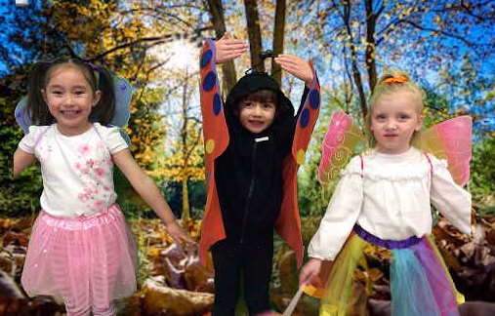
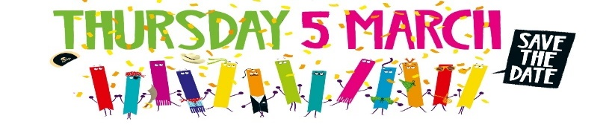

Reception were inspired by their minibeast topic in school and dressed up as their own!
Class theme for World Book Day. Children were encouraged to come dressed in an outfit that related to their class theme.
Class book themes:
Reception: Mad About Minibeasts
Year 1: Julia Donaldson stories
Year 2: Traditional Tales
Year 3: Naughty character Stories
Year 4: Heros and Villains
Year 5: Science Fiction stories
Year 6: Spy/detective stories
We were so excited for World Book Day again this year!! We absolutely loved celebrating our favourite books last year and could not wait for more reading fun! This year, each class came to school dressed up in their own class book theme. We explored our own book themes in class over the day where we did lots exciting activities including creative writing using ICT! We loved seeing everyone’s creative outfits and children bringing in their favourite books! To also celebrate, as we love our books fairs, we were also having our book fair back visiting school. It will would have arrived on Wednesday 18th March filled with lots more new books for us to buy but was postponed due to Covid 19.

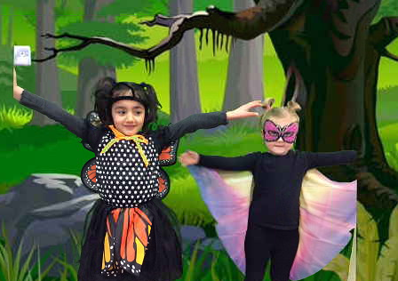
We have used World Book Day this year for our inspiration for writing using ICT and our fabulous green screen to generate a setting for our characters!
Year 6 were very serious with their spy/detective roles!
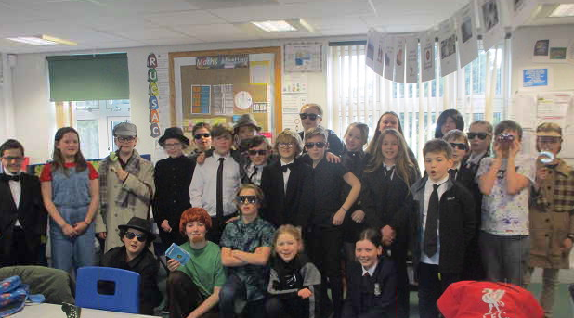

Year 4 looked fabulous dressed up as their heroes and villain theme!

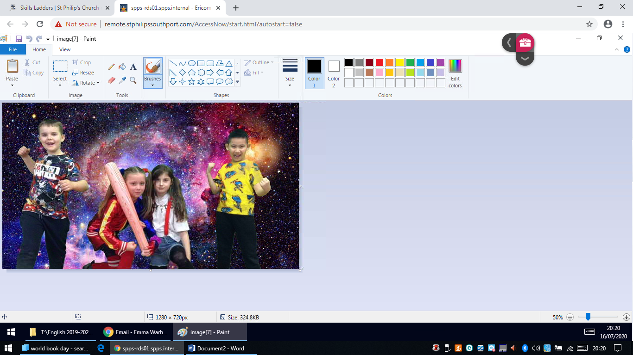
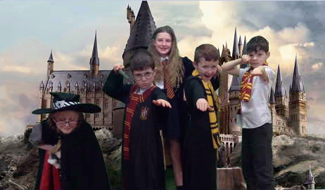
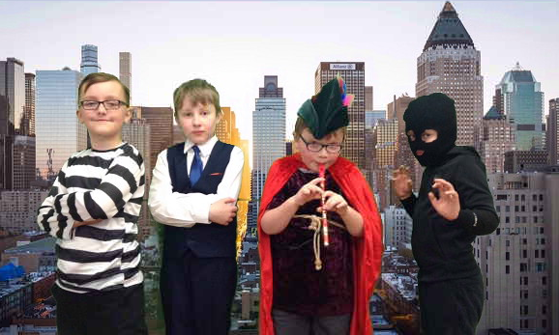
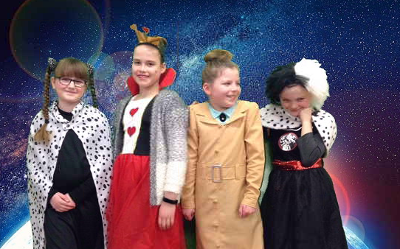
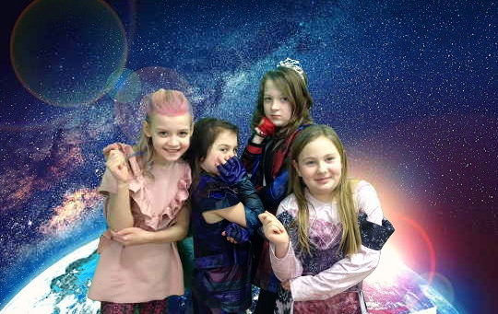
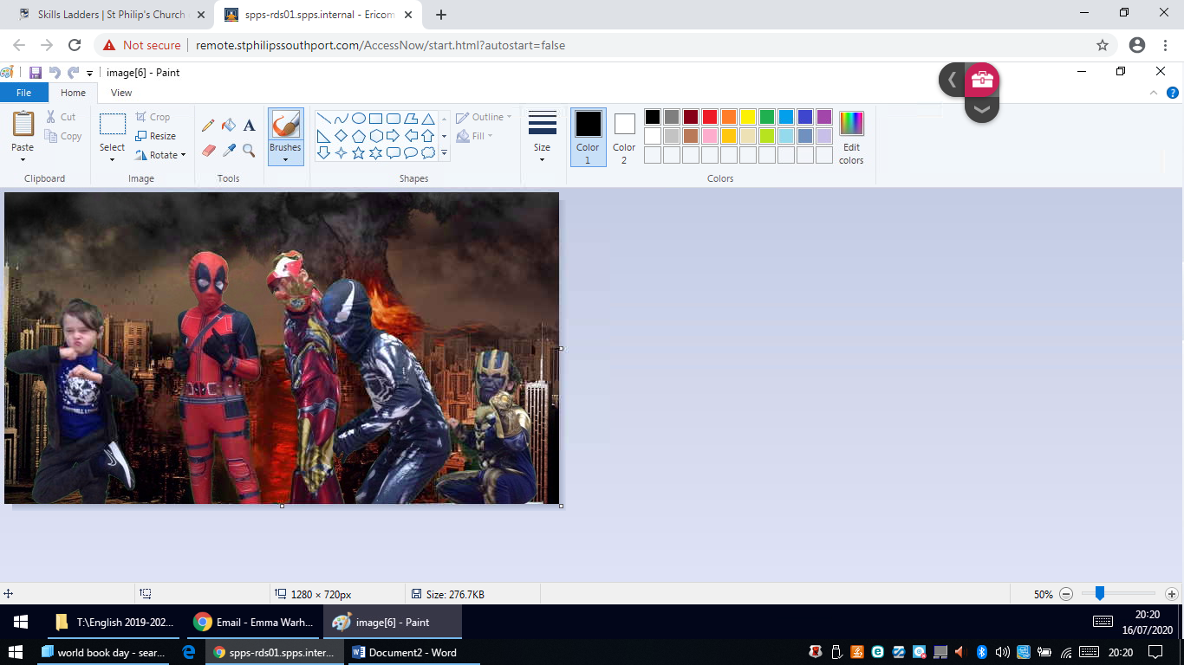

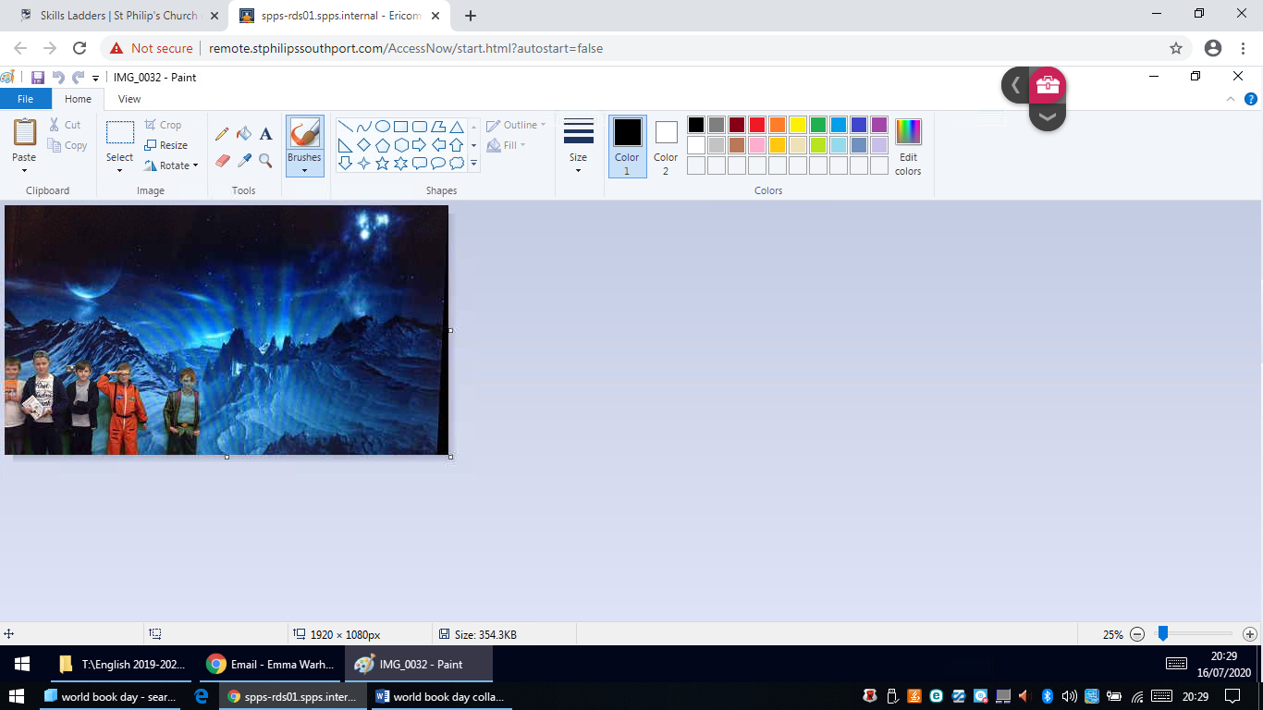
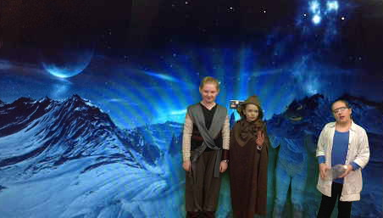
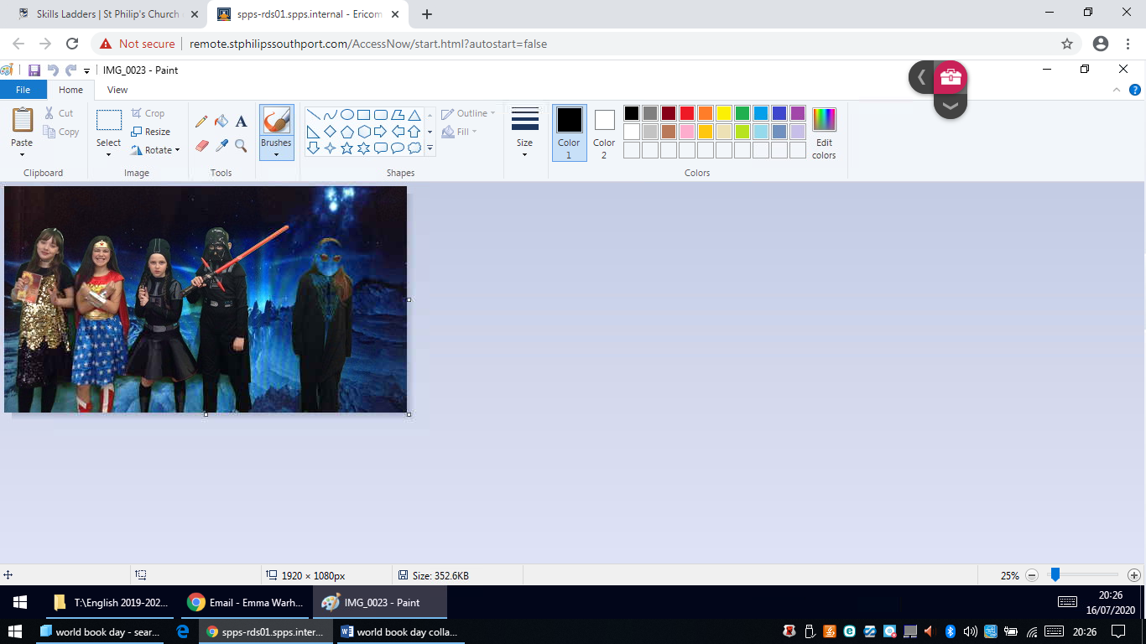
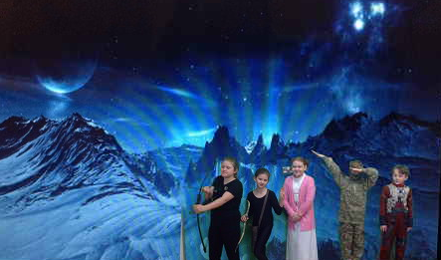
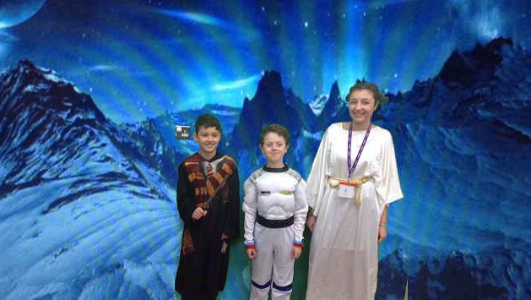
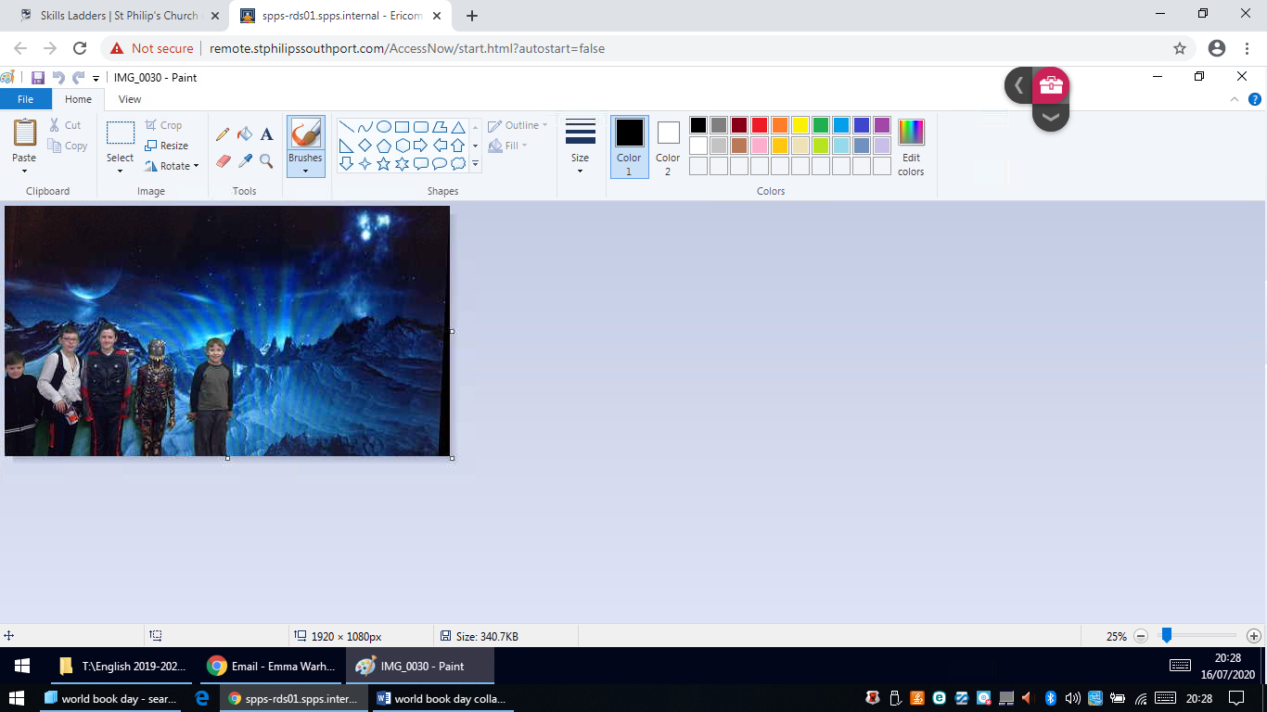

Year 5 all dressed ready for Science Fiction adventures!

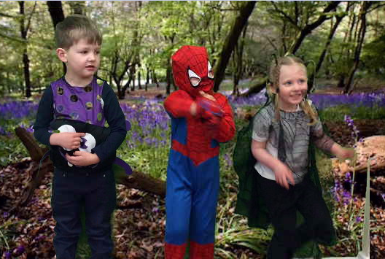
Reception are all ready for their mini beast story time!


