
My life in lockdown
Dear Diary, my life in lockdown has been very hot like the very hot sun
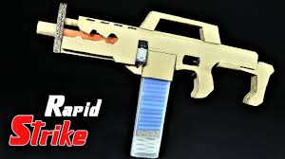
And I love shooting my sister with an electric gun.
And I’ve been playing a sport and I thought. 
The next game I could off bought.
And I sit with my mum and dad and they go terribly mad I get sad.
The next day they are still terribly mad. 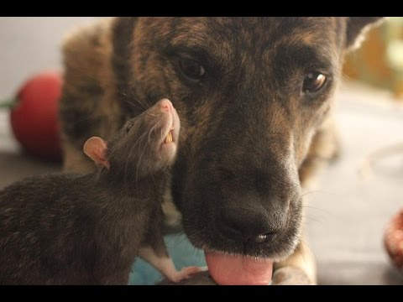

Wrote by Saul Forbes

