My life in lockdown.
My life in lockdown is going good and really fun,
I’ve been chilling on my trampoline under the hot sun.
I’ve been chilling with my mum and dad,
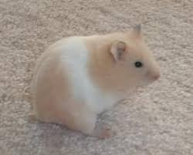
Sometimes they go really mad.
Most of the time I’ve been in school,
one day peekaboo was in a tiny pool.
Sometimes I lose track of time,
Sometimes I’m absolutely fine.
I have a hamster which is fat,
At least I don’t have a disgusting rat.
I like to play sport,
And I like to play with my water gun that I bought.
I might do a colouring sheet,
Which is very neat.
I like to wrestle my elf,
By myself!
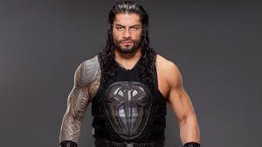
Leo Wilson YR 4

