In Lockdown I have been doing lots of painting of bee hives and I went to see the bees in my special bee suit along with my sister Leonie and my Dad too. We have got 2 hives at my dad’s work we have been trying to find the queen bee in colony 2

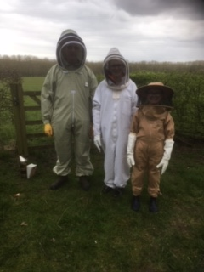

We have been baking cake and banoffee pie and school cake the school cake looks yummy!

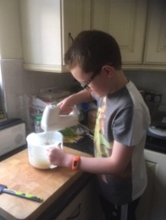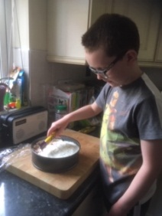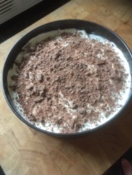

The whole family chopped a big bush and lots of gardening. We planted sum sun flowers but they did not grow because they were too old but we planned some beetroot.

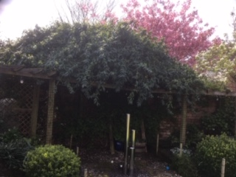

Tilly and I have been playing in the garden with the ball, and with toys in the house.

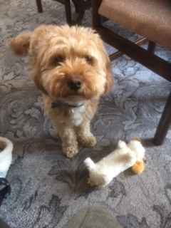

My family and my god-parents have been playing 5 crowns on face time, it worked really well, I came 5th.

I went to work with my Dad and helped in the garden and picked up sum twigs.

I have done lots of school work every day except on Saturday and Sunday.

We have done a very big rainbow it is really big and colourful.

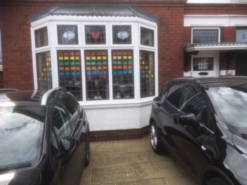

My cousin had a baby on Saturday 9th May and his name is Alfie, he is so cute.


