Reception
Leon Murphy
My life in lockdown

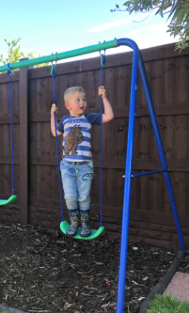
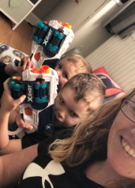
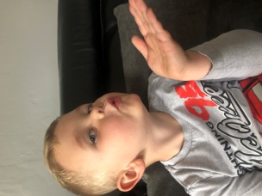
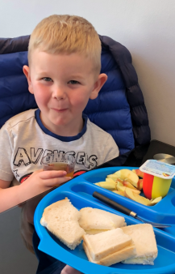
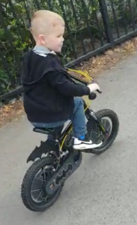
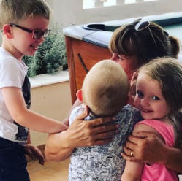
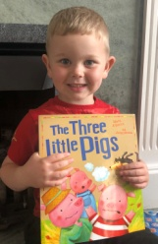
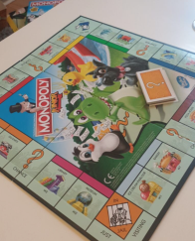
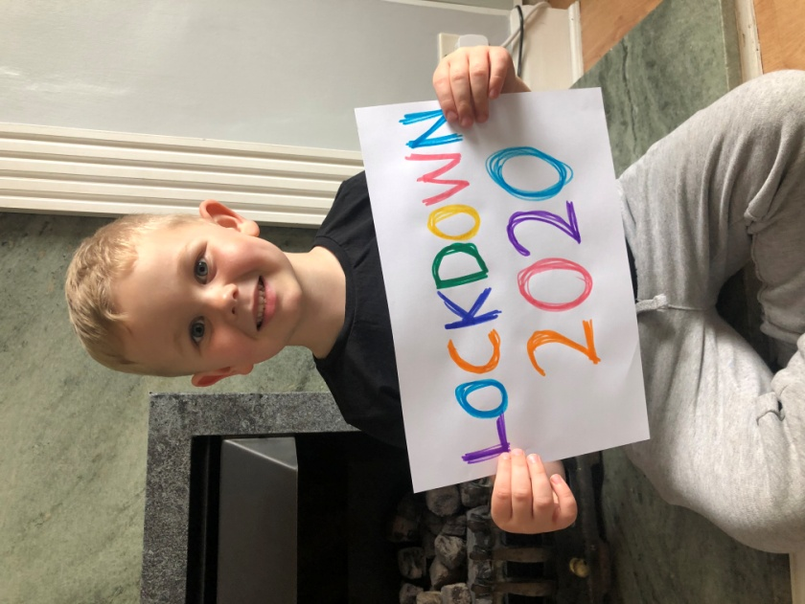
Boris sed we need to stay 2m apart but its ok I can blow kisses insted
Boris sed no
mcdonalds
but its ok I
can eat at home
Boris sed we can exercise so I lernd to ride my bike with no stabilizers
Stay Home
Thank you NHS
Boris sed we cant go out but its ok I can play games at home
Boris sed no work for grown ups but is ok we can play
Boris said
no going to
the park but
is ok I can
play in the
garden
Boris sed no scool but its ok I can do my work at home
Boris sed we cant see our famlee but its ok we can call them

