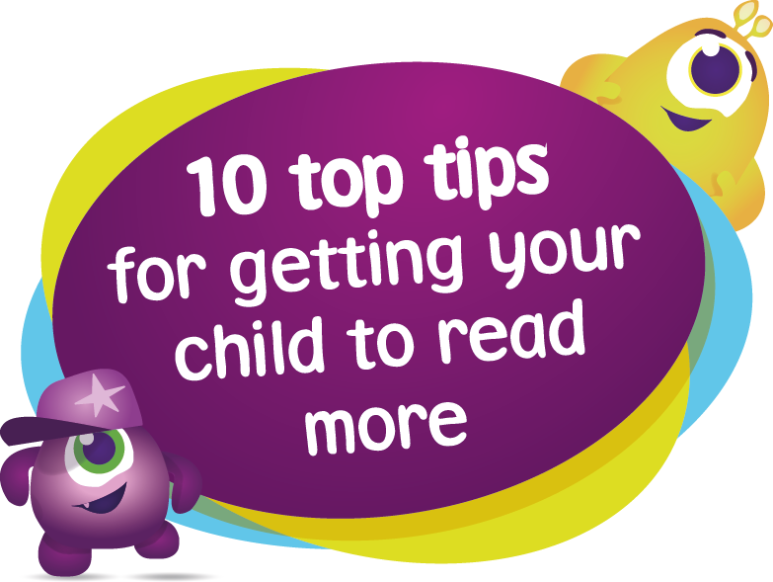
Reading with your child
Sharing a book with a child is fun - it's a time for closeness, laughing and talking together. It can also give children a flying start in life and help them become lifelong readers

Top 10 tips to help children enjoy reading
Reading should be fun. We asked experts and authors what you can do to help turn your kids into little bookworms.
1. Make books a part of family life – Always have books around at home. That way you and your children are ready to get reading, even if it’s only for ten minutes.
2. Join your local library – Get your child a library card. They’ll be able to get their hands on hundreds of fantastic books, as well as the latest video games, blu-rays and DVDs. Let them choose what they want to read to help them develop their own interests.
3. Read about something they’re interested in – Help your child find the right book for them. It doesn't matter if it's fiction, poetry, comic books or non-fiction.
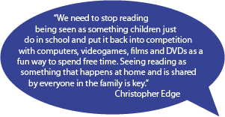
4. All reading is good – Don’t rule out non-fiction, comics, graphic novels, magazines or leaflets. Reading is reading and it’s all worthwhile.
5. Get comfortable! – Snuggle up together somewhere warm and cosy, whether it’s in bed, on a beanbag or on the sofa. And make sure your child has somewhere comfy to read on their own too.
6. Ask questions – To keep them interested in the story, ask your child questions as you read. Start with ‘Where did we get to last time?’, ‘Can you remember what’s happened so far?’ and 'What do you think will happen next?'.
7. Read whenever you get the chance – Have a book or magazine with you for any time your child has to wait, like at the doctor's or the dentist.
8. Read favourites again and again – Encourage your child to re-read the books and poems they love. Re-reading helps to build fluency and confidence.
9. Enjoy bedtime stories – Read with your kids at bedtime as often as you can. It’s a great way to end the day and to spend valuable time with them.
10. Make the most of rhyme and repetition – Books and poems with rhymes and repeated words or phrases are great for getting your kids to join in and remember the words.

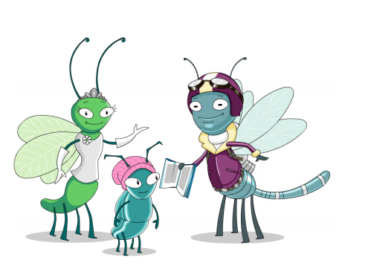
Why is reading so important? Evidence suggests that children who read for enjoyment every day not only perform better in reading tests than those who don’t, but also develop a broader vocabulary, increased general knowledge and a better understanding of other cultures. In fact, there’s evidence to suggest that reading for pleasure is more likely to determine whether a child does well at school than their social or economic background.
What difference could I make as a parent?
The short answer is: a lot! Parents are by far the most important educators in a child’s life and it’s never too young for a child to start, even if you’re only reading with your child for a few minutes a day. Before they’re born, babies learn to recognise their parents’ voices. Reading to your baby from the time they’re born gives them the comfort of your voice and increases their exposure to language. Building vocabulary and understanding Learning to read is about listening and understanding as well as working out print. Through hearing stories, children are exposed to a rich and wide vocabulary. This helps them build their own vocabulary and improve their understanding when they listen, which is vital as they start to read. It’s important for them to understand how stories work as well. Even if your child doesn’t understand every word, they’ll hear new sounds, words and phrases which they can then try out, copying what they have heard. As children start to learn to read at school, you can play an important role in helping to keep them interested in books, finding out what interests them and helping them to find books that will be engaging and fun for them. Give time to helping them practise reading the books they will bring home from school.

For more information and ideas to help your child develop a love of reading, visit:
The National Literacy Trust’s Words for Life website is packed full of information, advice and resources for parents to help develop children’s language and communication skills from 0-11 years: www.wordsforlife.org.uk
- BookTrust’s Bookfinder helps parents find the perfect book for their child, according to age and interests: www.booktrust.org.uk/books/bookfinder/
- BookTrust’s best books for children guide lists the top 100 books for children to read before they’re 14: www.booktrust.org.uk/books/100-best-books/
- The National Literacy Trust’s Literacy Apps website is a handy guide for parents with tips to on how to get the most out of apps that help young children learn communication skills: http://literacyapps.literacytrust.org.uk/

- Find stories and activities from popular CBeebies shows to boost your child’s literacy skills: www.wordsforlife.org.uk/cbeebies-magazine-activities

