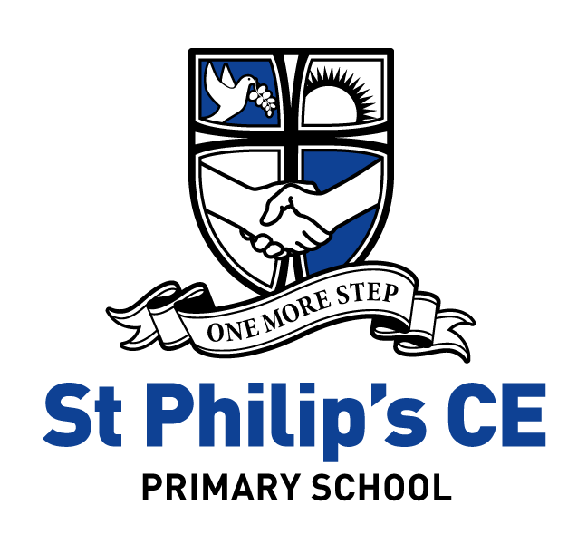

Reading at St Philip’s CE Primary School

Early Reading and Phonics:
Phonics is taught daily in Reception, Year One and Year Two. Each session is twenty minutes long and incorporates the main four elements; revisit, teach, practise, and apply revisit. The children are placed in ability groups according to the phase they are working within from phase 2 to phase 6.
At St Philip’s Primary School, we follow Jolly Phonics in Reception and progress on to the Letters and Sounds document and practice high quality phonics. As a school we subscribe to Phonics Play and use the planning and interactive materials to enliven the curriculum. This is followed by guidance from Support for Spelling to extend higher achieving pupils in Year Two.
The six phases of the Letters and Sounds document provides a structure for teachers to follow and plan children’s progression from, although the boundaries between the phases are not fixed, allowing teachers to plan across the phases depending on the class needs. Teachers’ assessment of individual children will inform the rate at which their children are able to progress through the phases and adapt the pace accordingly.
It is important that the five phases are embedded and the children have a sound understanding of the key knowledge and skills before the final sixth phase is introduced. Year 2 teachers will strive to be able to expose all children to the key elements of Phase 6 by the end of the academic year.
Each year, Reception will run parent workshops that are an introduction to phonics alongside Year 1, who will also host an annual workshop for parents that relates to the national phonics check
Daily Teaching:
Each child benefits from:
- A daily, discrete phonics session at 9:00am.
- Fluid groupings which change according to children’s progress.
- Small group teaching to enable focused differentiation.
- Highly trained practitioners leading fun, interactive and effective sessions.
- Effective assessments which track children’s achievement and attainment over time.
- The opportunity to work across an age phase rather than across a year group.
- A weekly spelling test linked directly to the group’s weekly learning objectives.

Early Readers (Reception)
Children will be split into very small groups of 1, 2 or 3 children based on their reading stage and ability. Each group of children will be taught by the teacher, TA and usually a second adult (TA) over the course of the week.
The children will also be learning independently, focused on phonics reading games / activities appropriate to the phonics stage in which they are securely working. As children’s reading skills become more developed, they may move onto reading linked to a ‘Big Question’ where they talk with a partner about an area of learning linked to Reading Dogs skills. This may be recorded by an adult onto stickers but there is no expectation for children to be recording their own answers in Reception.
Reading:
At St Philip’s CE Primary School, we want children to develop a love of reading.
We have a structured approach to the teaching of reading and aim to develop confident readers who enjoy a wide range of texts.
Children share books as a class, in groups and individually. We work with children to develop their understanding of texts through whole class comprehension activities and have recently introduced 'Reading Vipers' and ‘Reading Dogs’ to focus on the key areas of comprehension. We encourage KS2 pupils to take school library books home alongside individual reading books.

Children are supported to develop their reading skills and the level of support given depends on the needs of each child. We use published schemes such as Oxford Reading Tree, Collins Big Cat and Project X. Children are also supported by our volunteer parents, who regularly come into school. Book Banding is established in school. We have bought many new books over the last few years and introduced schemes, such as Collins Big Cat, which are proving popular.
Parental support is crucial in the development of a child's reading ability and we love to read your comments in their reading diaries.
Whole Class Reading:
From the start of Autumn term 2020, we at St Philip’s have moved away from a guided reading small focus group approach and instead now deliver the teaching of reading in a whole class environment.
From KS1, children learn the reading domains inline with the KS1 curriculum. Children transition between Years 1 and 2 from a guided group focus to a whole class setting.
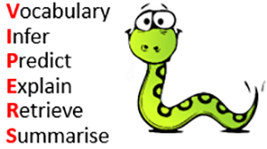
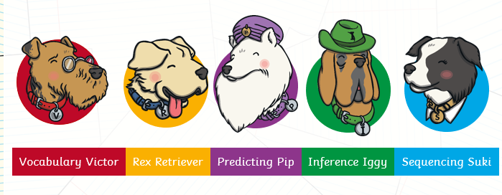
At St. Philip’s CE Primary, Reading Dogs are used to support the teaching of reading across EYFS and KS1. Reading VIPERS are used to support children with their reading comprehension skills form Years 3-6. VIPERS are a range of reading prompts based on the 2016 reading Content Domain Areas (CDAs) found in the National Curriculum Test Framework. Children are explicitly taught the skills of reading (outlined in the National Curriculum and the KS1 and KS2 test domains) through the use of VIPERS which were created by Rob Smith (The Literacy Shed). In EYFS and KS1, each class display the reading dogs in each classroom and in KS2 each classroom display the Reading VIPERS in their classroom and the class teacher makes explicit links to the skill the children will be learning about. This gives all children across the school a common language to discuss their reading knowledge and understanding.

All children will be working on the domains of the Reading Dogs/ VIPERS during class reading, whether it is reading as a class, in a small group, or one-to-one with an adult.

Whole Class Reading Lesson Structure

Our whole class reading lessons take place once a week focus reading lesson that teaches and models the reading skills covered in Reading Dogs (early years and KS1) and VIPERS (KS2). This is evidenced in our English books.
As well as this, children need a comprehension lesson once every two weeks linked to their English unit/foundation topics where children have the opportunities to access a full text that allows them to answer a mixture of comprehension questions as well as developing their reading stamina.
These are separate to but may complement literacy sessions.
Sessions may vary session to session/ class to class depending on the needs of the children but has a general rule time spent on each domain is based upon the English Reading Test Framework (2016) number of marks available for each content domain.

During a typical session the teacher will share what the content domain/s the children will be focusing on for that session. Teachers carefully select their reading objectives linked to the LAPS targets in each year group’s class reading folder. Where appropriate they are linked to and applied not just during English sessions but also cross linked to topic contexts.
During these sessions, teachers cover a variety of fiction, non-fiction, poetry, songs, picture books, even short films to ensure children get access to a wide range of texts. Types of text given are appropriate to the age and key stage of the children.

Children read during these sessions in a variety of different ways. They may hear the teacher model fluent reading and then have time to reread the same extract themselves, they may read individually and feedback, work in groups, take turns in pairs or read aloud to their peers. You may see a number of these different strategies during one session.

Teachers plan key questions each session based on the content domain being focused on.
Children are encouraged to orally speak the answer before writing anything down acknowledging their first answer may not always be their best. At times children are given sentence stems and vocabulary that is expected to be used within their answer. TA/ teacher support is also provided to support SEN pupils where necessary.

Children are encouraged to provide evidence for their answer based on a text extract or a picture they have seen in the book. Where appropriate children are encouraged to use evidence from a range of different places within the text as modelled to them in the lesson.

Further information can be found on our school website under our English/Reading page:
https://st-philips-church-of-england-primary-school.secure-primarysite.net/reading-3/

