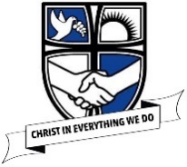

Design Technology at St Philip’s

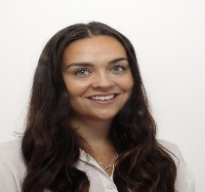
Here is a quick look into Design technology in our school!
Design technology Topics!
Reception – Using mixed media and getting expressive in line with the early learning goals.
Y1 -Making kites
Y2 – Making Australian Boomerangs
Y3 – Making Koulourakia
Y4 – Electrical circuits
Y5 – Designing and making boats
Y6 – Making Mayan headdresses
Hello all! My name is Miss Houghton and I am the Reception teacher. However, I am also the subject leader for Design Technology in our school! I love making unique designs and it is my job to make sure we all do dazzling pieces of DT within school!
Our Golden Thread 3 words!

Make

Plan

Evaluate

What is Art and Design at St Philip’s?
Year 5 – Making Maquettes!
At St Philips’ all children are given the opportunity to learn practically through Design technology. It teaches the children about the design of a range of objects, how certain working parts are made and how to join, fix and use materials effectively. The children learn to assemble, disassemble, plan, construct and evaluate their work.

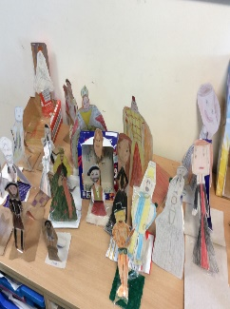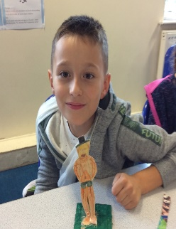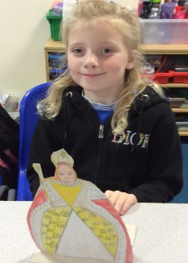
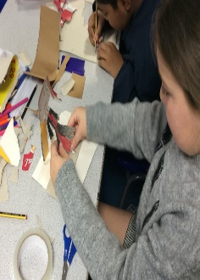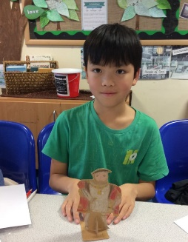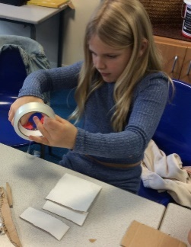
As part of year 4’s DT project the children have been looking at African Art. They carried out their design research and created a design brief focusing on geometric patterns. The children then put together their design ideas and chose one that they were going to do. They considered the colours and the pattern specifically. The children then considered the resources, materials and tools needed and got to work creating their design. Once the children completed their design they then self-evaluated.
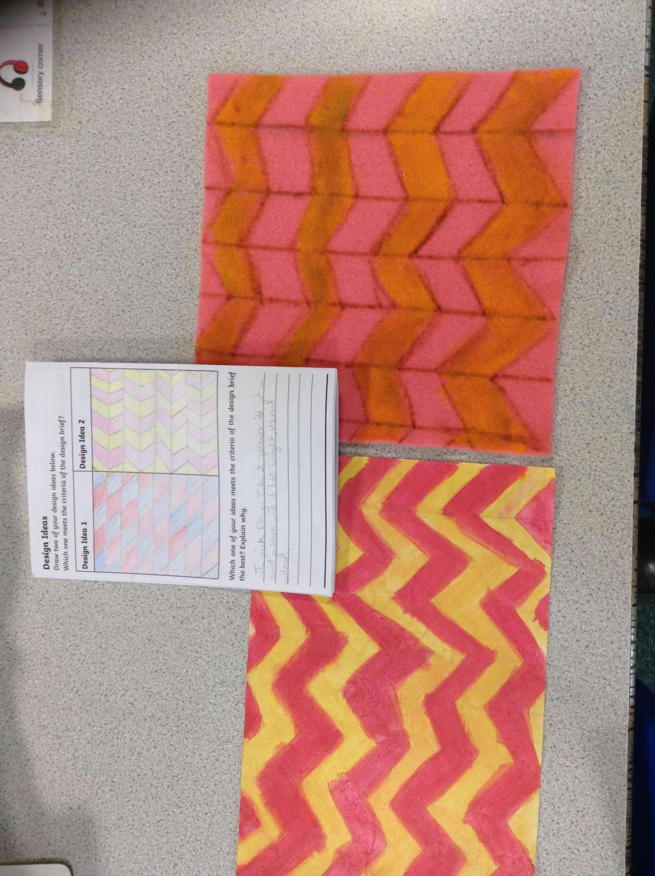

Year 4 -
Chinese Lanterns for Chinese new Year !

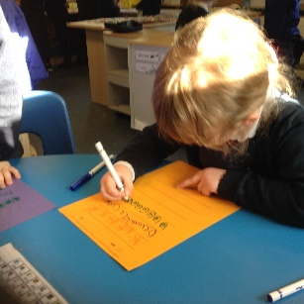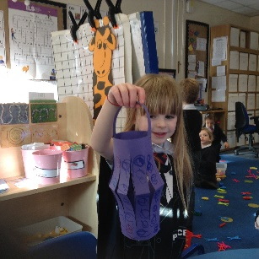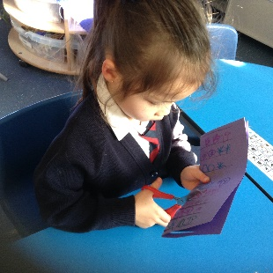
‘I used my cutting skills to ensure the design was correct’ - Samantha
‘We designed our Chinese lanterns based upon authentic Chinese patterns’ - Bella
‘We then assembled our lantern using scissors and glue’– Scarlett

Look at the school website below for more information and regular updates about what we are doing!
https://www.stphilipssouthport.com/design-technology-1/

/

‘We designed our own Chinese patterns’– Bella
‘I choose a purple lantern and used my cutting skills to get the end result’ – Scarlett
‘I can hold my scissors correctly in order to cut the correct parts of the lantern’ – Samantha

