

Design and Technology
Intentions, Implementation and Impact Statement

At St Philip’s our Design and Technology Curriculum is driven by our whole school vision and values.

Happiness, Love and Security Abound
Everyone is Special
Every Achievement is Celebrated
Relationships and Teamwork Matter
A Beacon of Light in the Community
Christ is in Everything We Do
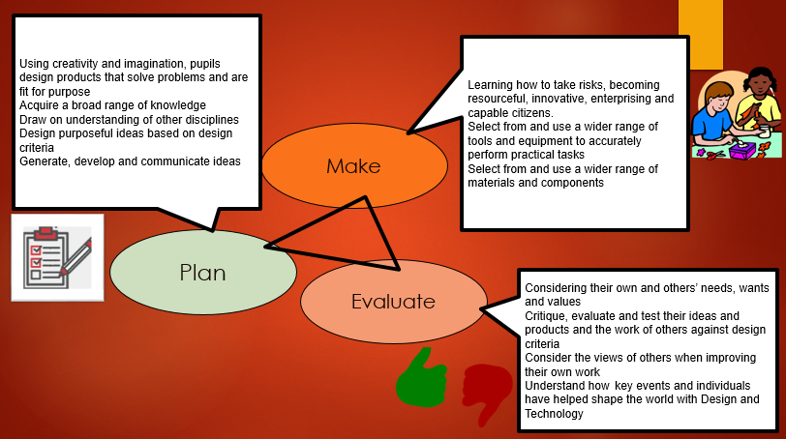

Subject Leader: Alexander Vernon

Design and Technology intentions:
Our golden threads run through our D&T provision - Educating for Wisdom, Knowledge and skills - Educating for hope and aspiration - Educating for community and living well - Educating for dignity and respect.
Design and Technology (D&T) enables children to actively contribute to the creativity, culture, wealth and well-being of themselves, their community and their nation. It allows them to gain ‘real-life experiences’ and encourages them to become independent, inquisitive problem solvers and thinkers as individuals and part of a team. D&T gives children the skills and abilities to engage positively with the designed and made world and allows them to harness the benefits of technology. Through the study of D&T, children combine practical skills with an understanding of aesthetic, social and environmental issues, as well as functions and industry. We aim to, wherever possible, link work to other disciplines such as mathematics, science, computing and art. The children are also given opportunities to reflect upon and evaluate past and present design technology, its uses and its effectiveness and are encouraged to become innovators and risk-takers.

In the EYFS and Infants, the main aims are to enjoy D&T through their ‘Creating with Materials’ Curriculum, learning the basic skills and techniques to be built upon as they progress through school. We encourage them to develop their curiosity, begin to design purposeful, functional, appealing products, learn about the importance of nutrition and help them to generate, develop, model and communicate their ideas through talking, drawing, templates, and, where appropriate, information and communication technology.

In KS1 this looks like:
Design:
- Design should be rooted in real life, relevant contexts to give meaning to the learning.
- Planned through appropriate formats: drawing, templates, talking and mock-ups.
Make:
- Children should be given a range of tools for their projects to choose from.
- Children should use a wide range of materials and components; textiles, construction equipment and ingredients.
Evaluate:
- Evaluate existing products.
- Evaluate their own products against design criteria.
.
As pupils progress, they learn to be able to think critically and develop a more rigorous understanding of D&T. They build on their existing knowledge and apply their knowledge and understanding in real-life contexts, relating it to the world around them and appreciating the work that goes into creating magnificent products.
By the end of KS2, we want our children to leave our school with a wide range of Design and Technology skills, developed through positive experiences.
In KS2 this looks like:
Design:
- Rooted in real life, relevant contexts to give meaning to the learning.
- Researched designs based on functional, appealing products with purpose.
- Planned by appropriate methods; annotated sketches, cross-sectional diagrams, prototypes, pattern pieces and computer aided design.
Make:
- Children can select from a wider range of tools than KS1.
- Children should use from and select a wider range of materials and components; textiles, construction equipment and ingredients.
Evaluate:
- Evaluations should be in comparison to existing products.
- Children should evaluate against a design criteria.
- Children should understand how key events and individuals have helped shape design and technology globally – products are in context.
Design and Technology: Implementation
Class teachers are supported in a range of ways:
- a subject leader with developing experience.
- medium term plans that complement the topics taught in each year group as well as covering the necessary skills.
- Knowledge organisers.
- CPD to be cascaded through staff.
A curriculum which …
- is carefully planned to build and deliver new skills, knowledge and appreciation and techniques.
- has a strong focus upon developing skills.
- develops children’s curiosity and enquiry, learning to examine, question and analyse.
- develops pupils understanding of why we study D&T.
- understanding the contribution that people, events and Design movements have made to our way of life now.
- is inclusive and considers all religions, race, cultures, age, abilities and gender.
- is taught with a focus on our Christian values.
Design and Technology: Impact
Children have become more confident in demonstrating the new skills they have learned.
D&T has been developed as a discreet subject, developing skills, vocabulary and understanding of techniques, as well as a supporting subject with cross-curricular links to most subjects. Children are learning how it enriches the world around us.
The children are enthusiastic about the subject and demonstrate high levels of enjoyment throughout the school.
How do I know I am better at D&T now than I was?
Children are encouraged to regularly review their emerging skills and successes.
They are encouraged to recognise their own personal development and skills they now have that they did not when they were younger.
Assisting a peer with a skill or technique because they have mastered it.
The areas outlined in the national curriculum and target tracker enable children to see how they are progressing. However, the practical aspects of the subject focus on children experimenting and through this, developing skills, techniques and knowledge and understanding of how, why and reasons for their choice of design. This builds children’s progress and ability but at differing speeds.
Progress expected ranges from understanding how to use different tools and materials for various purposes in planning executing and evaluating to detailed designs incorporating a range of skills.

