Design and Technology Policy

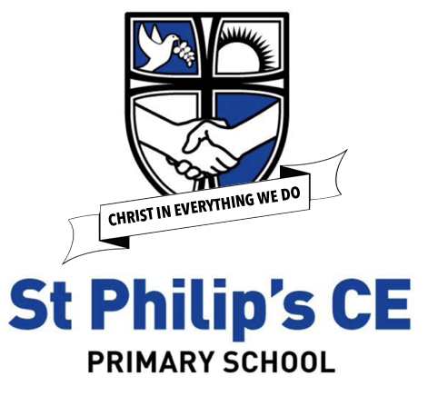

Lead | Alex Vernon
Head | Sandie Edward
Chair of Governors | Jeremy Hooper
Policy amended | Jan 2024
To be reviewed | Jan 2027

Mission statement

At St Philips, we strive for excellence in education by providing a safe, secure, caring family environment, where all children are valued and respected as individuals, enabling them to reach their full potential, whilst growing in their love and understanding of the Christian Faith.

Aims of the design and technology policy

Our design and technology policy follows The National Curriculum 2014 Guidelines and aims to ensure that all pupils:

- Our design and technology Policy follows The National Curriculum 2014 for Science Guidelines and aims to ensure that all pupils:

- develop the creative, technical and practical expertise needed to perform everyday tasks confidently and to participate successfully in an increasingly technological world

- build and apply a repertoire of knowledge, understanding and skills in order to design and make high quality prototypes and products and the work of others

- critique, evaluate and test their ideas and products and the work of others

- understand and apply the principals of nutrition and learn how to cook

Purpose of study

Design and technology (D&T) prepares pupils to participate in tomorrow’s rapidly changing technologies. They learn to think and intervene creatively to improve the quality of life. The subject calls for pupils to become autonomous and creative problem solvers both as individuals and as members of a team. They must look for needs, wants and opportunities, responding to them by developing a range of design ideas for making products and systems. In their designing and making, pupils combine practical skills with an understanding of aesthetics, social and environmental issues, function and industrial practices. As they do so they reflect on, learn from and evaluate present and past design technology, it uses and effects. Through D&T all pupils can develop innovation and become discriminating and informed users of products.

Expectations

By the end of each key stage, pupils are expected to know, apply and understand the matters, skills and processes specified, by the national curriculum, in the relevant programme of study.

Aims

Through our teaching of design and technology we aim to:

- develop imaginative thinking in children and to enable them to talk about what they like and dislike when designing and making things
- enable children to talk about how things work and to draw and model their ideas
- explore attitudes towards the made world and how we live and work within it
- develop an understanding of technological processes and products, their manufacture and their contribution to our society
- foster enjoyment, satisfaction and purpose in designing and making things
- develop the cross-curricular use of design and technology in other subjects

Teaching aims

- provide a relevant, challenging and enjoyable curriculum for D&T for all pupils;
- develop all pupils’ designing and making skills and technical knowledge and understanding, using a range of tools equipment and components safely;
- enable pupils to work with a range of products and in creative problem solving both as individuals and with others;
- encourage pupils to become understanding and discriminating consumers.

Strategy for implementation

Teaching and learning

D&T activities are taught in a variety of ways across the school, sometimes in blocks of taught time, as part of a topic, or in short skills-based activities.

Assessment and recording

Teachers will monitor and review individual progress during lessons and using evidence gathered over a period to summarise that progress. Progress is recorded termly on the Insight assessment system. Data from this is collated and analysed by the co-ordinator and then shared with the Headteacher and Link Governor. Findings from assessments will be used to inform the action- planning process. Within each unit there is a cross curricular link to another curriculum area. We will engage in whole school moderation exercises.

Continuity and progression
The scheme of work ensures that tasks provide both continuity and progression. Consolidation of the skills, knowledge and understanding in D&T is carried out by its use to support learning in other subjects, such as literacy, numeracy, science and art.

Inclusion
Teachers provide differentiated resources for each task, with extension activities for the more able. Appropriate tools and equipment are provided to ensure that all pupils have sufficient access to the D&T curriculum.

The curriculum

Planned activities are designed to enable pupils to develop their skills, knowledge and understanding, being taught through:
• investigating and evaluating a range of familiar products, including how they work and how well they work;
• focused practical tasks that develop a range of techniques, skills, processes and knowledge;
• design and make assignments where the pupils use a range of materials.
Safe Practice
When working with tools, equipment and materials, pupils are taught the appropriate health and safety procedures and understand the steps they should take to control risks. Groups are well supervised, and good hygiene procedures are followed during food preparation sessions.
POLICY REVIEW AND DEVELOPMENT

The design and technology policy is monitored and reviewed by the subject leader and staff. Agreed areas of development in science are incorporated in the School Improvement Plan.

