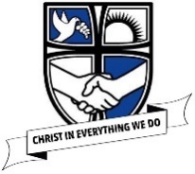

Art and Design at St Philip’s

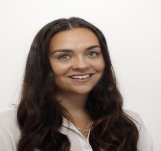
Here is a quick look into Art and Design in our school!
Hello all! My name is Miss Houghton and I am the Reception teacher. However, I am also the subject leader for Expressive Arts and Design in our school! I love getting creative and it is my job to make sure we all do amazing art work in school!
Look at the school website below for more information and regular updates about what we are doing!
https://www.stphilipssouthport.com/art-and-design/

As part of the Christmas festivities, we entered the Sefton Christmas Card competition whereby children designed a Christmas card for our local MP Patrick Hurley. We had two winners and a runner up! Well done to Millie, Jake and Sebastian.
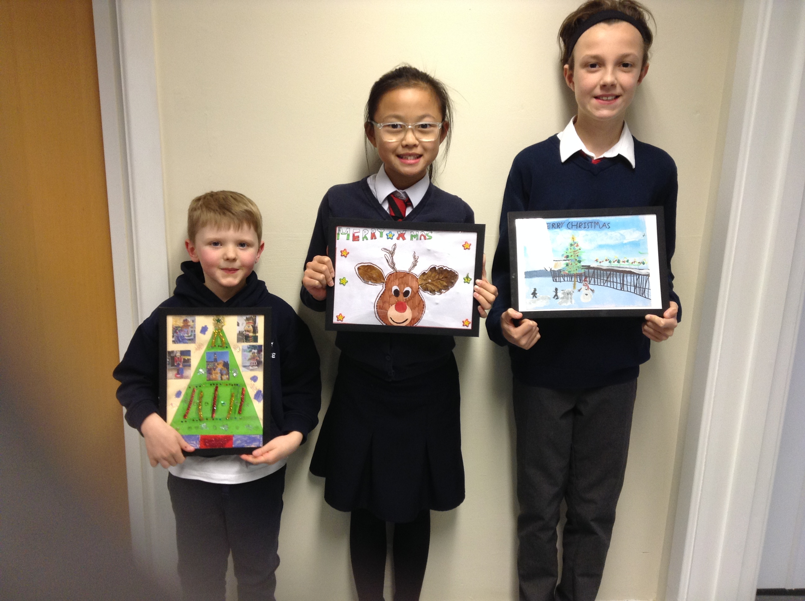

Christmas card competition!
At St Philip’s all children are given the opportunity to learn through art and design. This is through drawing, painting, printing, collage, 3D work and digital Art. All children progress each year enabling them to use a range of tools and mixed media to express themselves freely.
What is Art and Design at St Philip’s?
Our Golden Thread 3 words!

Creativity

Experience

Develop
Art and Design Topics!
Reception – Using mixed media and getting expressive in line with the early learning goals.
Y1 – London Landmarks
Y2 – Australian Adventures
Y3 – Making things happen
Y4 – Anglo Saxon Art
Y5 – African Media
Y6 – Tropical Art

Chinese number painting in Reception!

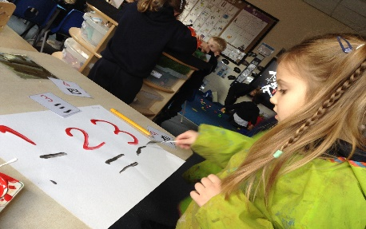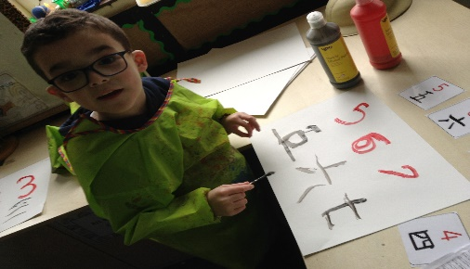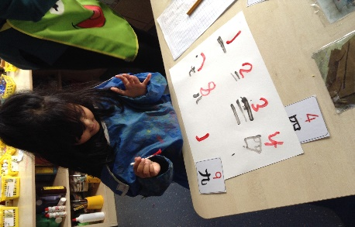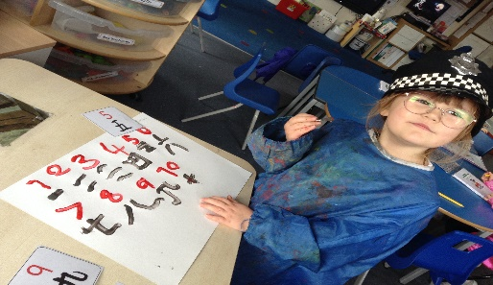
Christmas card making!

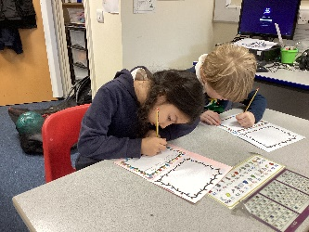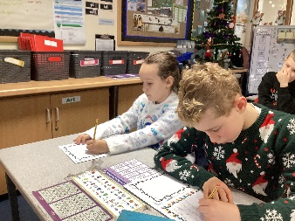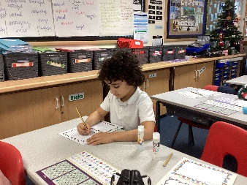
‘We then wrote messages to our family inside; the card was designed by me’- Ethan
‘We used different tools to design our Christmas card’ - Marta
‘We used mixed media to create the finished look’ – Adam

