Art and Design: intentions
Our golden threads run through our Art & design provision - Educating for Wisdom, Knowledge and skills - Educating for hope and aspiration - Educating for community and living well - Educating for dignity and respect.

Art, craft and design embodies some of the highest forms of human creativity. A high-quality art and design education should engage, inspire and challenge pupils, equipping them with the knowledge and skills to experiment, invent and create their own works of art, craft and design. Here at St. Philips we provide the children with every opportunity to do this. The children also learn how art and design reflect and shape our history and contribute to the culture, creativity and wealth of our nation.
In the EYFS and Infants, the main aims are to enjoy art, learning the basic skills and techniques to be built upon as they progress through school. We encourage them to develop their curiosity regarding various media and how they can experiment with them. They begin to learn about artists, sculptors, designers and architects from around the world and from the past to present day.
As pupils progress, they learn to be able to think critically and develop a more rigorous understanding of art and design. They build on their knowledge of artists, sculptors, designers and architects and begin to develop an understanding of their significance in the art world, their impact on our lives and changes they have been responsible for.
By the end of KS2, we want our children to leave our school with a wide range of Art and Design skills, developed through positive art experience and learned skills such as;
- developing their techniques, including their control and their use of materials, with creativity, experimentation and an increasing awareness of different kinds of art, craft and design.
- creating sketch books to record their observations and use them to review and revisit ideas
- improve their mastery of art and design techniques, including drawing, painting and sculpture with a range of materials (for example, pencil, charcoal, paint, clay)

We also aim for all children to:

- learn about great artists, architects and designers- in history through to the present day.

- enjoy all aspects of art and design.

- understand the importance of the subject- its impact on the world and how it relates to many other subjects.

- develop a sense of what they like or do not and the confidence to voice this.

- to develop and broaden their language and vocabulary and ability to use this to convey their own ideas and findings.

Art and Design: implementation
Class teachers are supported in a range of ways:
- a subject leader with considerable experience
- medium term plans that complement the topics taught in each year group, as well as covering the necessary art skills.
- a series of Art and Design ladders which outline progression from Year 1-6
- word banks for each topic
- knowledge organisers for topics covered through the school are now being supplemented with specific topics per year group.
- ideas for art and design rich visits (galleries) and opportunities within existing trips (architecture and design in churches/ cathedrals/mosques)
- ideas to involve families and wider members of our school community within art lesson

A curriculum which …
- is carefully planned to build and deliver new skills, knowledge and appreciation and techniques
- has a strong focus upon developing skills
- develops children’s curiosity and enquiry, learning to examine, question and analyse
- aims to develop pupils understanding of why we study art and design with an approach based upon skills and developing techniques
- encourages an understanding of the contribution that people, events and art movements have made to our way of life now
- is inclusive and considers all religions, race, cultures, age, abilities and gender
- is taught with a focus on our Christian values
INSET which has…
- demonstrated skills to aid staff learning and different ways to impart skills to the children
- ensured clear cross-curricular learning by working together to link skills and experiences with topics in various year groups.
- provided tuition for staff to develop their own skills, knowledge and understanding.
- equipped teachers with a bank of learning objectives and differentiated success criteria

Art and Design: impact
Children have become more expressive and confident in demonstrating the new skills they have learned.
Art has been developed as a discreet subject, developing skills, vocabulary and understanding of techniques, as well as a supporting subject with cross-curricular links to most subjects. Children are learning how it enriches the world around us -including understanding and appreciation of art and design around the world.
The children are enthusiastic about the subject and demonstrate high levels of enjoyment throughout the school.
Art monitors are a group of upper key stage two children who are keen to learn the background to art techniques, offering their time to help set up activities, record outcomes and value the need for care to be taken with resources.
There is a continuous production of high quality art work throughout the school which is displayed attractively and regularly incorporates other subjects and focuses.
Children are keen to discuss new skills they have learned, talk about other art and artist and consider ways they may improve their work.
Children enthusiastically entering art competitions.
Children bringing in their own work from home that is connected with work carried out in school.
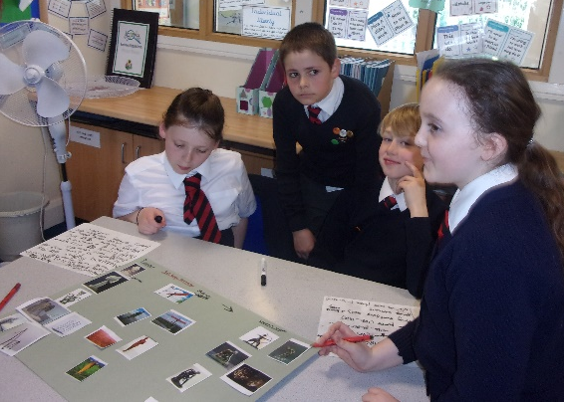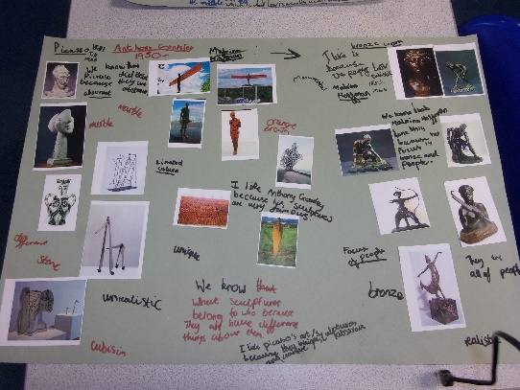
Identifying, grouping and describing work by different sculptors through the ages.
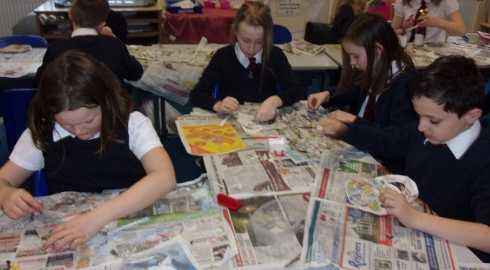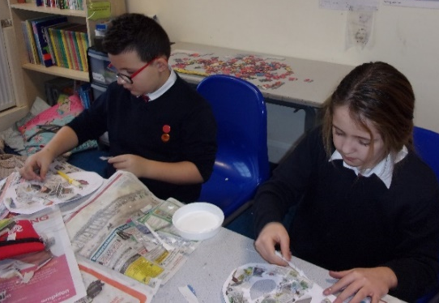
Making African masks using papier mache
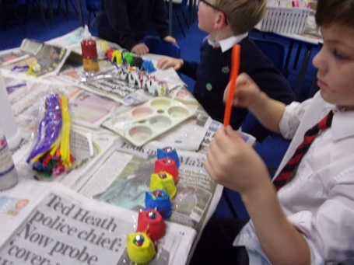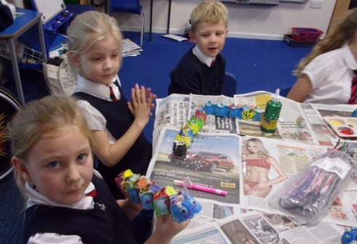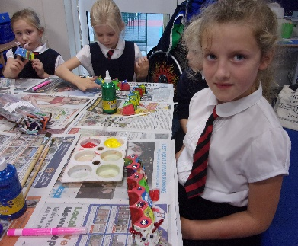
Creating 3D catterpillars
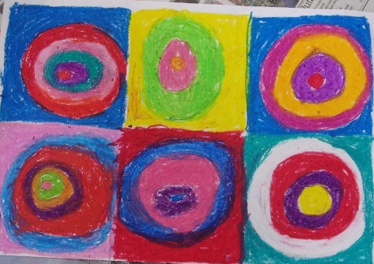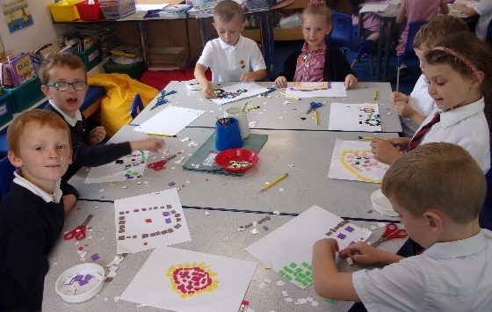
Y1 Kandinsky in oil pastels Mosaic collage
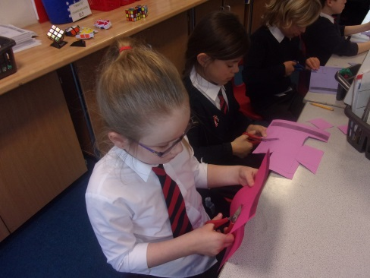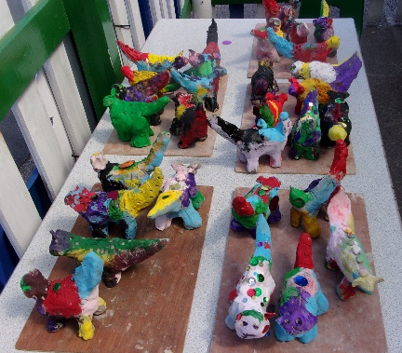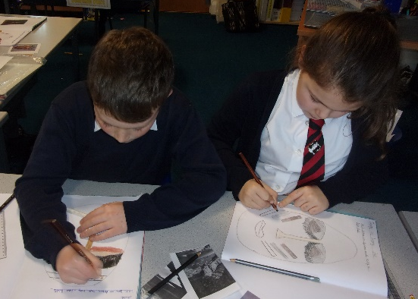
Making Easter baskets Lambananas in clay African art
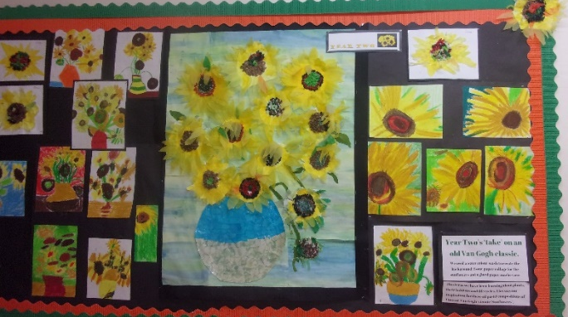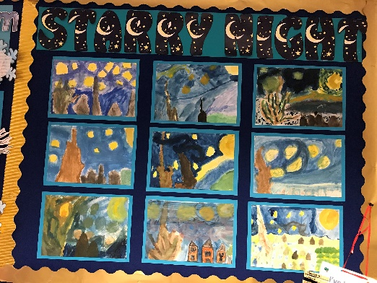
Vincent van Gogh’s ‘Sunflowers’ and ‘A Starry Night’
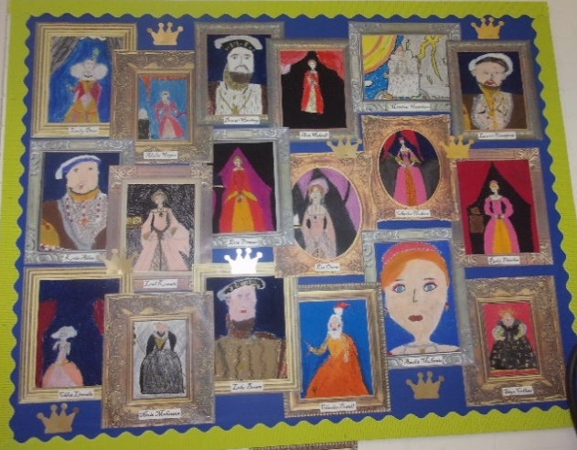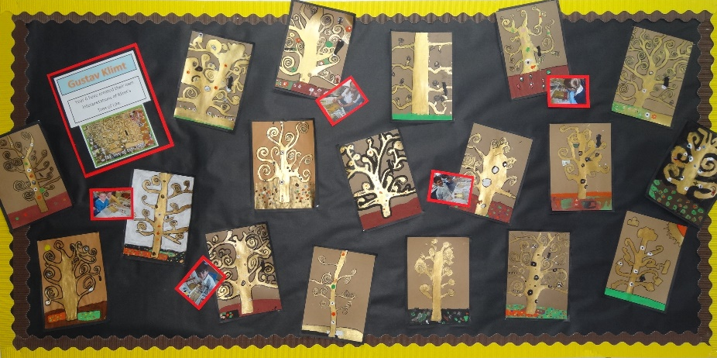
Tudor portraits Gustav Klimt’s ‘Tree of Life’
Cross-curricular displays
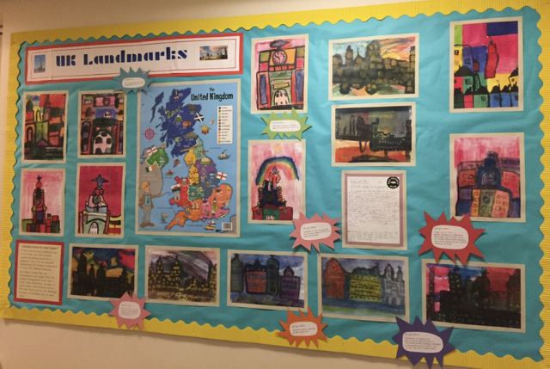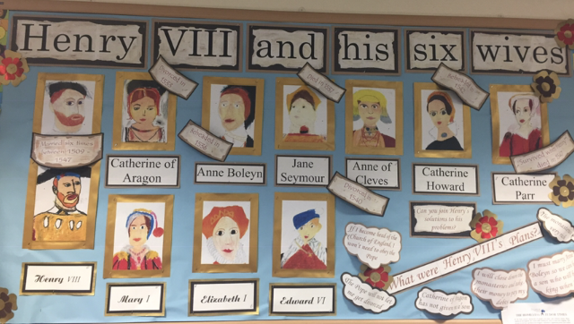
Geography, art & English History & art
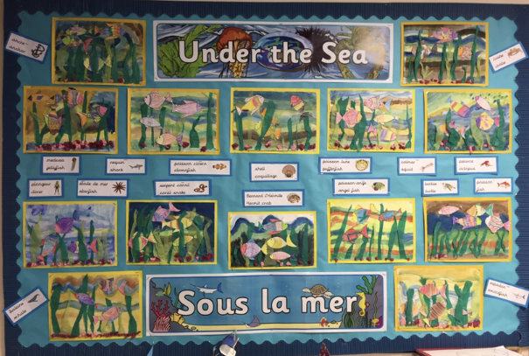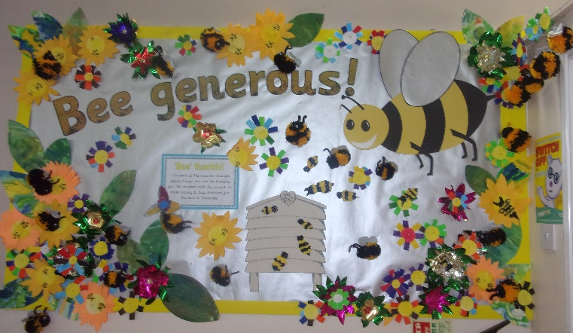
French, art & topic RE & art
How do I know I am better at Art and Design now than I was?
Children are encouraged to regularly review their emerging skills and successes.
They are encouraged to recognise their own personal development and skills which they now have that they did not when they were younger.
Art books recording their work so they can see their progression.
Assisting a peer with a skill or technique because they have mastered it.
Seeing their work displayed around the school.
Entering art competitions and receiving positive feedback.
The areas outlined in the national curriculum and target tracker enable children to see how they are progressing. However, the practical aspects of the subject focus on children experimenting and through this, developing skills, techniques and knowledge and understanding of how, why and reasons for choices of media. This builds children’s progress and ability but at differing speeds.
Progress expected ranges from mark making and mixing their own colours to children producing high quality compositions in various media and the ability to discuss their ideas and opinions. Children further up the juniors produce significant pieces of written work including biographies of artists.

