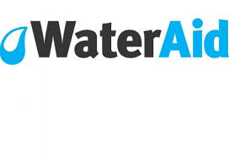

Friday 19thJuly 2019 Water Aid Day at St. Philip’s
Dear Parents/Carers,

Sometimes we take the simplest things for granted.
Water is one of those things.
We are so lucky to have fresh, clean water to drink every day.
We don’t think twice about having a bath or a shower and when we flush the toilet do we spare a thought for those who don’t have decent toilets to practice good hygiene?


Let’s take a moment to think about it.
In fact, on Friday 19th July all schools in the Southport Learning Partnership will be dressing up in clothes and outfits related to water for the day. Each child will bring in £1 to dress in this way and by doing this we will raise awareness of an amazing worldwide charity known as WaterAid.

WaterAid provides clean water, decent toilets and hygiene knowledge to people who don’t yet have access to them. Access to clean water and toilets is a human right, and should be a normal part of daily life for everyone, everywhere.
Our aim at St. Philip’s School Council is to raise awareness and vital funds to help WaterAid extend their reach to help people around the world in the most needy areas. Your outfit could be as simple as being blue. It could be a pirate, a diver, a mermaid, a showercap, a bottle of water, an ice cube…….the list goes on and in fact there will be a prize for the most unique outfit.
So, remember….. bring £1 to dress in an outfit of your choice related to water.

We will have a representative from WaterAid at school on Friday to deliver an assembly on the importance of their work and of course to present the winning prize for most unique outfit.

The School Council look forward to raising lots of money and taking a moment to appreciate the efforts of this amazing charity.
Thank you for your support,

Yours Sincerely,

Mrs. Maguire and St. Philip’s School Council.

