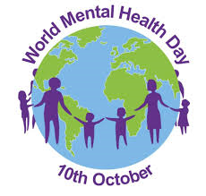
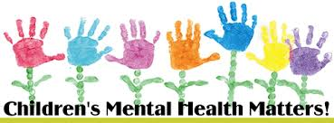
Dear Parents/Carers,

Thursday 10th October marks World Mental Health Day.
Mental Health is often an issue which is overlooked but it is imperative that it is everyone’s business. We all have times when we feel down or stressed or frightened. Most of the time those feelings pass. But sometimes they develop into a more serious problem and that could happen to any one of us. As a school community we need to remember that:
- Everyone is different. You may bounce back from a setback while someone else may feel weighed down by it for a long time.
- Your mental health doesn’t always stay the same. It can change as circumstances change and as you move through different stages of your life.
- There’s often a stigma attached to mental health problems. This means that people feel uncomfortable about them and don’t talk about them much. Many people don’t even feel comfortable talking about their feelings. But it’s healthy to know and say how you’re feeling.
World Mental Health Day is an ideal platform for St. Philip’s School Council to raise awareness of this very important issue.
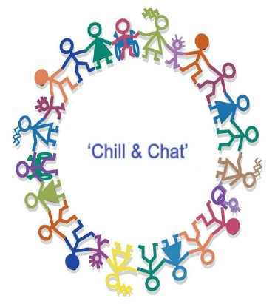
- We will be holding a Poster Competition open to all with the theme of “Mental Health Matters”. Two best entrants will be selected per class and will be announced on Thursday 10th October. The winning entrants will be used to adorn our walls to remind us of the importance of our mental health.
- Additionally, on World Mental Health Day for £1 donation, children in each class will be invited to the hall for a “Chill and a Chat”. Children can have a drink and a biscuit or healthy snack while chatting to their friends about their feelings and what to do if they feel a little stressed. During this time, we will explore the book “Scrambled Heads” and open up the conversation to talk about mental health and strategies that we can use to look after ourselves.
So, Thursday 10th October is a very important day for us to join together and talk about how we feel. All the School Council ask is that each child brings in £1 donation. Half of this money will go to Young Minds – a mental health charity for young people. The other half will go towards buying seating like bean bags so that the children can “chill out” in our playground. We look forward to raising the profile of Mental Health in our community
Thank you for your support,

Yours Sincerely,

Mrs. Maguire and St. Philip’s School Council.

