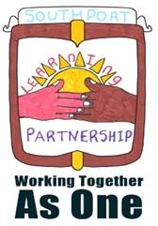






February 2019
Dear Parents/Carers
Our school is part of the Southport Learning Partnership where we work together with other schools on joint projects.

Each year on the last day of half term we take part in a Southport wide event called Love My Community. This year on Friday 15th February we hope every child in the town will wear something orange for the day in exchange for a donation of £1 to Muscular Dystrophy UK. We are very privileged to have a little boy in our school who lives with Muscular Dystrophy every day. He and his family are fantastic ambassadors for the charity MDUK and we are very excited that all schools in the Southport Learning Partnership have chosen to support him and the charity as a whole.
Muscular Dystrophy UK is the charity for the 70,000 people living with muscle-wasting conditions in the UK. They bring together people affected by more than 60 progressive muscle-weakening and wasting conditions.
Muscle-wasting conditions are very rare, affecting just over one in every 1,000 people.

Muscular Dystrophy UK provide vital information, advice, resources and support for people with these conditions, their families and the professionals who work with them.


Many thanks for your help with this appeal and we hope together we can all make a huge demonstration that we Love our Community!

Yours sincerely,
Mrs. Maguire and the School Council

