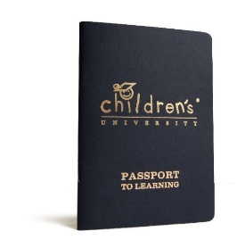
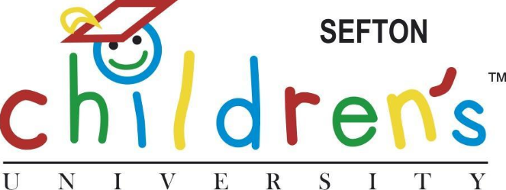

“There is always one moment in childhood when the door opens and lets the future in” – Graham Green
Dear Parents / Guardians,
We are delighted to welcome your school on board to participate in Children’s University.
What is Children’s University?
A national charitable organisation which celebrates learning that takes place outside of school hours.
Did you know that children in CU schools made two additional months progress in reading and maths comparted to children in other schools. (Education Endowment Foundation Evaluation Report, December 2017)
How does it work?

Your child can collect ‘credits’ by:
- attending after school clubs run by your childs school
- attending ‘Learning Destinations’ in your area (such as swimming lessons, cubs, brownies, music lessons, the list is endless!)
- attending structured activity sessions at libraries, museums, farms, leisure centres and more across the country.
- by taking part in holiday challenges set by your local CU.
Every hour of learning will equal 1 credit.
Children will collect their credits throughout the years and be invited to our full cap and gown graduation ceremonies when they meet certain targets.

4 Golden rules:
- Learning must be voluntary
- Learning must be out of normal school hours
- There must be structured learning taking place
- No more than 10 credits per activity per term (this is to encourage children to try lots of activities)

Why do it?
- Higher attainment and attendance
- Positive social, emotional and behaviour outcomes
- Raised aspirations, self-esteem and confidence
- Greater awareness of higher education opportunities
- Great tool to support transition to key stages
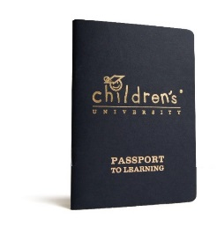
Passport to Learning
Hours earned at school clubs will be recorded by your school. However if you want to collect credits in external Learning Destinations then you will need to purchase a Passport to Learning from your school office which your child keeps for throughout their time at school.



Follow us on facebook Sefton Children’s University, Lancashire Children’s University, Warrington Children’s University
Follow us on twitter @seftoncu @lancashirecu @warringtoncu
Contact: Laura Ashcroft laura.ashcroft@elevate-ebp.co.uk 0151 330 5760 or 07392 870803

