
Welcome to Year 4
We are so excited to welcome you to our Year 4 ‘Creative Bubble’ in September! In our year group, there will be Mrs Afford, Miss Hankinson and Mrs Edwards.
You will have your own work pack filled with all the stationery you will need and will sit at a desk of two, spaced out and facing the front of the classroom. Please wear your winter uniform to school, PE will be on Tuesday and Thursday so please come to school in your PE kit that day (including blue jogging bottoms and blue jumpers/hoodies when it is cold). Just a reminder that earrings should be taken out for P.E and the latest guidance from Sefton is that they cannot be covered with tape now. White or black trainers suitable for sport NOT fashion should be worn.
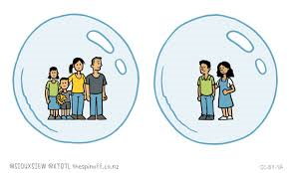
Our Year 4 Bubble will learn, play and eat together.
What to bring to our bubble
- Named water bottle
- Labelled Sunhat (if the weather is still nice)
- Labelled coat
- Named “own” soap / moisturiser for chapped hands (if you wish)
- A small pot/bag of fruit which has been labelled (if you want a mid-morning snack)
- Your inhaler (named) if you use one
- School bag (named)

What not to bring
- Cuddly teddies
- Toys from home
- Pencil cases

You will come in to, and out of, our bubble through the Junior playground door.
On arrival at school
- Keep a 2m distance from other parents and children
- Maintain 2m distance from the teacher on the door
- Go to peg, hang up coat
- Place water bottle and fruit snack on your desk
- Immediately wash hands

You will be coming in to school at slightly different times to some of your friends so here is our list – you need to find the first letter of your last name to work out what time you will come to school.
Start (Juniors)
8.45: A - F 8.50: G - M 8.55: N - Z All Finish 3.20 pm
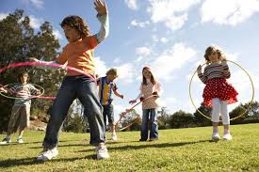
We will be having one morning playtime and lunch time daily. Mrs O’Neil will be looking after you during lunch time and you will eat lunch first in the classroom and then from 12:30 – 1:00pm will be playtime.

Our new school Christian value for Autumn term is Friendship, which will be a lovely start to our new school year. Remember if you have any worries there are always lots of people you can talk to in school – we are here to listen to you and help wherever we can.
Homework will be given out on a Friday, due in the following Wednesday. Spellings will be tested on a Friday and we will continue with our Key skills tests in Maths and daily class reading or IDL sessions before lunch.
Do not forget the ‘Covid summer catch up’ page on the Year 4 class web page- there are some fun activities on there to keep your brains active. Also please remember your logins for the computers and Purple Mash as we will continue to use these in September! We will also be using email to contact your families a lot more, although we will only reply in office hours to make sure we all get a break from technology!
Can I also remind you that we are a nut-free school and it is even more important this year as Miss Hankinson has a severe nut allergy? I would also like to request that your child does not bring in any products made from latex as I too have a severe allergy. Thank you for your co-operation in this
Have a lovely end of summer and we are looking forward to seeing you Thursday 3rd September
Love from,
The Year 4 Team
Mrs Afford, Miss Hankinson and Mrs Edwards


