
September 2020
Dear Parents / Carers in Year 4,
Learning at home
Monday | Tuesday | Wednesday | Thursday | Friday
Times Tables Practice | Times Tables Practice | Times Tables Practice | Times Tables Practice | Times Tables Practice
SPaG/WoD | SPaG/WoD | SPaG/WoD | SPaG/WoD | Key Skills
Maths | Maths | Maths | Maths | Maths
English | English | English | English | English
Reading/IDL | Reading/IDL | Reading/IDL | Reading/IDL | Reading/IDL
Computing | PE | French | PE (Swimming) | Science
RE | Geography/History | Art | Science | Music/PSCHE

Please find a list below of learning that your child can take part in, if school or your child’s bubble is closed due to Covid restrictions/quarantine.
Children will need to log onto their class pages of the website for daily updates and also onto Purple Mash to complete tasks set. You will find a knowledge organiser for each subject for the term on the class website which will help you with key Information to support learning at home.
We suggest chunking up the time your child has in the day and focussing on short spells of learning in each subject. We have included a basic timetable from school to support you with this.
Each child can, if requested, have a blank exercise book to record their work in, but we suggest just using a nice notebook from home. High standards of presentation should be maintained. Any work in the book requires a date and a title. Once we re-open the completed books and work should be sent back into school. We are unable to mark this work but we will most definitely reward effort. We suggest that a family member talks through tasks that the children have completed and we would welcome a written comment, smiley face or a note about any difficulties.
As always, we would encourage project work and home research which our children (and Parents!) are so good at.
Thank you for your continued support. You can contact me via email between the hours of 9 am and 3pm with questions and queries related to learning.
Although this is a really sad time and we will miss you all, keep on working hard and remember that we will all be back together very soon. Enjoy your time at home, learning at your own pace. Be kind, be helpful and we’ll see you soon.
affordj@sps.sefton.school hankinsone@sps.sefton.school
Mrs Afford and Miss Hankinson
English including phonics, reading, spelling, grammar and punctuation

Brief overview of coverage

Characterisation

Y4 | Spellings | School website.
Y4 | Reading - Serial Mash | Purple Mash.
Y4 | Handwriting | Purple Mash.
Y4 | Classroom secrets, free home learning packs. | https://classroomsecrets.co.uk/home-online-learning/
Y4 | Writing ideas with images, new prompt daily. | http://www.pobble365.com/
Y4 | Writing tasks. | Purple Mash under ‘to dos’.
Y4 | The School Run for grammar or reading worksheets | https://www.theschoolrun.com/
Y4 | Twinkl Home School Closure Pack | https://www.twinkl.co.uk/resource/year-4-school-closure-home-learning-resource-pack-t-e-2549913

Maths including times tables

Brief overview of coverage

Place value, Roman numerals, addition & subtraction, problem solving

Y4 | Times tables practice. | Purple Mash, see website.
Y4 | White Rose small steps, order to learn concepts in  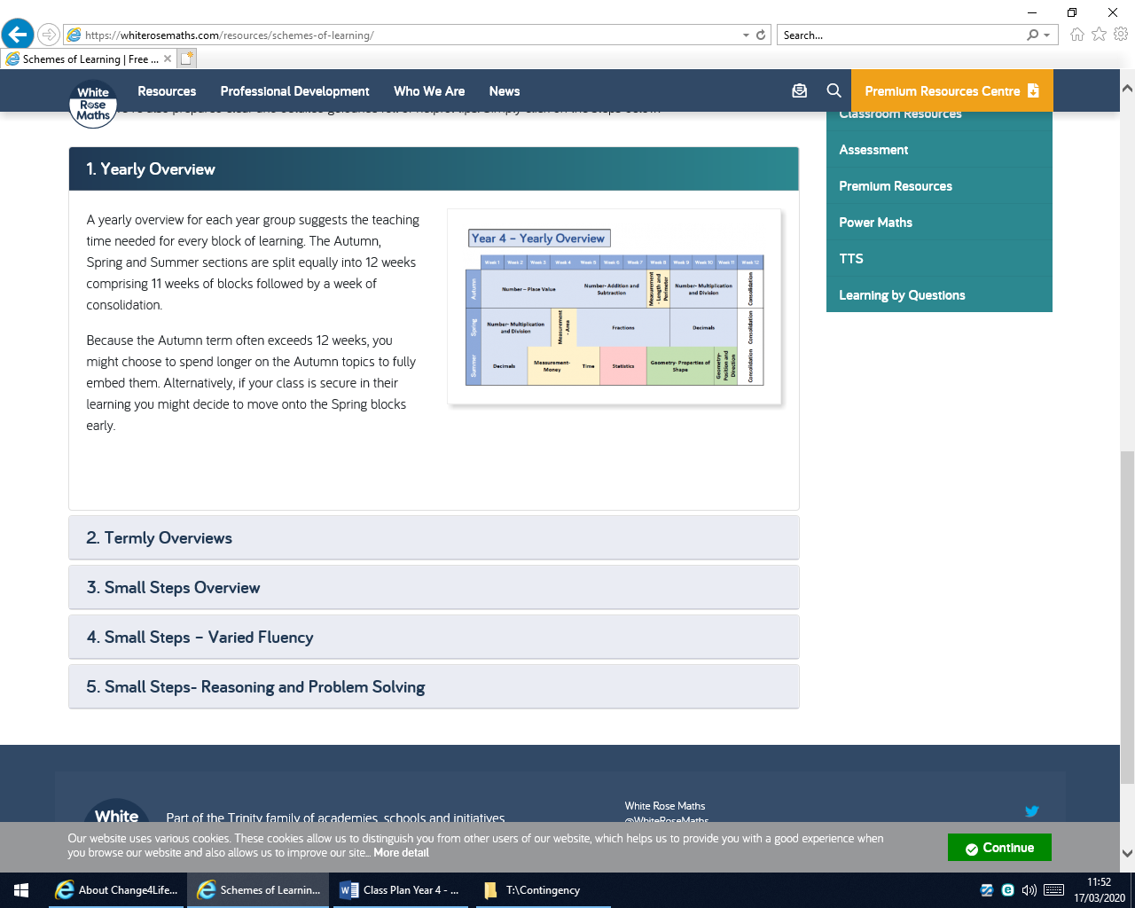 | https://whiterosemaths.com/resources/schemes-of-learning/primary-sols/  https://whiterosemaths.com/wp-content/uploads/2019/SoLs/Primary/SOL-Year-4-2018-19-Spring-Term-Block-4-FINAL.pdf
Y4 | Classroom secrets, free home learning packs. | https://classroomsecrets.co.uk/home-online-learning/
Y4 | Arithmetic practice | http://mentalarithmetic.co.uk/
Y4 | BBC Super Movers – PE twist on various subjects | https://www.bbc.co.uk/teach/supermovers
Y4 | Twinkl Home School Closure Pack | https://www.twinkl.co.uk/resource/year-4-school-closure-home-learning-resource-pack-t-e-2549913
Y4 | Worksheets on key concepts, free to register | https://masterthecurriculum.co.uk/

French

Brief overview of coverage

Y4 | Twinkl topics | https://www.french (specific Y4 topic)
Y4 | Duolingo (also an app) | https://www.duolingo.com/
Y4 | Twinkl Home School Closure Pack | https://www.twinkl.co.uk/resource/year-4-school-closure-home-learning-resource-pack-t-e-2549913
Y4 | BBC Bitesize French resources | https://www.bbc.co.uk/bitesize/subjects/z39d7ty
Y4 | Useful resources | http://www.primaryresources.co.uk/mfl/mfl_french.htm

Humanities - Geography

Brief overview of coverage

Mapping

Y4 | Maps | www.google.co.uk/maps  www.bing.com/maps
Y4 | World map and revision of continents | https://www.bbc.co.uk/bitesize/articles/z4dxt39
Y4 | Boosting map reading skills | https://www.rgs.org/schools/teaching-resources/map-skills/map-skills-map-skills-year-four/
Y4 | Twinkl Home School Closure Pack | https://www.twinkl.co.uk/resource/year-4-school-closure-home-learning-resource-pack-t-e-2549913

Science

Brief overview of coverage

Animals in their habitats including humans

Y4 | BBC Bitesize – Animals and their habitats | https://www.bbc.co.uk/bitesize/clips/zbp6n39
Y4 | Stem learning – Animals and their habitats | https://www.stem.org.uk/resources/community/collection/12774/year-4-living-things-and-their-habitats
Y4 | Twinkl Home School Closure Pack | https://www.twinkl.co.uk/resource/year-4-school-closure-home-learning-resource-pack-t-e-2549913

Design Technology

Brief overview of coverage

Y4 | Enjoy making something creative with your child! | https://www.youtube.com/user/mistermaker

PE

Brief overview of coverage
Y4 | The Body Coach – Joe Wicks |  | https://www.youtube.com/playlist?list=PLyCLoPd4VxBuxu3sLztrvWFehzv-LnR2c
Y4 | Go Noodle movement and games |  | https://www.gonoodle.com/
Y4 | Cosmic Kids Yoga |  | https://www.youtube.com/user/CosmicKidsYoga
Y4 | Change 4 Life |  | https://www.nhs.uk/change4life/about-change4life
Y4 | Free Active cards |  | School website.
Y4 | BBC Super Movers – PE twist on various subjects |  | https://www.bbc.co.uk/teach/supermovers
RE

Brief overview of coverage
God, David & the Psalms

Y4 |  | Religious Education – BBC Bitesize |  | https://www.bbc.co.uk/bitesize/subjects/z7hs34j
Y4 |  | RE resources and worksheets |  | http://www.primaryresources.co.uk/re/re.htm
Y4 |  | Useful resources and videos. |  | https://www.reonline.org.uk/

PSHE

Brief overview of coverage

Y4 | One Decision – Keeping Safe | https://www.1decision.co.uk/  UN: stphilipsprimary  PW: stphilipsps6ss
Y4 | BBC PSHE resources | https://www.bbc.co.uk/bitesize/subjects/zqtnvcw

Music

Brief overview of coverage

Y4 | BBC Bring the Noise | https://www.bbc.co.uk/teach/bring-the-noise
Y4 | BBC Music 4-11 | http://www.bbc.co.uk/schools/websites/4_11/site/music.shtml
Y4 | Orchestra music | https://www.bbc.co.uk/teach/ten-pieces
Y4 | From Mr Dempsey | www.tacklemusic.co.uk/stphilips  Password - StPhilipsSouthport

Computing

Brief overview of coverage
Y4 | Purple Mash objectives | See to dos on Purple Mash.
Y4 | BBC Bitesize Computing resources for revision | https://www.bbc.co.uk/bitesize/subjects/zvnrq6f

Useful websites for all subjects - free parent accounts may need to be created.
https://www.purplemash.com/login/
https://www.twinkl.co.uk/resource/year-4-school-closure-home-learning-resource-pack-t-e-2549913
https://classroomsecrets.co.uk/free-home-learning-packs/
https://www.bbc.co.uk/teach/supermovers
https://www.theschoolrun.com/
https://www.topmarks.co.uk/

