TIME TRAVELLER TASK: The Vikings PROJECT
A project is supposed to take several weeks. Stage 1 = research. Stage 2 and 3 write it. Stage 4 the finishing touches like title page, contents and bibliography (list of websites/books used)
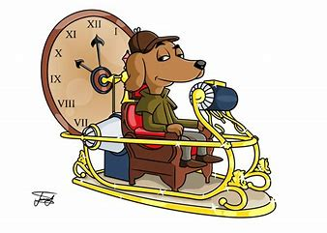
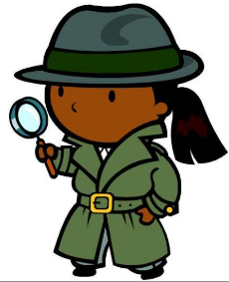
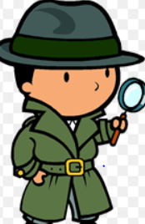
Ask most people about the lives in Viking times and if they know anything, they will say they were very different from us.
Your task
LO: To write a as a time traveller to Viking Britain. Your mission is to explore what was similar and different to how we live today. Finish with an answer to the question: Were lives in Viking Britain really so different from lives today?
Good = you can list lots of similarities and differences
Very good = you can write in paragraphs to show similarities AND differences
Excellent = AND you can weigh up these similarities and differences to give a convincing answer to the question above.
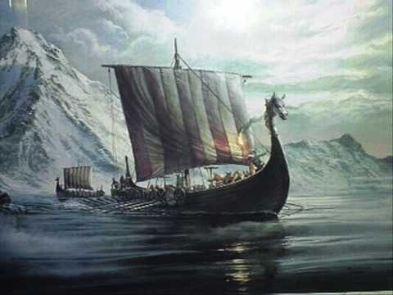
Stage 1….Research stage
Use the resources below to learn about the Vikings.
https://www.bbc.co.uk/bitesize/topics/ztyr9j6/articles/ztqbr82
https://www.bbc.co.uk/teach/class-clips-video/history-ks2-the-vikings-animation/zhrygwx
https://www.bbc.co.uk/cbbc/watch/horrible-histories-song-vikings-and-garfunkel?collection=horrible-histories-songs
https://www.bbc.co.uk/bitesize/clips/z4pnvcw
Now list in tables like this what you think about what you have found out. You can choose your own topics: these are just ideas…you might like to look at lives of children or women
Different to us | Neither/not sure/both |  | Similar to us
Homes and buildings
Made of wood and thatch  Only one room  No inside toilets or showers |  |  | Had heat and fuel for cooking inside  Some decorations
Food
Beliefs/religion
Clothes/fashion
Jobs/tasks/chores
Transport
Laws
Stages 2 and 3 = Now you can start to write your project. You can hand write or use a computer. There are 3 parts to this.
1 = Write an introduction. Remember you are writing as a time traveller. You need to explain what your task is and set the scene. This should be fun but you need to make this your best writing so take care with punctuation and spelling. You should be trying to show off correct use of advanced punctuation and more complex sentences such as those starting with fronted adverbials. Here is an example:
Spinning rapidly through time, my challenge in this project is to travel back to investigate the Vikings. Wish me luck! Aargh….my time machine has given me a headache. I’ve travelled back in time one thousand years. I’ve crash landed in Viking York: they call it Jorvik. I’m going to investigate and find out just what its like to live here. My task is to find lots of evidence to help me answer the question- Were lives in Viking Britain really so different from lives today?
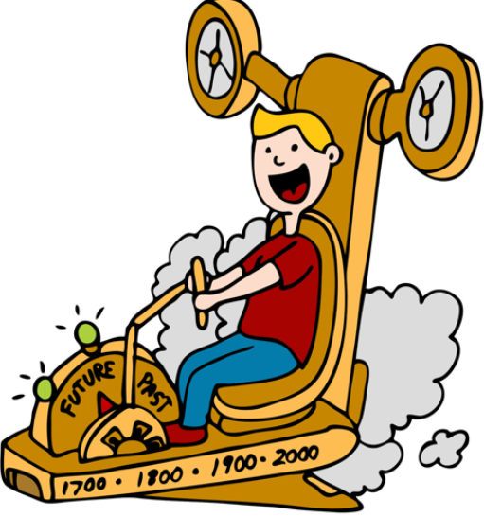
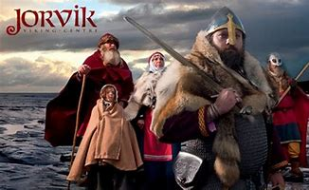

2 = Now write your chapters: give each one a title and write making it really clear what you think is similar and different. You can do this by using the following
Different | Similar
strange  unusual  We don’t do this  I’ve never seen anything like this before | the same  I recognise this  just like we do
Chapter 1 Homes and towns
Staggering slowly out of my time machine, I find myself next to some Viking homes. This must be a village or town however I do not see the stone and brick buildings that we have today and I don’t see the big buildings we have like churches and banks and cinemas. Instead I see small, wooden huts. In a one roomed house (I have many more rooms in my home) there is a family gathered around a fire eating a meal of………………………………….How strange! Their home is decorated with………
I see that they do have shops just that they are outside people’s houses. The one in front of me is making leather items. I recognise most of what he is making and selling for example...
Other shops I can see include……
Overall, I think in answer to my question about how different were lives here, in terms of the villages and homes they were…..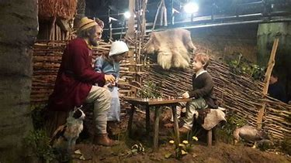 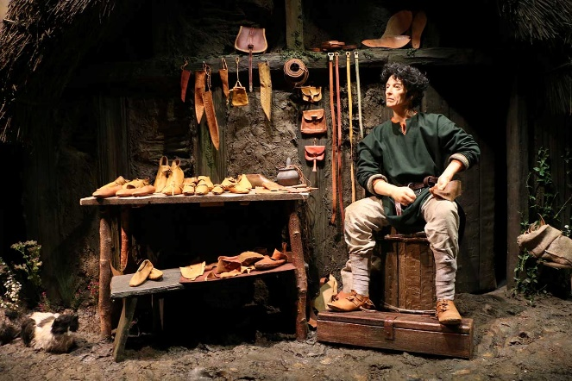
Try to write between 3 and 5 chapters. Make sure you read over your work and neatly correct any mistakes. You can add pictures too. Either draw them yourself or copy from a website.
3. Now it is time to write your conclusion. You have investigated and written about your findings in your chapters. Your conclusion is your big, overall answer to the question: Were lives in Viking Britain really so different from lives today?
Here is an example. Don’t copy it though! You must make sure that you give the answer that fits your investigation. If you have found more differences that is what you must say!
Returning sadly to the 21st century, I think back to what I saw and heard. Overall, I would say that the lives of the Vikings were very ordinary. They spent almost all their time doing their jobs and spending time with family much like we do. Many of the jobs are still done today like farming, making tools and clothes. They wore clothes quite similar to ours- dresses and trousers. They did have some big differences too though. Their religion was different. Also there are many things we have now that were not invented then like……
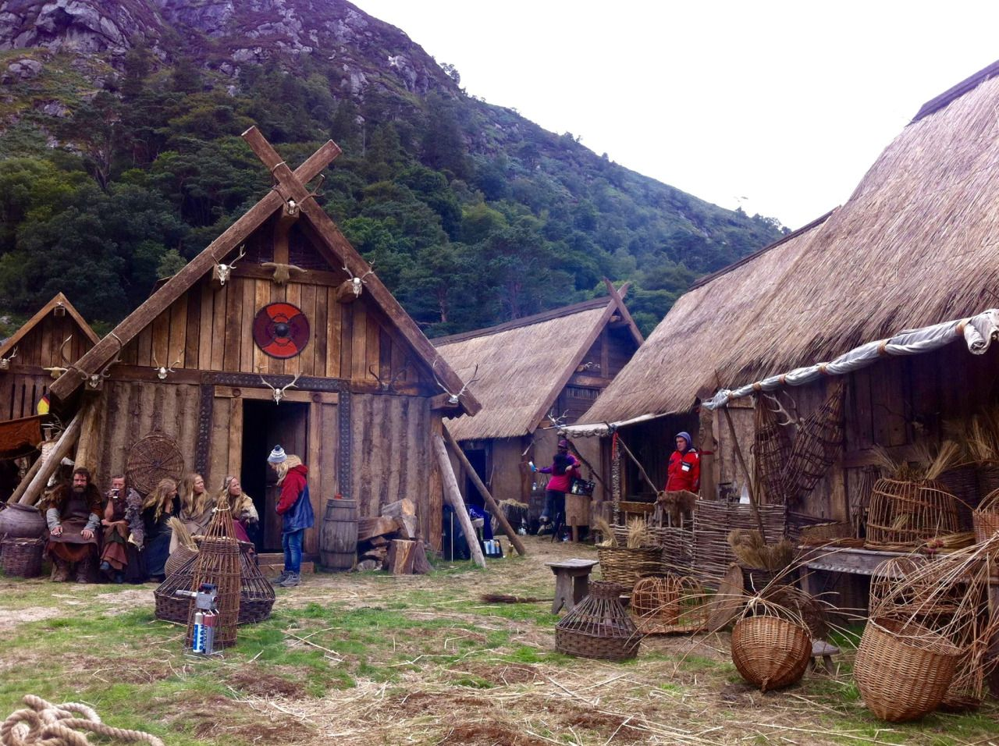
Stage 3 = The finishing touches- there are 3 of them
- Create a contents page
This says what is on each page e.g.
Contents
Introduction
Chapter 1, 2 ,3 and 4
Conclusion
Bibliography

- Make a list- either under your contents or on a back page- of all the websites and books you have used
Bibliography
https://www.bbc.co.uk/bitesize/topics/ztyr9j6/articles/ztqbr82
https://www.bbc.co.uk/teach/class-clips-video/history-ks2-the-vikings-animation/zhrygwx
https://www.bbc.co.uk/cbbc/watch/horrible-histories-song-vikings-and-garfunkel?collection=horrible-histories-songs
https://www.bbc.co.uk/bitesize/clips/z4pnvcw

- Lastly…you have almost finished….enjoy designing a title page. It must include
Your name
A title like My Viking Investigation
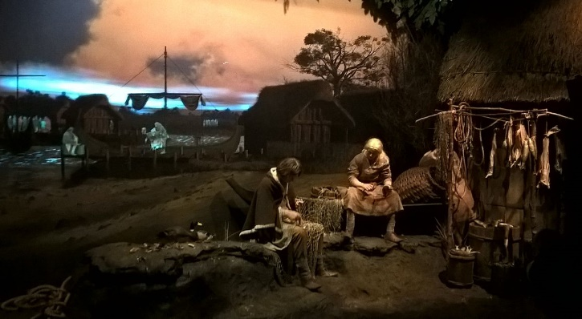

My Viking Investigation by Jane Smith

