Ordering Angles
Friday 12th June
LO. To order different angles and label according to size of the angle.
Order the following sets of angles, labelling the largest as number 1 and the smallest as number 4.
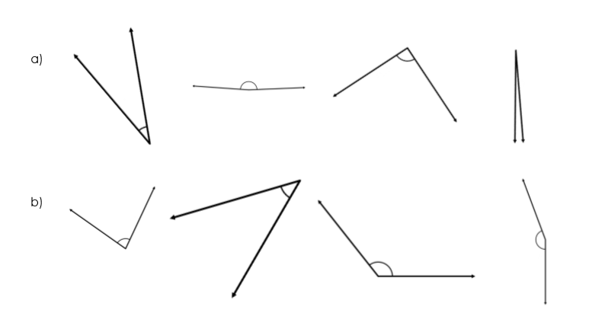
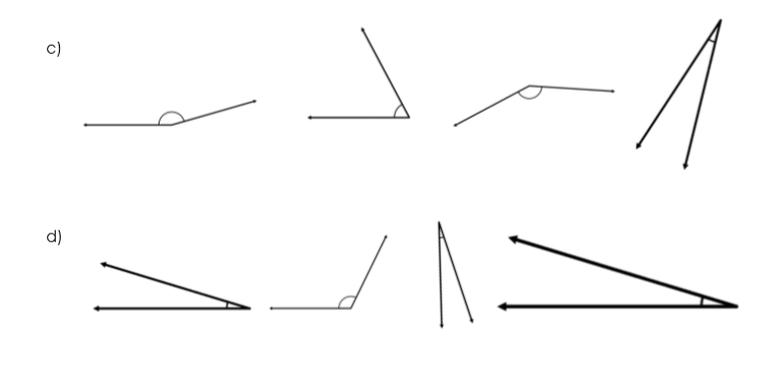
Now draw your own set of 4 angles, drawing the smallest first and finishing with the largest. Label them the same way you have the others.

