17.06.20
LO: To complete a symmetrical design.
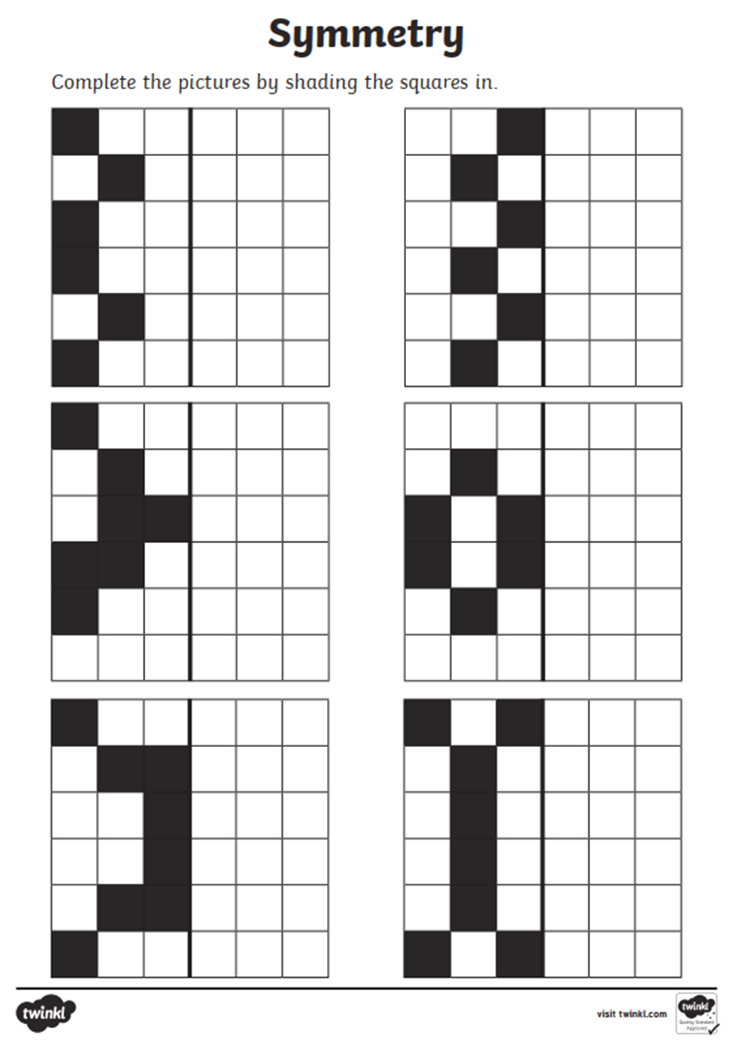
Copy (press ctrl + c) and paste (press ctrl + v) the square on the right, then move into the correct space to make the design symmetrical!

