Reflective Symmetry in Colour
Friday 19th June
LO. To Complete a simple pattern with respect to a specific line of symmetry.
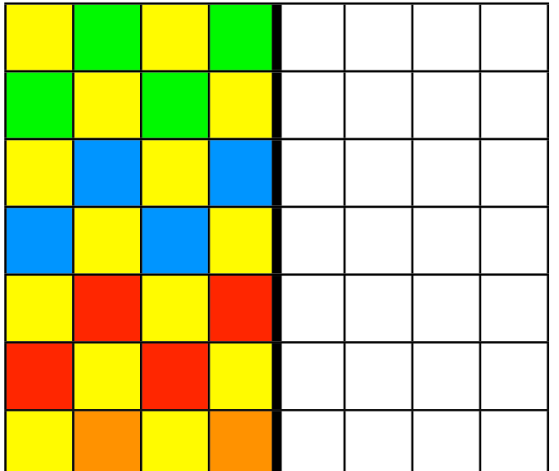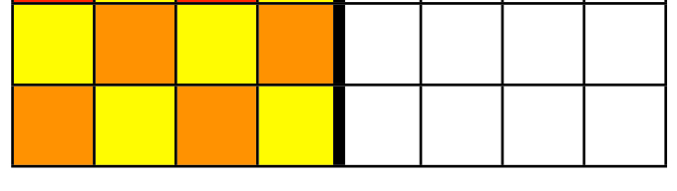
Look at the patterns created by colouring the squares. Using the same colours, create the reflective symmetry of the pattern. It helps if you hold a mirror on the thick black line so you can see what the finished pattern should look like. Then fill in the squares using the correct colours.
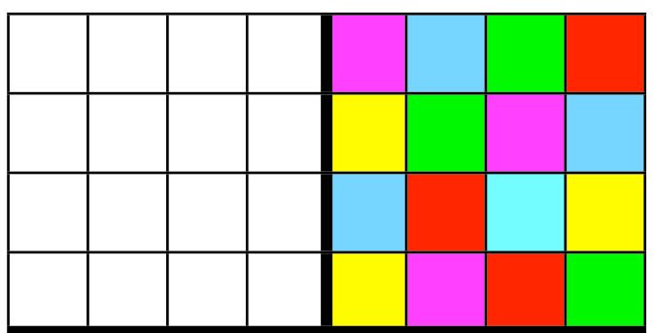
This time you need to create the symmetry four ways. There are two lines of symmetry in this pattern not just one as in the first pattern. The top square on the left needs to reflect the colours opposite and then the two bottom squares need to reflect the squares above as well as opposite each other. Again, using a mirror placed on the heavy lines will help you.


